Figure S2a Forest plot of odds ratios for patients receiving palonosetron with 1-day or 3-day dexamethasone for prevention of chemotherapy induced nausea and vomiting, comparing MEC studies with AC studies: Complete response (CR) in the delayed period.
MEC, moderately emetogenic chemotherapy; AC, anthracycline and cyclophosphamide.

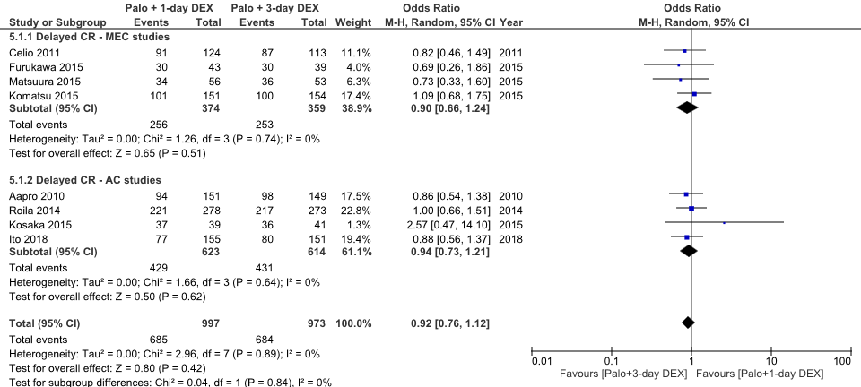

Figure S2b Forest plot of odds ratios for patients receiving palonosetron with 1-day or 3-day dexamethasone for prevention of chemotherapy induced nausea and vomiting, comparing MEC studies with AC studies: Complete protection (CP) in the delayed period.
MEC, moderately emetogenic chemotherapy; AC, anthracycline and cyclophosphamide.

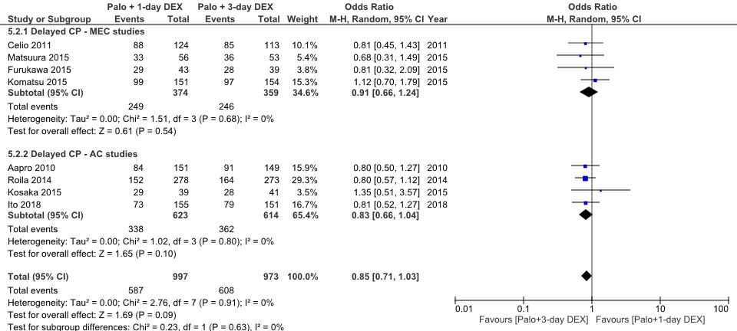

Figure S2c Forest plot of odds ratios for patients receiving palonosetron with 1-day or 3-day dexamethasone for prevention of chemotherapy induced nausea and vomiting, comparing MEC studies with AC studies: Total control (TC) in the delayed period.
MEC, moderately emetogenic chemotherapy; AC, anthracycline and cyclophosphamide.

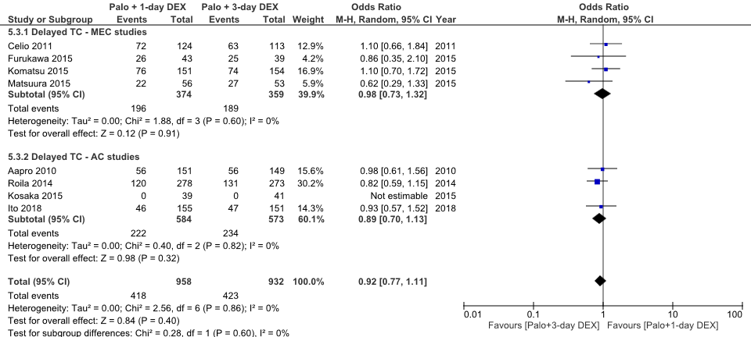

Figure S3a Forest plot of odds ratios for patients receiving palonosetron with 1-day or 3-day dexamethasone for prevention of chemotherapy induced nausea and vomiting, comparing unblinded studies with single-blind and double-blind studies: Complete response (CR) in the delayed period.

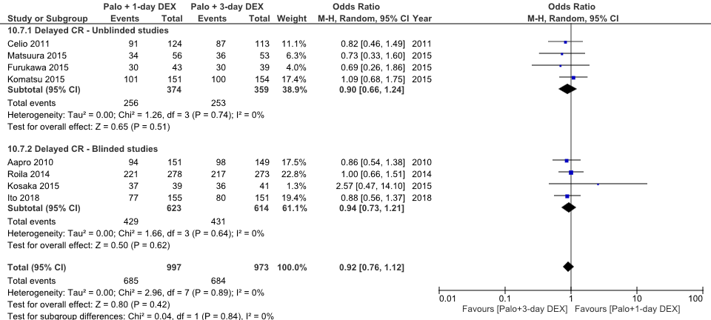

Figure S3b Forest plot of odds ratios for patients receiving palonosetron with 1-day or 3-day dexamethasone for prevention of chemotherapy induced nausea and vomiting, comparing unblinded studies with single-blind and double-blind studies: Complete protection (CP) in the delayed period.

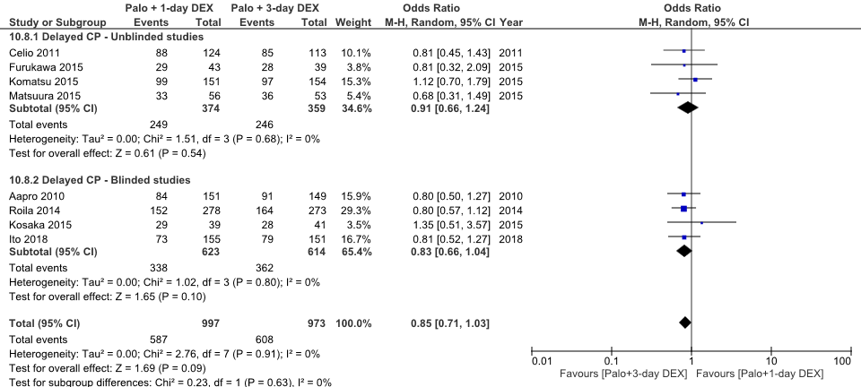

Figure S3c Forest plot of odds ratios for patients receiving palonosetron with 1-day or 3-day dexamethasone for prevention of chemotherapy induced nausea and vomiting, comparing unblinded studies with single-blind and double-blind studies: Total control (TC) in the delayed period.

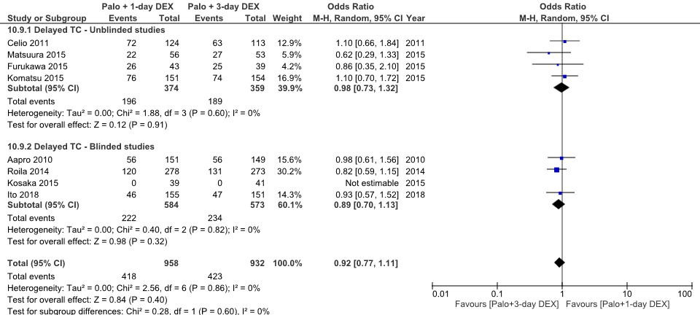

Figure S4a Forest plot of odds ratios for patients receiving palonosetron with 1-day or 3-day dexamethasone for prevention of chemotherapy induced nausea and vomiting, comparing small studies with large studies: Complete response (CR) in the delayed period.

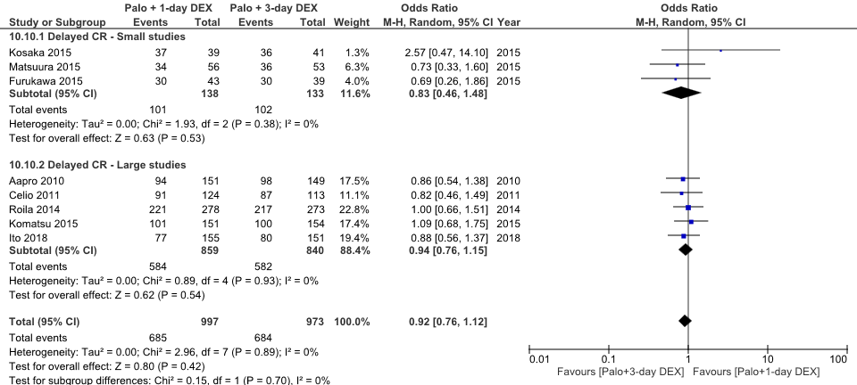

Figure S4b Forest plot of odds ratios for patients receiving palonosetron with 1-day or 3-day dexamethasone for prevention of chemotherapy induced nausea and vomiting, comparing small studies with large studies: Complete protection (CP) in the delayed period.

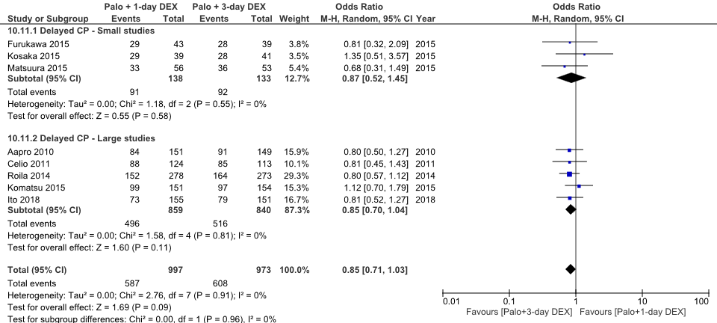

Figure S4c Forest plot of odds ratios for patients receiving palonosetron with 1-day or 3-day dexamethasone for prevention of chemotherapy induced nausea and vomiting, comparing small studies with large studies: Total control (TC) in the delayed period.

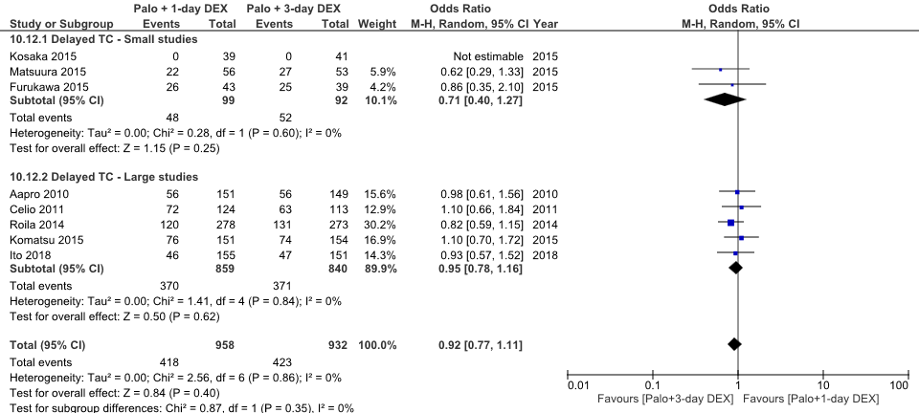

Figure S5a Forest plot of odds ratios for patients receiving palonosetron with 1-day or 3-day dexamethasone for prevention of chemotherapy induced nausea and vomiting, comparing mixed studies with only-female studies: Complete response (CR) in the delayed period.

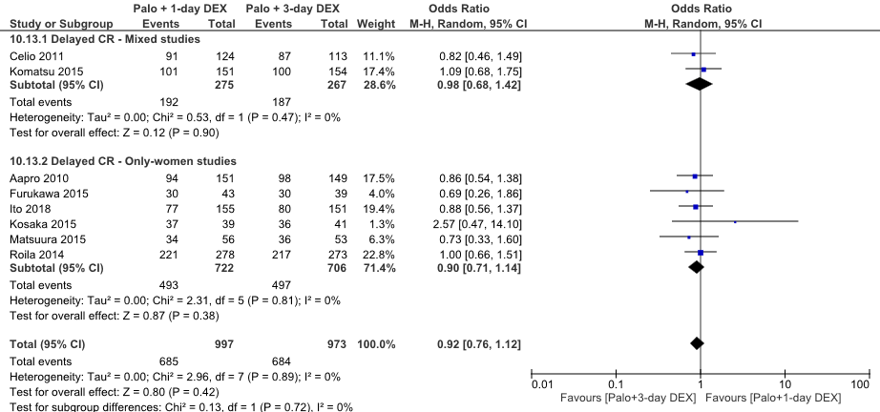

Figure S5b Forest plot of odds ratios for patients receiving palonosetron with 1-day or 3-day dexamethasone for prevention of chemotherapy induced nausea and vomiting, comparing mixed studies with only-female studies: Complete protection (CP) in the delayed period.

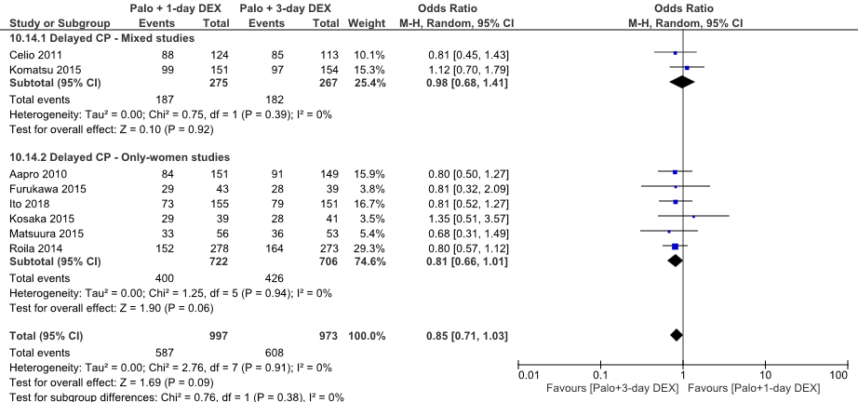

Figure S5c Forest plot of odds ratios for patients receiving palonosetron with 1-day or 3-day dexamethasone for prevention of chemotherapy induced nausea and vomiting, comparing mixed studies with only-female studies: Total control (TC) in the delayed period.

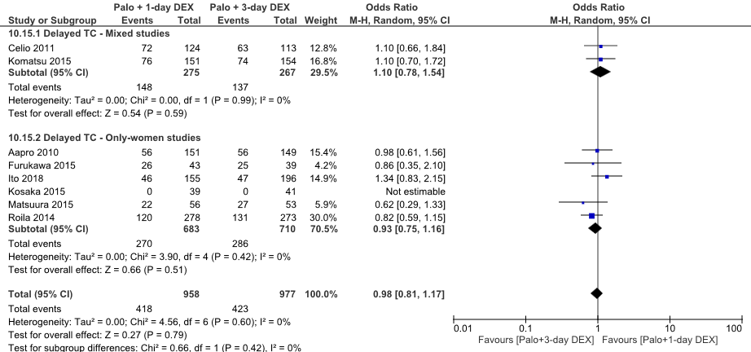

Figure S6a Forest plot of odds ratios for patients receiving palonosetron with 1-day or 3-day dexamethasone for prevention of chemotherapy induced nausea and vomiting, comparing studies without NK-1RA with studies including NK-1RA: Complete response (CR) in the delayed period.
NK-1RA, neurokinin-1 receptor antagonist.

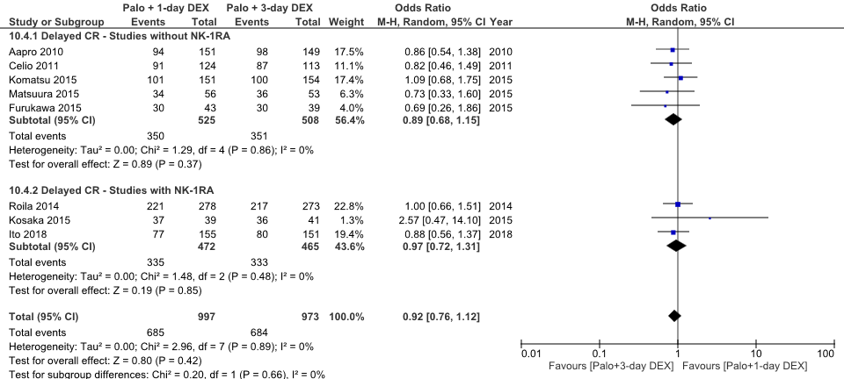

Figure S6b Forest plot of odds ratios for patients receiving palonosetron with 1-day or 3-day dexamethasone for prevention of chemotherapy induced nausea and vomiting, comparing studies without NK-1RA with studies including NK-1RA: Complete protection (CP) in the delayed period.
NK-1RA, neurokinin-1 receptor antagonist.

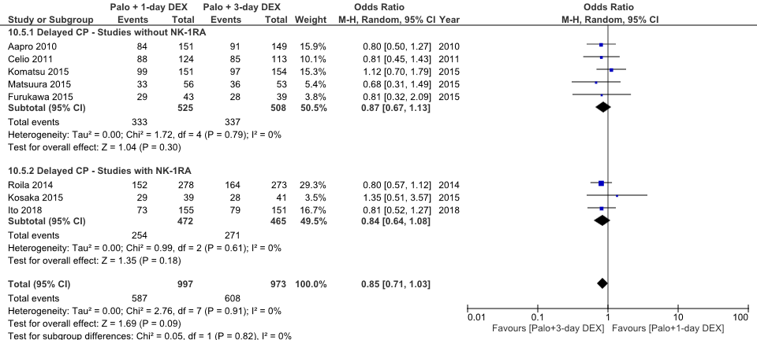

Figure S6c Forest plot of odds ratios for patients receiving palonosetron with 1-day or 3-day dexamethasone for prevention of chemotherapy induced nausea and vomiting, comparing studies without NK-1RA with studies including NK-1RA: Total control (TC) in the delayed period.
NK-1RA, neurokinin-1 receptor antagonist.

