Supplemental Tables S1-S5

Table S1 Cell lines used in this study
Cell line | Cell type
Carcinoma
PA-1 | Human ovary teratocarcinoma cell line
MCF7 | Human breast adenocarcinoma (well-differentiated) cell line
MDAMB231 | Human breast adenocarcinoma (poorly differentiated) cell line
Ishikawa | Human endometrial adenocarcinoma (well-differentiated) cell line
HEC50B | Human endometrial adenocarcinoma (poorly differentiated) cell line
HCC827 | Human lung adenocarcinoma (parental) cell line
HCC827 GRH2 | Human lung adenocarcinoma (gefitinib-resistant) cell line
HCC827 ARH | Human lung adenocarcinoma (afatinib‐resistant) cell line
A549 | Human lung adenocarcinoma cell line
H1299 | Human lung large cell carcinoma cell line
PC-9 | Human lung adenocarcinoma (well-differentiated) cell line
HCC4006 | Human lung adenocarcinoma cell line
H1975 | Human lung adenocarcinoma cell line
Mesothelioma
MSTO-211H | Human malignant biphasic mesothelioma cell line
H2052 | Human malignant mesothlioma cell line
Non-malignant cells
HBEC-5KT | Human immortalized bronchial epithelial cell line
MeT-5A | Human immortalized mesothelial cell line
HCC827 GRH2 and HCC827 ARH had been established from parental cell lines HCC827 in a prior study.32 HBEC-5KT is a non-malignant bronchial epithelial cell line established by expressing hTERT and Cdk4 genes (Cancer Res. 2004;64:9027-34). Met-5A is a TERT-transformed normal mesothelial cell line (Am. J Pathol. 1989;134:979-91)

Table S2 RNA resources used for analysis
 | Sex | Age
Human
Whole eye | female | 37 weeks | BioChain, catalog number R1244108-10
Thyroid | male | 50 years | Agilent Technologies, catalog number 540039
Lung | male | 34 and 59 years (pooled from 4 donors) | Agilent Technologies, catalog number 540019
Ovary | female | 47 years | Agilent Technologies, catalog number 540071
Testis | male | 21 - 29 years (pooled from 5 donors) | Clontech, catalog number 636533
Uterus | female | 23 - 63 years (pooled from 8 donors) | Clontech, catalog number 636551
Pancreas | female | 76 years | Agilent Technologies, catalog number 540023
Breast | female | 40 - 55 years (pooled from 5 donors) | Agilent Technologies, catalog number 540045
Bone marrow | male/female | 58 - 76 years (pooled from 4 donors) | Clontech, catalog number 636643
Peripheral leukocyte | male/female | 18 - 54 years (pooled from 426 donors) | Clontech, catalog number 636592
Heart | male | 30, 30 and 39 years (pooled from 3 donors) | Clontech, catalog number 636643
Cerebellum | male/female | 16 - 70 years (pooled from 24 donors) | Clontech, catalog number 636643
Kidney | female | 40 years | Clontech, catalog number 636643
Liver | male/female | 24 - 64 years (pooled from 3 donors) | Clontech, catalog number 636643
Placenta | female | 23 - 30 years (pooled from 3 donors) | Clontech, catalog number 636643
Skeletal muscle | male | 20 years | Clontech, catalog number 636643
Spleen | male/female | 22 - 69 years (pooled from 15 donors) | Clontech, catalog number 636643
Colon | male | 23 - 63 years (pooled from 3 donors) | Clontech, catalog number 636643
Small intestine | male/female | 20 - 61 years (pooled from 5 donors) | Clontech, catalog number 636643
Spinal code | male | 20 - 59 years (pooled from 7 donors) | Clontech, catalog number 636643
Stomach | male | 40 years | Clontech, catalog number 636643
Lung | male | 55 years | Zyagen, catalog number HR-601
Lung | male | 23 years | BioChain, catalog number R1234152-50
MSCs from adipose tissue (Msc-AT) |  |  | PromoCell catalog number C-14092
MSCs from bone marrow (Msc-BM) |  |  | PromoCell catalog number C-14090
Mouse
Testis | male | 4 months (pooled from 2 animals) | Japan SLC, C57BL/6N
Ovary | female | 4 months (pooled from 2 animals) | Japan SLC, C57BL/6N
Somatic tissues | male/female | 4 months (pooled from 4 animals) | Japan SLC, C57BL/6N
Postnatal eye | male/female | 3 days (independent 4 animals) | Japan SLC, C57BL/6N

Table S3 PCR primer sets for RT-PCR and qPCR
 | Primer |  | Sequence | Product size
Human
OCT4A | forward | hOCT4A-FO | 5′-AGAGAGGGGTTGAGTAGTCCCTTCGCA-3′ | 1347(A), 1465(A1) bp
 | reverse | hOCT4A, B-RV1 | 5′-CAAGAGCATCATTGAACTTCACCTTC-3′
OCT4Bv | forward | hOCT4B-FO | 5′-AGGCAGATGCACTTCTACAGACTATTC-3′ | 995(B), 1228(B1),  1512(B2), 1774 (Bns) bp
 | reverse | hOCT4A, B-RV1 | 5′-CAAGAGCATCATTGAACTTCACCTTC-3′
GAPDH | forward | hGAPDH-FO | 5′-GCTTGTCATCAATGGAAATCCC-3′ | 210 bp
 | reverse | hGAPDH-RV | 5′-TTCACACCCATGACGAACATG-3′
Mouse
Oct-3/4A | forward | mOct-3/4A-FO | 5′-CCCCAATGCCGTGAAGTTGGAGAAGGT-3′ | 452 bp
 | reverse | mOct-3/4A, B-RV | 5′-TCTCTAGCCCAAGCTGATTGGCGATGTG-3′
Oct-3/4B | forward | mOct-3/4B-FO1 | 5′-GACTCTGACAAGTCTGCCTTTCTCACT-3′ | 437 bp
 | forward | mOct-3/4B-FO2 | 5′-AGCCTTAAAACTTCTTCAGAATAGGTC-3′ | 430 bp
 | forward | mOct-3/4B-FO3 | 5′-ATGAAAGCCCTGCAGAAGGAGCTAGAACA-3′ | 397 bp
 | reverse | mOct-3/4A, B-RV | 5′-TCTCTAGCCCAAGCTGATTGGCGATGTG-3′
G3pdh | forward | mGAPDH-FO | 5′-CTGTGGTACAAGAGGTGGACACA-3′ | 308 bp
 | reverse | mGAPDH-RV | 5′-GCATCTCCTTCTCCAGCTGCTCA-3′
Human
SPP1all | forward | hSPP1all-FO | 5′-ACCATGAGAATTGCAGTGATTTGC-3′ | 407(a), 365(b), 327(c) bp
 | reverse | hSPP1all, c-RV | 5′-TCAGTGACCAGTTCATCAGATTCA-3′
SPP1C | forward | hSPP1c-FO | 5′-CTGGAAGTTCTGAGGAAAAGCAGAATG-3′ | 253 bp
 | reverse | hSPP1all, c-RV | 5′-TCAGTGACCAGTTCATCAGATTCA-3′
18S rRNA | forward | 18S-FO | 5′-ACCCGTTGAACCCCATTCGTGA-3′ | 159 bp
 | reverse | 18S-RV | 5′-GCCTCACTAAACCATCCAATCGG-3′
beta-ACTIN | forward | ACTB-FO | 5′-CACCATTGGCAATGAGCGGTTC-3′ | 135 bp
 | reverse | ACTB-RV | 5′-AGGTCTTTGCGGATGTCCACGT-3′
SPP1 all: a common primer pair for detection of SPP1A, SPP1B and SPP1C

Table S4 Analysis of DNA variations according to sequencing analysis
 | OCT4A clone # |  |  | OCT4B clone #
 | A | A1 | total | B | B1 | B2 | Bns | total
Eye | 7 | 1 | 8 | 11 | 3 | 0 | 2 | 16
Pancreas | 7 | 0 | 7 | 9 | 0 | 2 | 1 | 12
Thyroid | 6 | 0 | 6 | 5 | 0 | 0 | 7 | 12
Testis | 7 | 0 | 7 | 6 | 2 | 1 | 0 | 9
Uterus | 3 | 0 | 3 | 3 | 2 | 0 | 2 | 7
Lung | 5 | 3 | 8 | 12 | 3 | 3 | 0 | 18
Breast | 4 | 0 | 4 | 11 | 3 | 5 | 2 | 21
OCT4, octamer-binding transcription factor 4

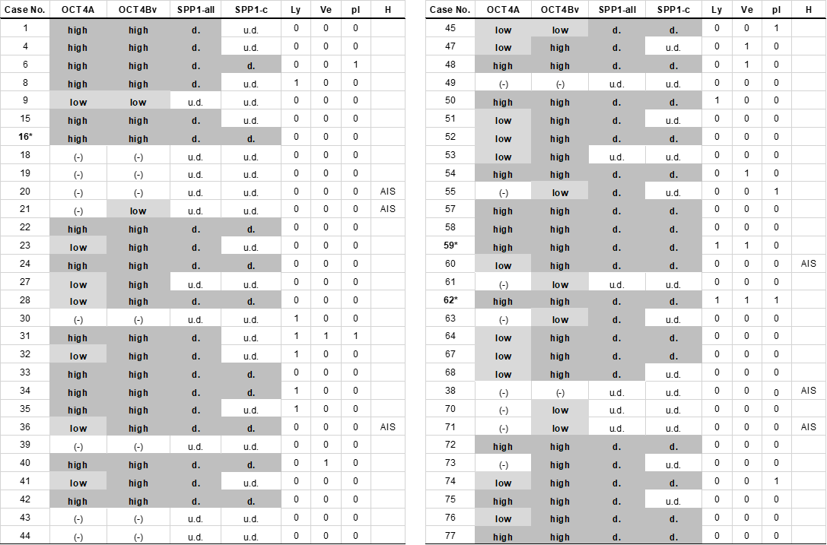
Table S5 Summary of clinical data and OCT4/SPP1 expression analysis
