Additional file 4. Total episodes of cancer-related hospitalisation (a), rate per prevalent person (b), total associated cost (2019 Australian dollars, c), and cost per prevalent person (d) based on corrected prevalence.
- Female breast cancer
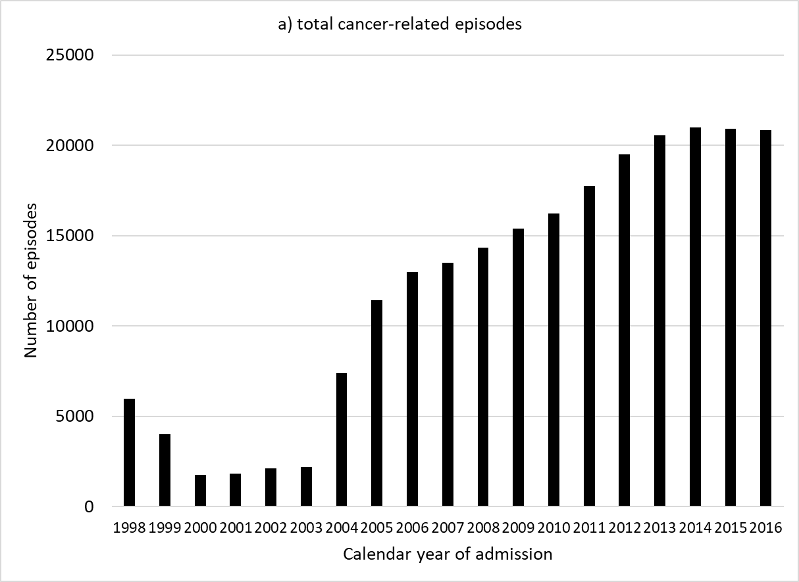
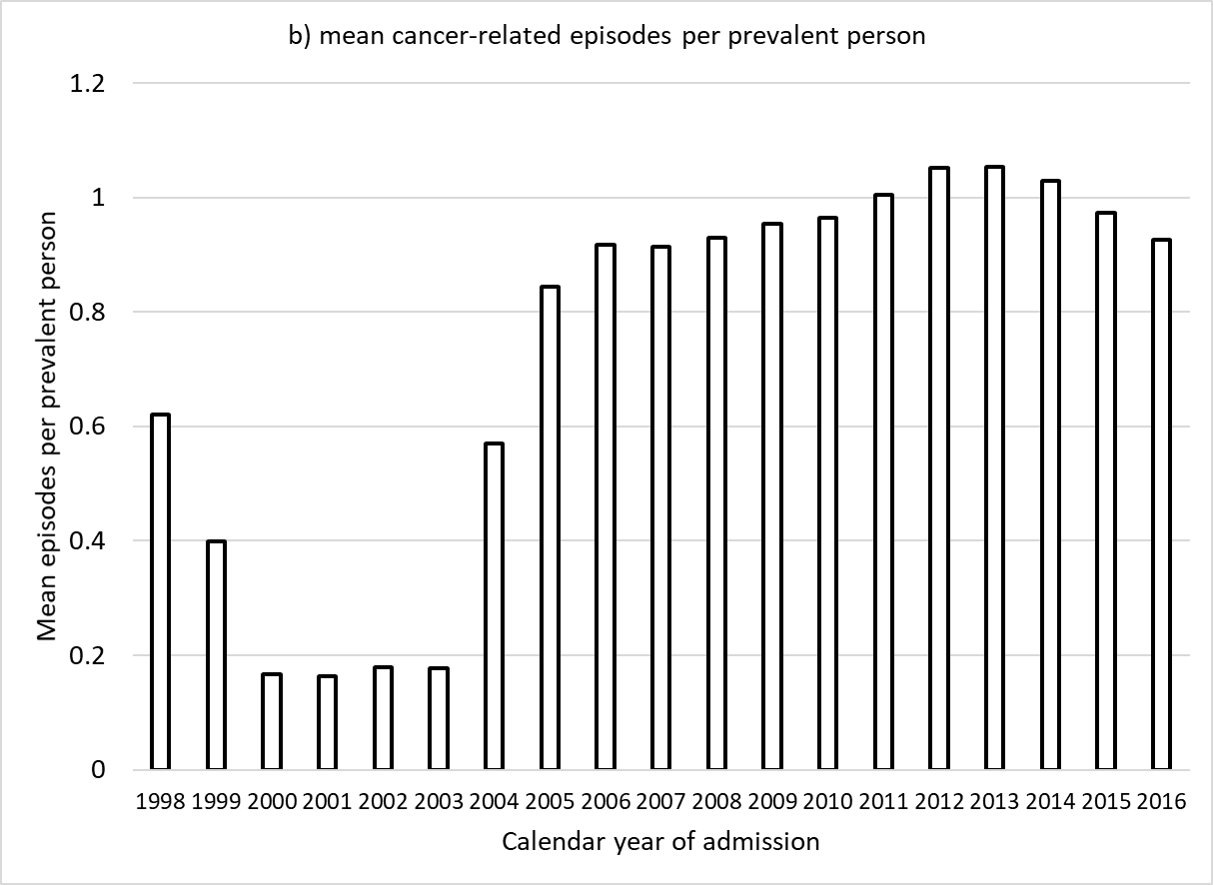
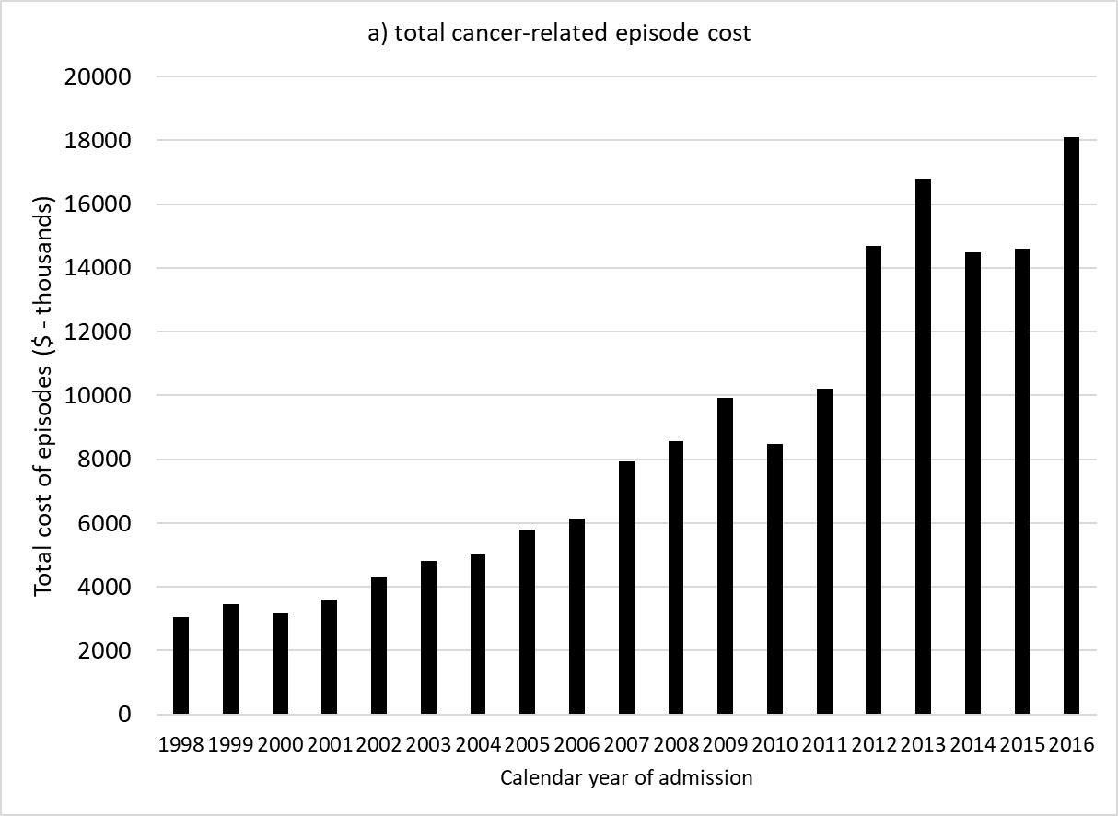
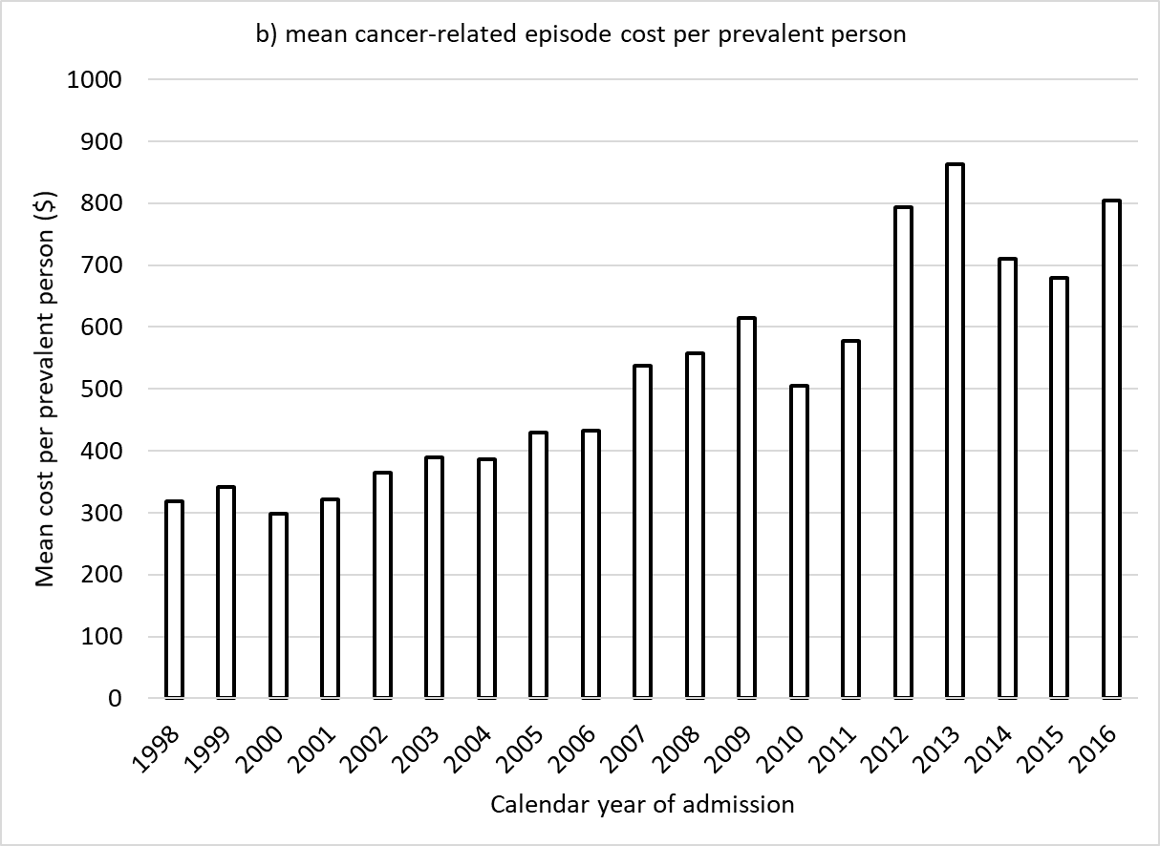

- Colorectal cancer
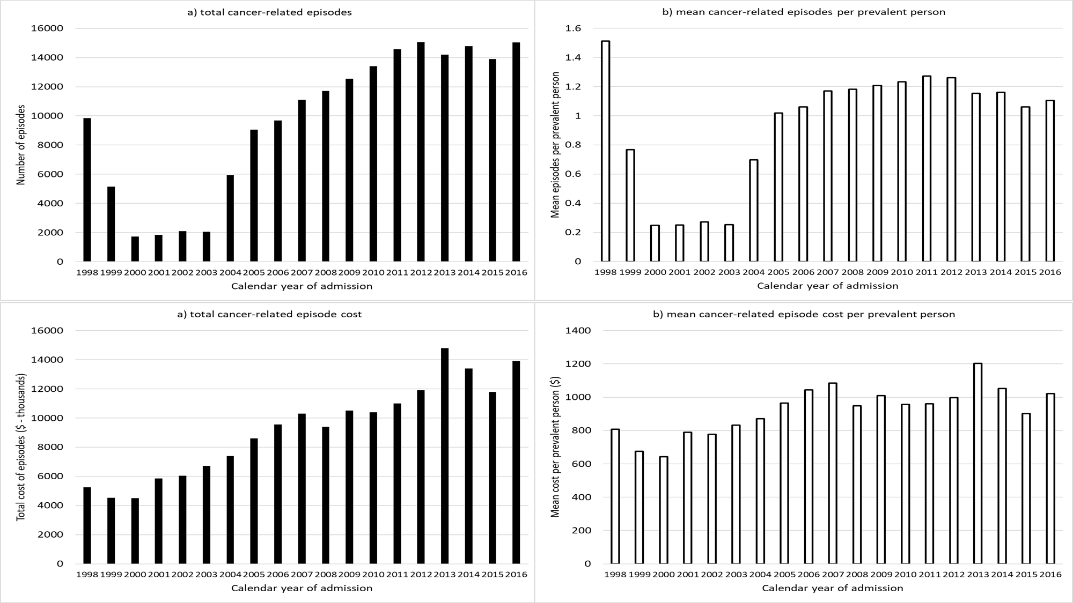
- Lung cancer
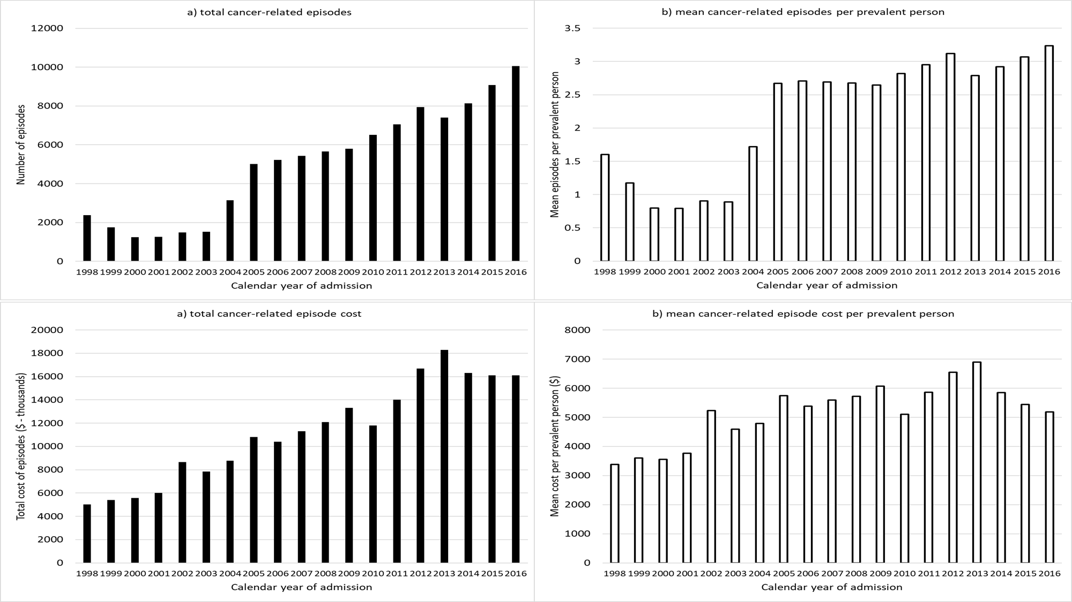
- Prostate cancer
