Supplementary Table 1. Time-to-events by LOT
 | 1LOT  (n = 652) | 2LOT  (n = 184) | 3LOT  (n = 18)
Treatment initiation†
Mean time (months) to treatment initiation (95% CI) | 6.5 (5.6-7.3) | 1.2 (0.8-1.6) | 1.0 (0.5-1.5)
Treatment holiday
n patients (%) | 339 (52.0%) | 80 (43.5%) | 6 (33.3%)
Mean duration (days) of treatment holiday* (95% CI) | 54.4 (43.5-65.4) | 35.2 (20.5-49.8) | 20.3 (1.3-39.3)
Dose increase or reduction
n patients (%) | 298 (45.7%) | 82 (44.6%) | 4 (22.2%)
Mean time (months) to dose increase or reduction* (95% CI) | 4.8 (3.8-5.8) | 2.1 (1.4-2.9) | 2.1 (1.3-3.0)
Discontinuation
n patients (%) | 574 (88.0%) | 159 (86.4%) | 16 (88.9%)
Mean time (months) to discontinuation* (95% CI) | 10.5 (9.5-11.6) | 5.2 (4.2-6.3) | 5.6 (1.7-9.5)
Reason for discontinuation, n (%)
Disease progression | 411 (71.6%) | 115 (72.3%) | 11 (68.8%)
Treatment toxicity/adverse event | 108 (18.8%) | 31 (19.5%) | 5 (31.3%)
Other | 106 (18.5%) | 33 (20.8%) | 2 (12.5%)
Abbrev: LOT: line of therapy; CI: confidence interval
*Mean time to/of event amongst patients that experienced event
†Calculated as the time from index date or end date or previous LOT to start date of subsequent LOT
NB: more than one reason for discontinuation is possible hence the number of patients may exceed total that experience discontinuation

Supplementary Table 2. Adverse events by LOT
Adverse Event, n (%) | 1LOT | 2LOT | 3LOT
Number of Patients | 652 | 184 | 18
Fatigue | 411 (63.0%) | 103 (56.0%) | 8 (44.4%)
Sore Mouth | 309 (47.4%) | 73 (39.7%) | 8 (44.4%)
Diarrhoea | 284 (43.6%) | 66 (35.9%) | 5 (27.8%)
Nausea | 251 (38.5%) | 40 (21.7%) | 4 (22.2%)
Hypertension | 202 (31.0%) | 25 (13.6%) | 2 (11.1%)
Hand Foot Syndrome | 148 (22.7%) | 31 (16.8%) | 1 (5.6%)
Dyspnoea | 134 (20.6%) | 51 (27.7%) | 5 (27.8%)
Vomiting | 121 (18.6%) | 20 (10.9%) | 2 (11.1%)
Weight Loss | 117 (17.9%) | 23 (12.5%) | 2 (11.1%)
Skin Rash | 94 (14.4%) | 28 (15.2%) | 0 (0.0%)
Anaemia | 85 (13.0%) | 25 (13.6%) | 4 (22.2%)
Hypothyroidism | 70 (10.7%) | 14 (7.6%) | 3 (16.7%)
Fever | 35 (5.4%) | 4 (2.2%) | 1 (5.6%)
Psychological | 34 (5.2%) | 5 (2.7%) | 2 (11.1%)
Fluid Retention | 34 (5.2%) | 11 (6.0%) | 1 (5.6%)
Reduced Renal Function | 33 (5.1%) | 11 (6.0%) | 0 (0.0%)
Thrombocytopenia | 33 (5.1%) | 1 (0.5%) | 1 (5.6%)
Joint Muscle Problems | 31 (4.8%) | 6 (3.3%) | 0 (0.0%)
Impaired Wound Healing | 29 (4.4%) | 6 (3.3%) | 0 (0.0%)
Irregular Heart Beat | 17 (2.6%) | 4 (2.2%) | 0 (0.0%)
Hyperthyroidism | 4 (0.6%) | 1 (0.5%) | 0 (0.0%)
Hypotension | 3 (0.5%) | 1 (0.5%) | 0 (0.0%)
Pneumonitis | 1 (0.2%) | 6 (3.3%) | 0 (0.0%)
Myocarditis | 0 (0.0%) | 0 (0.0%) | 0 (0.0%)
Abbrev: LOT: Line of therapy; FU: Follow-Up;

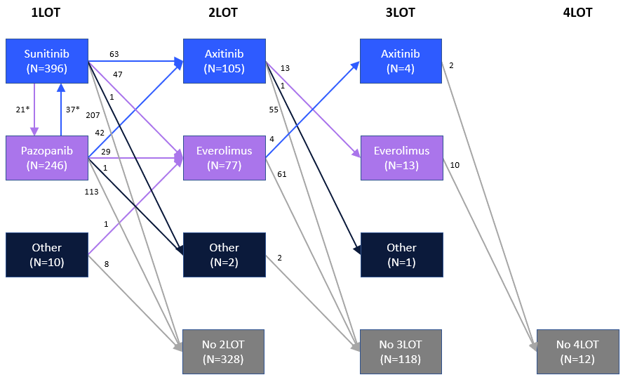
Supplementary Figure 1. Treatment pathways for patients receiving systemic therapies
* Denotes patients who were transferred to a supplementary 1LOT regimen due to intolerance of the exiting regimen.

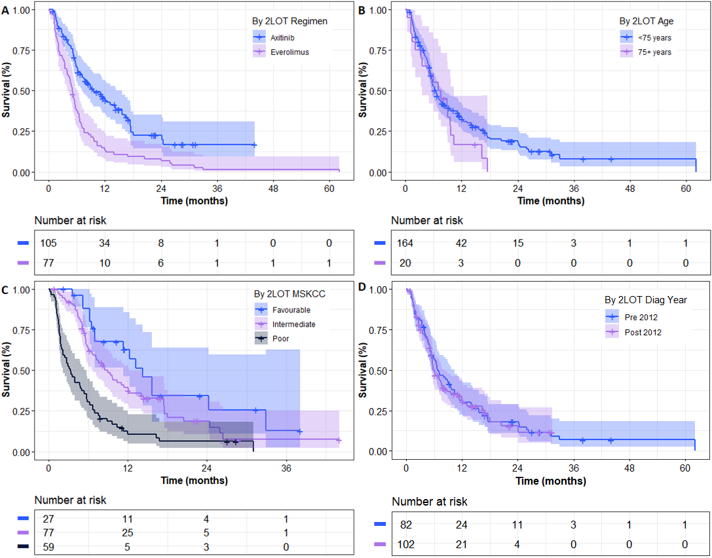
Level | OS estimates, % (95% CI)
Level | Median  (months) | Year 1  (% (95% CI)) | Year 2  (% (95% CI)) | Year 3  (% (95% CI)) | Year 5  (% (95% CI))
A. By 2LOT Regimen – Wilcoxon (χ²=20.77; p<0.01); Log-Rank (χ²=21.56; p<0.01);
Axitinib | 9.59 | 45.4%  (36.3%-56.8%) | 22.6%  (14.5%-35.2%) | 16.9%  (9.3%-30.8%) | NR
Everolimus | 5.03 | 13.4%  (7.5%-23.7%) | 8.0%  (3.7%-17.2%) | 1.3%  (0.2%-9.4%) | 1.3%  (0.2%-9.4%)
B. By 2LOT Age – Wilcoxon (χ²=0.72; p=0.40); Log-Rank (χ²=1.57; p=0.21);
< 75 years | 6.44 | 33.4%  (26.6%-42.0%) | 19.0%  (13.2%-27.4%) | 7.9%  (3.4%-18.4%) | 7.9%  (3.4%-18.4%)
75+ years | 7.28 | 16.9%  (6.1%-46.7%) | NR | NR | NR
C. By 2LOT MSKCC – Wilcoxon (χ²=46.11; p<0.01); Log-Rank (χ²=33.48; p<0.01);
Favourable | 14.26 | 62.8%  (46.1%-85.6%) | 34.3%  (18.4%-63.8%) | 12.9%  (2.5%-65.0%) | NR
Intermediate | 8.90 | 39.3%  (29.2%-52.7%) | 18.7%  (10.6%-33.0%) | 7.5%  (2.2%-25.2%) | NR
Poor | 3.32 | 10.6%  (4.9%-23.0%) | 6.3%  (2.2%-18.2%) | NR | NR
D. By 2LOT Diagnosis Year – Wilcoxon (χ²=0.13; p=0.72); Log-Rank (χ²=0.07; p=0.79)
Pre 2012 | 6.70 | 31.3%  (22.6%-43.4%) | 18.0%  (11.2%-29.1%) | 6.9% (2.6%-18.1%) | 6.9% (2.6%-18.1%)
Post 2012 | 6.05 | 32.2%  (23.8%-43.7%) | 15.4%  (8.2%-28.9%) | NR | NR
E. By 2LOT Subtype – Wilcoxon (χ²=0.00; p=0.98); Log-Rank (χ²=0.02; p=0.90);
Clear Cell | 6.93 | 33.8%  (26.5%-43.0%) | 17.2%  (11.3%-26.2%) | 11.5%  (6.4%-20.5%) | 11.5%  (6.4%-20.5%)
Non-Clear Cell | 6.51 | 29.3%  (15.7%-54.8%) | 23.4%  (10.9%-50.4%) | NR | NR
Abbrev: CI: confidence interval; LOT: line of therapy; MSKCC: memorial sloan kettering cancer center; NR: not reached; OS: overall survival
Supplementary Figure 2. Overall survival from 2LOT stratified by key baseline characteristics
A: By regimen; B: By Age; C: By MSKCC score; D: By Diagnosis Year; E: By Histological Subtype (not shown)

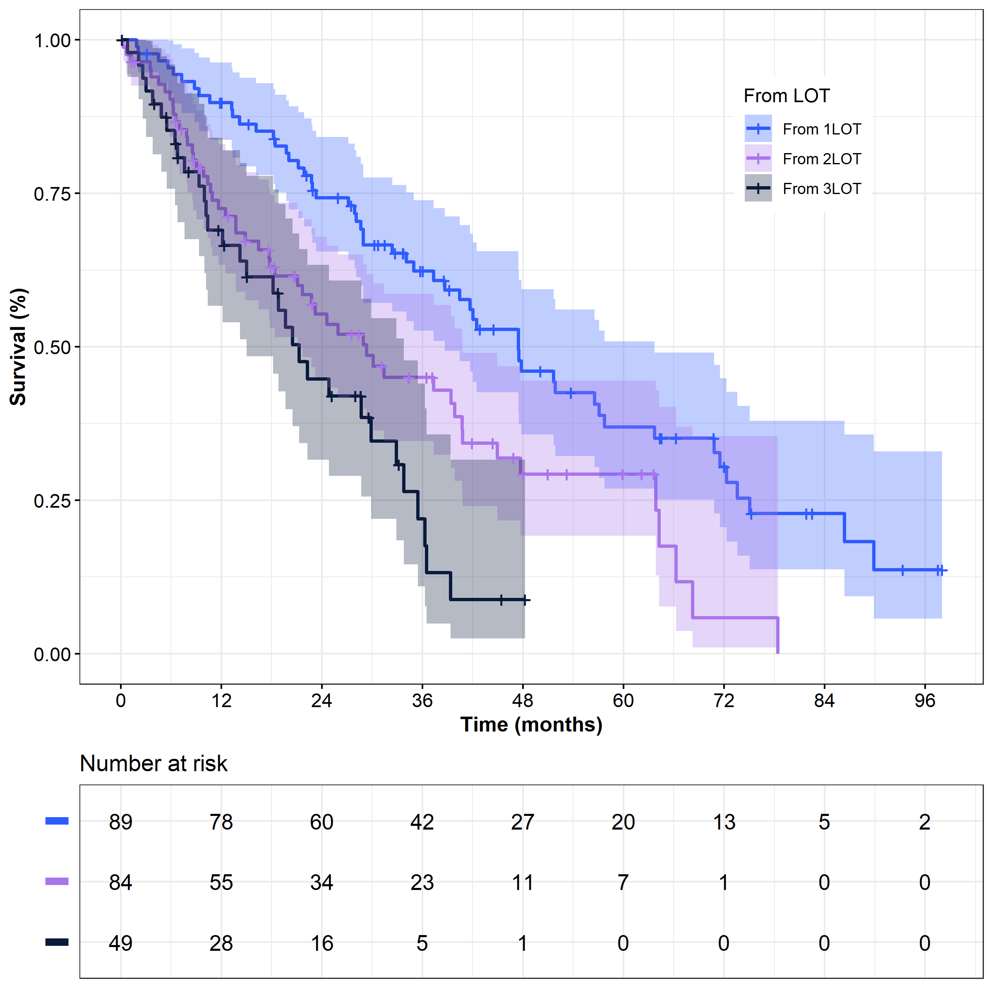
Time point | OS estimates, % (95% CI)
Time point | Median  (months) | Year 1  (% (95% CI)) | Year 2  (% (95% CI)) | Year 3  (% (95% CI)) | Year 5  (% (95% CI))
From  1LOT | 47.47 | 89.8%  (83.7%-96.3%) | 74.3%  (65.5%-84.2%) | 62.3%  (52.6%-73.9%) | 37.0%  (26.8%-50.9%)
From  2LOT | 29.34 | 72.5%  (63.4%-83.0%) | 55.3%  (45.0%-67.9%) | 45.0%  (34.6%-58.6%) | 29.2%  (19.2%-44.5%)
From 3LOT | 21.32 | 69.0%  (56.7%-84.0%) | 44.8%  (31.6%-63.4%) | 22.0%  (11.0%-44.0%) | NR
Abbrev: CI: confidence interval; LOT: line of therapy; NR: Not Reached; OS: overall survival
Supplementary Figure 3. Overall survival by LOT in patients receiving interleukin-2/interferon-alpha at any LOT
Shaded region denotes 95% confidence interval

