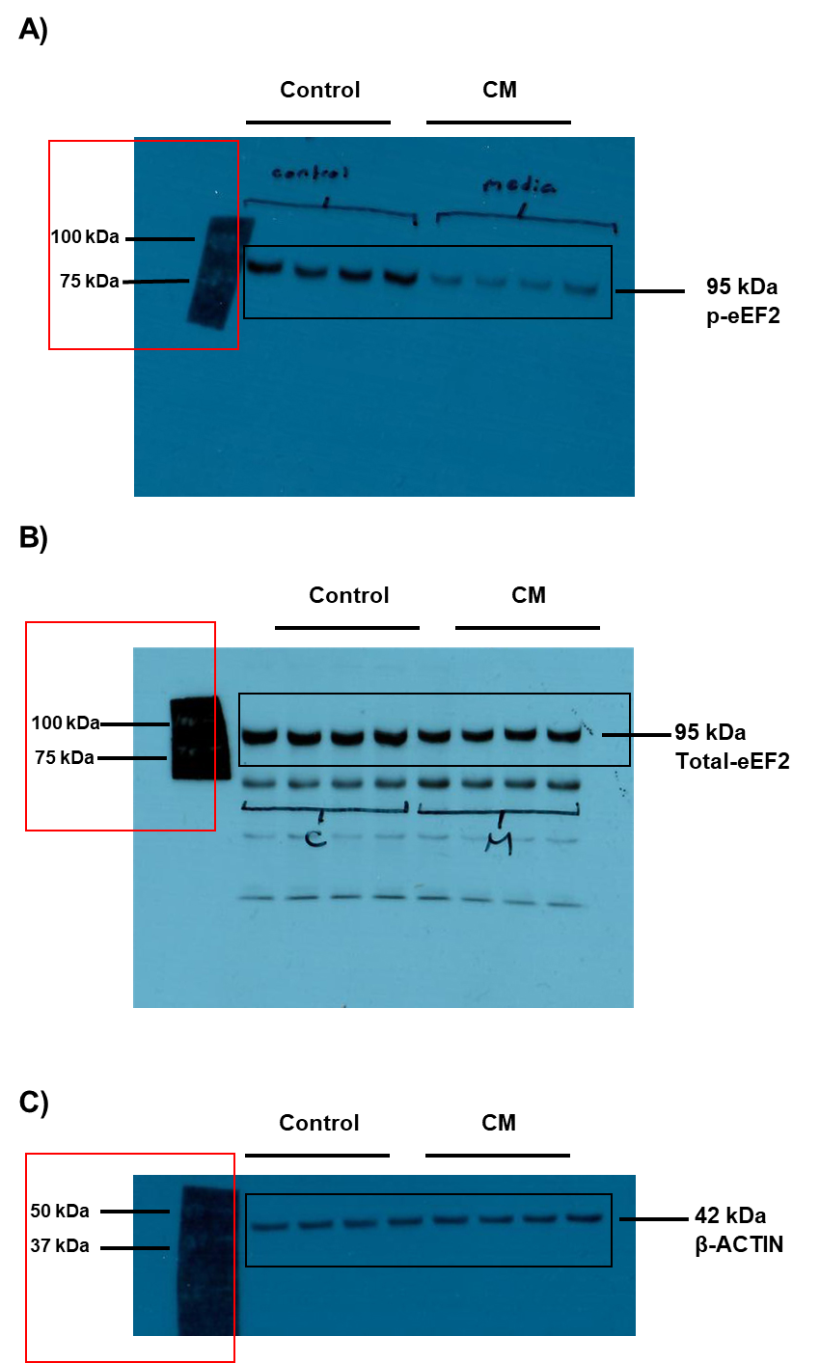
Supplementary Figure 1. The original, full blot for phosphorylated eukaryotic elongation factor-2 (p-eEF2), total-eEF2 and β-ACTIN.
A: Phosphorylated eukaryotic elongation factor-2 (p-eEF2), B: total-eEF2, C: β-ACTIN, CM: conditioned medium.

