City : IP :
Center: University Hospital Regional Center Proximity Center Military hospital
Context : Day hospital for chemo session Consultation Hospitalization Emergency
I/-General Data :
Sociodémographic data:
Sex: Male Female
Age:
Religion : Muslim Other if other, please specify:…………….
Civil status: Single Married divorced Widower
Number of children :
Level of education : Illiterate mosque Elementary High School
University
Profession :
Personal income : Personal pension Spouse pension Children aid
Still working other
Monthly income : <1500MAD 1500-3000MAD 3000-5000MAD
5000-8000MAD >8000MAD
Living: urbain rural
Medical coverage: Ramed CNOPS CNSS Military
Health insurance None
Living : Alone with spouse with chidren Nursing home
Accompanying to the hospital: None 1 person >1 person
Request by the family to hide the diagnosis from the patient: non oui
Toxic habits :
Smoking: Never Former Active
Alcohol use : Never Former Active
Use of medicinal plants: No Yes
II/-Daily habits :
Toilet: Independent Partially dependent Totally dependent
Clothing: Independent Partially dependent Totally dependent
Bath: Independant Partially dependent Totally dependent
Walking indoor: Independent Partially dependent Totally dependent
Walking outdoor: Independent Partially dependent Totally dependent
Food: Cooking + errands Cooking Cooking made by another person
Number of meals per day : 3 meals + snacks 3 meals Less than 3 meals
Prayer : no standing Sitting Lying
Ablutions : no Wet Dry
Ramadan fasting: no yes
Optional fasting: no more than 4 days per month Less than 4 days per month
Sexual activity : no yes
III/-Clinical data :
Comorbidities:
Hypertension : no yes
Diabetes : no yes
Dyslipidemia : no yes
Cardiopathy : no yes
Osteoporosis : no yes
Arthrosis : no yes
Renal injury : non yes
Age adjusted Charlson Comorbidity Index (http://tools.farmacologiaclinica.info/index.php?sid=37146):
- Age range :
Δ <50 Δ50-59 Δ60-69 Δ70-79 Δ80-89 Δ90-99
- AIDS.
- Metastatic solid cancer.
- Liver disease moderate or severe.
- Lymphoma.
- Leukemia.
- Non metastatic solid cancer.
- Diabetes Mellitus with end organ dammage.
- Moderate or severe chronic kidney disease.
- Hemiplegia
- Uncomplicated Diabetes.
- Mild liver disease.
- Peptic ulcere disease.
- Connective tissue disease.
- COPD.
- Dementia.
- Cerebrovascular accident.
- Peripheral vascular disease.
- Myocardial infarction.
- Congestive heart failure.
One year survival according to aaCCI:
Fracture in the previous year: no yes
Falls : No yes Number
Complication : minor major
Number of medications per day : 0 < 3 ≥3
Cancer data:
Localization : H&N Breast col endomètre ovaire poumon esophagus stomach colon rectum kidney bladder prostate STS bone sarcoma skin pancréas Liver biliary tract CUP Other
Stage : Localized Locally advanced Metastatic at the outset Locoregional relapse Metastatic relapse

Status :1st consultation work-up in progress Under treatment Follow-up
Treatment : Chemotherapy Radiotherapy concomittant chemoradiotherapy BSC
The patient has declined oncological treatment : no yes
Treatment : Standard adjusted doses Systematic use of G-CSF less toxic and less efficient treatmet ( for example : monotherapy instead of polychemotherapy, carboplatin instead of cisplatin)
Strategy : curative palliative
Pain and clinical exam :
PS :
Douleur (EVS) :
Poids :
Taille :
Screening for frailty : G8
(https://www.siog.org/files/public/g8_english_0.pdf)
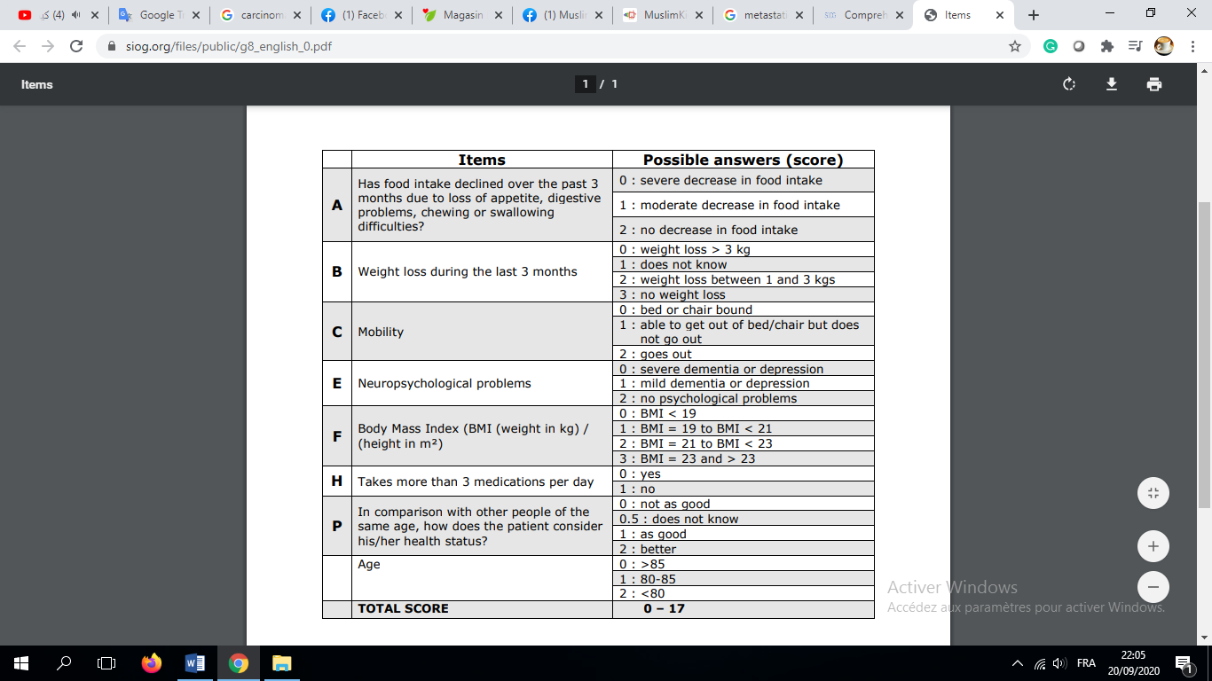
Score :
IV/-Quality of life : EORTC QLQ-C30.
We have used the Moroccan validated version.
This is a link to the original English version :
https://qol.eortc.org/questionnaire/eortc-qlq-c30/

