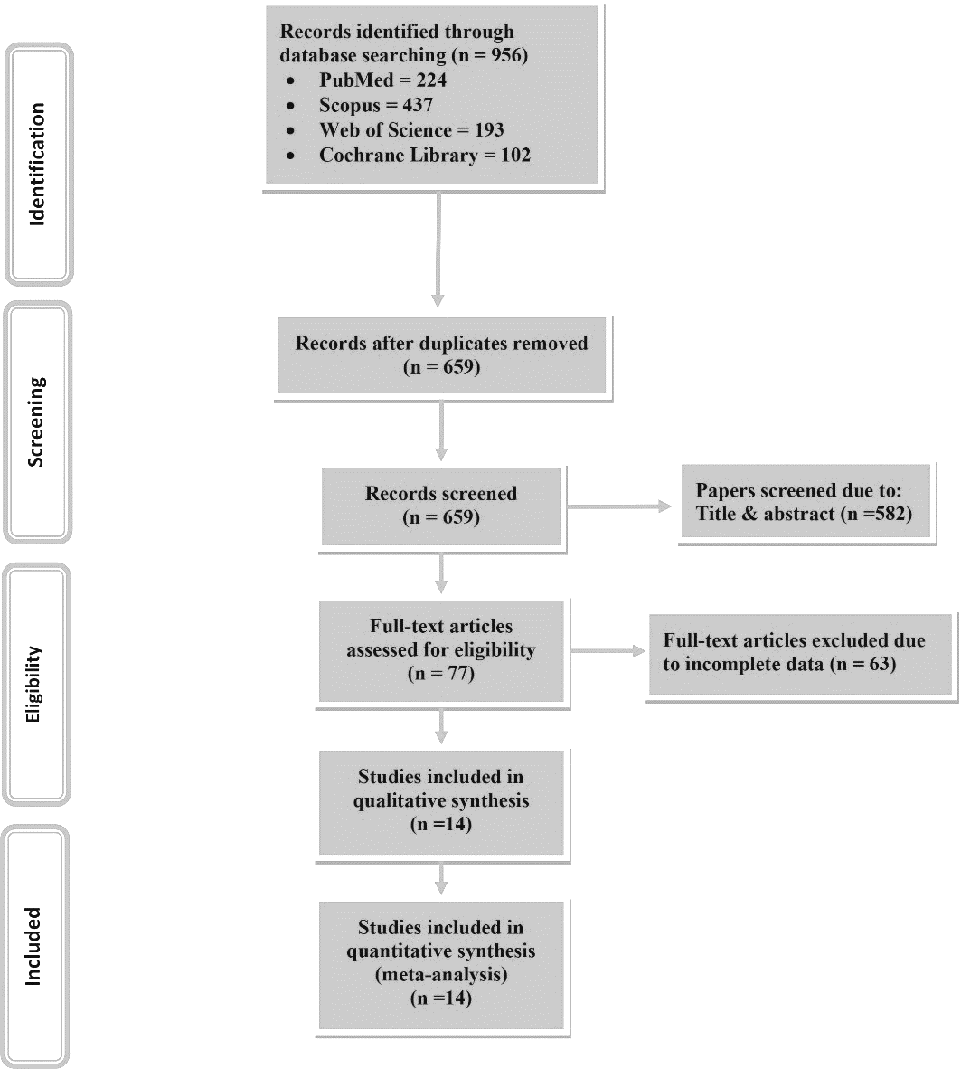
Supplementary Figure 1. PRISMA Flowchart of the study selection procedure

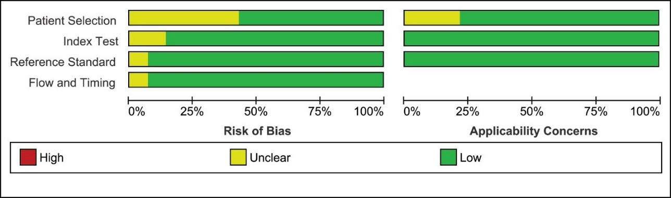
Supplementary Figure 2. Quality assessment graph
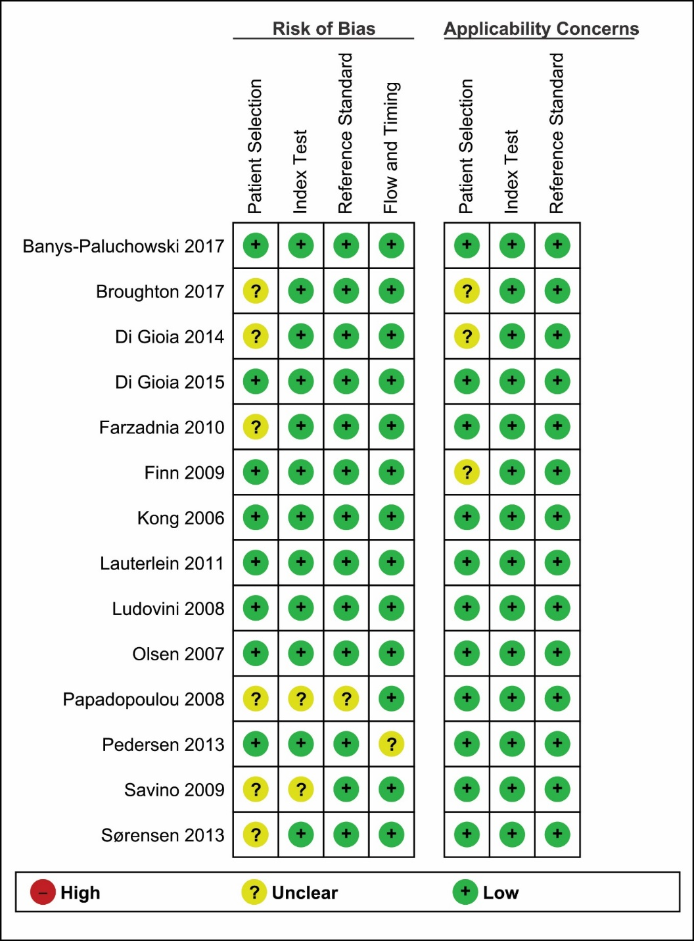
Supplementary Figure 3. methodological quality summary

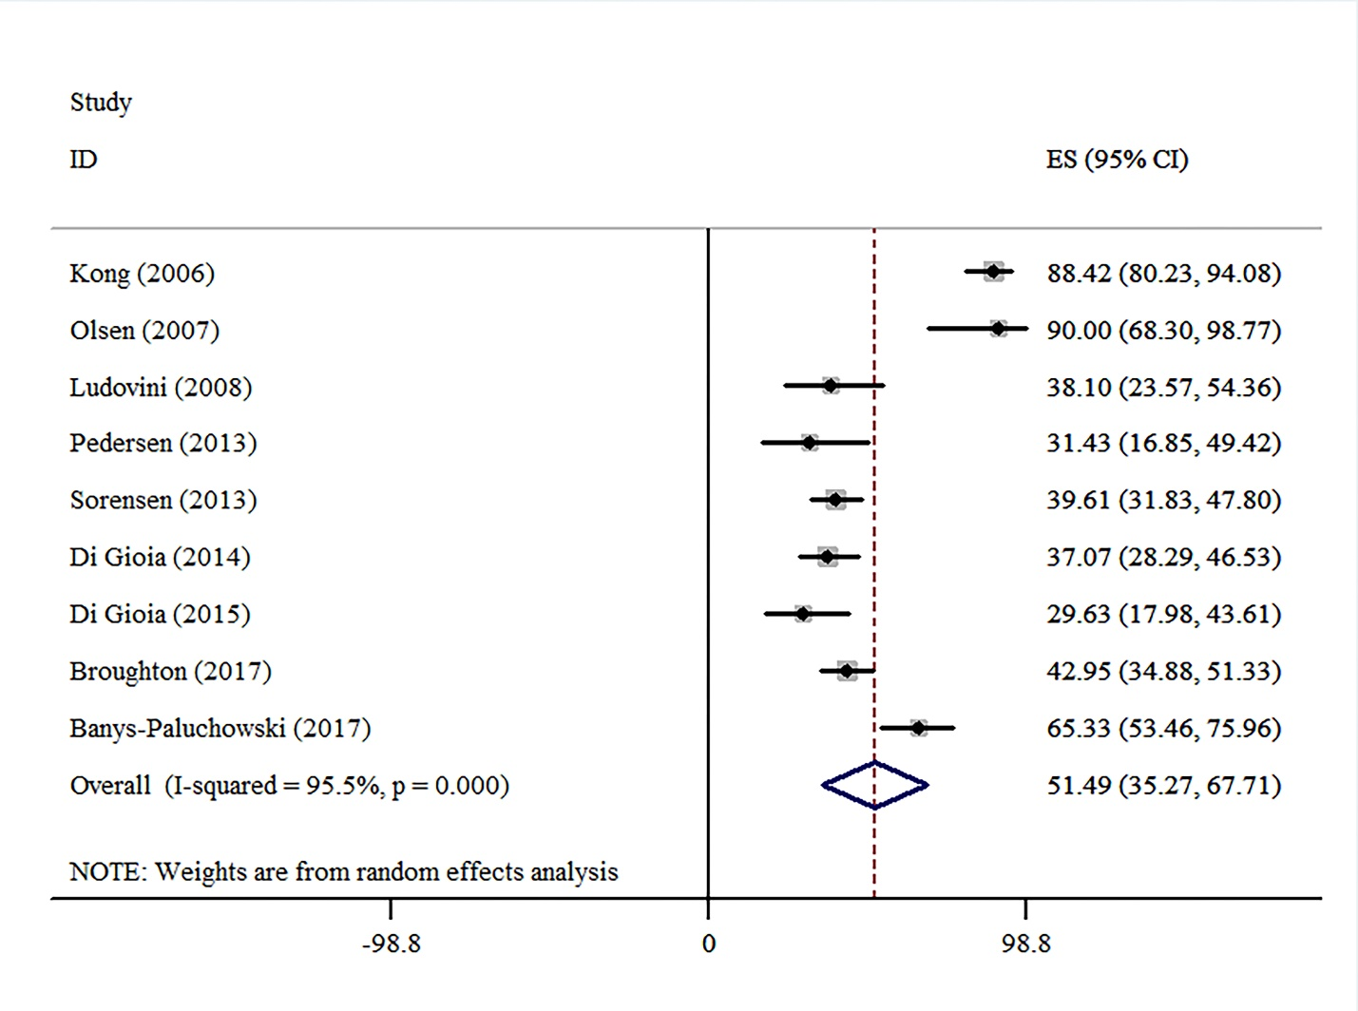
Supplementary Figure 4. Forest plot for sensitivity analysis of serum-HER2 sensitivity

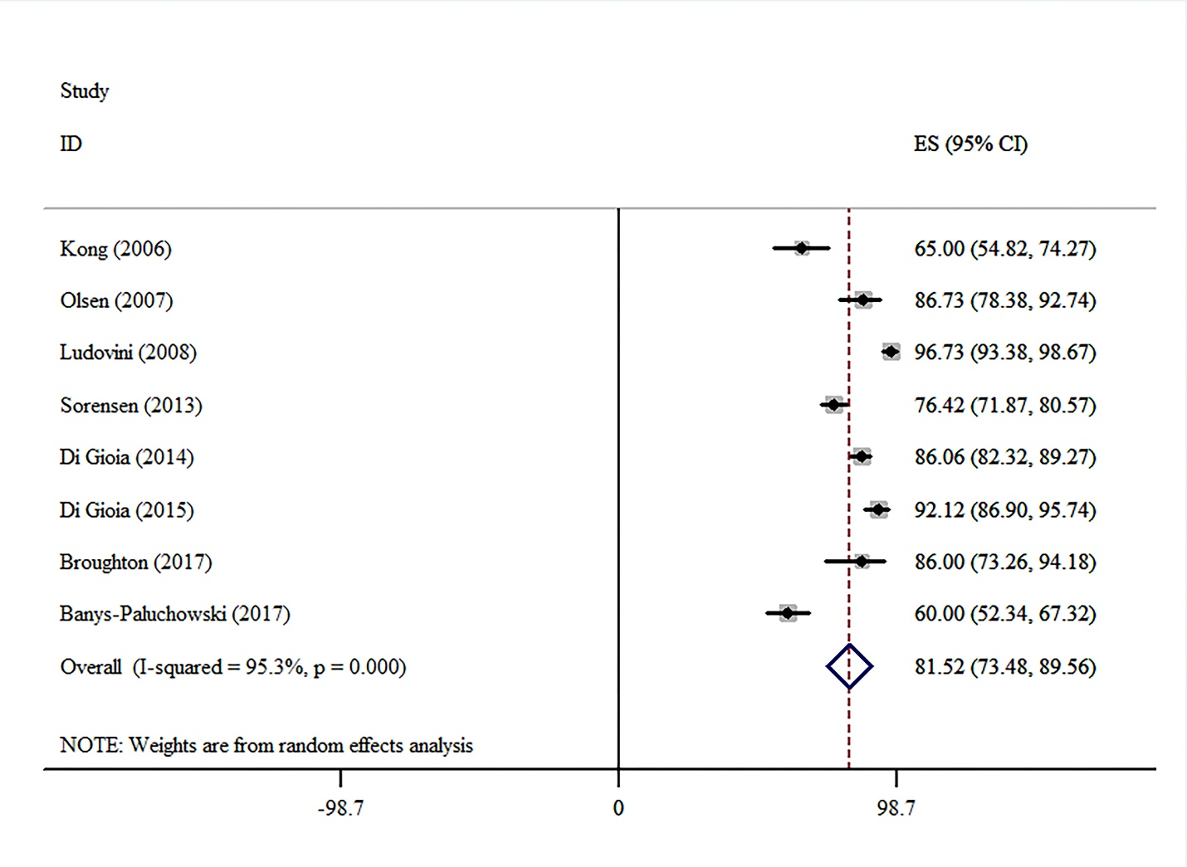
Supplementary Figure 5. Forest plot for sensitivity analysis of serum-HER2 specificity

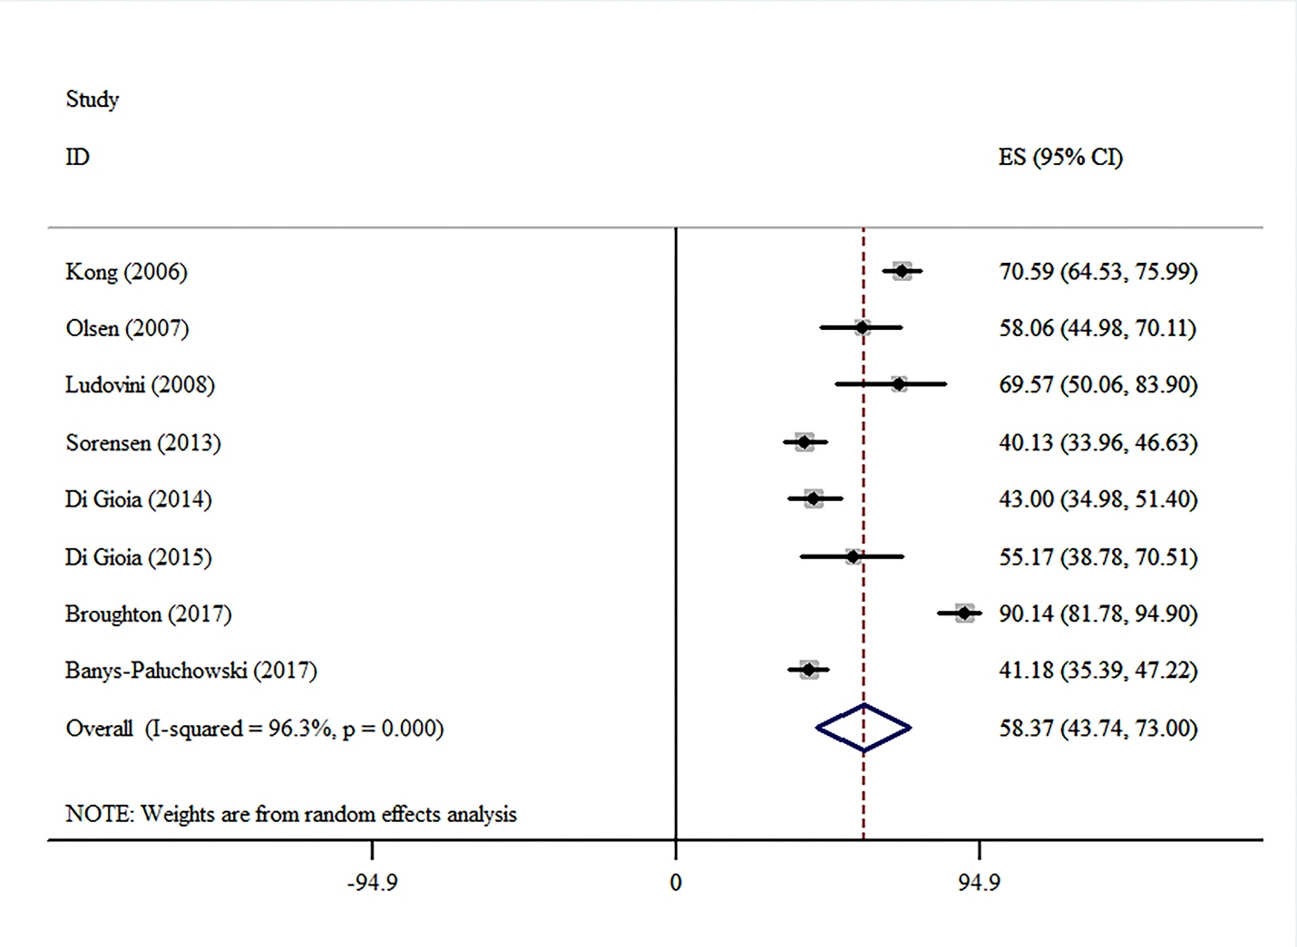
Supplementary Figure 6. Forest plot for sensitivity analysis of serum-HER2 Positive Predictive Value

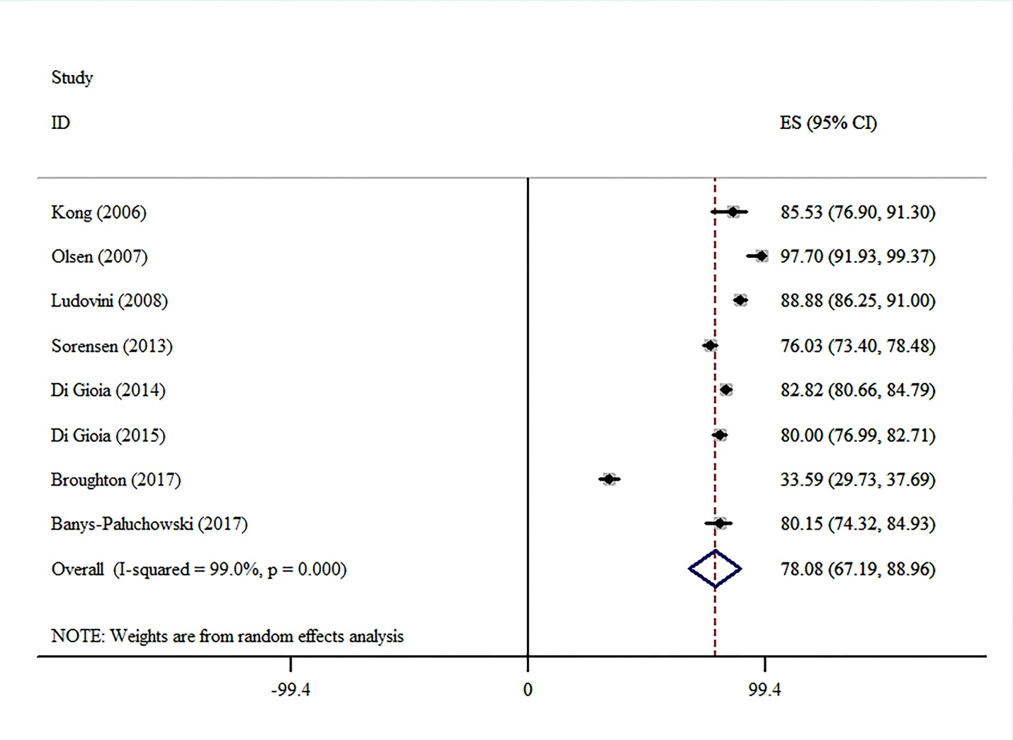
Supplementary Figure 7. Forest plot for sensitivity analysis of serum-HER2 Negative Predictive Value

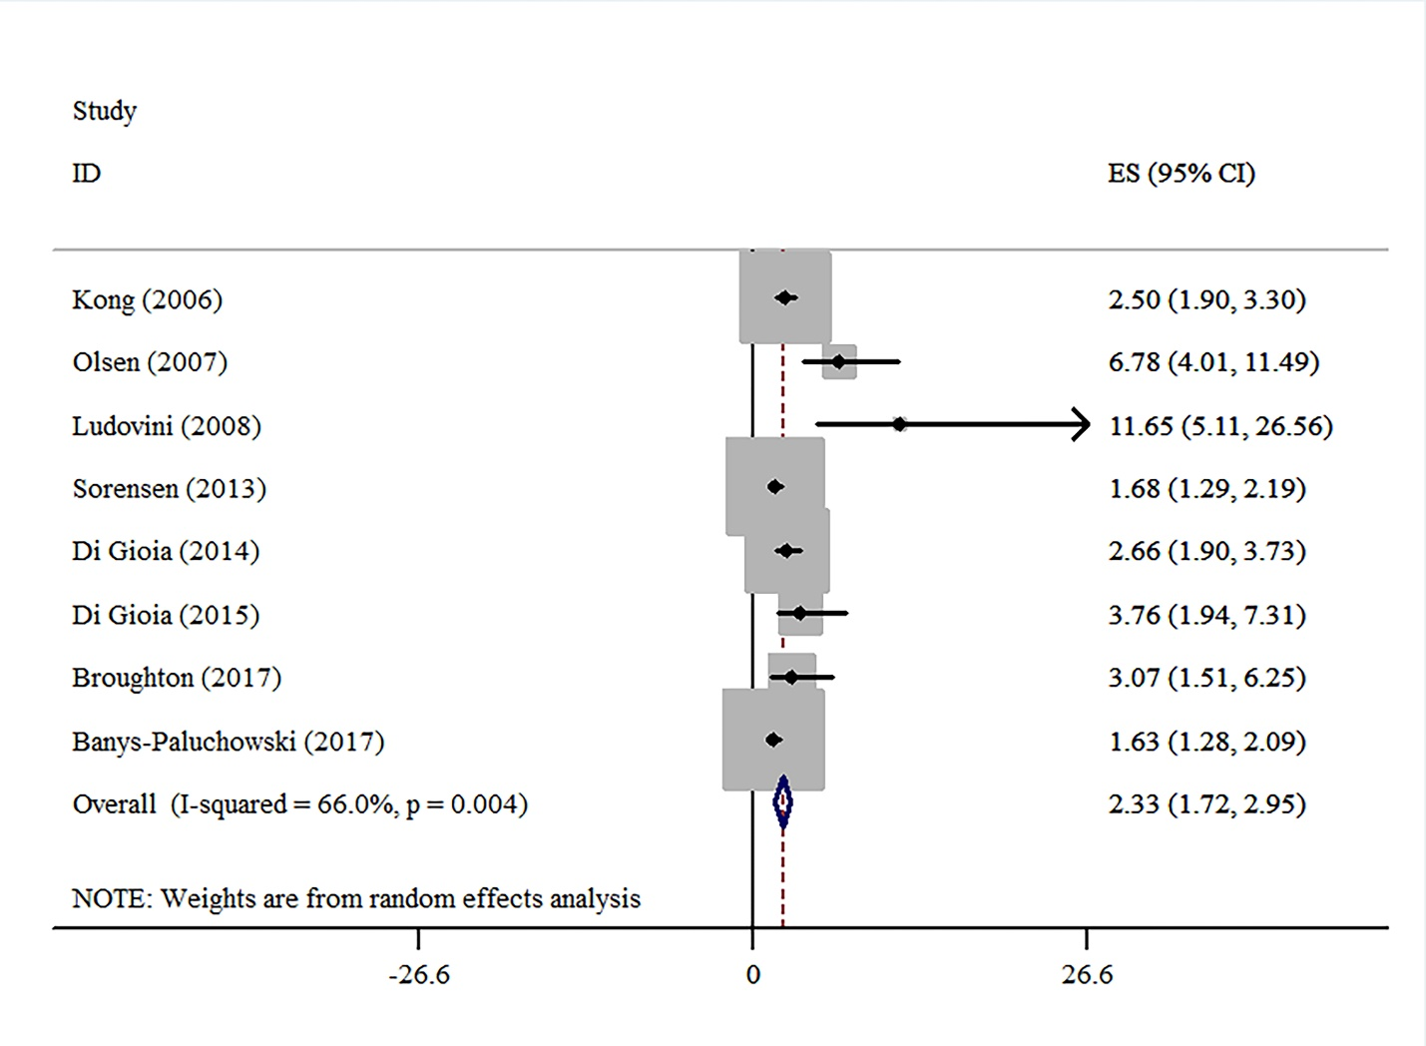
Supplementary Figure 8. Forest plot for sensitivity analysis of serum-HER2 Positive Likelihood Ratio

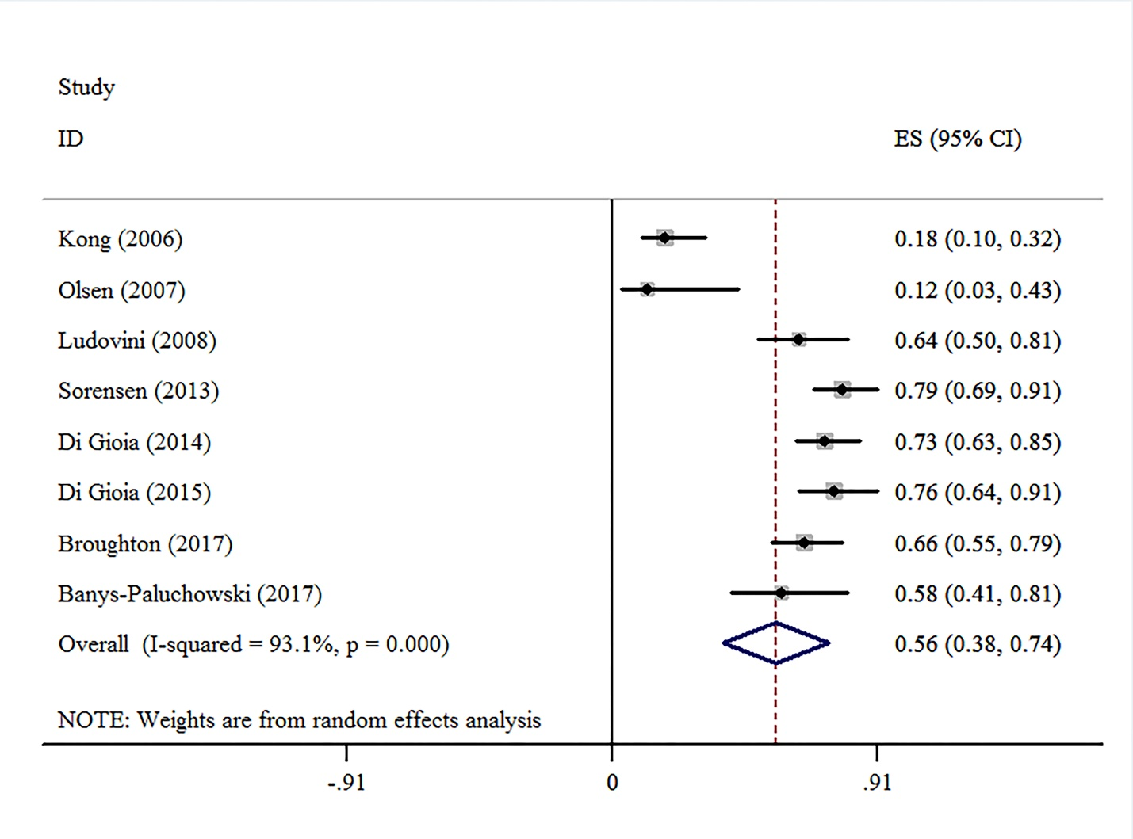
Supplementary Figure 9. Forest plot for sensitivity analysis of serum-HER2 Negative Likelihood Ratio

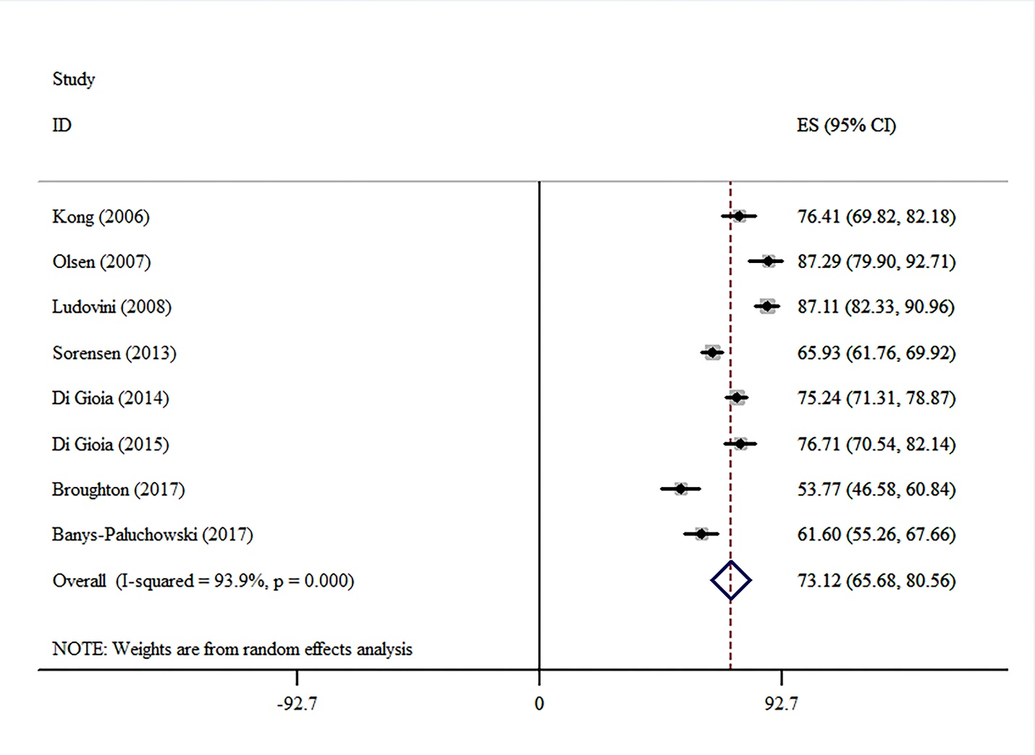
Supplementary Figure 10. Forest plot for sensitivity analysis of serum-HER2 accuracy

