Patient Name and MRN: Lesions Identification Worksheet

This worksheet is to document and to follow the ≤5 highest risk bone metastases identified at the time of randomization to receive either standard of care (Arm 1) or radiation (Arm 2).

Highest risk bone metastases definition per protocol:
- Bulkiest sites of osseous disease ≥ 2cm
- Disease involving the hip (acetabulum, femoral head, femoral neck), shoulder (acromion, glenoid, humeral head), or sacroiliac joints
- Disease in long bones with1/3-2/3 cortical thickness (humerus, radius, ulna, clavicle, femur, tibia, fibula, metacarpus, phalanges)
- Disease in junctional spine (C7-T1, T12-L1, L5-S1) and/or disease with posterior element involvement.

Example:
Lesion location (detailed): left superior acetabulum

Highest risk bone metastases definition (1, 2, 3
or 4): 2

Date of imaging study (within 4 weeks of study entry): 6/11/2017

Image study type (CT, PET/CT, MRI): CT

Best image series/number (s) to identify the lesion:

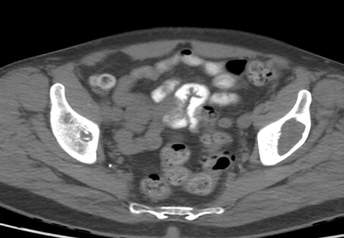
Screenshot of the imaging study that identifies the lesion and its location (optional):

Lesion 1:
Lesion location (detailed):

Highest risk bone metastases definition (1, 2, 3
or 4):

Date of imaging study (within 4 weeks of study entry):

Image study type (CT, PET/CT, MRI):

Best image series/number (s) to identify the lesion:

Screenshot of the imaging study that identifies the lesion and its location (option

Lesion 2:
Lesion location (detailed):

Highest risk bone metastases definition (1, 2, 3
or 4):

Date of imaging study (within 4 weeks of study entry):

Image study type (CT, PET/CT, MRI):

Best image series/number (s) to identify the lesion:

Screenshot of the imaging study that identifies the lesion and its location (optional):

Lesion 3:
Lesion location (detailed):

Highest risk bone metastases definition (1, 2, 3
or 4):

Date of imaging study (within 4 weeks of study entry):

Image study type (CT, PET/CT, MRI):

Best image series/number (s) to identify the lesion:

Screenshot of the imaging study that identifies the lesion and its location (optional):

Lesion 4:
Lesion location (detailed):

Highest risk bone metastases definition (1, 2, 3
or 4):

Date of imaging study (within 4 weeks of study entry):

Image study type (CT, PET/CT, MRI):

Best image series/number (s) to identify the lesion:

Screenshot of the imaging study that identifies the lesion and its location (optional):

Lesion 5:
Lesion location (detailed):

Highest risk bone metastases definition (1, 2, 3
or 4):

Date of imaging study (within 4 weeks of study entry):

Image study type (CT, PET/CT, MRI):

Best image series/number (s) to identify the lesion:

Screenshot of the imaging study that identifies the lesion and its location (optional):

