Additional file 2. The dilemma of diagnosis of the LR and RN
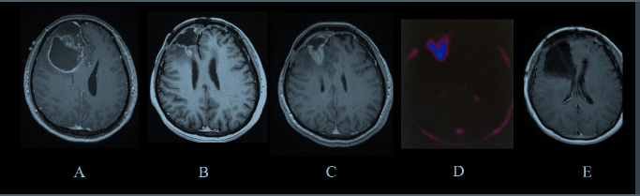
Case 1.
A. Forty-year-old female, presented with headache and dizziness. Histological-proven
glioblastoma, MGMT (-), IDH1(+), 1p19q (-).
B. RANO criteria diagnosed recurrence. Seventeen months after surgery and adjuvant
chemoradiation IMRT 56Gy/28fx and temozolomide.
C, D. Recurrence diagnosed by RANO criteria and 11C-methionine PET. Six months after
CyberKnife 20Gy/5fx with concurrent bevacizumab.
E. Histological-proven radiation necrosis after gross total resection

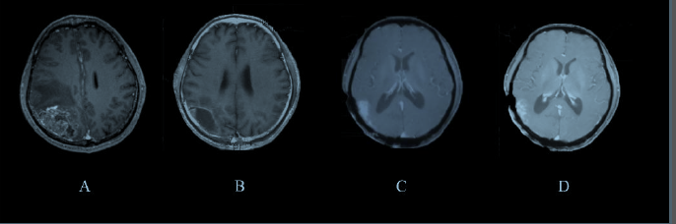
Case 2.
A. Fifty-eight years old male. Histological-proven glioblastoma, MGMT (-), IDH1(-), 1p19q (-),
TERT (+).
B. Treated with surgery and adjuvant chemoradiation IMRT 60Gy/30fx plus temozolomide and
TTF. Four months after initial diagnosis.
C. Twelve months after surgery, RANO criteria diagnosed recurrence.
D. Three months follow-up after CyberKnife 25Gy/5fx with concurrent bevacizumab.

