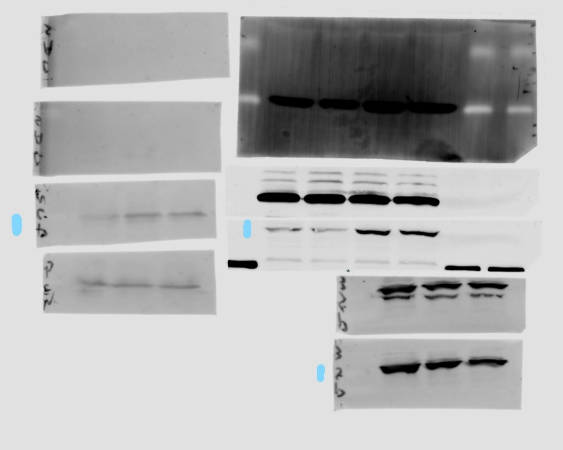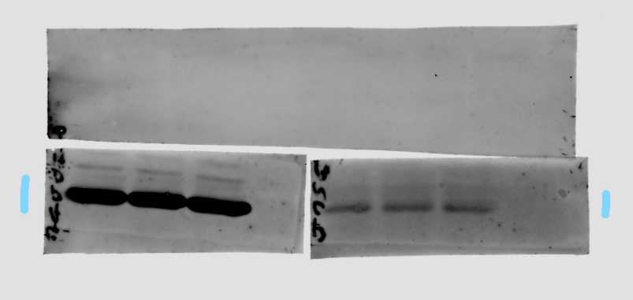
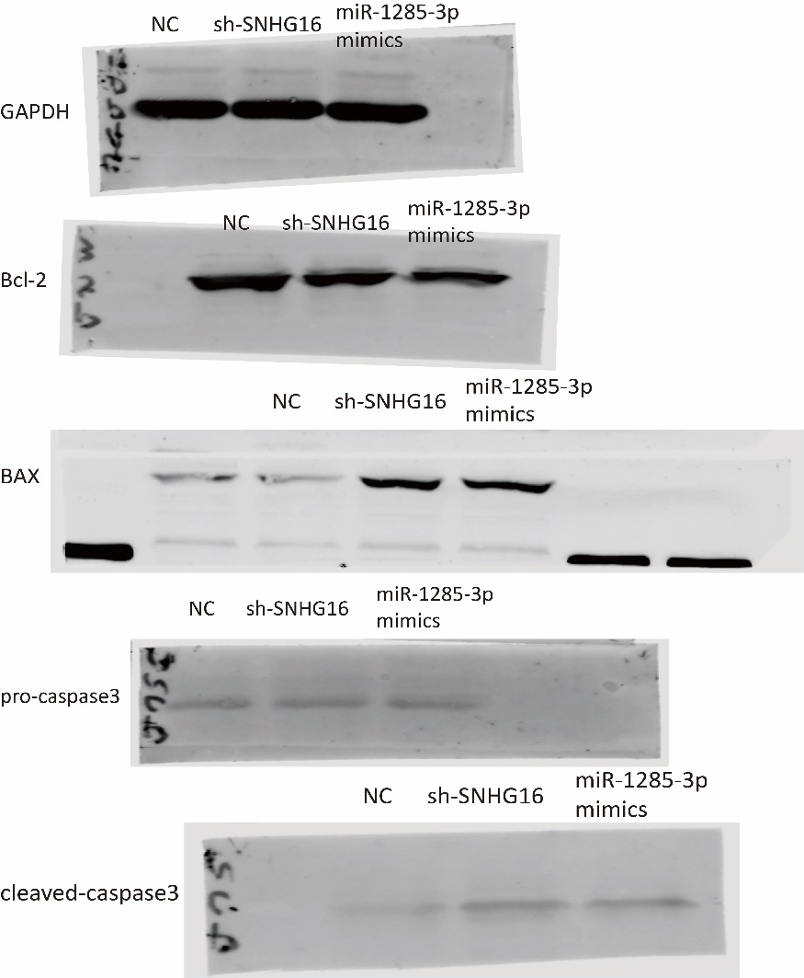

Figure legends
All the original, full-length gel and blot images was shown above, and all the samples were labelled as the last figure. Figure were taken by odyssey software

