Supplementary Material
Title Page:
Comparing the Characteristics and Predicting the Survival of Patients with Head and Neck Melanoma versus Body Melanoma: A Population-based Study
Yuxin Ding, MD^{1#}, Runyi Jiang, MD^{2#}, Yuhong Chen, MD¹, Jing Jing, PhD¹, Xiaoshuang Yang, MD¹, Xianjie Wu, PhD¹, Xiaoyang Zhang, MD¹, Jiali Xu, MD¹, Piaopiao Xu, MD¹, ShuChen LiuHuang, MFA³, Zhongfa Lu, PhD, MD^{1*}
¹ Department of Dermatology, The Second Affiliated Hospital, School of Medicine, Zhejiang University, Hangzhou, China, No. 88, Jiefang Road, Hangzhou 310009, China
² Spinal Tumor Center, Department of Orthopaedic Oncology, Changzheng Hospital, Second Military Medical University, Shanghai, 200003, China
³ China Academy of Art, Hangzhou, 310000, China
# Yuxin Ding, Runyi Jiang Contributed equally to this work.
*Corresponding author:
Zhongfa Lu, Department of Dermatology, The Second Affiliated Hospital, School of Medicine, Zhejiang University, Hangzhou, China, No. 88, Jiefang Road, Hangzhou 310009, China.
TEL: +86-137-5712-8317; E-mail: lzfskin@zju.edu.cn

Supplementary Figure
Fig. S1 Kaplan-Meier curves of OS were delineated based on the identified independent prognostic factors, including age, sex, histology, thickness, ulceration, stage, metastases, and surgery (a-d, i-l) for HNM training cohort, (e-h, m-p) for BM training cohort.
OS = overall survival; HNM = head and neck melanoma; BM = body melanoma
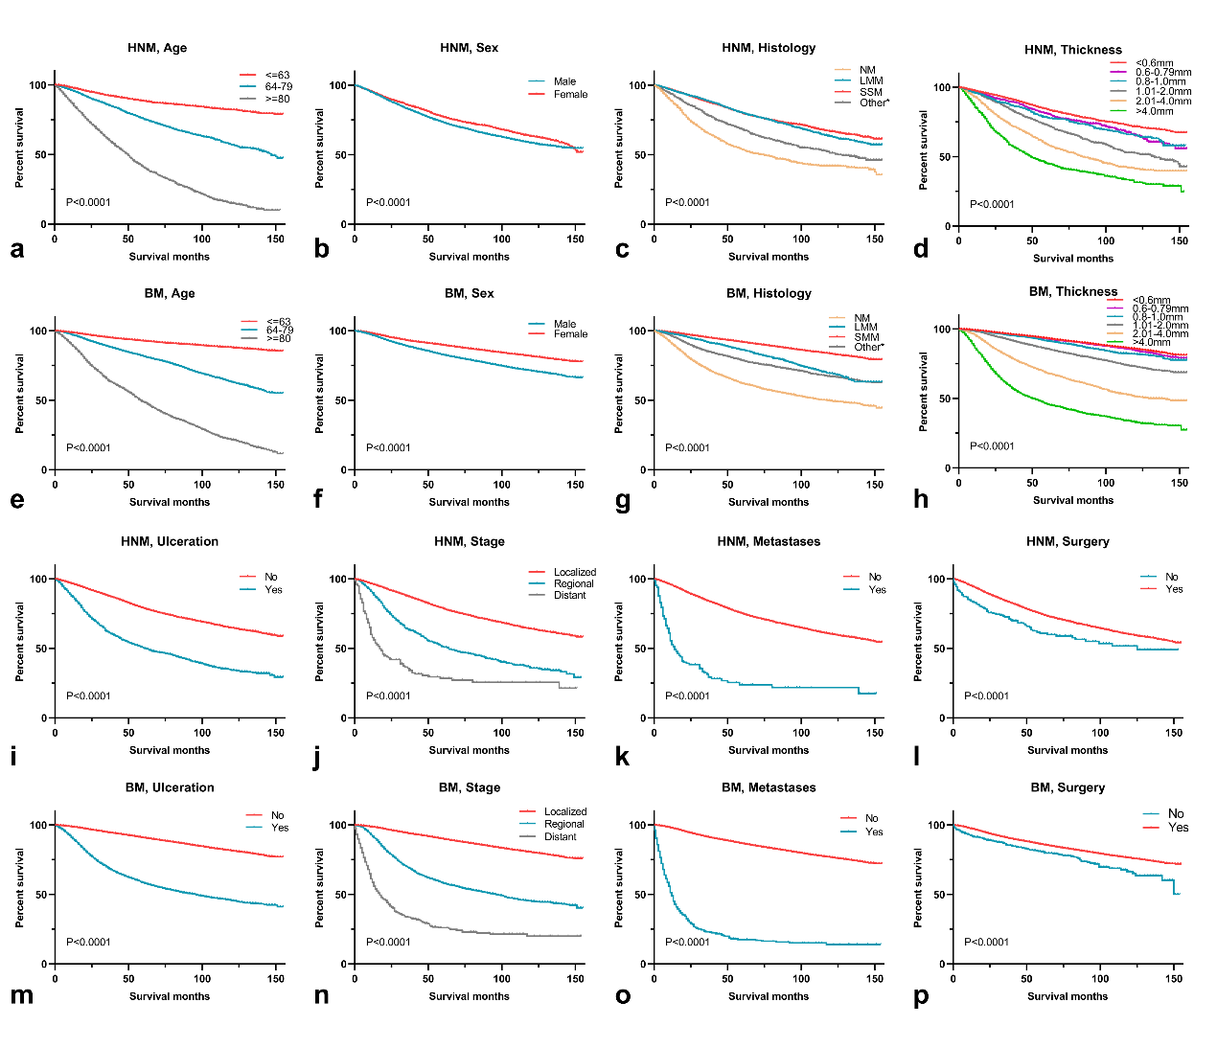

Fig. S2 Calibration curves showed the probability of 3-, 5- and 10-year overall survival (OS) between the nomogram prediction and the actual observation. Perfect prediction would correspond to the 45-degree line.
The calibration curves predicted OS of patients with HNM in the training group (a-c) and in the validation group (d-f). The calibration curves predicted OS of patients with BM in the training group (g-h) and in the validation group (j-l).
