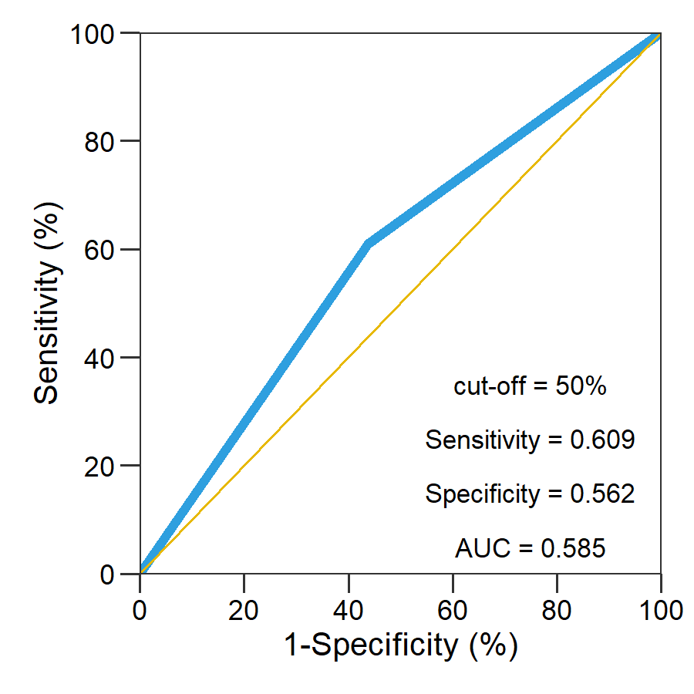
Figure S1. Receiver operating characteristic curve and the corresponding area under the curve (AUC) analyses of ZNF331 methylation on gastric cancer risk.

