Supplementary material

A latent class trajectory comparison of specific age and decade recall in the context of obesity related cancer

Charlotte Watson, Professor Andrew G Renehan and Dr Nophar Geifman
Supplementary Table 1: Obesity Related Cancers

Cancer Site | ICD-10 code
Oesophagus (lower third) | C15.5, C15.8
Colorectal | C18.0 - 18.9, C19.9, C20.0
Liver | C22.0
Gallbladder | C23.9
Pancreas | C25.0 - 25.9
Breast* | C50.0 - 50.9
Corpus Uteri / Endometrial | C54.0 - 54.9, C55.9
Ovary | C56.9
Kidney | C64.9
Gastric Cardia | C16.0
Malignant meningioma | C70.0, C70.1, C70.9
Thyroid | C73.0, C73.9
Multiple myeloma | C90.0
* Breast was not stratified by menopausal status

Lauby-Secretan B, Scoccianti C, Loomis D, Grosse Y, Bianchini F, Straif K. Body Fatness and Cancer--Viewpoint of the IARC Working Group. Colditz G, Anderson AS, Herbert RA, Kaaks R, Thompson HJ, Baker JL, Breda J, Byers T, Cleary MP, Di Cesare M, Gapstur SM, Gunter M, Hursting SD, Leitzmann M, Ligibel J, Renehan A, Romieu I, Shimokawa I, Ulrich CM, Wade K, Weiderpass E. N Engl J Med 2016; 375: 794-8.

Supplementary Table 2: Baseline Characteristics for Women by latent class assignment
 | Lean Small Increase | Lean Moderate Increase | Lean Heavy Increase | Medium Increase | N-Shaped
No of participants | 29134 | 74524 | 69314 | 37424 | 8531
Mean entry age, years | 63.36 (5.47) | 63.23 (5.47) | 62.41 (5.3) | 61.32 (5.1) | 60.14 (4.73)
Body Measures
Mean BMI at baseline, kg/m² | 20.71 (1.57) | 24.07 (1.75) | 28.41 (2.45) | 33.48 (4.75) | 37.73 (8.71)
Mean BMI at 20, kg/m² | 19.19 (1.51) | 20.3 (1.59) | 21.29 (1.81) | 23.31 (2.99) | 27.36 (6.31)
Mean BMI at 50, kg/m² | 20.19 (1.25) | 22.77 (1.43) | 25.77 (2.01) | 30.23 (4.09) | 36.43 (8.37)
Comorbidities
Diabetes | 585 (2%) | 2164 (3%) | 4007 (6%) | 5048 (13%) | 2042 (24%)
Heart disease | 1141 (4%) | 3054 (4%) | 3153 (5%) | 2409 (6%) | 703 (8%)
Smoking Status
Never | 15567 (53%) | 41519 (56%) | 39354 (57%) | 20959 (56%) | 4502 (53%)
Former | 9676 (33%) | 25735 (35%) | 24103 (35%) | 13301 (36%) | 3044 (36%)
Current | 3891 (13%) | 7258 (10%) | 5857 (8%) | 3161 (8%) | 985 (12%)
Missing | 0 (<1%) | 12 (<1%) | 0 (<1%) | 3 (<1%) | 0 (<1%)
Ethnicity
Non Hispanic White | 25597 (88%) | 67678 (91%) | 62020 (89%) | 32141 (86%) | 7003 (82%)
Black | 605 (2%) | 2445 (3%) | 4251 (6%) | 3707 (10%) | 1151 (13%)
Hispanic | 355 (1%) | 1067 (1%) | 1102 (2%) | 716 (2%) | 169 (2%)
Asian | 2395 (8%) | 2887 (4%) | 1414 (2%) | 444 (1%) | 74 (1%)
Other | 170 (1%) | 429 (1%) | 503 (1%) | 401 (1%) | 125 (1%)
Missing | 12 (<1%) | 18 (<1%) | 24 (<1%) | 15 (<1%) | 9 (<1%)
Highest Educational level achieved, %
<8 years | 125 (<1%) | 307 (<1%) | 501 (1%) | 455 (1%) | 128 (2%)
8-11 years | 1143 (4%) | 3516 (5%) | 4077 (6%) | 2947 (8%) | 854 (10%)
Completed high school | 6713 (23%) | 19617 (26%) | 20521 (30%) | 11038 (29%) | 2273 (27%)
Post high school or college | 10228 (35%) | 26593 (36%) | 24962 (36%) | 13911 (37%) | 3353 (39%)
College/ Postgraduate | 10866 (37%) | 24329 (33%) | 19125 (28%) | 9023 (24%) | 1902 (22%)
Missing | 59 (<1%) | 162 (<1%) | 128 (<1%) | 50 (<1%) | 21 (<1%)
Drug Use
Ibuprofen use 3+ times a week | 4705 (16%) | 12998 (17%) | 12868 (19%) | 6704 (18%) | 1459 (17%)
Missing | 164 (1%) | 498 (1%) | 449 (1%) | 329 (1%) | 95 (1%)
Aspirin use 3+ times a week | 5126 (18%) | 13034 (17%) | 12244 (18%) | 5925 (16%) | 1206 (14%)
Missing | 83 (<1%) | 220 (<1%) | 161 (<1%) | 123 (<1%) | 56 (1%)
HRT use ever, % | 20581 (71%) | 51263 (69%) | 45625 (66%) | 22682 (61%) | 4616 (54%)
Never | 8382 (29%) | 22860 (31%) | 23268 (34%) | 14459 (39%) | 3838 (45%)
Outcomes
Number of cancer diagnoses, % | 3687 (13%) | 9340 (13%) | 8964 (13%) | 4739 (13%) | 1104 (13%)
Number of obesity related cancer diagnoses, % | 2051 (7%) | 5687 (8%) | 5708 (8%) | 3083 (8%) | 704 (8%)
Number of non-obesity related cancer diagnoses, % | 1564 (5%) | 3425 (5%) | 3056 (4%) | 1492 (4%) | 346 (4%)
Mean age of cancer diagnosis, y | 69.9 (6.51) | 70.04 (6.49) | 69.26 (6.33) | 68.04 (6.05) | 66.1 (5.89)
Mean age of obesity related cancer diagnosis, y | 69.21 (6.42) | 69.71 (6.51) | 68.79 (6.29) | 67.95 (5.96) | 65.72 (5.88)
Mean age of non-obesity related cancer diagnosis, y | 70.91 (6.5) | 70.66 (6.4) | 70.37 (6.24) | 68.4 (6.25) | 67.15 (5.89)

Supplementary Table 3: Baseline Characteristics for Men by latent class assignment
 | Lean Increase | Lean Heavy Increase | High Lean Stable | Medium Increase | Medium Heavy Increase | N-Shaped
No of participants | 27947 | 34183 | 44549 | 42241 | 38772 | 2618
Mean entry age, years | 63.89 (5.49) | 62.88 (5.34) | 63.36 (5.39) | 62.21 (5.16) | 61.39 (4.98) | 59.45 (4.54)
Body Measures
Mean BMI at baseline, kg/m² | 22.76 (1.69) | 27.31 (1.94) | 25.22 (1.43) | 28.93 (1.92) | 32.04 (4.5) | 35.6 (8.77)
Mean BMI at 20, kg/m² | 20.27 (1.49) | 20.41 (1.42) | 23.04 (1.29) | 24.76 (1.55) | 24.91 (3.74) | 27.18 (6.62)
Mean BMI at 50, kg/m² | 22.3 (1.43) | 25.46 (1.75) | 24.91 (1.25) | 28.03 (1.64) | 30.66 (3.82) | 35.05 (8.45)
Comorbidities
Diabetes | 1227 (4%) | 2670 (8%) | 2365 (5%) | 3690 (9%) | 7005 (18%) | 719 (27%)
Heart disease | 2966 (11%) | 4640 (14%) | 5310 (12%) | 5887 (14%) | 6502 (17%) | 500 (19%)
Smoking Status
Never | 10364 (37%) | 10924 (32%) | 17936 (40%) | 16032 (38%) | 12285 (32%) | 801 (31%)
Former | 12927 (46%) | 19714 (58%) | 21135 (47%) | 21882 (52%) | 22044 (57%) | 1439 (55%)
Current | 4656 (17%) | 3542 (10%) | 5469 (12%) | 4321 (10%) | 4437 (11%) | 375 (14%)
Missing | 0 (<1%) | 3 (<1%) | 9 (<1%) | 6 (<1%) | 6 (<1%) | 3 (<1%)
Ethnicity
Non Hispanic White | 23252 (83%) | 29782 (87%) | 39767 (89%) | 38676 (92%) | 34465 (89%) | 2276 (87%)
Black | 1346 (5%) | 1460 (4%) | 1470 (3%) | 1570 (4%) | 2146 (6%) | 162 (6%)
Hispanic | 572 (2%) | 927 (3%) | 886 (2%) | 775 (2%) | 947 (2%) | 80 (3%)
Asian | 2637 (9%) | 1682 (5%) | 2145 (5%) | 799 (2%) | 660 (2%) | 38 (1%)
Other | 134 (<1%) | 314 (1%) | 272 (1%) | 392 (1%) | 506 (1%) | 59 (2%)
Missing | 6 (<1%) | 18 (<1%) | 9 (<1%) | 29 (<1%) | 48 (<1%) | 3 (<1%)
Highest Educational level achieved, %
<8 years | 382 (1%) | 435 (1%) | 393 (1%) | 429 (1%) | 606 (2%) | 78 (3%)
8-11 years | 1880 (7%) | 2700 (8%) | 2664 (6%) | 2547 (6%) | 3196 (8%) | 248 (9%)
Completed high school | 4514 (16%) | 6618 (19%) | 7262 (16%) | 7842 (19%) | 7982 (21%) | 542 (21%)
Post high school or college | 8385 (30%) | 11862 (35%) | 13348 (30%) | 13905 (33%) | 13998 (36%) | 966 (37%)
College/ Postgraduate | 12746 (46%) | 12467 (36%) | 20787 (47%) | 17425 (41%) | 12933 (33%) | 776 (30%)
Missing | 40 (<1%) | 101 (<1%) | 95 (<1%) | 93 (<1%) | 57 (<1%) | 8 (<1%)
Drug Use
Ibuprofen use 3+ times a week | 3491 (12%) | 5081 (15%) | 5904 (13%) | 6296 (15%) | 5826 (15%) | 429 (16%)
Missing | 68 (<1%) | 145 (<1%) | 146 (<1%) | 176 (<1%) | 198 (1%) | 12 (<1%)
Aspirin use 3+ times a week | 5460 (20%) | 6519 (19%) | 8917 (20%) | 8277 (20%) | 6861 (18%) | 380 (15%)
Missing | 48 (<1%) | 89 (<1%) | 72 (<1%) | 86 (<1%) | 78 (<1%) | 12 (<1%)
Outcomes
Number of cancer diagnoses, % | 3506 (13%) | 4096 (12%) | 5717 (13%) | 5064 (12%) | 4827 (12%) | 262 (10%)
Number of obesity related cancer diagnoses, % | 974 (3%) | 1161 (3%) | 1558 (3%) | 1602 (4%) | 1731 (4%) | 95 (4%)
Number of non-obesity related cancer diagnoses, % | 2520 (9%) | 2920 (9%) | 4144 (9%) | 3444 (8%) | 3075 (8%) | 167 (6%)
Mean age of cancer diagnosis, y | 71.09 (6.15) | 70.51 (6.23) | 70.96 (6.19) | 69.84 (6.28) | 68.76 (5.89) | 68.27 (5.93)
Mean age of obesity related cancer diagnosis, y | 70.47 (6.46) | 70.27 (6.29) | 70.72 (6.36) | 69.65 (6.31) | 68.81 (5.88) | 67.45 (5.91)
Mean age of non-obesity related cancer diagnosis, y | 71.35 (5.99) | 70.6 (6.19) | 71.06 (6.12) | 69.91 (6.26) | 68.7 (5.9) | 68.74 (5.9)

Supplementary Figure 1: PLCO data exclusions

Supplementary Figure 2: Scoping model for men and women

Panels A and B depict the residuals for the age specific recall data. C and D for decade recall data and E and F for all BMI data. Based on these, a cubic random effect structure was chosen for all.

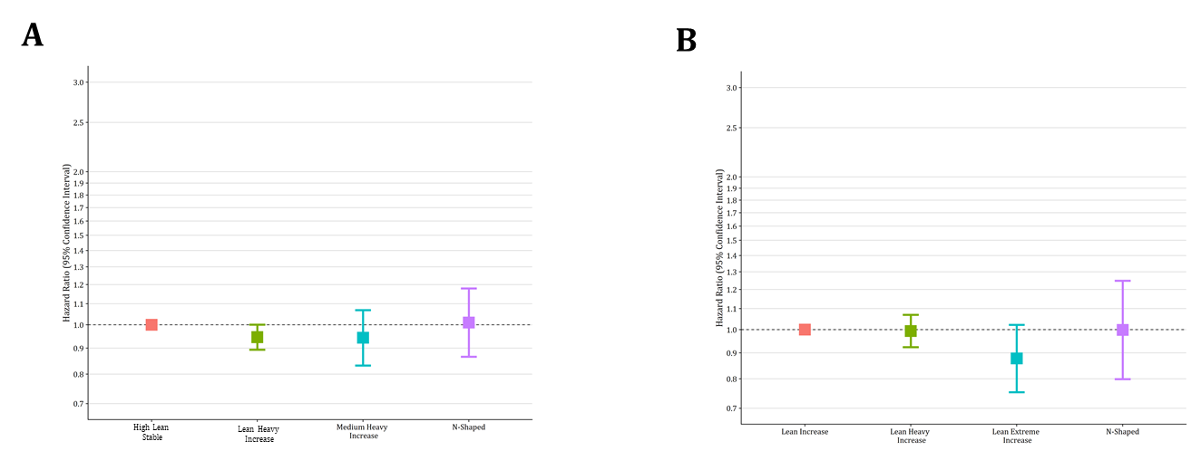
Supplementary Figure 3: Non obesity related cancer incidence for the combined data trajectories

Panel A shows the association of the “all data” trajectory class assignments in men with non-obesity related cancers. Panel B in women.

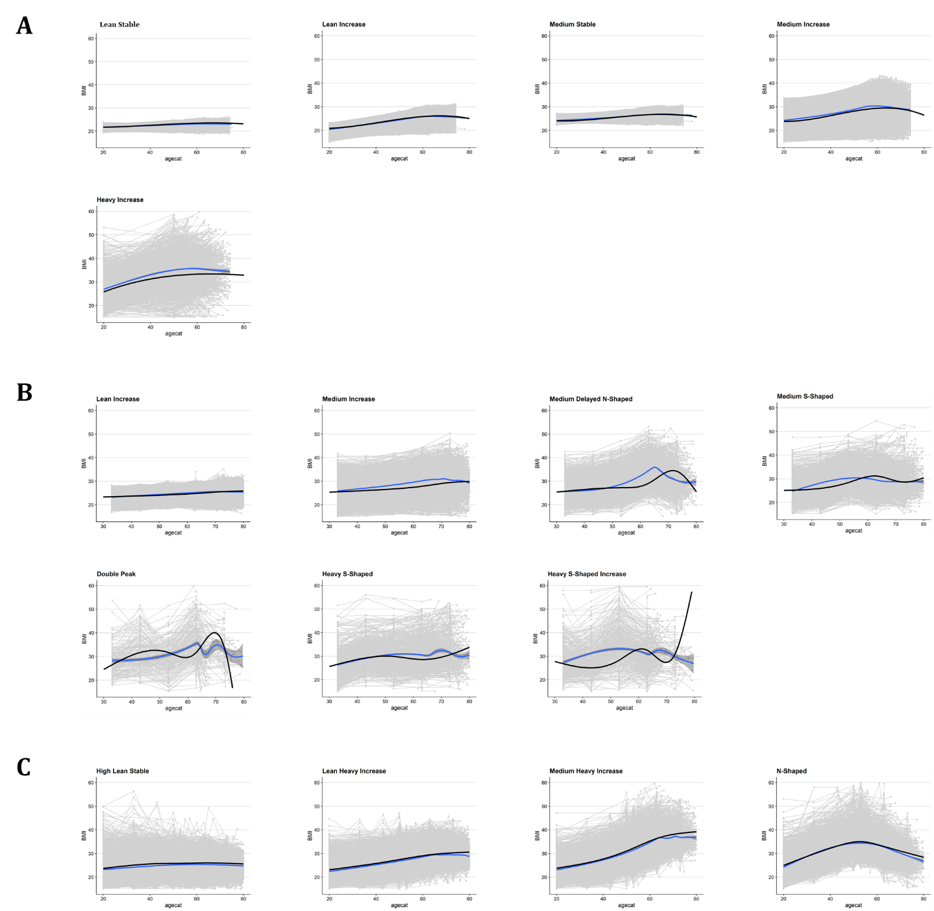
Supplementary Figure 4: Raw trajectories vs Predicted Trajectory in men

Panel A depicts the difference between the raw data and the predicted trajectory for the model derived in specific age recalled data, Panel B for decade recalled data and Panel C for the combined data.

