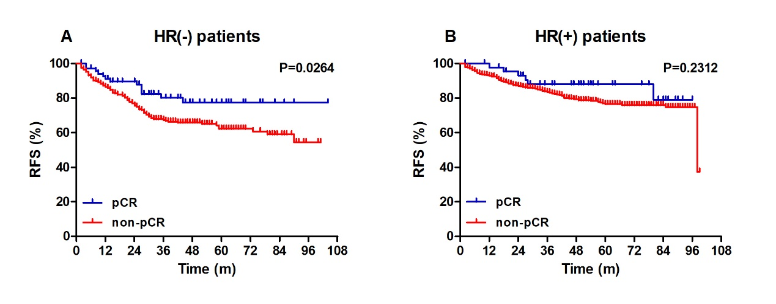
Figure S1 RFS outcomes in the pCR and non-pCR groups by HR status
Notes: (A) In the HR (-) group, patients with pCR exhibited better 3-year RFS compared with non-pCR patients (80.1% vs 67.4%, log-rank, P = 0.0264). (B) In the HR (+) group, no significant differences were showed in RFS graphs (log-rank, P = 0.2312).
Abbreviations: RFS, recurrence-free survival; pCR, pathological complete response; HR, hormone receptor.

