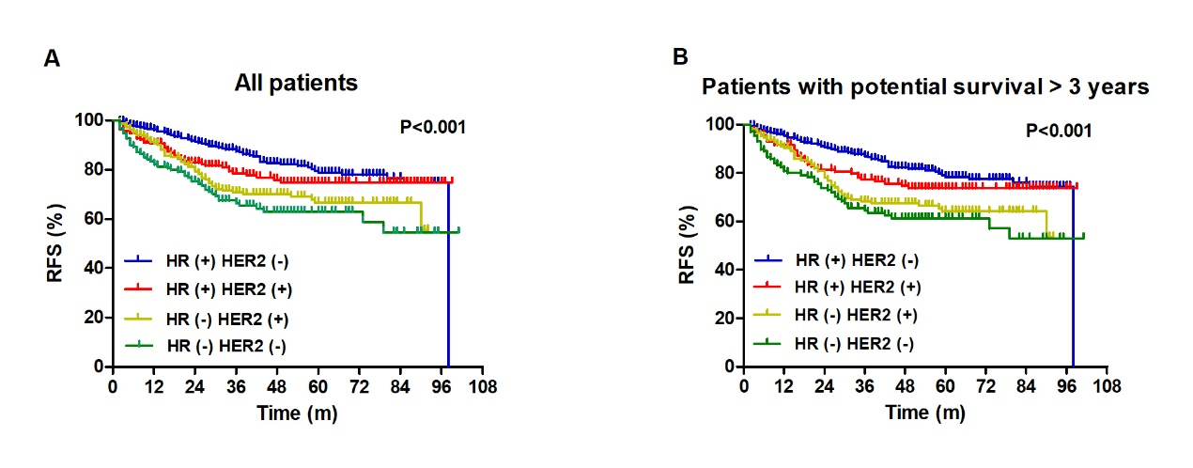
Supplementary material 1. RFS outcomes by molecular subtypes

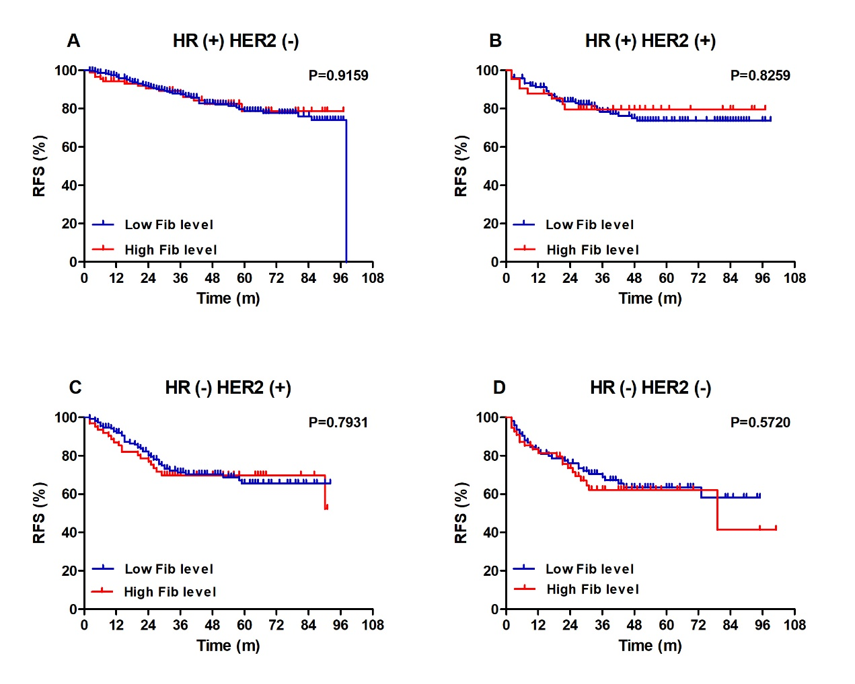
Supplementary material 2. Survival analysis on Fib levels and RFS by molecular subtypes

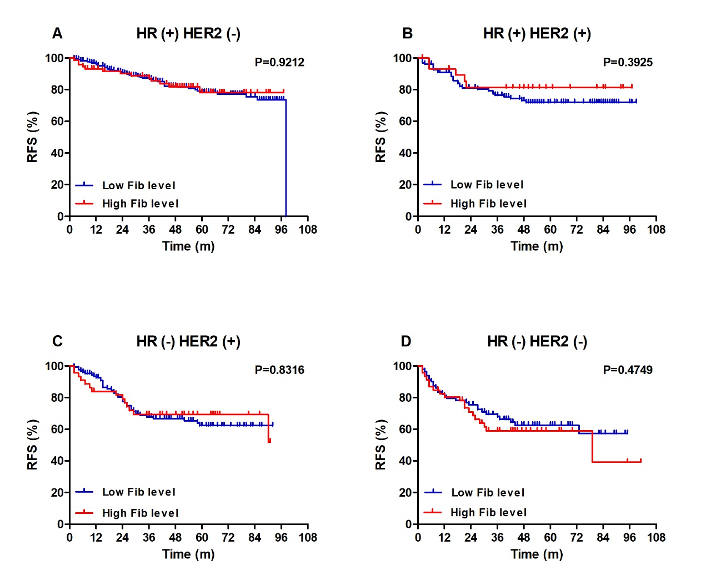
Supplementary material 3. Survival analysis on Fib levels and RFS by molecular subtypes (potential survival more than 3 years)

