Supplementary Data 2. DNA sequence of RFC1.
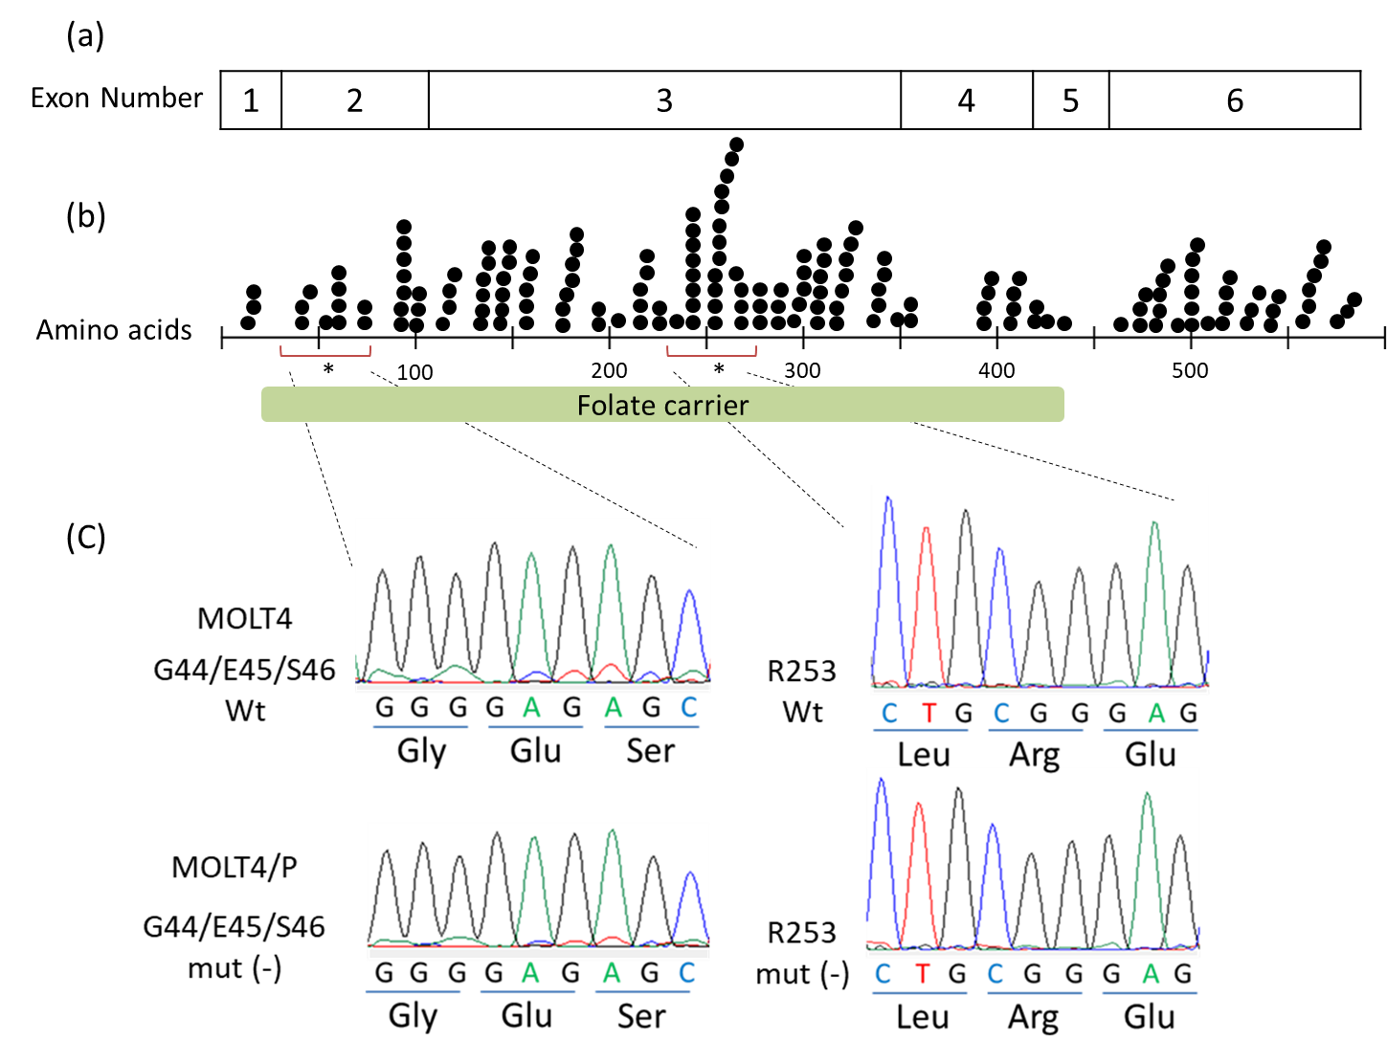
created by author based on COSMIC v86.
* Rothem L et al. Biochem J. 2002;367,741-750.
Zhao R et al. Mol Pharmacol.1999;56,68-76.
Sequencing analysis of exons 2 and 3 of RFC1 (SLC19A1) was performed using genomic PCR and RT-PCR. (a, b) Distribution of point mutations in RFC1, as previously reported. (c) Sanger sequencing of RFC1 exon2 and exon3. There were no acquired somatic mutations in PDX-resistant cells. Exon 2 (MOLT4 and PDX-resistant cells), exon 3 (MOLT4 and PDX-resistant cells).

