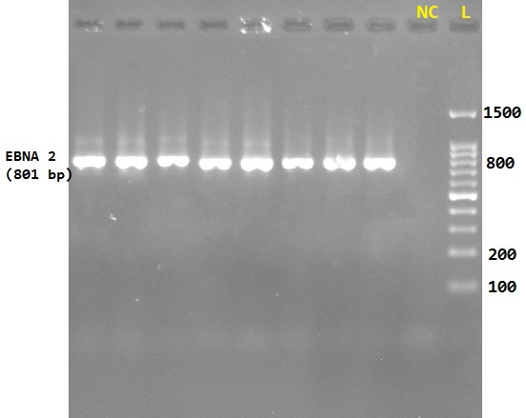
Figure 1. PCR amplification of the RBV EBER-2 gene. The first round of the PCR was amplified by using a specific primer (EBNA-2F: GGAAACCCGTCACTCTC and EBNA-2R: TAATGGCATAGGTGGAATG) which gives an amplicon size of 801 bp. L; ladder (100-1500), NC (negative control).

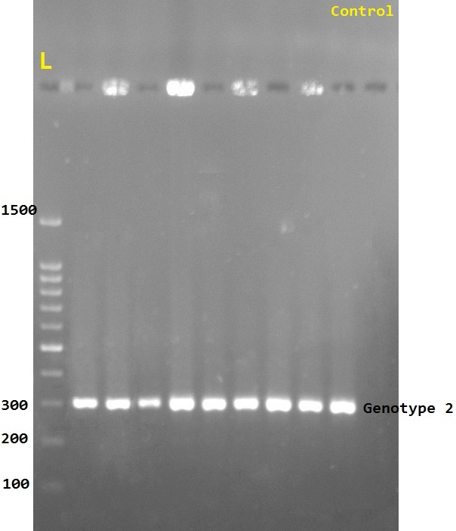
Figure 2. PCR amplification of EBV genotypes. The second round of the RT-PCR was amplified by using forward primer EBNA-2C (AGGGATGCCTGGACACAAGA), which is common to both EBV genotypes 1 and 2, as well as reverse primers EBNA-2G (GCCTCGGTTGTGACAGAG, amplicon size: 250 bp,) and EBNA-2B (TTGAAGAGTATGTCCTAAGG, amplicon size: 300 bp, EBV genotype 2), that are specific primers for genotypes 1 and 2, respectively.

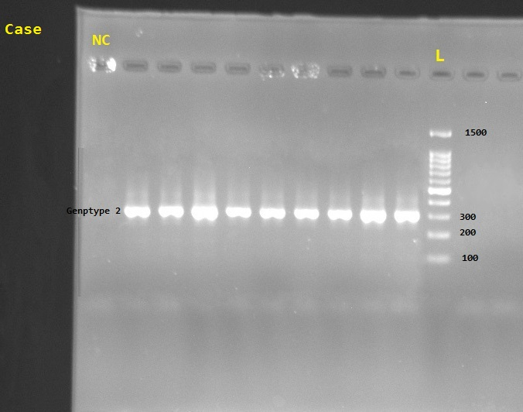
lml
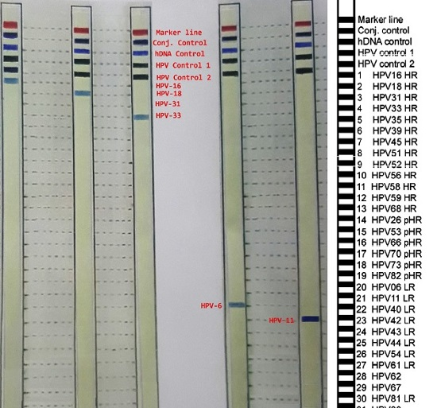
Figure 3. Nitrocellulose Strips After Staining. The detected genotypes were HR-HPV types, 16, 18, and 33, as well as LR-HPV 6 and 11.

