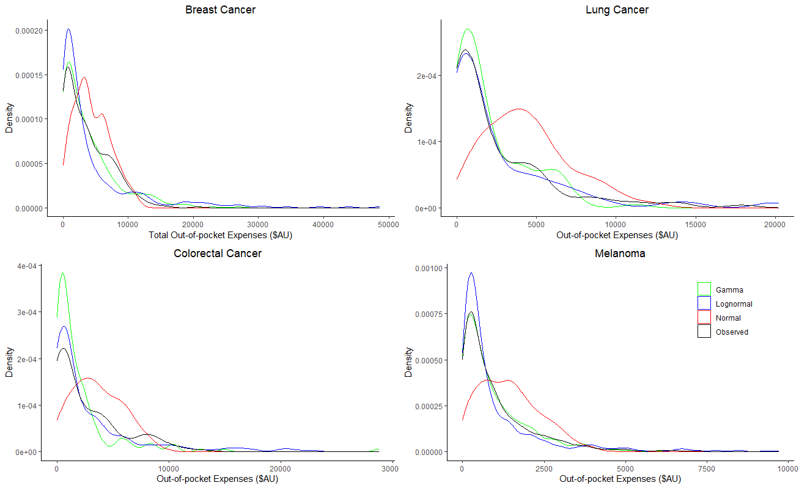
Additional File 1. Density plots for the tested gamma, lognormal and normal distributions. Observed values fitted better a gamma distribution. Diagnostic tests confirmed the appropriateness of the family and link parameters. Variables from a full model (year of diagnosis, age group, sex, marital status, level of education, private health insurance status (yes/no), body mass index, drinks per week and self-health assessment (poor, good and excellent)) were excluded based on their statistical significance and the Akaike Information Criterion (AIC). All analyses were performed using R. Statistical significance was considered at p<0.05.

