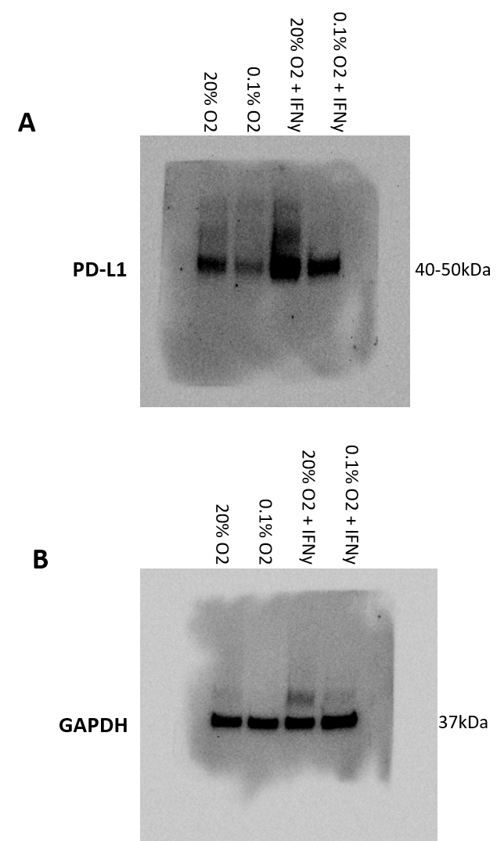

Supplementary Figure 5. Full length original and unprocessed Western blots shown in Figure 1A. Western blot showing the presence/absence of A) PD-L1 and B) GAPDH across different experimental conditions. GAPDH was used as an experimental loading control. Independent experiments were performed at least three times and a representative blot is shown.

