Table S1 The best cutoff values of continuous variables for predicting liver metastasis.
Variable | Cutoff value | Sensitivity | Specificity | Youden index
Age (years old) | 67 (≥ 67 vs. < 67) | 21.2% | 85.9% | 0.071
ApoAI (g/L) | 1.22 (< 1.22 vs. ≥ 1.22) | 50.0% | 55.6% | 0.056
ApoB (g/L) | 1.06 (≥ 1.06 vs. < 1.06) | 30.8% | 77.4% | 0.082
ApoB-to-apoAI ratio | 0.63 (≥ 0.63 vs. < 0.63) | 80.8% | 31.3% | 0.121
CEA (ng/ml) | 6.1 (≥ 6.1 vs. < 6.1) | 44.2% | 63.4% | 0.076
CA19-9 (U/ml) | 26.3 (≥ 26.3 vs. < 26.3) | 34.6% | 80.0% | 0.146
Abbreviations: CEA, carcinoembryonic antigen; CA19-9, carbohydrate antigen 19-9; apoAI, apolipoprotein A-I; apoB, apolipoprotein B.

Table S2 Candidate predictors in patients with different serum apolipoprotein B to apolipoprotein A-I ratios.
 | ApoB-to-apoAI ratio < 0.63 (N = 175) | ApoB-to-apoAI ratio ≥ 0.63 (N = 424) | Chi-square | P value
Age (years old)
< 67 | 148 (84.6%) | 359 (84.7%) | 0.001 | 0.976
≥ 67 | 27 (15.4%) | 65 (15.3%)
Gender
Female | 69 (39.4%) | 134 (31.6%) | 3.385 | 0.066
Male | 106 (60.6%) | 290 (68.4%)
Differentiation
High-moderate | 156 (89.1%) | 380 (89.6%) | 0.030 | 0.862
Low | 19 (10.9%) | 44 (10.4%)
Distance to anal verge (cm)
≥ 5 | 110 (62.9%) | 291 (68.6%) | 1.867 | 0.172
< 5 | 65 (37.1%) | 133 (31.4%)
Clinical T stage
cT3-1 | 93 (53.1%) | 231 (54.5%) | 0.089 | 0.765
cT4 | 82 (46.9%) | 193 (45.5%)
Clinical N stage
cN0 | 31 (17.7%) | 75 (17.7%) | 0.000 | 0.994
cN+ | 144 (82.3%) | 349 (82.3%)
CEA (ng/ml)
< 6.1 | 108 (61.7%) | 262 (61.8%) | 0.000 | 0.986
≥ 6.1 | 67 (38.3%) | 162 (38.2%)
CA19-9 (U/ml)
< 26.3 | 134 (76.6%) | 329 (77.6%) | 0.074 | 0.786
≥ 26.3 | 41 (23.4%) | 95 (22.4%)
TRG
2-1 | 89 (50.9%) | 185 (43.6%) | 2.605 | 0.106
5-3 | 86 (49.1%) | 239 (56.4%)
Pathologic T stage
pT3-0 | 162 (92.6%) | 388 (91.5%) | 0.186 | 0.666
pT4 | 13 (7.4%) | 36 (8.5%)
Pathologic N stage
pN0 | 131 (74.9%) | 339 (80.0%) | 1.903 | 0.168
pN+ | 44 (25.1%) | 85 (20.0%)
Active viral hepatitis
No | 149 (85.1%) | 368 (86.8%) | 0.285 | 0.593
Yes | 26 (14.9%) | 56 (13.2%)
Chemotherapy cycle
≥ 8 | 88 (50.3%) | 194 (45.8%) | 1.021 | 0.312
< 8 | 87 (49.7%) | 230 (54.2%)
Abbreviations: apoB, apolipoprotein B; apoAI, apolipoprotein A-I; CEA, carcinoembryonic antigen; CA19-9, carbohydrate antigen 19-9; TRG, tumor regression grade.

Figure S1 Overall survival of the patients grouped by different pathoclinical factors. Age ≥ 67 years old, distance to anal verge < 5 cm, cT4 stage, CEA ≥ 6.1 ng/ml, CA19-9 ≥ 26.3 U/ml, TRG 5-3, pT4 and pN+ stage correlated with a decreased 5-year overall survival. Abbreviations: CEA, carcinoembryonic antigen; CA19-9, carbohydrate antigen 19-9; apoAI, apolipoprotein A-I; apoB, apolipoprotein B; TRG, tumor regression grade.
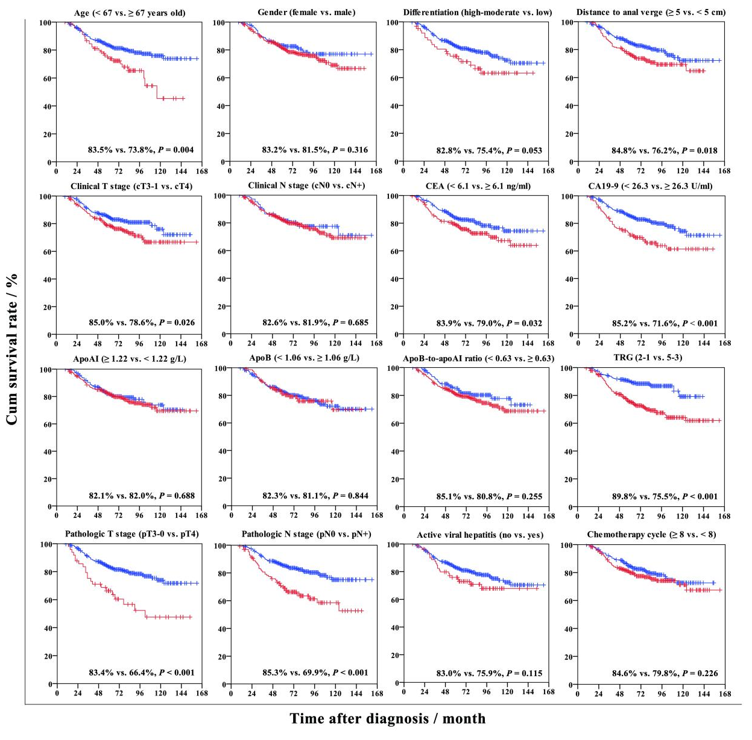

Figure S2 Other-metastasis-free survival of the patients grouped by different pathoclinical factors. CEA ≥ 6.1 ng/ml, CA19-9 ≥ 26.3 U/ml, TRG 5-3, pT4 and pN+ stage correlated with a decreased 5-year other-metastasis-free survival. Abbreviations: CEA, carcinoembryonic antigen; CA19-9, carbohydrate antigen 19-9; apoAI, apolipoprotein A-I; apoB, apolipoprotein B; TRG, tumor regression grade.
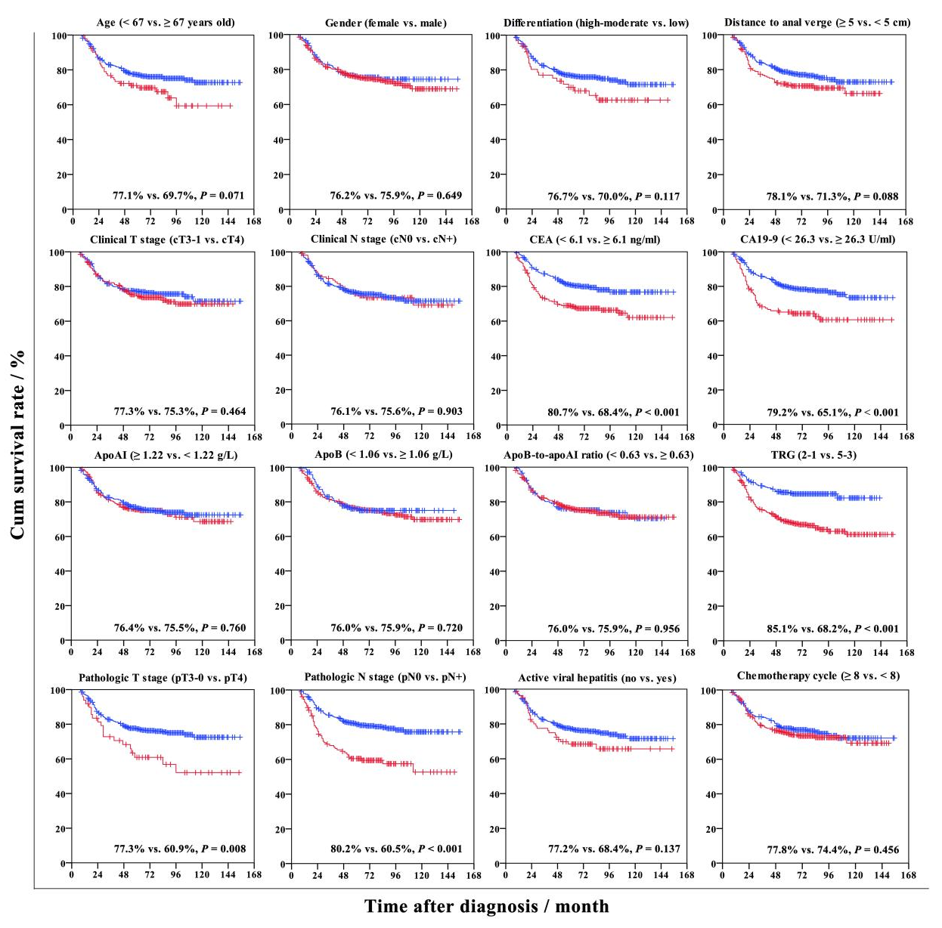

Figure S3 Multivariate survival analysis involving possible predictors of overall and other-metastasis-free survivals. A: age ≥ 67 years old, distance to anal verge < 5 cm, CA19-9 ≥ 26.3 U/ml, TRG 5-3, pT4 and pN+ stage maintained to independently predict a decreased 5-year overall survival. B: CA19-9 ≥ 26.3 U/ml, TRG 5-3, pT4 and pN+ stage maintained to independently predict a decreased 5-year other-metastasis-free survival. Abbreviations: CEA, carcinoembryonic antigen; CA19-9, carbohydrate antigen 19-9; TRG, tumor regression grade. * P < 0.05, ** P < 0.01.
