Roles of extended human papillomavirus genotyping and multiple infections in early detection of cervical precancer and cancer and HPV vaccination
Fangbin Song^{1,2#}, Peisha Yan^{1,2#}, Xia Huang^{1,2}, Chun Wang^{1,2}, Hui Du^{1,2*}, Xinfeng Qu^{3*}, and Ruifang Wu^{1,2*}

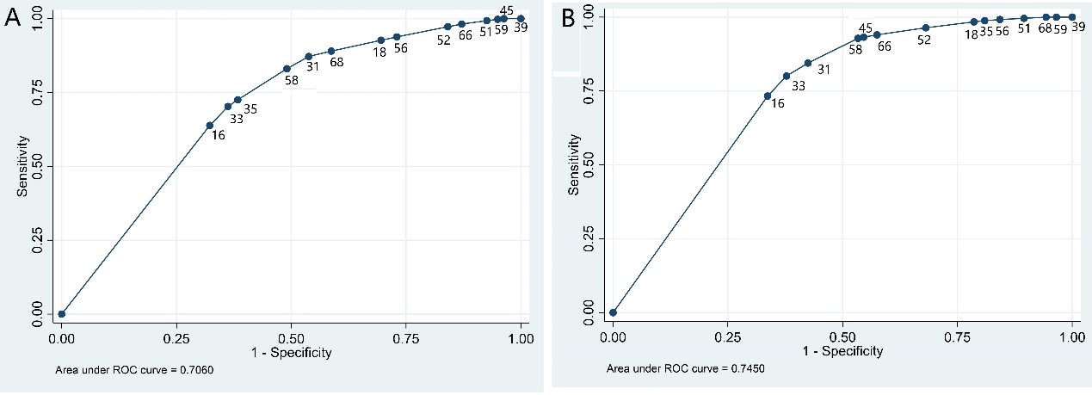
FIGURE S1 Receiver operating characteristic (ROC) curves of cumulative sensitivity/1-specificity of hierarchical and ordering hrHPV genotypes (A) for CIN2+, area under curve (AUC) = 0.71 (0.68-0.73); (B) for CIN3+, AUC= 0.75 (0.72-0.77).

Table S1 Individual genotypes by histology
HPV genotypes |  | Histology, n (%)
HPV genotypes | Total | ≤CIN1 | CIN2 | CIN3+
6† | 115 | 83 (72.2) | 20 (17.4) | 12 (10.4)
11† | 47 | 32 (68.1) | 11 (23.4) | 4 (8.5)
16 | 1,020 | 602 (59.0) | 139 (13.6) | 279 (27.4)
18 | 375 | 290 (77.3) | 54 (14.4) | 31 (8.3)
31 | 184 | 134 (72.8) | 19 (10.3) | 31 (16.8)
33 | 150 | 85 (56.7) | 26 (17.3) | 39 (26.0)
35 | 85 | 54 (63.5) | 16 (18.8) | 5 (5.9)
39 | 182 | 144 (79.1) | 29 (15.9) | 9 (4.9)
45 | 68 | 52 (76.5) | 9 (13.2) | 7 (10.3)
51 | 236 | 186 (78.8) | 33 (14.0) | 17 (7.2)
52 | 386 | 278 (72.0) | 63 (16.3) | 45 (11.7)
56 | 134 | 101 (75.4) | 19 (14.2) | 14 (10.4)
58 | 363 | 235 (64.7) | 62 (17.1) | 66 (18.2)
59 | 101 | 78 (77.2) | 15 (14.9) | 8 (7.9)
66 | 141 | 108 (76.6) | 25 (17.7) | 8 (5.7)
68 | 202 | 147 (72.8) | 35 (17.3) | 20 (9.9)

Note: †HPV6 infection incudes single HPV6 infection, and co-infection with HPV6 and high-risk genotypes and/or HPV11; HPV11 infection incudes single HPV11 infection, and co-infection with HPV11 and high-risk genotypes and/or HPV6.

