Positive H. pylori status predicts better prognosis of non-cardiac gastric cancer patients: results from cohort study and meta-analysis

Zhifang Jia^{1,a}, Min Zheng^{1,a}, Jing Jiang^{1,3}, Donghui Cao¹, Yanhua Wu¹, Yuzheng Zhang^{1,3}, Yingli Fu¹, Xueyuan Cao^{2,*}

¹ Division of Clinical Research, the First Hospital of Jilin University, Changchun, China
² Department of Gastrointestinal Surgery, the First Hospital of Jilin University, Changchun, China
³ Department of Epidemiology and Biostatistics, School of Public Health, Jilin University, Changchun, China

ª Contributed equally to this work.

*Corresponding author. Department of Gastrointestinal Surgery, the First Hospital of Jilin University, Changchun, China.

Corresponding author: Xueyuan Cao
Email address: jd3d2ub@jlu.edu.cn

Supplementary materials:

The detailed retrieving strategies in PubMed and Embase
PubMed:
((((("Stomach Neoplasms"[MeSH Terms] OR "gastric cancer"[Title/Abstract]) OR "gastric neoplasms"[Title/Abstract]) OR "stomach cancer"[Title/Abstract]) OR "stomach neoplasm"[Title/Abstract]) OR "cancer of the stomach"[Title/Abstract]) AND ("survival"[Title/Abstract] OR "prognosis"[Title/Abstract])) NOT ((((((("review"[Publication Type] OR "clinical conference"[Publication Type]) OR "comment"[Publication Type]) OR "lecture"[Publication Type]) OR "review"[Title]) OR "overview"[Title]) OR "meta-analysis"[Title]) OR "case report"[Title]) AND 1994/1/1:2020/4/10[Date - Publication] filter:english

Embase:
('stomach cancer'/exp OR 'stomach adenoma'/exp OR 'gastric cancer':ti,ab,kw OR 'gastric neoplasm':ti,ab,kw OR 'stomach neoplasm':ti,ab,kw) AND 'survival':ti,ab,kw NOT ('meta analysis':ti,ab,kw OR [meta analysis]/lim OR 'systematic review':ti,ab,kw OR [systematic review]/lim OR 'lecture':ti OR 'case report':ti OR [erratum]/lim OR [letter]/lim OR [note]/lim OR [review]/lim OR [short survey]/lim) AND [embase]/lim AND [1994-2020]/py AND [english]/lim

sTable 1. The modified Newcastle-Ottawa quality assessment scale used for assessing the quality of the studies included in meta-analysis
Section | Items | Evidence | Score
Selection of population | Representativeness of the exposed cohort | All patients were diagnosed as gastric cancer and grouped according to H. pylori status | 1
Selection of population | Selection of the unexposed cohort | All patients were diagnosed as gastric cancer and grouped according to H. pylori status | 1
Selection of population | Ascertainment of exposure | By certain methods | 1
Selection of population | Ascertainment of exposure | From medical records or not mentioned in this article | 0
Selection of population | Outcome of interest not present at start of study | Yes/No | 1/0
Comparability | Control for important factor or additional factor | Adjusted for known prognostic factors | 2
Comparability | Control for important factor or additional factor | Univariate analysis only | 1
 | Control for important factor or additional factor | Calculated by researchers | 0
Internal validity | Outcome assessment | Defined clearly and detected objectively | 1
Internal validity | Follow-up long enough for outcomes to occur | Median length of follow-up > 36m | 1
Internal validity | Follow-up long enough for outcomes to occur | The outcome of interest was detected among half of subjects | 1
Internal validity | Follow-up long enough for outcomes to occur | Length of follow-up was unavailable or not long enough to detect the outcome | 0
Internal validity | Adequacy of follow-up of cohorts | More than 80% of target subjects were included in prognostic studies | 1
Internal validity | Adequacy of follow-up of cohorts | 20% of subjects failed to follow up | 0

sTable 2. Multivariable analysis of variables associated with the overall survival of gastric cancer in our cohort study
Variables | HR | 95% CI | P
Age (>65 vs ≤65 years) | 1.48 | 1.19-1.84 | 0.0004
Length (>4.5cm vs ≤4.5cm) | 1.38 | 1.12-1.71 | 0.0029
T stage (T3-T4 vs T1-T2) | 2.46 | 1.72-3.51 | <.0001
N stage (N1-N3 vs N0) | 2.17 | 1.55-3.03 | <.0001
Lymphovascular invasion (positive vs negative) | 1.82 | 1.31-2.55 | 0.0004
Perineural invasion (positive vs negative) | 1.35 | 1.06-1.71 | 0.0163
Post-operational chemotherapy (yes vs no) | 0.77 | 0.61-0.96 | 0.0191

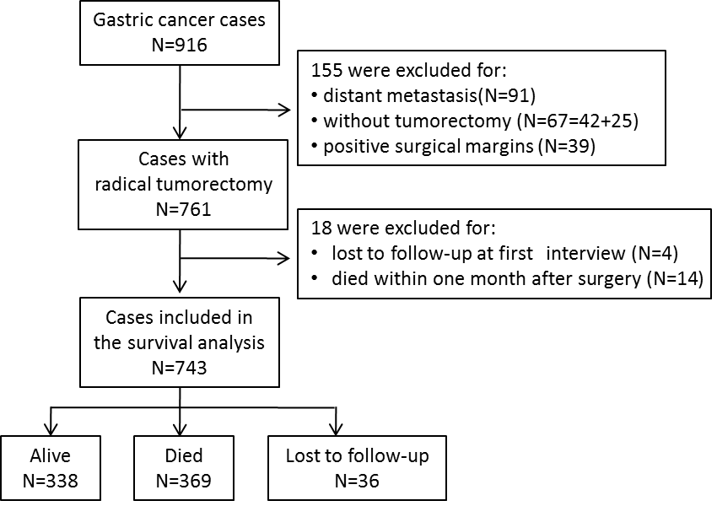

sFigure 1. Flow chart for patient screening in our prospective cohort study
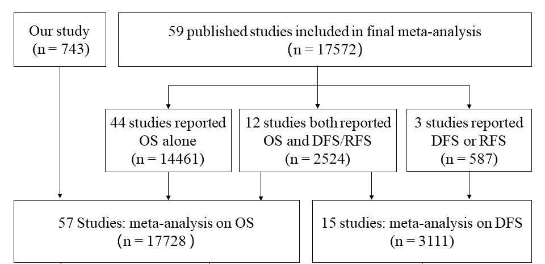
sFigure 2. Number of studies included in meta-analysis section
n: Number of gastric cancer patients. OS: overall survival. DFS: disease-free survival. RFS: relapse-free survival.

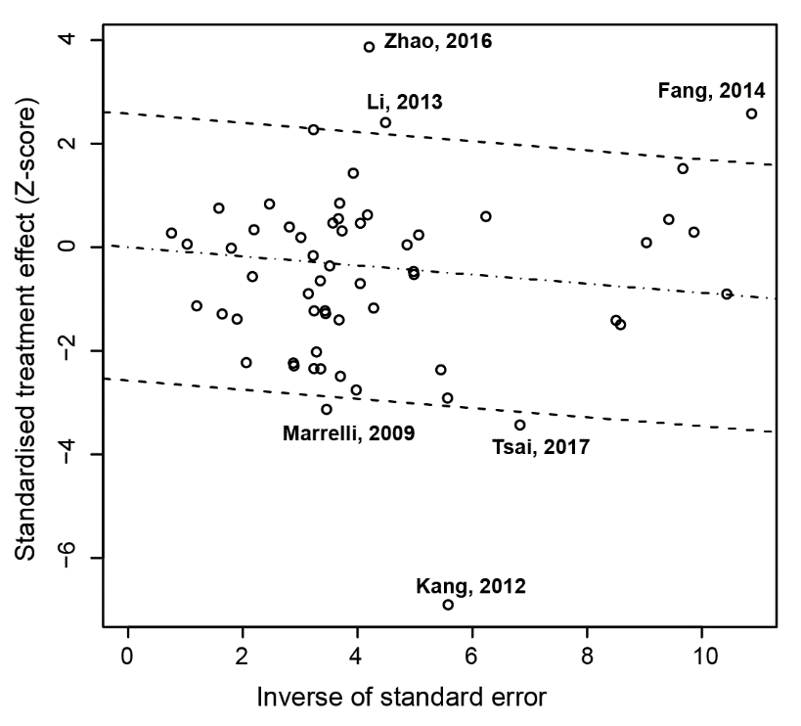
sFigure 3. Galbraith’s plot for the association of H. pylori status at diagnosis with OS for gastric cancer patients

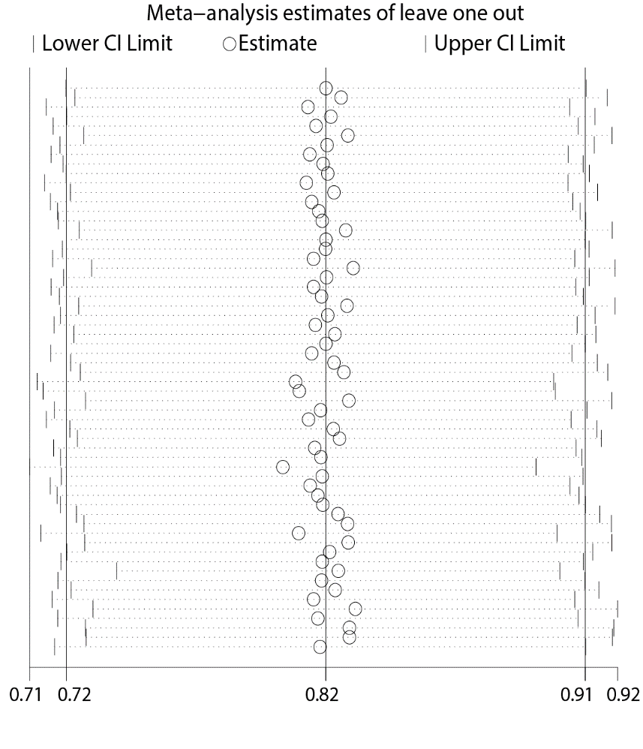
sFigure 4. Leave-one-out analysis for the association of H. pylori status at diagnosis with OS for gastric cancer patients
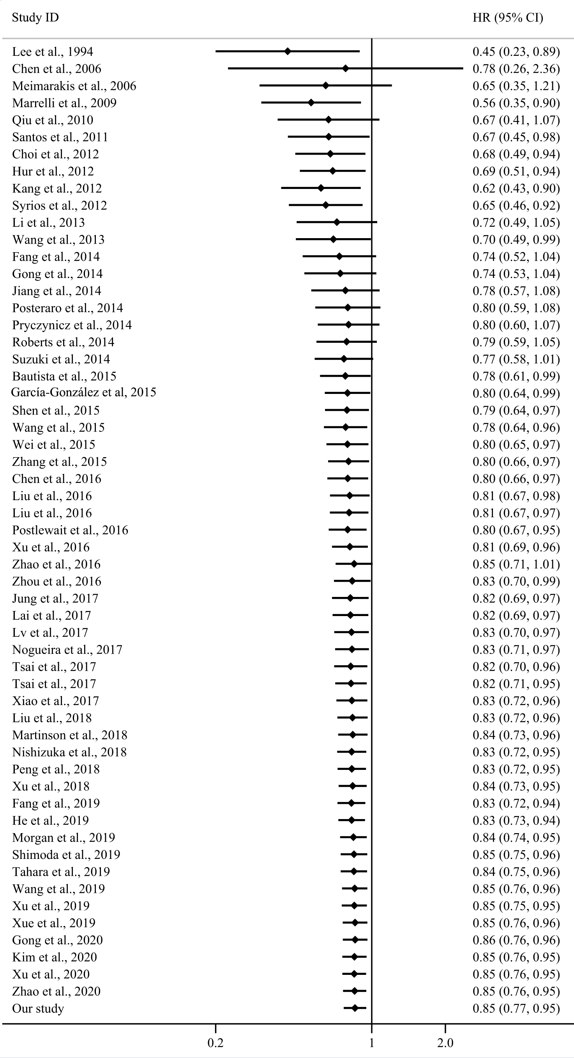
sFigure 5. Cumulative meta-analysis for the association of H. pylori status with OS for GC patients
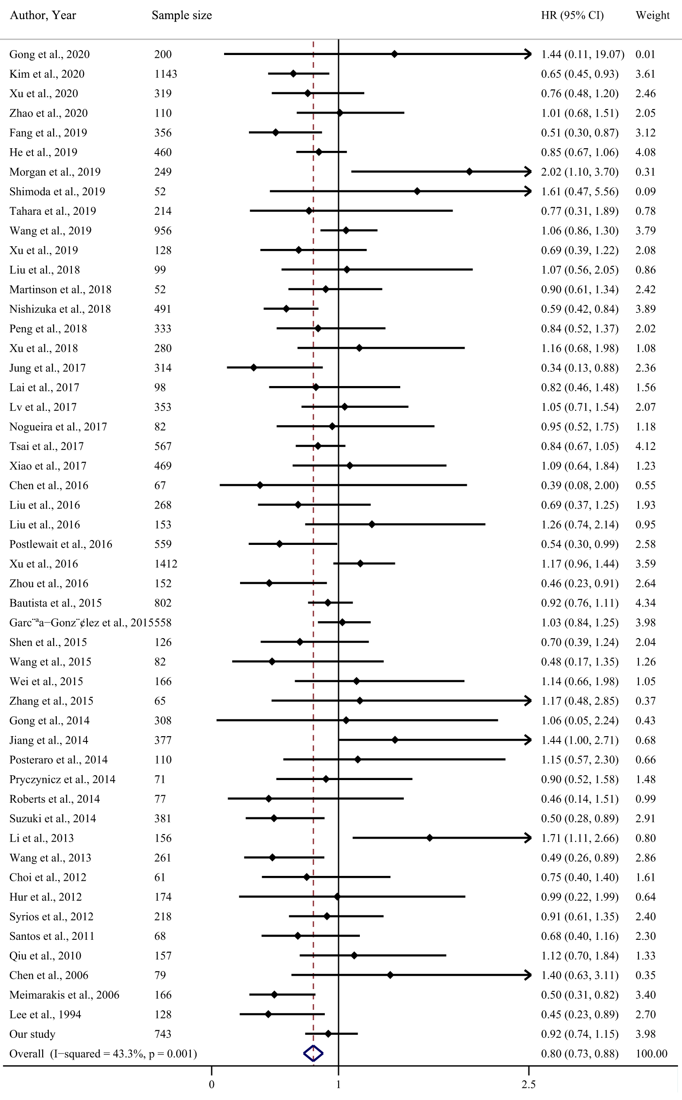
sFigure 6. Forest plot for the association of H. pylori status with OS on GC (6 studies removed version)
6 studies removed: This version of the forest plot displays results of meta-analysis when 6 studies were removed to reduce the heterogeneity.

