Supplementary Table 1

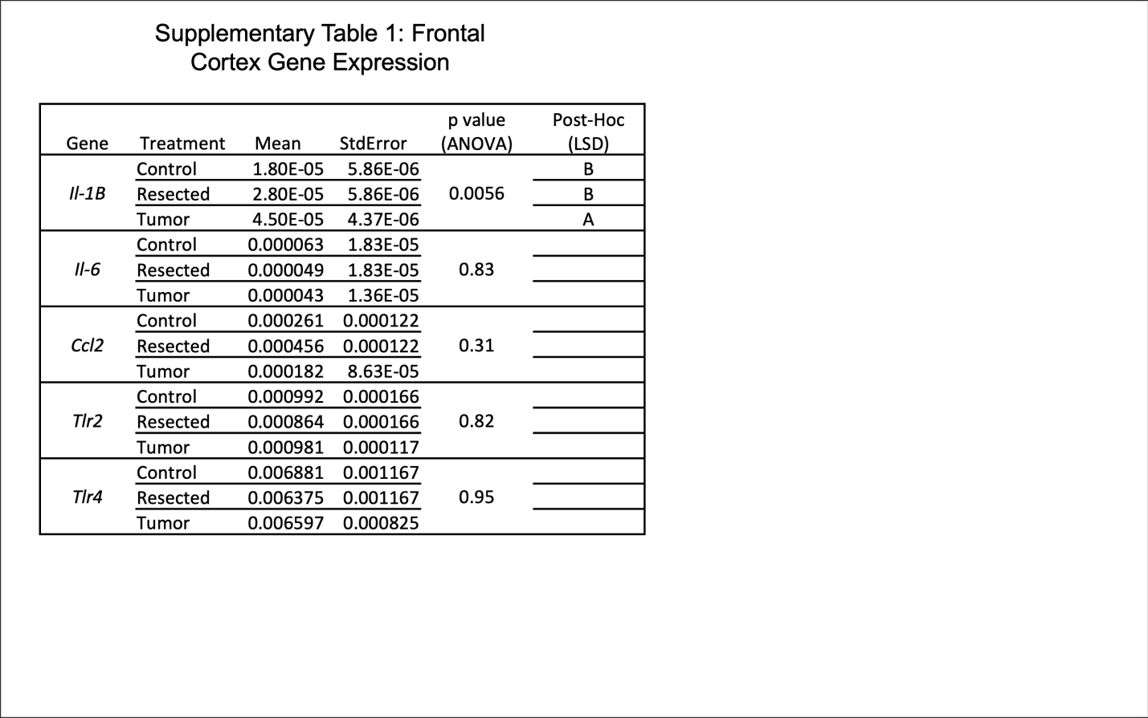

Supplementary Table 1: Brain inflammation-related gene expression. Among several pro-inflammatory genes in bacterial signaling pathways, only expression of Il-1B is higher in the frontal cortex of Tumor-bearing mice and is attenuated by Resection.

Supplementary Table 2

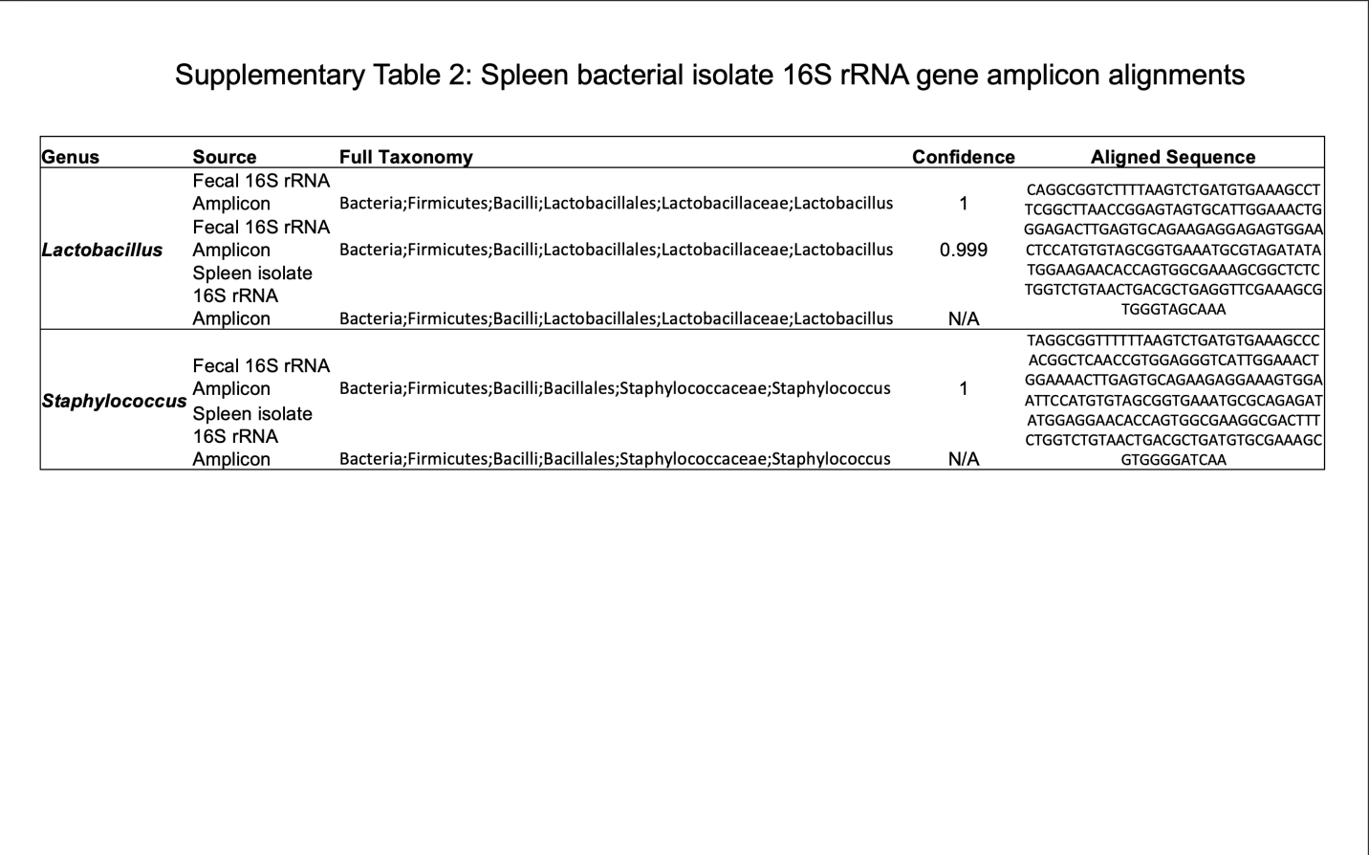
Supplementary Table 2: Spleen bacterial isolate 16S rRNA gene amplicon alignments. Isolates from mouse spleens in the genera Lactobacillus and Streptococcus have 100% sequence matches to fecal 16S rRNA amplicon sequences, suggesting that these bacterial translocated from the intestine to the spleen.

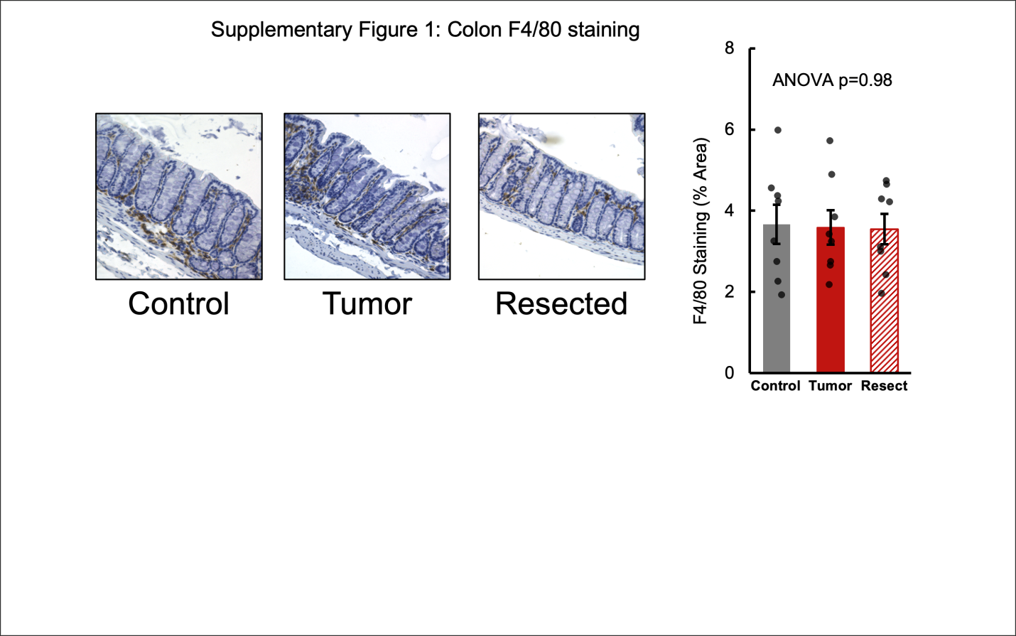
Supplementary Figure 1: Mammary tumors do not affect colonic monocyte and macrophage infiltration. Although markers of colonic barrier function are altered by tumor implantation, there is no difference in colonic F4/80 staining between treatment groups, a marker of monocyte and macrophage infiltration.

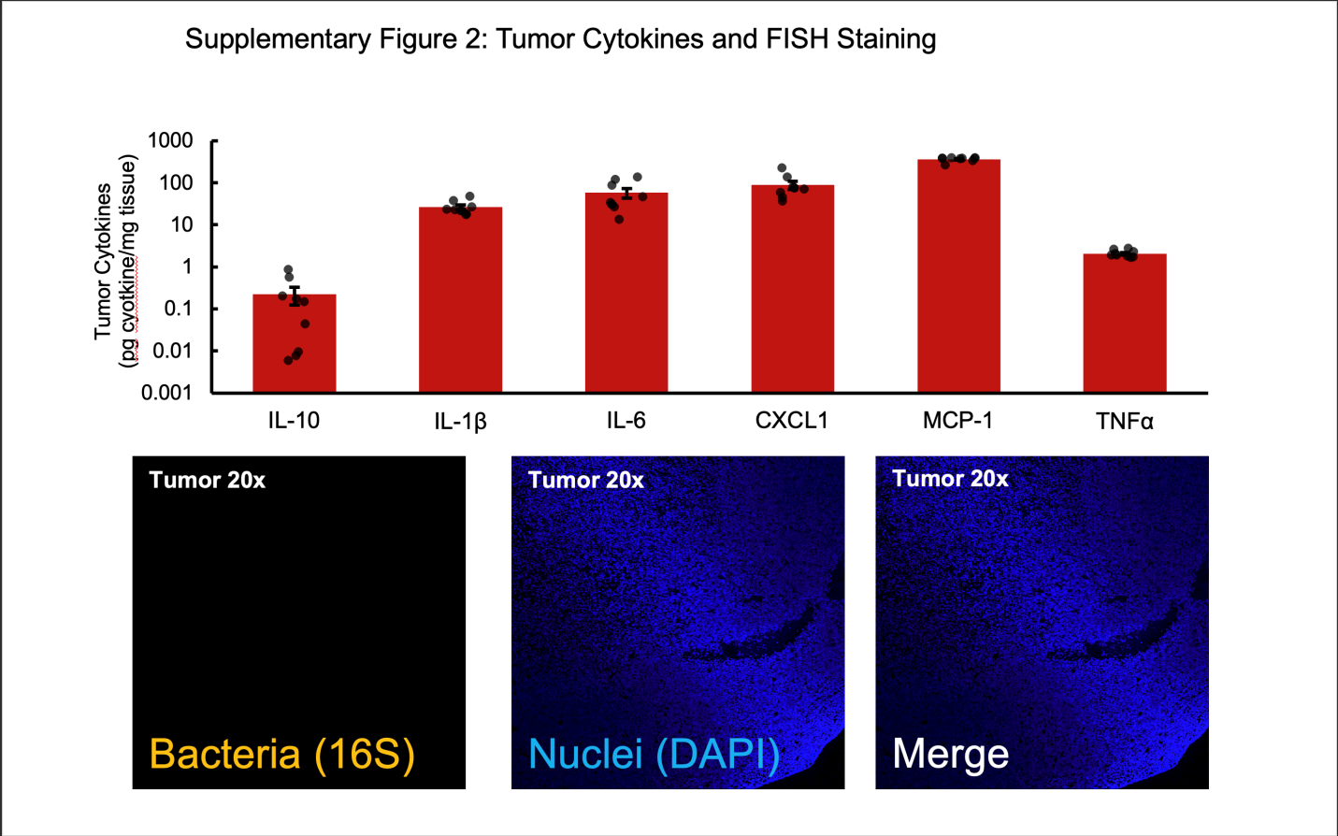
Supplementary Figure 2: Tumor Cytokines and FISH. Implanted tumors produce many cytokines, but do not have detectable fluorescence for bacterial DNA.

