Table S1. The degree information of 29 BC patients.
No. | Gender | Age | Stage | Degree
1 | Male | 79 | T4aN2M0 | High
2 | Female | 51 | T2 | High
3 | Male | 56 | T1 | High
4 | Male | 64 | Ta | Low
5 | Male | 48 | Ta | Low
6 | Male | 65 | T1 | High
7 | Male | 63 | T2 | High
23 | Male | 70 | Ta | Low
24 | Female | 78 | T4N1M0 | High
25 | Male | 69 | Ta | Low
26 | Male | 68 | T4 | High
27 | Male | 62 | T3 | High
28 | Male | 53 | T3 | High
29 | Male | 65 | Ta | Low
30 | Male | 62 | Ta | Low
31 | Male | 68 | T1 | High
32 | Female | 81 | T2 | High
33 | Male | 72 | T1 | High
34 | Male | 92 | T1 | High
35 | Male | 59 | Ta | Low
36 | Male | 73 | T3 | High
37 | Female | 66 | Ta | Low
38 | Male | 53 | T1 | Low
39 | Female | 81 | Ta | High
40 | Male | 82 | T2b | Low
41 | Female | 57 | T2bN1M0 | High
42 | Female | 87 | Ta | High
43 | Female | 70 | Ta | High
44 | Male | 85 | T3 | High

Table S2. The top 10 characteristic metabolites in high and low BC patients.
No | High grade | Low grade
1 | Heptanoic acid | Myristic acid
2 | AMP | Citrulline
3 | Propionic acid | Linoleic acid
4 | Proline | GUDCA
5 | Malic acid | N-Methylnicotinamide
6 | Picolinic acid | Palmitoleic acid
7 | 5-Aminolevulinic acid | AMP
8 | GUDCA | 7-DHCA
9 | Fumaric acid | GCDCA
10 | 3-Hydroxylisovalerylcarnitine | 2-Furoic acid

Table S3. The top 10 characteristic metabolites in male and female BC patients.
No. | Male | Female
1 | Myristic acid | Tridecanoic acid
2 | Propionic acid | Salicyluric acid
3 | 5-Aminolevulinic acid | Shikimic acid
4 | Malic acid | Hexanylcarnitine
5 | 2-Furoic acid | GDCA
6 | 4-Hydroxybenzoic acid | Octanoylcarnitine
7 | Heptanoic acid | Dodecanoylcarnitine
8 | AMP | Picolinic acid
9 | Acetylglycine | LCA
10 | GUDCA | Decanoylcarnitine

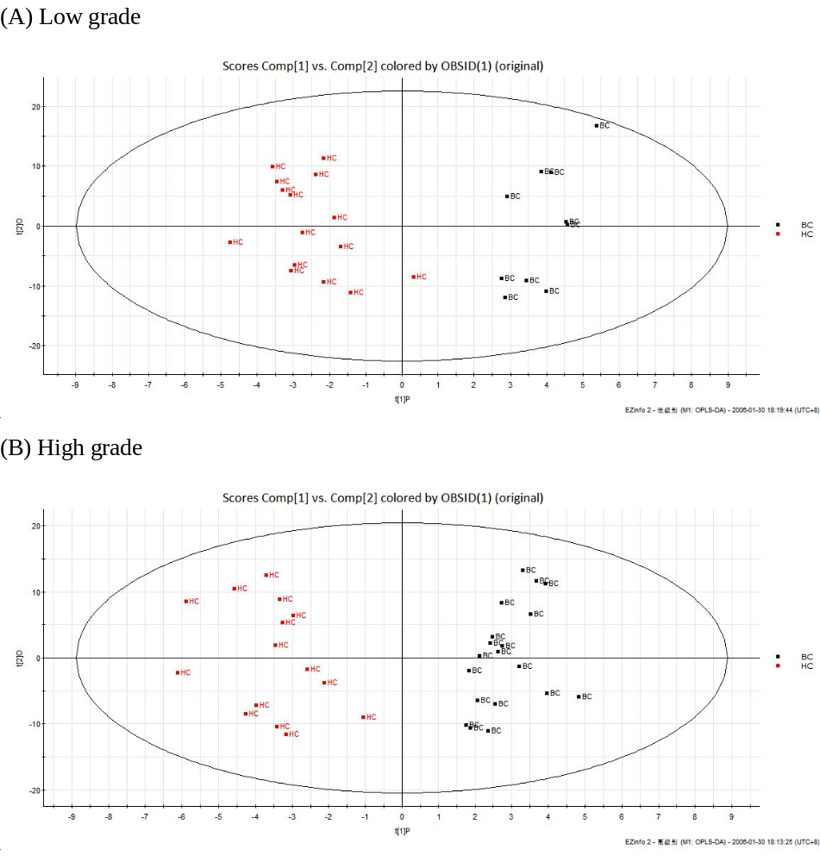
Figure S1. The OPLS-DA score plot for HC and high and low grade BC patients.

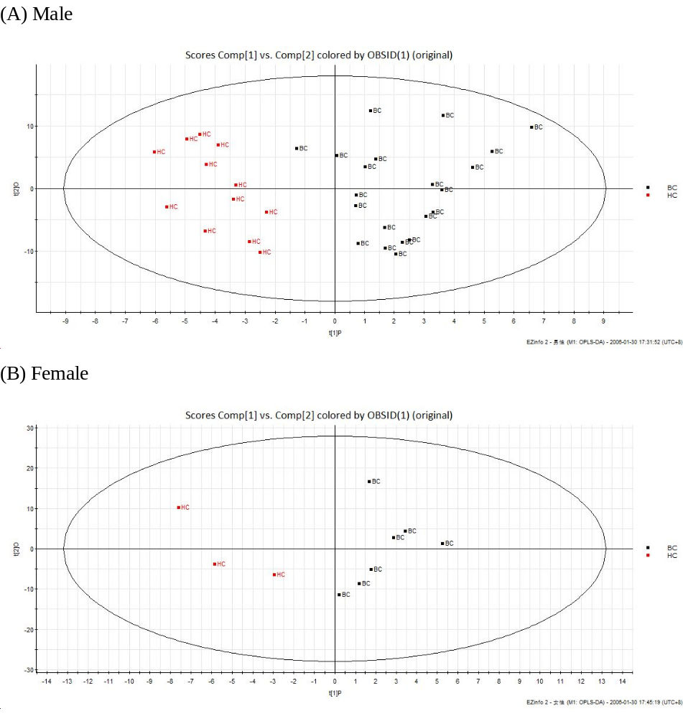
Figure S2. The OPLS-DA score plot for HC and BC groups in male and female.

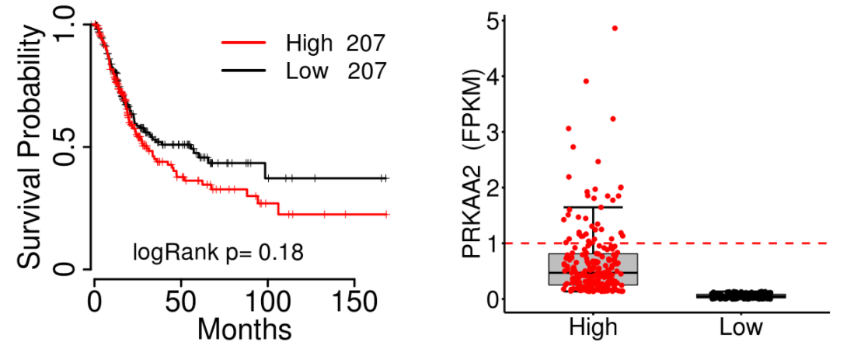

Figure S3. The survival probability and expression of Protein Kinase AMP-Activated Catalytic Subunit Alpha 2 (PRKAA2)

