Appendix B

Detailed description and

numerical example of

multinomial network meta-analysis

As the data contain ordered categorical outcomes, the likelihood which relates the data to the parameters of the models, was specified as $r_{iTk}\sim multinomial(p_{iTk},n_{iT})$. 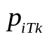being the probability for response category $k$ in patients with treatment in study , 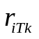 the number of patients within each response category $k$ and 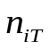 the total number of patients with treatment in study .
For modelling ordered categorical outcomes, the fixed effect multinomial logistic model was specified as:
$$\log\left(Y_{iTk}\right)=\left\{\begin{aligned}α_{ik} \\ α_{ik}+β_{ibzk}=α_{ik}+d_{zk}-d_{bk}\end{aligned} | {if \left(T=b\right), b∈1,2,…,tx \atop if \left(T=z\right), z>b, z∈2,3,…,tx}\right. k=2,3$$
$$d_{12}=d_{13}=0$$
Each treatment combination $T$ is designated to a specific index. Therefore, this index runs from 1 to the total number of treatments $tx$. For each study one treatment is assigned as the base treatment $b$ (i.e., often the control arm treatment) and the other treatment as the non-base treatment(i.e., often the experimental arm treatment). The non-base treatments follow all the base treatments $b$in numerical order and therefore has indices running from 2 to $tx$.
Dexamethasone (treatment index=1) is taken to be the reference treatment for the presented analysis results but note that is not necessarily dexamethasone in every trial. 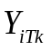 are the hazards for response category $k$ among all patients for treatment T in study . The odds are only estimated for category $k=2$ (PR-group) and $k=3$ (<PR-group), because the odds for category $k=1$ (CR-group) is inherent for ordered categorical outcomes. 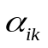are the log odds for category $k$ for base treatment $b$ in study $i$. 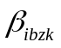 are the relative effects for treatment versus , and is estimated for PR and <PR separately. are identified by expressing them in terms of the reference treatment dexamethasone: $β_{ibzk}=d_{zk}-d_{bk}$ with $d_{12}=d_{13}=0$.
The log odds were transformed to response specific probabilities for $k=2$ (PR) and $k$=3 (<PR) by the following formula:
$$p_{iTk}=\frac{Y_{iTk}}{1+\sum_{m=2}^{3}{Y_{iTm}}}$$
The probability of response category CR, corresponding to $k=1$, is inherent and calculated as
$$p_{iT1}=1-\sum_{m=2}^{3}{p_{iTm}}$$
The remaining $d$’s (one for each treatment) were calculated based on the available direct RCT evidence and the requirement that the indirect evidence should generate similar results.
A smaller network was used to show the step-by-step calculations of the multinomial network meta-analysis. For this network, data from two trials were synthesized:
- POLLUX (comparing DaraLenDex and LenDex) and
- ASPIRE (comparing CarLenDex and LenDex).
LenDex is used as reference treatment in this network. In Figure 6 the network is presented with three treatment regimens: [1] LenDex, [2] DaraLenDex and [3] CarLenDex (the numbers between square brackets also correspond to their treatment index in the WinBUGS code file). The solid lines between the treatments indicate direct evidence available from a phase III RCT and the dotted line between the treatments indicate indirect evidence used in the NMA. Every white colored box represents a treatment regimen and is accompanied by a grey box. In the grey boxes the trial data and WinBUGS results are presented. The sources (i.e., POLLUX, ASPIRE or WinBUGS) are followed by three percentages (i.e., CR/PR/<PR rates) and the number of patients (N) assigned to that specific treatment is presented.
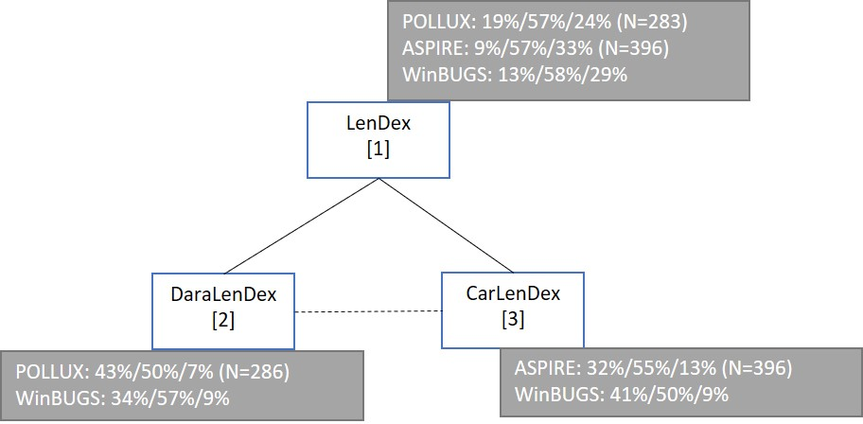
Fig.6 Illustrative example of the network meta-analysis (ASPIRE and POLLUX)

The data
In order to populate the WinBUGS data code file, the following variables were used and explained here:
i=study index (1=POLLUX, 2=ASPIRE)
j=treatment index (1=LenDex, 2=DaraLenDex, 3=CarLenDex)
k=outcome index (1=CR, 2=PR, 3=<PR)
Tx[i,1] = control treatment index j (1=LenDex, 2=DaraLenDex, 3=CarLenDex)
Tx[i,2]=experimental treatment index j (1=LenDex, 2=DaraLenDex, 3=CarLenDex)
na[i] = number of arms in study i (i.e., 2 in this example)
The variable r[i,j,k] is the number of patients in study i for treatment j and outcome k (i.e., 1 for CR, 2 for PR and 3 for <PR).
The WinBUGS code for the data is:
The WinBUGS code for the initial values is:
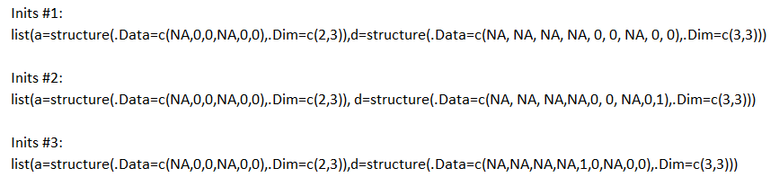
The model estimates based on $r_{iTk}$ which is the number of patients within each response category $k \left(k=2=PR, k=3=<PR\right).$ And of course, the $r_{iT1}$ which is the number of CR patients with treatment in study is calculated using ${1-r}_{iT2}-r_{iT3}$.
The likelihood which relates the data to the parameters of the models, was specified as multinomial distribution with two parameters representing the proportion of PR patients ($p_{iT2}$) or <PR patients ($p_{iT3}$) with treatment in study and the total number of patients with treatment in study : $r_{iTk}\sim multinomial(p_{iTk},n_{iT})$.
And so, the fixed effect ordered categorical model was specified as^{12, 33}:
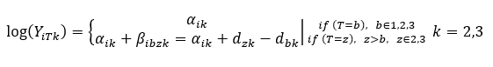
In this smaller network this means that for every iteration the model calculates the $α_{12}$, $α_{13}$ and $d_{22}$,$d_{23}$for POLLUX and $α_{22}$, $α_{23}$ and $d_{32}$,$d_{33}$ for ASPIRE after drawing new numbers for the different response categories PR and <PR from the multinomial distribution.
The following steps are done in the model for each study and every treatment arm.
Step 1: Calculate all the proportions per response category
Calculate the proportions per response category by dividing the number of patients in the response category by the number of intention-to-treat patients in the specific arm. For example, there were 396 LenDex ITT patients in the ASPIRE trial of which were 37 CR, 227 PR and 132 <PR patients. Therefore, the proportion of CR LenDex ASPIRE patients is $p_{iTk}$ = $p_{211}=\frac{37}{396}=9\%$, PR LenDex patients is $p_{212}=\frac{227}{396}=57\%$ and <PR LenDex patients is $p_{213}=\frac{132}{396}=33\%$.
 |  | i = 1 = POLLUX |  |  | i = 2 = ASPIRE
 |  | T =1=LenDex | T=2=DaralenDex |  | T=1=LenDex | T=3=CarLenDex
 | response | $$p_{11k}$$ | $$p_{12k}$$ |  | $$p_{21k}$$ | $$p_{22k}$$
k=1 | CR | 19% | 43% |  | 9% | 32%
k=2 | PR | 57% | 50% |  | 57% | 55%
k=3 | <PR | 24% | 7% |  | 33% | 13%

Step 2: Calculate (Y) the hazards of the <PR category
The hazards of the <PR category ($Y_{iT3}$) is calculated using both the proportion of PR and <PR patients calculated in step 1. The formula for $Y_{iT3}$ can be deduced from the formula:
$$p_{iT3}=\frac{Y_{iT3}}{1+\sum_{m=2}^{3}{Y_{iTm}}}$$
Which gives us
$$Y_{iT3}=\frac{p_{iT3}}{(1-p_{iT2}-p_{iT3})}$$

So, for the LenDex arm in POLLUX the $Y_{113}=\frac{p_{113}}{1-p_{112}-p_{113}}=\frac{24\%}{1-57\%-24\%}=1.24$ and for DaraLenDex $Y_{123}=\frac{p_{123}}{1-p_{122}-p_{123}}=\frac{7\%}{1-50\%-7\%}=0.16$.
 |  | i = 1 = POLLUX |  |  | i = 2 = ASPIRE
 |  | T =1=LenDex | T=2=DaralenDex |  | T =1=LenDex | T=3=CarLenDex
 | response | $$Y_{113}$$ | $$Y_{123}$$ |  | $$Y_{213}$$ | $$Y_{233}$$
k=3 | <PR | 1.24 | 0.16 |  | 3.57 | 0.40

Step 3: Calculate the hazards (Y) of the PR category
The hazards of the PR category ($Y_{iT2}$) is calculated using both the proportion of PR and the hazards of the <PR category. The formula for $Y_{iT2}$ can be deduced from the formula:
$$p_{iT2}=\frac{Y_{iT2}}{1+\sum_{m=2}^{3}{Y_{iTm}}}$$
Which gives us
$$Y_{iT2}=\frac{\left(1+Y_{iT3}\right)p_{iT2}}{1-p_{iT2}}$$
So, for the LenDex arm in POLLUX the $Y_{112}=\frac{(1+Y_{113})p_{112}}{1-p_{112}}=\frac{\left(1+1.24\right)*57\%}{1-57\%}=3.00.$
 |  | i = 1 = POLLUX |  |  | i = 2 = ASPIRE
 |  | T =1=LenDex | T=2=DaralenDex |  | T =1=LenDex | T=3=CarLenDex
 | response | $$Y_{112}$$ | $$Y_{122}$$ |  | $$Y_{212}$$ | $$Y_{232}$$
k=2 | PR | 3.00 | 1.16 |  | 6.14 | 1.74

Step 4: Calculate the log hazards ($α_{i2}$ and $α_{i3}$) for PR and <PR categories
Take the log of the hazards for PR and <PR categories. So, for LenDex in the POLLUX trial the $α_{12}=\ln\left(Y_{112}\right)=\ln\left(3\right)=$ 1.10
 |  | i =1=POLLUX |  | i=2=ASPIRE
 | response | $$α_{1k}$$ |  | $$α_{2k}$$
k=2 | PR | 1.10 |  | 1.81
k=3 | <PR | 0.22 |  | 1.27

Step 5: Calculate the relative difference in hazards for PR and <PR categories for the non-reference treatments (d’s)
So, using the following formula we can calculate the d’s:
Which gives us
$$d_{ik}=\log\left(Y_{iTk}\right)-α_{ik}$$
Then for DaraLenDex we get for PR $d_{12}=\log\left(Y_{122}\right)-α_{12}=\log\left(3.00\right)-1.10=-0.95$.
 |  | i =1=POLLUX |  | i=2=ASPIRE
 | response | $$d_{1k}$$ |  | $$d_{2k}$$
k=2 | PR | -0.95 |  | -1.26
k=3 | <PR | -2.03 |  | -2.18

Step 6: Calculate the proportion of patients for the reference treatment (LenDex) combining LenDex data from both trials
The model uses the average of the proportions of LenDex for PR and <PR. This means for PR $α_{avg,2}=average\left(α_{12},α_{22}\right)=\frac{(1.10+1.81)}{2}=1.46$ and <PR $α_{avg,3}=average\left(α_{13},α_{23}\right)=\frac{\left(0.21, 1.27\right)}{2}=0.74$.

Step 7: Calculate the proportion of CR patients
$$π_{T1}=\frac{1}{1+exp⁡(α_{avg,2}+d_{T2})+exp⁡(α_{avg,3}+d_{T3})}$$

Therefore, for LenDex the proportion of CR patients becomes
$$π_{11}=\frac{1}{1+\exp\left(1.46+0\right)+exp⁡(0.74+0)}=13\%$$

The CR proportions for DaraLendex and CarLendex are presented in the table below.
Response | LenDex | DaraLenDex | CarLenDex
CR | 13% | 34% | 41%

Step 7: Calculate the proportion of PR and <PR patients

$$π_{Tk}=π_{T1}*\exp\left(α_{avg,k}+d_{Tk}\right), k=2,3$$

Subsequently, for LenDex the proportion of PR patients is
$$π_{12}=π_{11}*\exp\left(α_{avg,2}+d_{12}\right)=13\%*\exp\left(1.46+0\right)=58\%$$
For all the other proportions please see table below.
Response | LenDex | DaraLenDex | CarLenDex
PR | 58% | 57% | 50%
<PR | 28% | 9% | 10%

