Appendix C

SUCRA results
This appendix presents all SUCRA related results of the multinomial network meta-analysis conducted on response in relapsed and/or refractory multiple myeloma. (see figures 7 to 12).
Abbreviations used in the following figures:
Bor=bortezomib,
Car=carfilzomib,
Dara=daratumumab.
Dex=dexamethasone,
Elo=elotuzumab,
Ixa=ixazomib,
Len=lenalidomide,
Obl=oblimersen,
Pano=panobinostat,
PLD=pegylated liposomal doxorubicin,
Pom=pomalidomide,
Thal=thalidomide

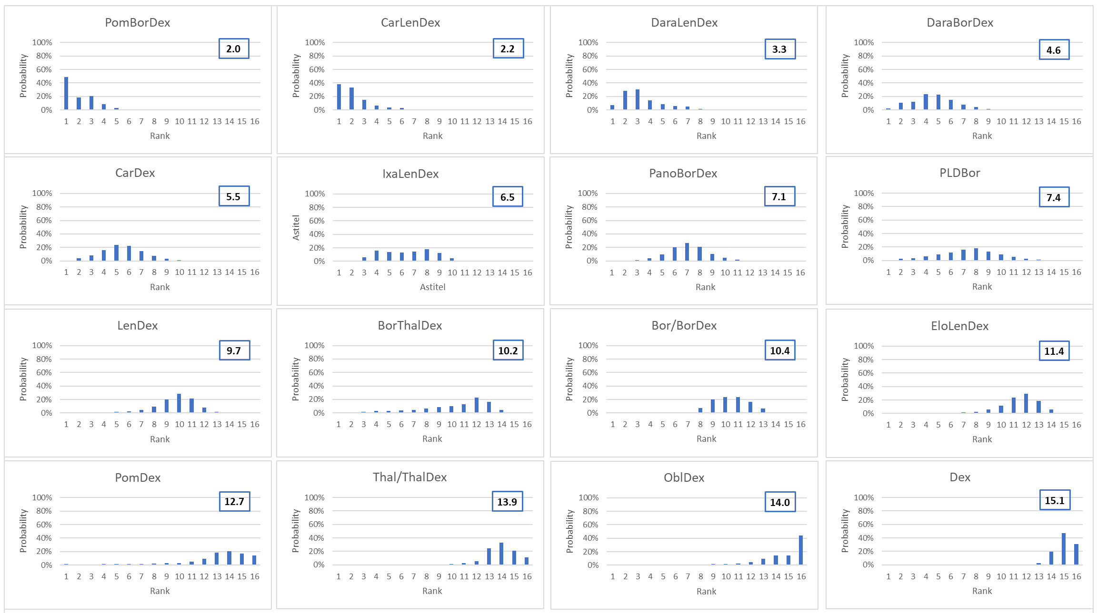Fig.7 Distribution of the probabilities of being at each rank for CRR
Figure 7 presents for every treatment the probabilities of being at each rank (from 1 as best to 16 as worst) are shown together with their mean ranks for CRR.

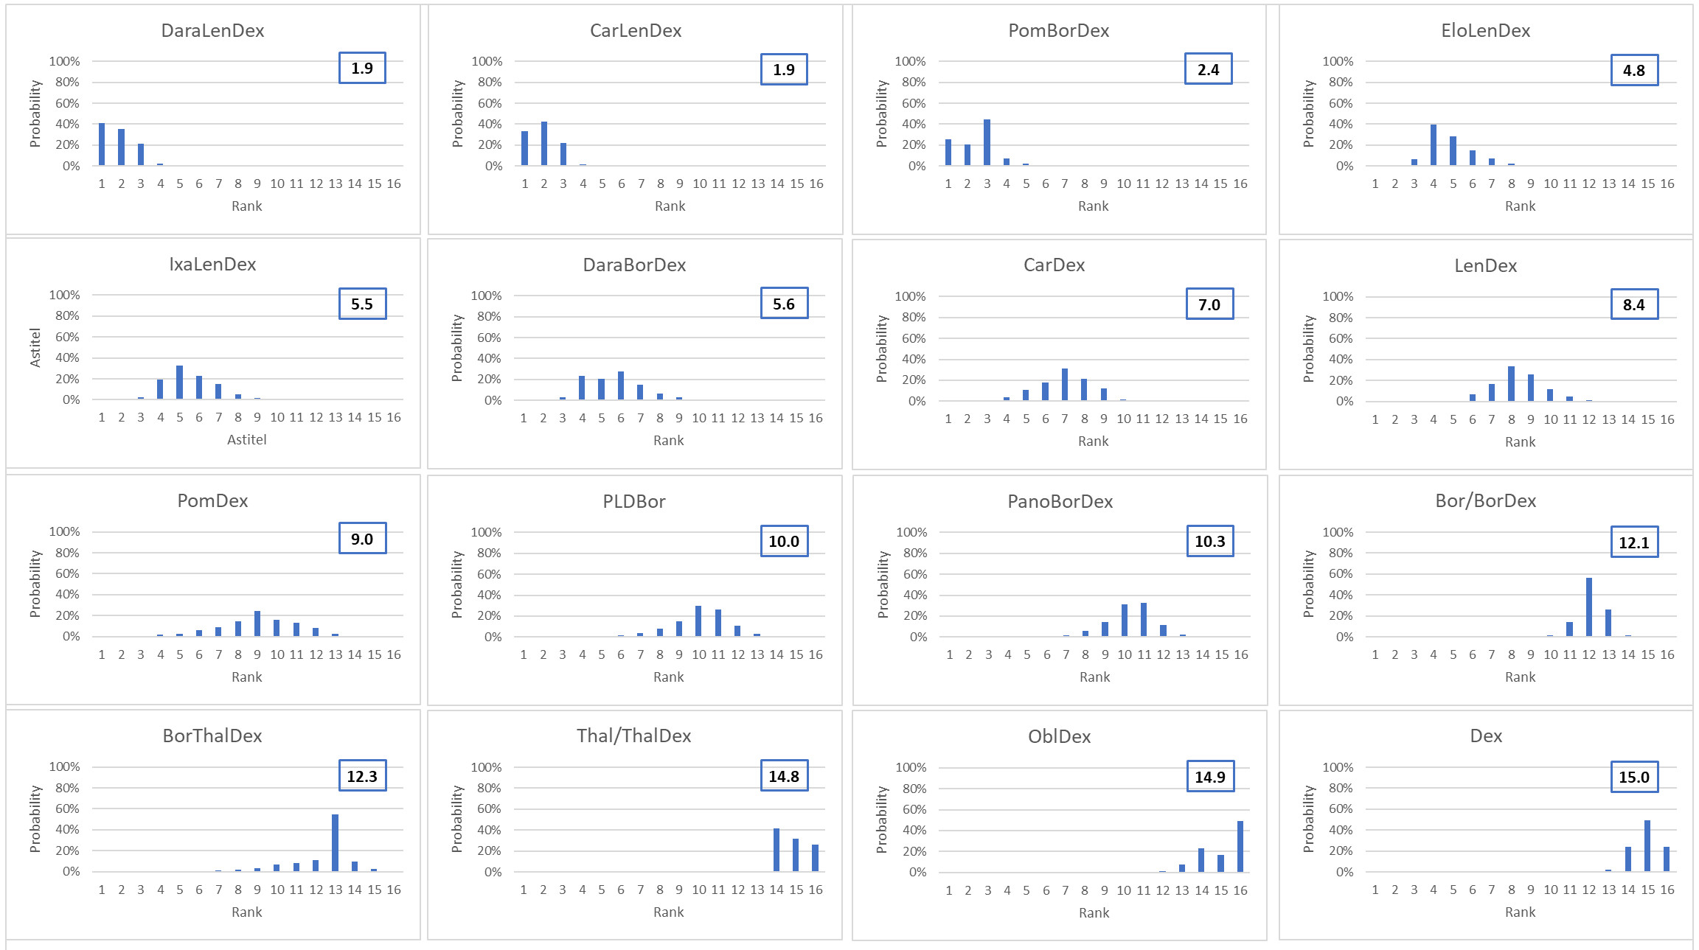Fig.8 Distribution of the probabilities of being at each rank for ORR
Figure 8 presents for every treatment the probabilities of being at each rank (from 1 as best to 16 as worst) are shown together with their mean ranks for ORR.

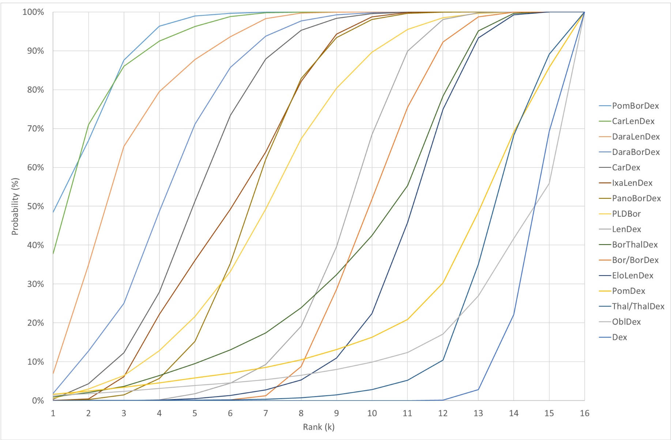
Fig.9 SUCRA for CRR
Figure 9 shows the cumulative probability of being among the k best treatments for CRR. The surface under the cumulative ranking (SUCRA) curve represents the SUCRA score. The treatments in the legends box are sorted on their SUCRA score.
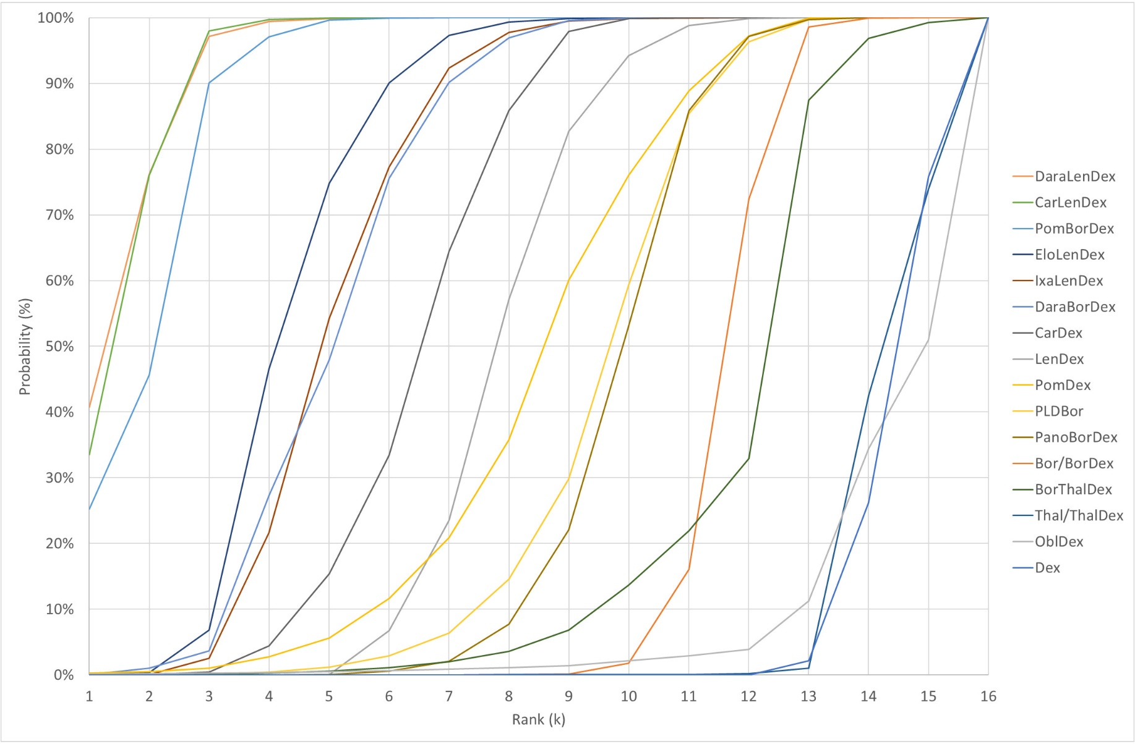
Fig.10 SUCRA for ORR
Figure 10 shows the cumulative probability of being among the k best treatments for ORR. The surface under the cumulative ranking (SUCRA) curve represents the SUCRA score. The treatments in the legends box are sorted on their SUCRA score.
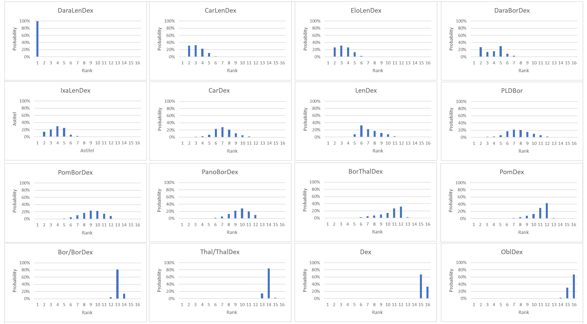
Fig.11 Distribution of the probabilities of being at each rank for PFS HR
Figure 11 presents for every treatment the probabilities of being at each rank (from 1 as best to 16 as worst) are shown together with their mean ranks for progression-free survival.

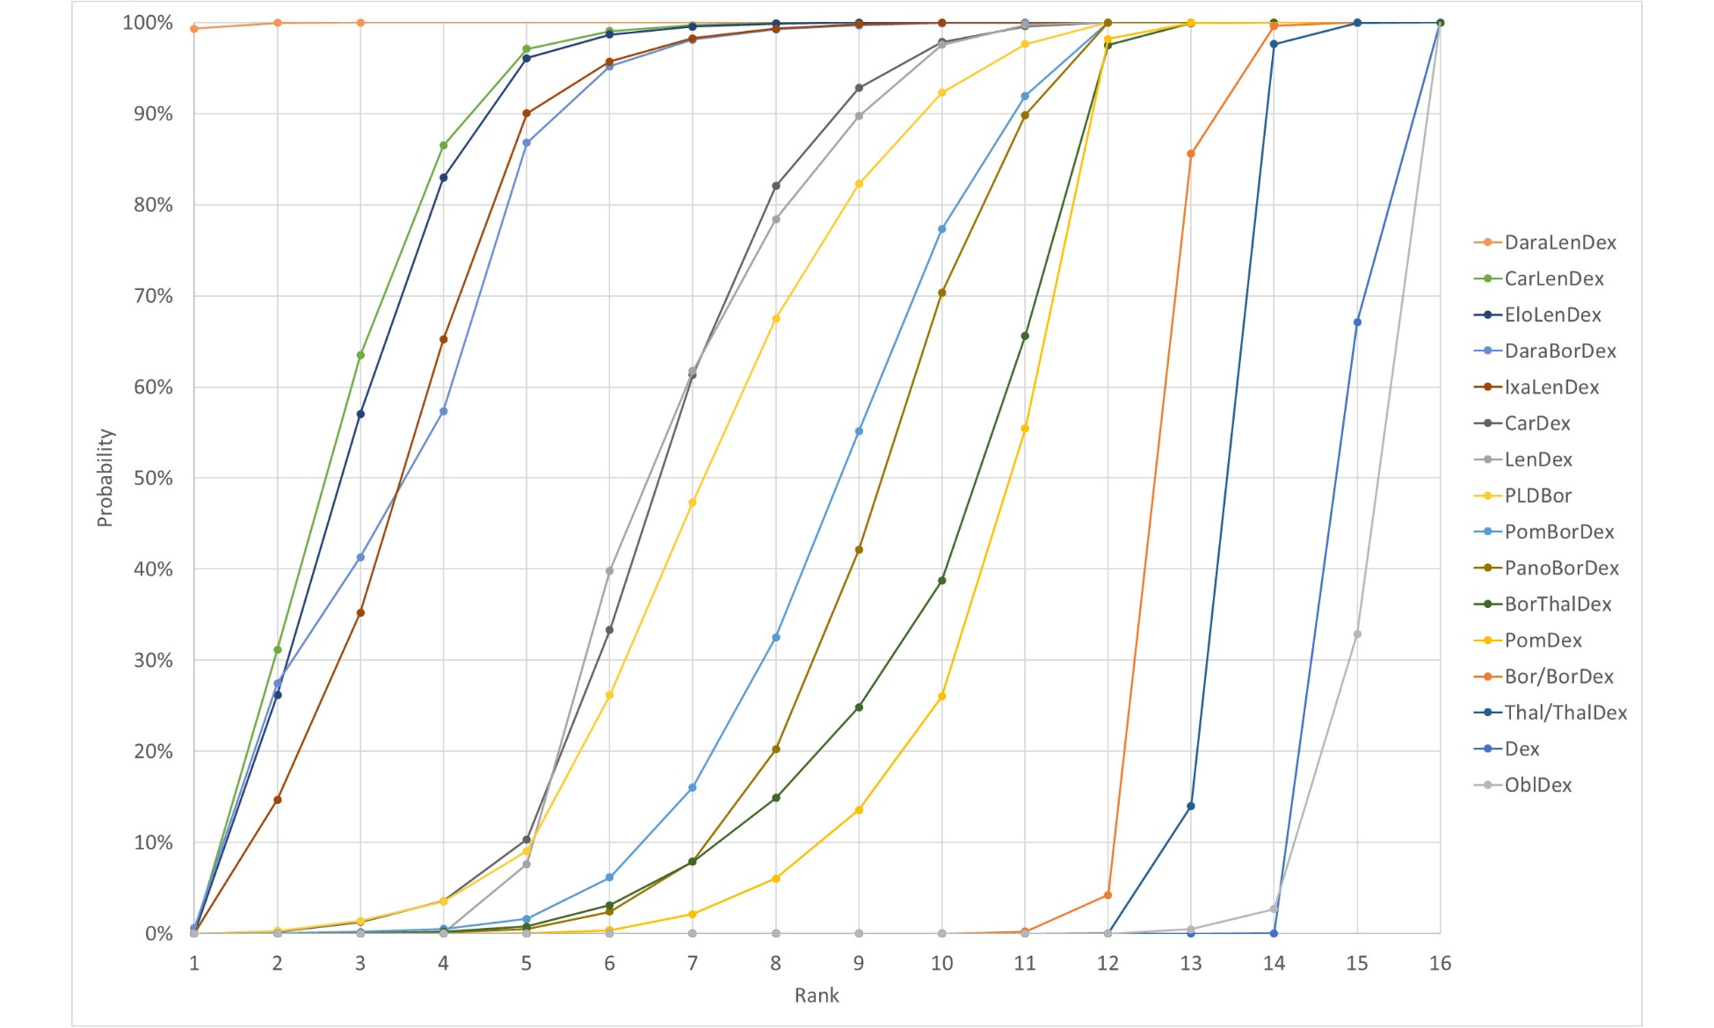
Fig.12 SUCRA for PFS HR
Figure 12 shows the cumulative probability of being among the k best treatments for progression-free survival. The surface under the cumulative ranking (SUCRA) curve represents the SUCRA score. The treatments in the legends box are sorted on their SUCRA score.

