Appendix D

Results scenario analyses
This appendix presents the scenario analyses on the multinomial NMA in RR MM treatments. Figure 13 presents the forest plots of the three scenario analyses with CRR outcome. Figure 14 shows the three scenario analyses results with ORR outcome.
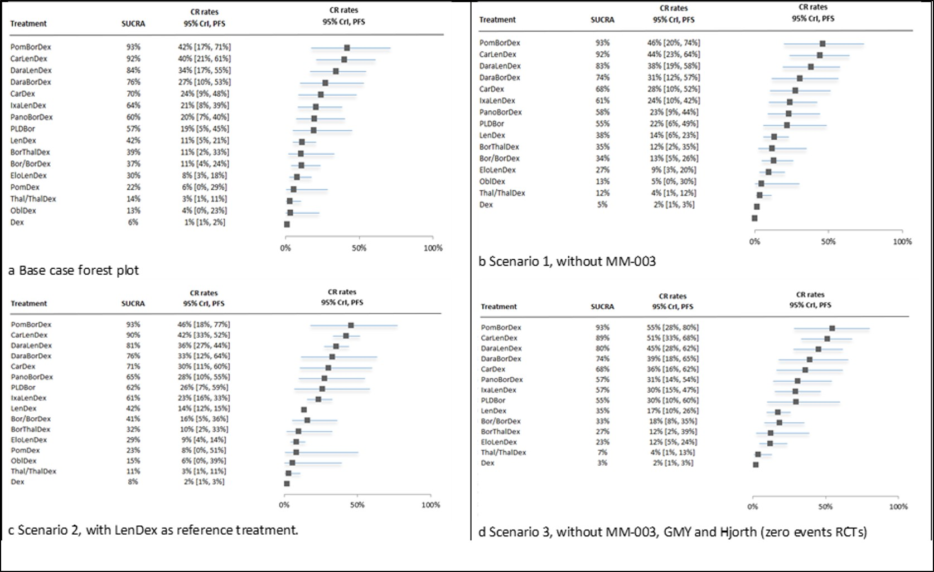Fig.13 Forest plots for base case and scenario analysis with CRR outcome. a Base case CR rates (16 treatments, 17 trials), b scenario 1, without MM-003 (15 treatments, 16 trials), c scenario 2, with LenDex as reference treatment instead of Dex (16 treatments, 17 trials), d scenario 4, without MM-003 trials, GMY and Hjorth 2012 because of zero events (14 treatments, 14 trials).
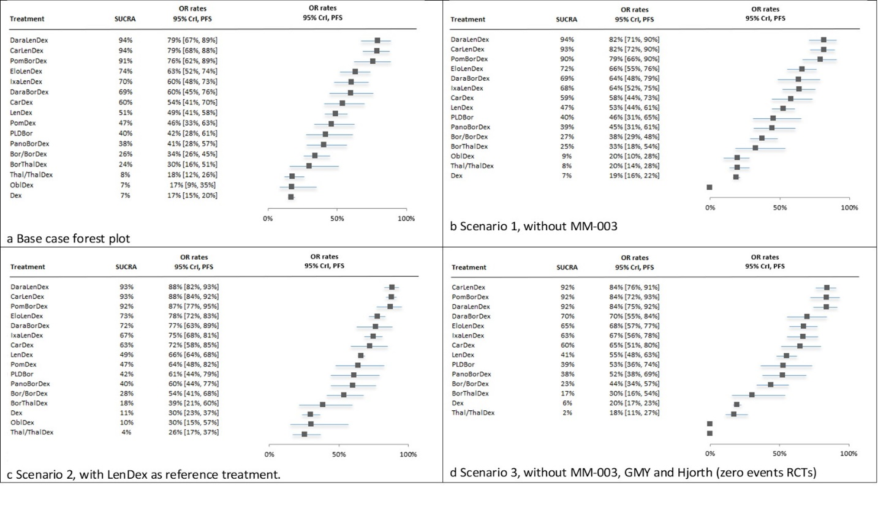Fig.14 Forest plots for base case and scenario analysis with ORR outcome. a Base case OR rates (16 treatments, 17 trials), b scenario 1, without MM-003 (15 treatments, 16 trials), c scenario 2, with LenDex as reference treatment instead of Dex (16 treatments, 17 trials), d scenario 4, without MM-003 trials, GMY and Hjorth 2012 because of zero events (14 treatments, 14 trials).

