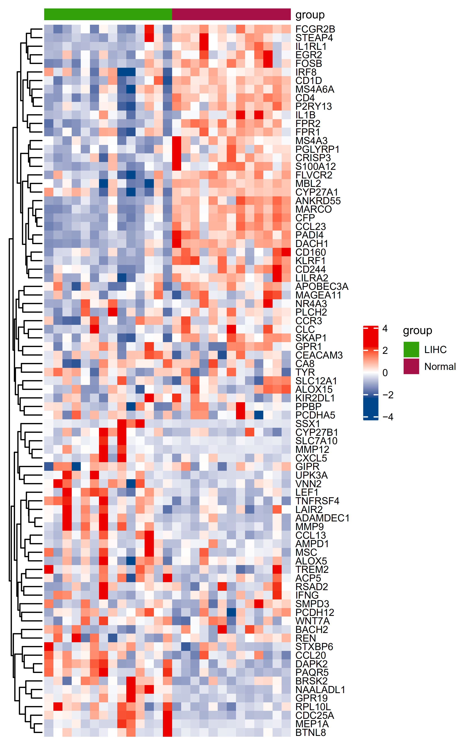
Figure S2. Heat map of 89 DEGs related to immune infiltration in the data set GSE89377.

