Table S1 Literature search criteria for PubMed
(((((((((((((((((Carcinoma, Non-Small-Cell Lung[MeSH Terms]) OR (non-small-cell lung cancer[Title/Abstract])) OR (non-small cell lung cancer[Title/Abstract])) OR (non small-cell lung cancer[Title/Abstract])) OR (non small cell lung cancer[Title/Abstract])) OR (non-small-cell lung carcinoma[Title/Abstract])) OR (non-small cell lung carcinoma[Title/Abstract])) OR (non small-cell lung carcinoma[Title/Abstract])) OR (non small cell lung carcinoma[Title/Abstract])) OR (nsclc[Title/Abstract])) OR (lung non-squamous[Title/Abstract])) OR (lung nonsquamous[Title/Abstract])) OR (lung adenocarcinoma[Title/Abstract])) AND ((epidermal growth factor receptor[Title/Abstract]) OR (EGFR[Title/Abstract]))) AND (((((((((((treatment[Title/Abstract]) OR (therapy[Title/Abstract])) OR (tyrosine kinase inhibitor[Title/Abstract])) OR (TKI[Title/Abstract])) OR (osimertinib[Title/Abstract])) OR (dacomitinib[Title/Abstract])) OR (afatinib[Title/Abstract])) OR (erlotinib[Title/Abstract])) OR (gefitinib[Title/Abstract])) OR (icotinib[Title/Abstract])) OR (chemotherapy[Title/Abstract]) OR ((((first-line[Title/Abstract]) OR (first line[Title/Abstract])) OR (treatment-naive[Title/Abstract])) OR (treatment-naïve[Title/Abstract])) OR (untreated[Title/Abstract]))) AND ((((((((OS[Title/Abstract]) OR (overall survival[Title/Abstract])) OR (overall-survival[Title/Abstract]) ) OR (MST[Title/Abstract])) OR (progression-free survival[Title/Abstract])) OR (progression free survival[Title/Abstract])) OR (PFS[Title/Abstract])) OR (iPFS[Title/Abstract]))) AND (((((((Randomized Controlled Trial[Publication Type]) OR (controlled clinical trial[Publication Type])) OR (randomized[Title/Abstract])) OR (randomised[Title/Abstract])) OR (randomly[Title/Abstract])) OR (trial*[Title/Abstract])) OR (phase[Title/Abstract]))) AND (("0001/01/01"[Date - Publication] : "2020/09/30"[Date - Publication]))

Table S2 Literature search criteria for Embase
('lung tumor'/exp OR 'non-small-cell lung cancer':ti OR 'non-small cell lung cancer':ti OR 'non small-cell lung cancer':ti OR 'non small cell lung cancer':ti OR 'non-small-cell lung carcinoma':ti OR 'non-small cell lung carcinoma':ti OR 'non small-cell lung carcinoma':ti OR 'non small cell lung carcinoma':ti OR 'nsclc':ti OR 'lung non-squamous':ti OR 'lung nonsquamous':ti OR 'lung adenocarcinoma':ti) AND ('epidermal growth factor receptor':ab,ti OR 'EGFR':ab,ti ) AND ('treatment':ab,ti OR 'therapy':ab,ti OR 'tyrosine kinase inhibitor':ab,ti OR 'TKI':ab,ti OR 'osimertinib':ab,ti OR 'dacomitinib':ab,ti OR 'afatinib':ab,ti OR 'erlotinib':ab,ti OR 'gefitinib':ab,ti OR 'icotinib':ab,ti OR 'chemotherapy':ab,ti OR 'first-line':ab,ti OR 'first line':ab,ti OR 'treatment-naive':ab,ti OR 'treatment-naïve':ab,ti OR 'untreated':ab,ti ) AND ('OS':ab,ti OR 'overall survival':ab,ti OR 'overall-survival':ab,ti OR 'MST':ab,ti OR 'progression-free survival':ab,ti OR 'progression free survival':ab,ti OR 'PFS':ab,ti) AND ('Randomized Controlled Trial':it OR 'controlled clinical trial':it OR 'randomized':ab,ti OR 'randomised':ab,ti OR 'randomly':ab,ti OR 'trial':ab,ti OR 'phase':ab,ti) AND [1966-2020]/py

Table S3 Literature search criteria for Cochrane
((non-small-cell lung cancer):ti OR (non-small cell lung cancer):ti OR (non small-cell lung cancer):ti OR (non small cell lung cancer):ti OR (non-small-cell lung carcinoma):ti OR (non-small cell lung carcinoma):ti OR (non small-cell lung carcinoma):ti OR (non small cell lung carcinoma):ti OR (nsclc):ti OR (lung non-squamous):ti OR (lung nonsquamous):ti OR (lung adenocarcinoma):ti) AND ((epidermal growth factor receptor):ti,ab,kw OR (EGFR):ti,ab,kw ) AND ((treatment):ti,ab,kw OR (therapy):ti,ab,kw OR (tyrosine kinase inhibitor):ti,ab,kw OR (TKI):ti,ab,kw OR (osimertinib):ti,ab,kw OR (dacomitinib):ti,ab,kw OR (afatinib):ti,ab,kw OR (erlotinib):ti,ab,kw OR (gefitinib):ti,ab,kw OR (icotinib):ti,ab,kw OR (chemotherapy):ti,ab,kw OR (first-line):ti,ab,kw OR (first line):ti,ab,kw OR (treatment-naive):ti,ab,kw OR (treatment-naïve):ti,ab,kw OR (untreated):ti,ab,kw ) AND ((OS):ti,ab,kw OR (overall survival):ti,ab,kw OR (overall-survival):ti,ab,kw OR (MST):ti,ab,kw OR (progression-free survival):ti,ab,kw OR (progression free survival):ti,ab,kw OR (PFS):ti,ab,kw) AND ((Randomized Controlled Trial):pt OR (controlled clinical trial):pt OR (randomized):ti,ab,kw OR (randomised):ti,ab,kw OR (randomly):ti,ab,kw OR (trial):ti,ab,kw OR (phase):ti,ab,kw)

Table S4 Comparisions of the fit of consistency and inconsistency models using deviance information criteria (DIC)
Model | PFS |  |  |  | OS
Model | All | < 65 years old | >= 65 years old |  | All | < 65 years old | >= 65 years old
Consistency | 43.171 | 23.992 | 23.851 |  | 23.946 | 12.597 | 23.851
Inconsistency | 41.634 | 23.802 | 24.082 |  | 24.325 | 14.038 | 24.082
PFS: progression free survival, OS: overall survival.

The DIC is a Bayesian model evaluation criteria that measures model fit adjusted with complexity of the model¹.
Smaller DIC value correspond to more preferable models. Difference between DIC from different models below 5 could be accepted.

References:

- Spiegelhalter DJ, Best NG, Linde C. Bayesian measures of model complexity and fit. Journal of the Royal Statistical Society: Series B (Statistical Methodology) 2002;64:583-639.

Table S5 Node-splitting analysis of inconsistency.
All P value was below 0.05, indicating no significant inconsistencies between the direct effect and indirect effects.
Nodes | Direct effect | Indirect effect | Overall | P
PFS: Overall
Chemotherapy, Afatinib | 2.30(1.70-3.20) | 5.00(2.90-8.40) | 2.90(2.10-4.10) | 0.025
SoC, Afatinib | 1.30(0.90-2.00) | 0.61(0.39-1.00) | 0.97(0.66-1.40) | 0.022
SoC, Chemotherapy | 0.27(0.18-0.38) | 0.57(0.34-0.92) | 0.34(0.23-0.47) | 0.020
PFS: <65 years old
Chemotherapy, Afatinib | 2.30(0.95-5.70) | 5.20(1.10-27.00) | 2.80(1.30-6.20) | 0.245
SoC, Afatinib | 1.50(0.40-5.20) | 0.65(0.17-2.50) | 1.00(0.39-2.60) | 0.235
SoC, Chemotherapy | 0.29(0.11-0.81) | 0.64(0.12-0.36) | 0.36(0.15-0.84) | 0.264
PFS: >= 65 years old
Chemotherapy, Afatinib | 2.70(0.78-11.00) | 5.20(0.56-49.00) | 3.20(1.30-10.00) | 0.482
SoC, Afatinib | 1.20(0.18-7.30) | 0.60(0.10-4.00) | 0.91(0.27-3.00) | 0.495
SoC, Chemotherapy | 0.23(0.06-0.79) | 0.45(0.04-3.50) | 0.28(0.09-0.76) | 0.488
OS: Overall
Chemotherapy, Afatinib | 1.30(0.97-1.70) | 0.92(0.50-1.70) | 1.20(0.94-1.60) | 0.288
SoC, Afatinib | 1.10(0.76-1.70) | 1.60(0.89-2.80) | 1.30(0.94-1.70) | 0.329
SoC, Chemotherapy | 1.20(0.79-2.00) | 0.90(0.55-1.40) | 1.00(0.76-1.50) | 0.356
OS: <65 years old
Chemotherapy, Afatinib | 1.20(0.69-2.00) | 1.30(0.42-4.40) | 1.20(0.82-1.80) | 0.758
SoC, Afatinib | 1.50(0.69-3.40) | 1.30(0.49-3.70) | 1.40(0.88-2.30) | 0.795
SoC, Chemotherapy | 1.10(0.51-2.40) | 1.30(0.51-3.20) | 1.20(0.72-2.00) | 0.779
OS: >= 65 years old
Chemotherapy, Afatinib | 2.70(0.78-11.00) | 5.20(0.56-49.00) | 3.20(1.30-10.00) | 0.482
SoC, Afatinib | 1.20(0.18-7.30) | 0.60(0.10-4.10) | 0.91(0.27-3.00) | 0.495
SoC, Chemotherapy | 0.23(0.06-0.79) | 0.45(0.04-3.50) | 0.28(0.09-0.76) | 0.488
PFS: progression free survival, OS: overall survival.

Figure S1 Density plot for progression-free survival (PFS) and overall survival (OS) in all included patients, in elderly patients and in non-elderly patients.
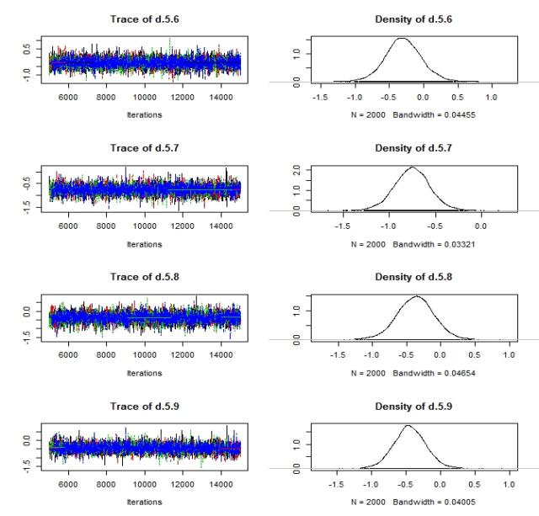
- Density plot for PFS in all patients
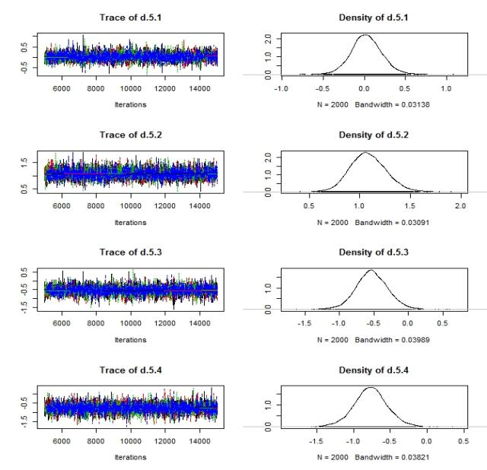

B)Density plot for PFS in patients below 65 years old
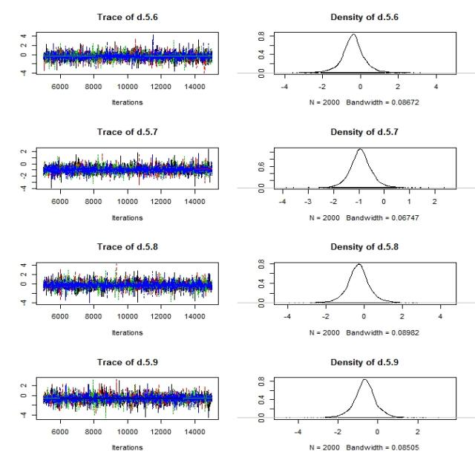
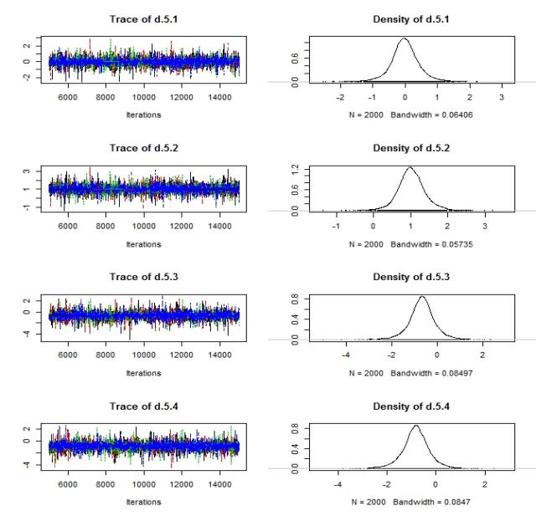
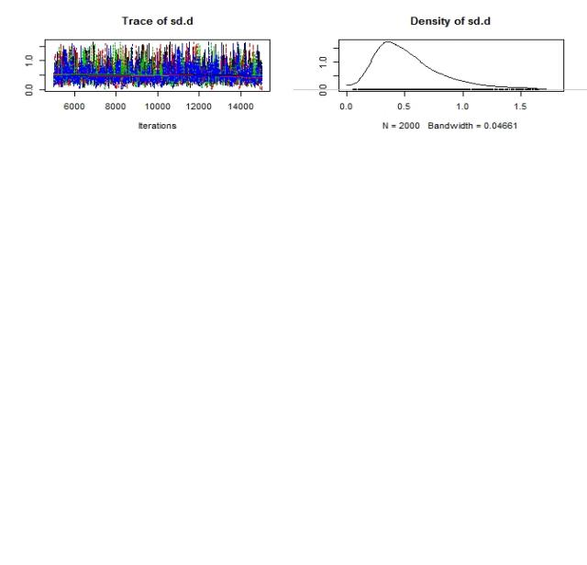

C) Density plot for PFS in patients over 65 years old
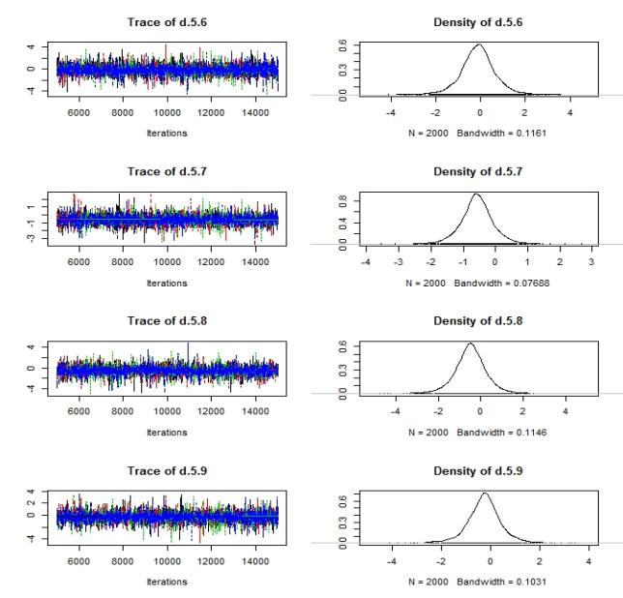
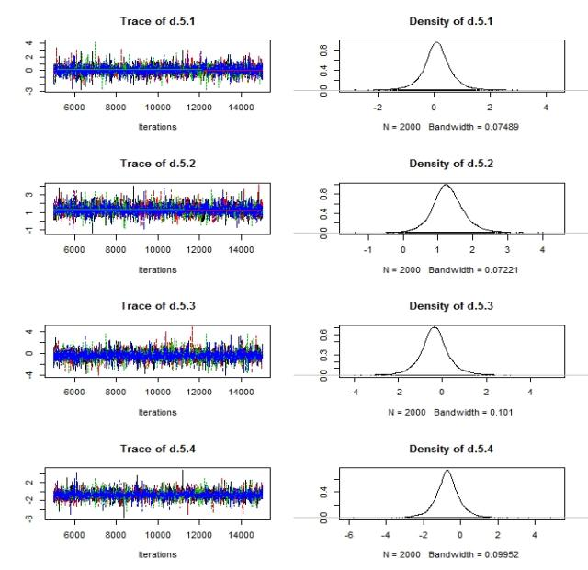
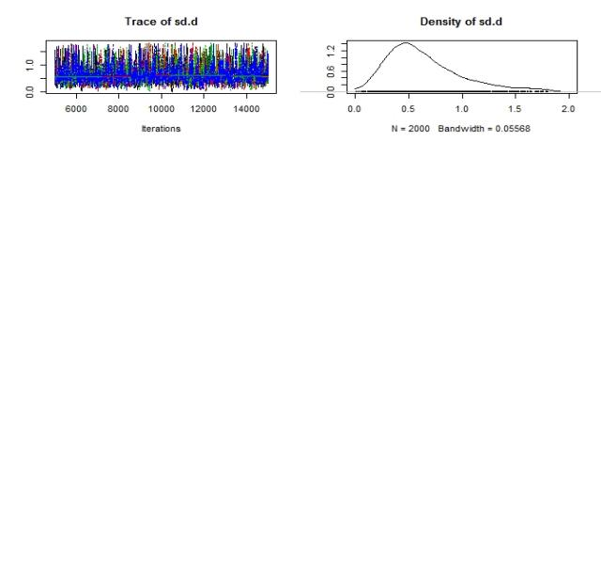

D) Density plot for OS in all patients
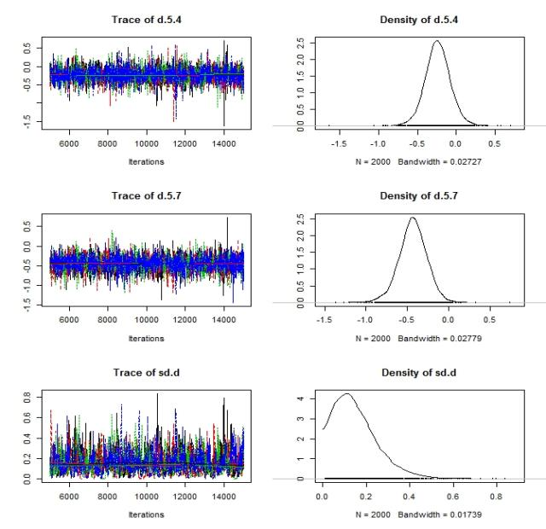
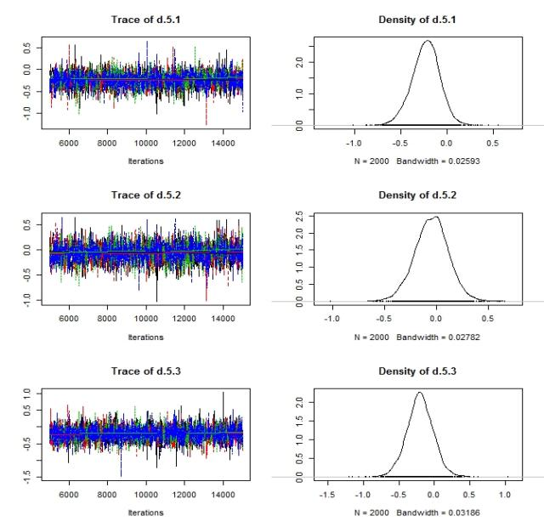

E) Density plot for OS in patients below 65 years old
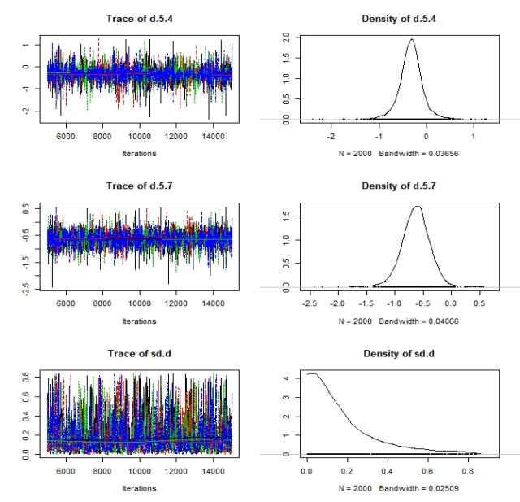
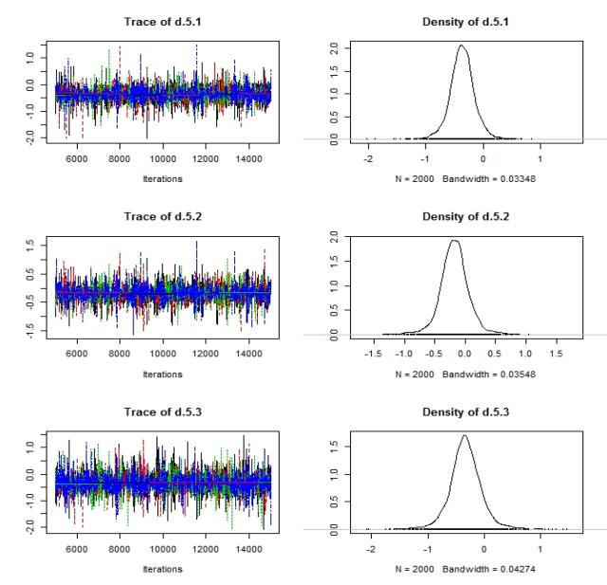

F) Density plot for OS in patients over 65 years old
