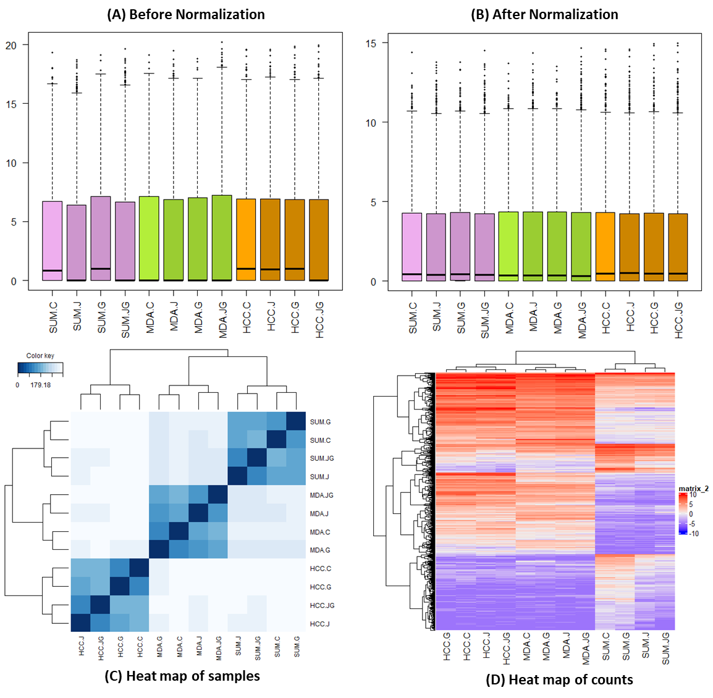
Figure S1. Box plot (A) before and (B) after normalization explaining the distribution of gene counts; (C) Heat map of samples (D) Heat map of gene counts among the samples.
Cell lines: MDA: MDA-MB-231; HCC: HCC-1806; SUM: SUM-159
Treatments: J: JQ1; G: GSK2801; JG: JQ1 & GSK2801

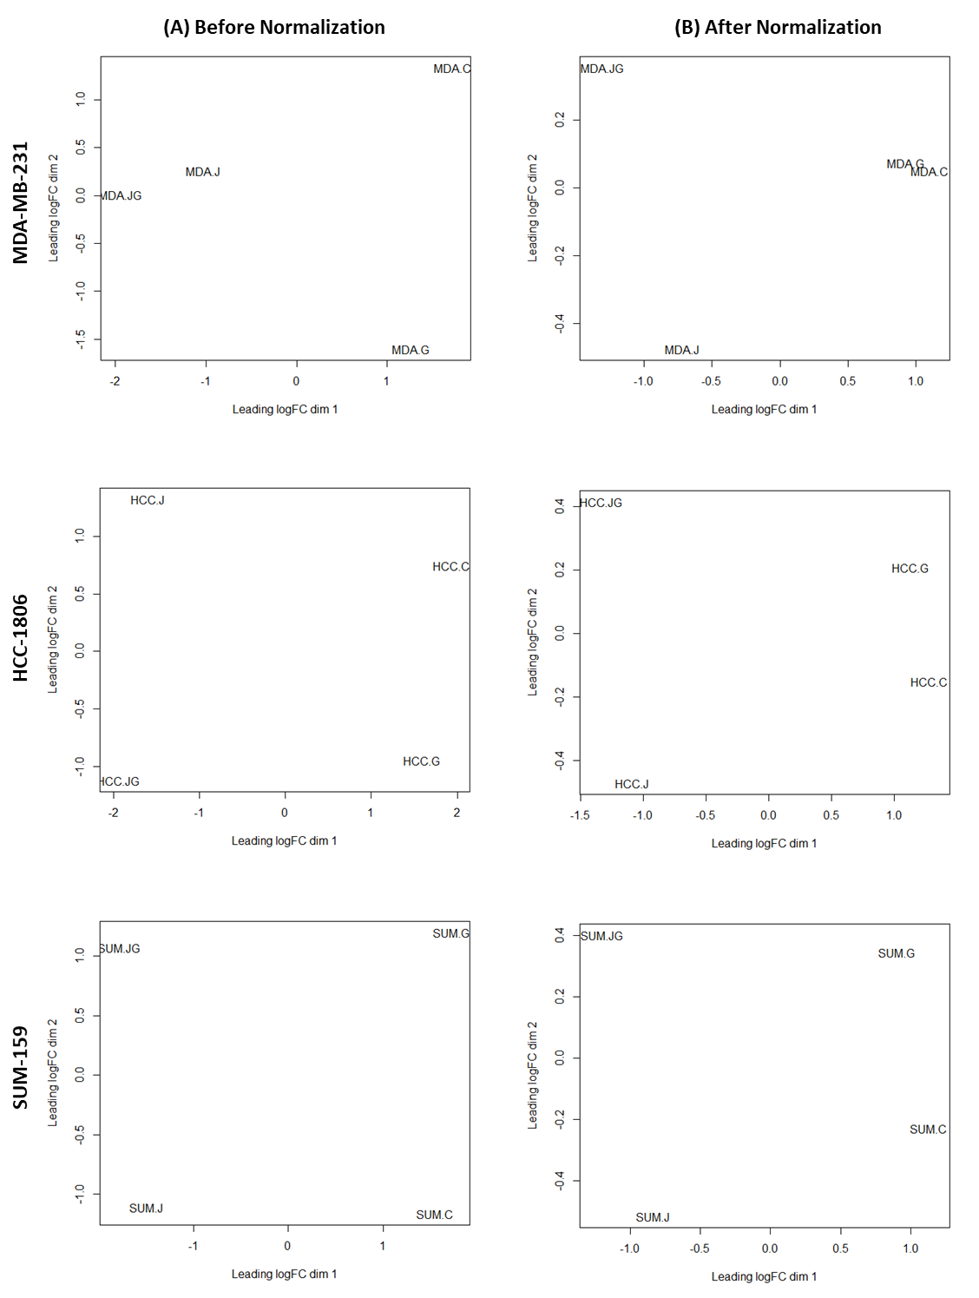
Figure S2. Multidimensional scaling plots before (left) and after (right) normalization explaining the distribution of control and treated samples among three different breast cancer cell lines.
Cell lines: MDA: MDA-MB-231; HCC: HCC-1806; SUM: SUM-159
Treatments: J: JQ1; G: GSK2801; JG: JQ1 & GSK2801

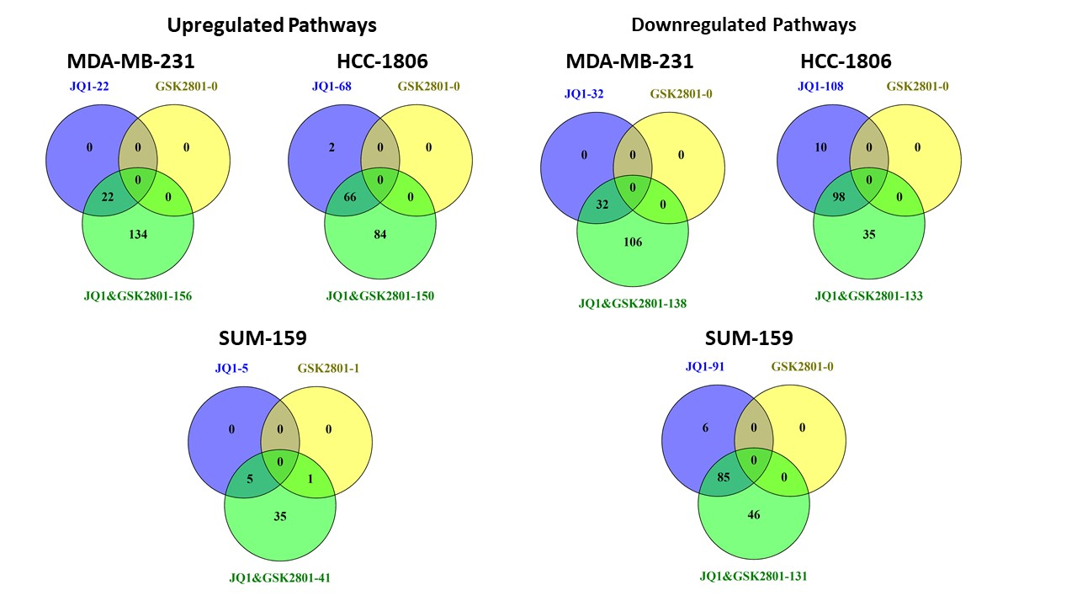
Figure S3. Number of up and downregulated metabolic pathways. The number of upregulated and downregulated pathways in the three different treatment conditions (JQ1, GSK2801 and JQ1&GSK2801) across three different TNBC cell lines. The unique and shared number of pathways among different treatment conditions are represented.

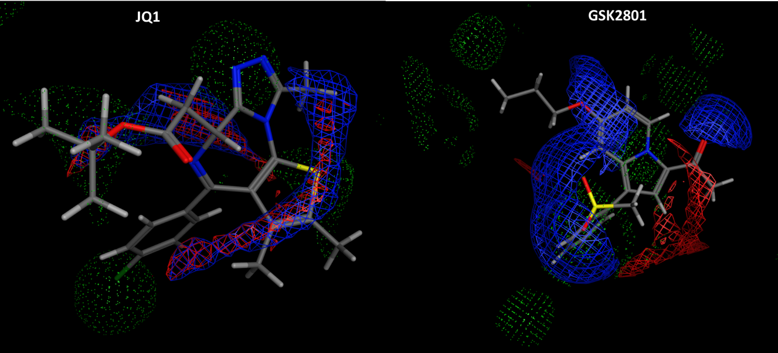
Figure S4. Optimized conformation of JQ1 and GSK2801. The structures are represented in stick model with the hydrogen bond donor (blue) and acceptor (red) surface areas. The electron density clouds are represented in green dots.
Table S1. RNASeq data sets. RNASeq expression data retrieved from GEO database. Three different TNBC cell lines were treated with JQ1 and GSK2801 alone and in combination for 72 hours. DMSO was used as a vehicle and served as an internal control.
GEO ID | SRA ID | Cell lines | Treatment
GSM3263568 | SRR7508559 | SUM159 | DMSO
GSM3263569 | SRX4378999 | SUM159 | JQ1-300nM
GSM3263570 | SRX4379000 | SUM159 | GSK2801-10uM
GSM3263571 | SRX4379001 | SUM159 | JQ1-300nM & GSK2801-10uM
GSM3263572 | SRX4379002 | MDAMB231 | DMSO
GSM3263573 | SRX4379003 | MDAMB231 | JQ1-100nM
GSM3263574 | SRX4379004 | MDAMB231 | GSK2801-10uM
GSM3263575 | SRX4379005 | MDAMB231 | JQ1-100nM & GSK2801-10uM
GSM3263576 | SRX4379006 | HCC1806 | DMSO
GSM3263577 | SRX4379007 | HCC1806 | JQ1-500nM
GSM3263578 | SRX4379008 | HCC1806 | GSK2801-10uM
GSM3263579 | SRX4379009 | HCC1806 | JQ1-500nM & GSK2801-10uM

Table S2. The genes and primers. Primers used for the evaluation of gene expression in the breast cancer cell lines under different treatment conditions.
Gene | Primers 5’3’ | Product size
PTPRC | F: TTCATGCAGCTAGCAAGTGG  R: AGTCAGCCGTGTCCCTAAGA | 116
MUC19 | F: CACCTTCAGAGACTGCCACA  R: TCACATGCACAGGCTTCTTC | 78
KCNB1 | F: AGGCGAGGAGTTCGATAACA  R: ATGGTGGAGAGGACGATGAA | 135
TAGLN | F: GGCCAAGGCTCTACTGTCTG  R: CCTCCAGCTCCTCGTCATAC | 142
KISS1 | F: CCCACCCTCTGGACATTCAC  R: CCTAGAAGTGCCTTGAGGCTTG | 105
18S rRNA | F: GTAACCCGTTGAACCCCATT  R: CCATCCAATCGGTAGTAGCG | 151

Table S3. Smear plots and volcano plots representing the DEGs in MDA-MB-231 cell lines among different treatment conditions. Green dots-downregulated, red dots-upregulated genes.
JQ1
GSK2801
JQ1& GSK2801

Table S4. Smear plots and volcano plots representing the DEGs in HCC-1806 cell lines among different treatment conditions. Green dots-downregulated, red dots-upregulated genes.
JQ1
GSK2801
JQ1& GSK2801

Table S5. Smear plots and volcano plots representing the DEGs in SUM-159 cell lines among different treatment conditions. Green dots-downregulated, red dots-upregulated genes.
JQ1
GSK2801
JQ1& GSK2801

Table S6. Ramachandran plots explaining the valid stereochemical quality of five down regulated proteins.
Protein name | Ramachandran plot
PTPRC | 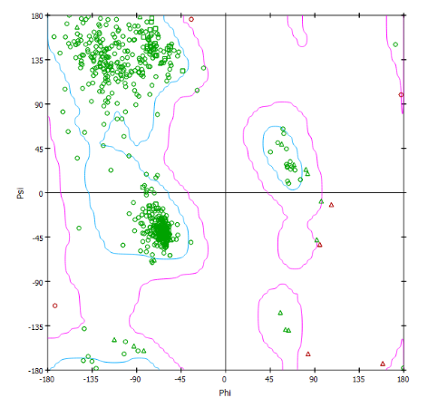
MUC19 | 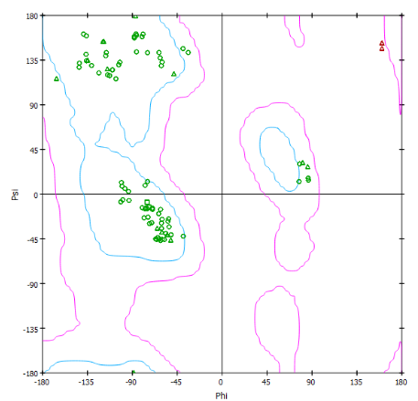
KCNB1 | 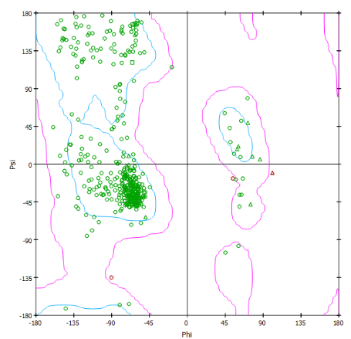
TAGLN | 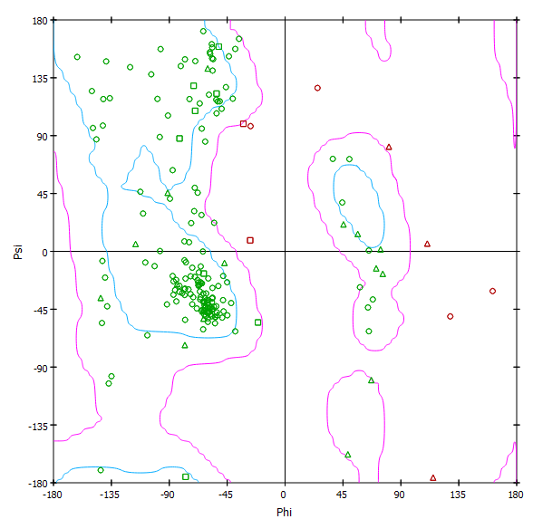
KISS1 | 