Supplementary Material

Enhancement of the International Prognostic Index with β2-microglobulin, platelet count and red blood cell distribution width: a new prognostic model for diffuse large B-cell lymphoma in the rituximab era

Table of Content
Table S1. Univariate analyses for progression-free survival and overall survival in the training cohort 2
Table S2. Multivariate analyses for progression-free survival and overall survival in the training cohort 3
Table S3. The Harrell’s C-index for 5-year overall survival prediction 4
Table S4 The association of serum creatinine level and serum β2M level in all patients 5
Fig. S1 Kaplan–Meier curves of survival outcomes in the training cohort. 6
Fig. S2 Calibration curves. 7
Fig. S3 Progression-free survival (PFS) for risk groups defined by four prognostic models in the training cohort. 8
Fig. S4 Progression-free survival (PFS) for risk groups defined by four prognostic models in the validation cohort. 9

Table S1. Univariate analyses for progression-free survival and overall survival in the training cohort
Prognostic factors | Progression-free survival |  | Overall survival
Prognostic factors | HR (95%CI) | P value | HR (95%CI) | P value
Age >60 years | 1.442 (1.131-1.838) | 0.003 | 1.738 (1.322-2.285) | <0.001
Male gender | 1.012 (0.897-1.141) | 0.847 | 1.017 (0.887-1.167) | 0.807
ECOG PS ≥2 | 3.059 (2.266-4.129) | <0.001 | 3.991 (2.906-5.482) | <0.001
Ann Arbor stage III-IV | 4.467 (3.466-5.755) | <0.001 | 4.187 (3.136-5.588) | <0.001
Extranodal site ≥2 | 3.209 (2.513-4.098) | <0.001 | 3.287 (2.494-4.332) | <0.001
Bone marrow involvement | 2.342 (1.572-3.487) | <0.001 | 2.286 (1.481-3.527) | <0.001
LDH level > normal | 2.242 (1.751-2.865) | <0.001 | 2.732 (2.049-3.650) | <0.001
β2M level > normal | 2.698 (2.121-3.431) | <0.001 | 2.815 (2.141-3.701) | <0.001
Serum creatinine level > normal | 3.072 (1.824-5.175) | <0.001 | 3.039 (1.695-5.449) | <0.001
Hemoglobin <120g/L | 1.883 (1.451-2.445) | <0.001 | 1.961 (1.460-2.632) | <0.001
Albumin <35g/L | 2.488 (1.742-3.546) | <0.001 | 2.284 (1.514-3.445) | <0.001
ALC <1.75×10⁹/L | 1.431 (1.112-1.838) | 0.005 | 1.917 (1.417-2.592) | <0.001
AMC ≥0.65×10⁹/L | 1.946 (1.509-2.510) | <0.001 | 1.951 (1.462-2.602) | <0.001
ANC ≥6.41×10⁹/L | 1.891 (1.405-2.544) | <0.001 | 1.887 (1.348-2.642) | <0.001
PLT <157×10⁹/L | 2.093 (1.558-2.811) | <0.001 | 2.305 (1.668-3.184) | <0.001
LMR <2.55 | 2.467 (1.940-3.138) | <0.001 | 2.737 (2.083-3.596) | <0.001
NLR ≥3.68 | 2.009 (1.564-2.581) | <0.001 | 2.113 (1.593-2.802) | <0.001
PLR ≥184 | 1.616 (1.268-2.060) | <0.001 | 1.872 (1.423-2.463) | <0.001
RDW ≥14.5% | 2.466 (1.849-3.288) | <0.001 | 3.015 (2.209-4.114) | <0.001
PDW ≥12.8 fl | 1.255 (0.969-1.626) | 0.085 | 1.349 (1.010-1.803) | 0.043
MPV <9.1 fl | 1.154 (0.833-1.600) | 0.388 | 1.332 (0.930-1.908) | 0.134
IPI risk group
Low (0-1) | Reference |  | Reference
Low-intermediate (2) | 2.548 (1.841-3.597) | <0.001 | 3.342 (2.265-4.931) | <0.001
High-intermediate (3) | 4.519 (3.311-6.168) | <0.001 | 5.194 (3.584-7.526) | <0.001
High (4-5) | 7.483 (5.251-10.664) | <0.001 | 9.891 (6.628-14.762) | <0.001
Abbreviation: ECOG, Eastern Cooperative Oncology Group; PS, performance status; LDH, lactate dehydrogenase; β2M, β2-microglobulin; ALC, absolute lymphocyte count; AMC, absolute monocyte count; ANC, absolute neutrophil count; PLT, platelet; LMR, the lymphocyte to monocyte ratio; NLR, the neutrophil to lymphocyte ratio; PLR, the platelet to lymphocyte ratio; RDW, red blood cell distribution width; PDW, platelet distribution width; MPV, mean platelet volume; IPI, International Prognostic Index; HR, hazard ratio; CI, confidence interval

Table S2. Multivariate analyses for progression-free survival and overall survival in the training cohort
Prognostic factors | Progression-free survival |  | Overall survival
Prognostic factors | HR (95%CI) | P value | HR (95%CI) | P value
Bone marrow involvement | 1.445 (0.951-2.193) | 0.085 | 1.119 (0.703-1.780) | 0.636
β2M level > normal | 1.543 (1.181-2.016) | 0.001 | 1.411 (1.040-1.913) | 0.027
Serum creatinine level > normal | 1.497 (0.839-2.673) | 0.172 | 1.517 (0.790-2.912) | 0.211
Hemoglobin <120g/L | 0.873 (0.628-1.214) | 0.420 | 0.846 (0.588-1.217) | 0.366
Albumin <35g/L | 1.245 (0.822-1.885) | 0.302 | 1.007 (0.633-1.604) | 0.976
ALC <1.75×10⁹/L | 0.859 (0.621-1.188) | 0.357 | 1.082 (0.739-1.583) | 0.686
AMC ≥0.65×10⁹/L | 1.033 (0.757-1.410) | 0.837 | 1.053 (0.737-1.505) | 0.776
ANC ≥6.41×10⁹/L | 1.058 (0.729-1.534) | 0.768 | 1.169 (0.767-1.780) | 0.468
PLT <157×10⁹/L | 1.433 (1.010-2.034) | 0.044 | 1.548 (1.038-2.308) | 0.032
LMR <2.55 | 1.293 (0.917-1.824) | 0.143 | 1.295 (0.874-1.920) | 0.198
NLR ≥3.68 | 1.135 (0.771-1.669) | 0.522 | 1.096 (0.710-1.692) | 0.678
PLR ≥184 | 1.272 (0.886-1.828) | 0.192 | 1.477 (0.990-2.204) | 0.056
RDW ≥14.5% | 1.438 (1.022-2.023) | 0.037 | 1.758 (1.214-2.547) | 0.003
PDW ≥12.8 fl | ND | ND | 1.123 (0.815-1.548) | 0.479
IPI risk group
Low (0-1) | Reference |  | Reference
Low-intermediate (2) | 2.003 (1.411-2.845) | <0.001 | 2.401 (1.593-3.618) | <0.001
High-intermediate (3) | 2.922 (2.053-4.159) | <0.001 | 3.346 (2.211-5.064) | <0.001
High (4-5) | 4.073 (2.684-6.182) | <0.001 | 5.341 (3.301-8.644) | <0.001
Abbreviation: β2M, β2-microglobulin; ALC, absolute lymphocyte count; AMC, absolute monocyte count; ANC, absolute neutrophil count; PLT, platelet; LMR, the lymphocyte to monocyte ratio; NLR, the neutrophil to lymphocyte ratio; PLR, the platelet to lymphocyte ratio; RDW, red blood cell distribution width; PDW, platelet distribution width; IPI, International Prognostic Index; HR, hazard ratio; CI, confidence interval; ND, not done.

Table S3. The Harrell’s C-index for 5-year overall survival prediction
Risk model | C-index (95%CI)
Risk model | Training cohort | Validation cohort
New model | 0.750 (0.719-0.781) | 0.733 (0.682-0.784)
IPI | 0.723 (0.690-0.756) | 0.706 (0.653-0.759)
R-IPI | 0.710 (0.681-0.739) | 0.664 (0.610-0.718)
NCCN-IPI | 0.713 (0.682-0.744) | 0.664 (0.608-0.720)
Abbreviation: C-index, concordance index; CI, confidence interval; IPI, International Prognostic Index; R-IPI, revised International Prognostic Index; NCCN-IPI, National Comprehensive Cancer Network International Prognostic Index

Table S4 The association of serum creatinine level and serum β2M level in all patients
 | Overall, n (%) | Serum creatinine level
 | Overall, n (%) | Elevated, n (%) | Normal, (%) | P value
Serum β2M level
Elevated, n (%) | 310 (31.1) | 21 (75.0) | 289 (29.8) | <0.001
Normal, n (%) | 688 (68.9) | 7 (25.0) | 681 (70.2)
Abbreviation: β2M, β2-microglobulin

Fig. S1 Kaplan–Meier curves of survival outcomes in the training cohort. (a) Progression-free survival (PFS) according to β2-microglobulin (β2M); (b) Overall survival (OS) according to β2M; (c) PFS according to red blood cell distribution width (RDW); (d) OS according to RDW; (e) PFS according to platelet (PLT); (f) OS according to PLT.
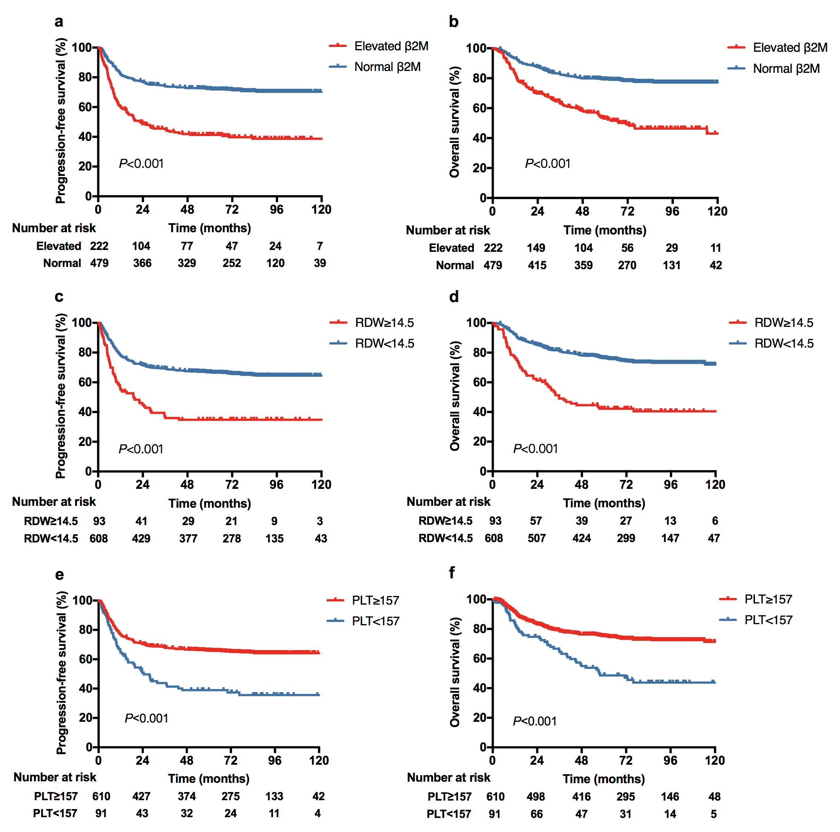

Fig. S2 Calibration curves. (a)The calibration curves for predicting 5-year overall survival (OS) in the training cohort; (b) The calibration curves for predicting 5-year OS in the validation cohort. The predicted OS by the new prognostic model is plotted on the x-axis, and the actual OS is plotted on the y-axis.
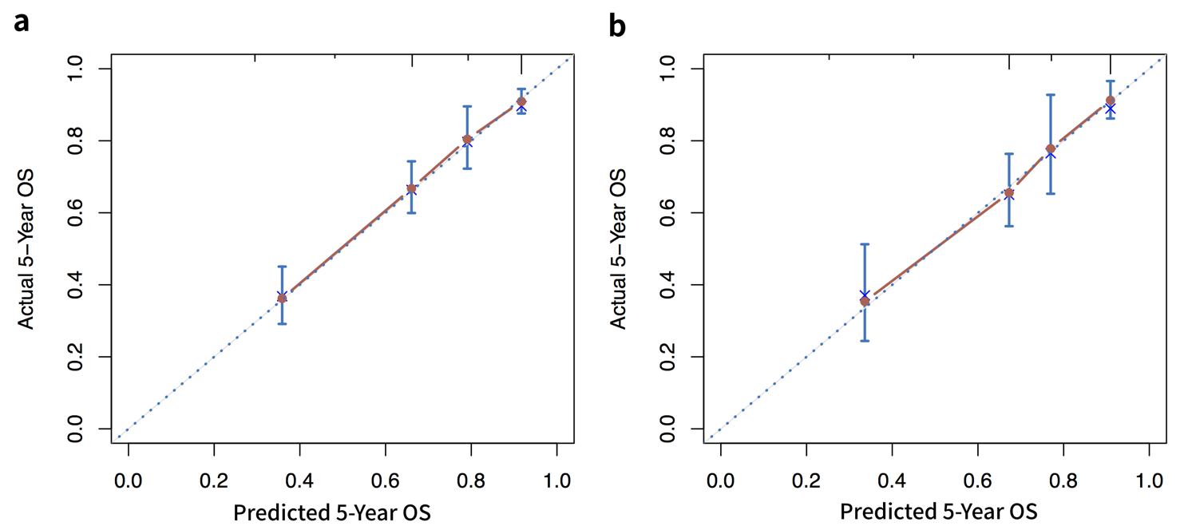

Fig. S3 Progression-free survival (PFS) for risk groups defined by four prognostic models in the training cohort. (a) PFS stratified by the new model; (b) PFS stratified by the International Prognostic Index (IPI); (c) PFS stratified by the revised IPI (R-IPI); (d) PFS stratified by the National Comprehensive Cancer Network IPI (NCCN-IPI).
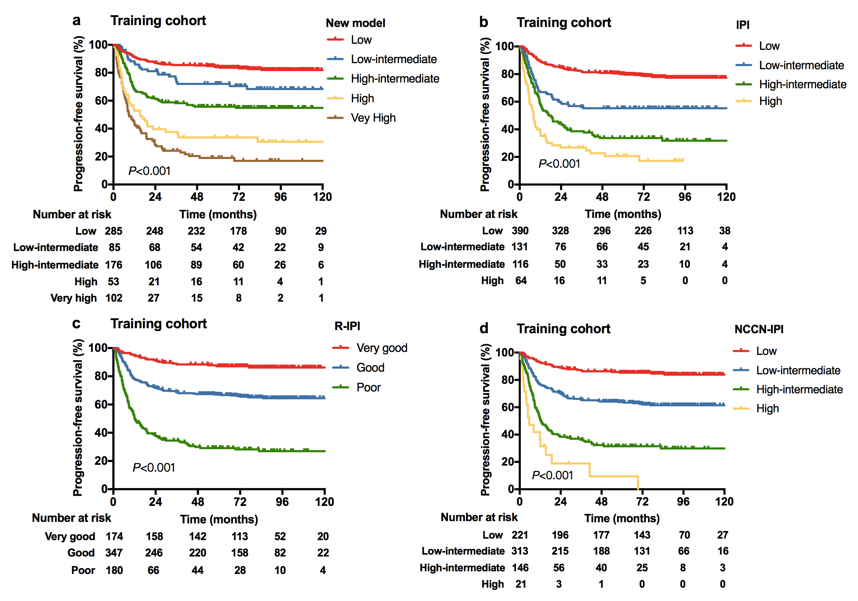

Fig. S4 Progression-free survival (PFS) for risk groups defined by four prognostic models in the validation cohort. (a) PFS stratified by the new model, (b) PFS stratified by the International Prognostic Index (IPI); (c) PFS stratified by the revised IPI (R-IPI); (d) PFS stratified by the National Comprehensive Cancer Network IPI (NCCN-IPI).
