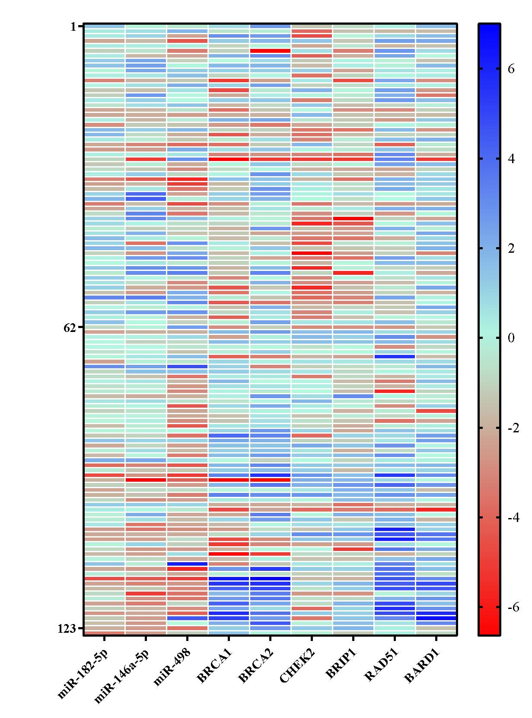
Supplementary Figure 1. Heat map showing expression pattern (log2 transformed) of miR-182-5p, miR-146a-5p, miR-498 and their downstream targets in BC samples and adjacent normal tissues. The expression values are arranged from red (low expression) to blue (high expression). Each row shows one sample, and each column demonstrates a transcript.

Breast tumors
Adjacent normal tissues
Relative expression (log2 ^{fold change)}

