Supplementary Information file

Original, unprocessed versions of western blot :

- Western blot SOD1 in U251-MG cell-lines ; Figure 5C in manuscript
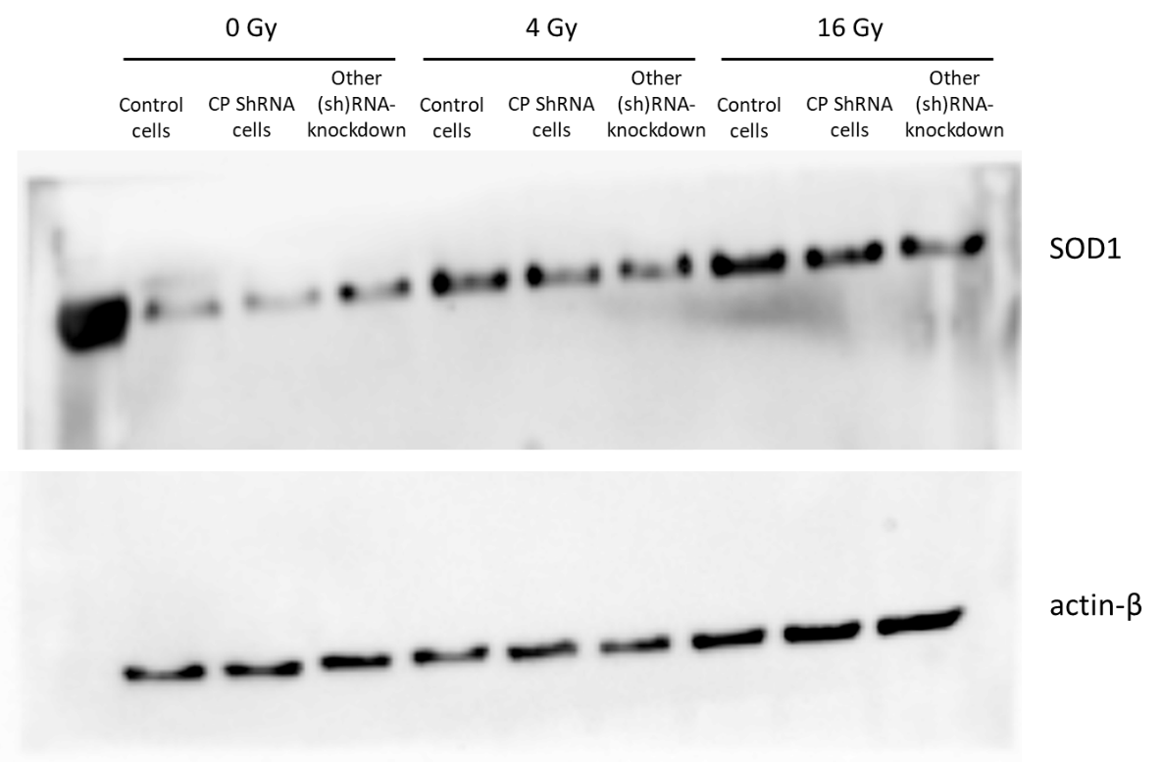

- Western blot SOD1 in U87-MG cell-lines ; Figure 5D in manuscript
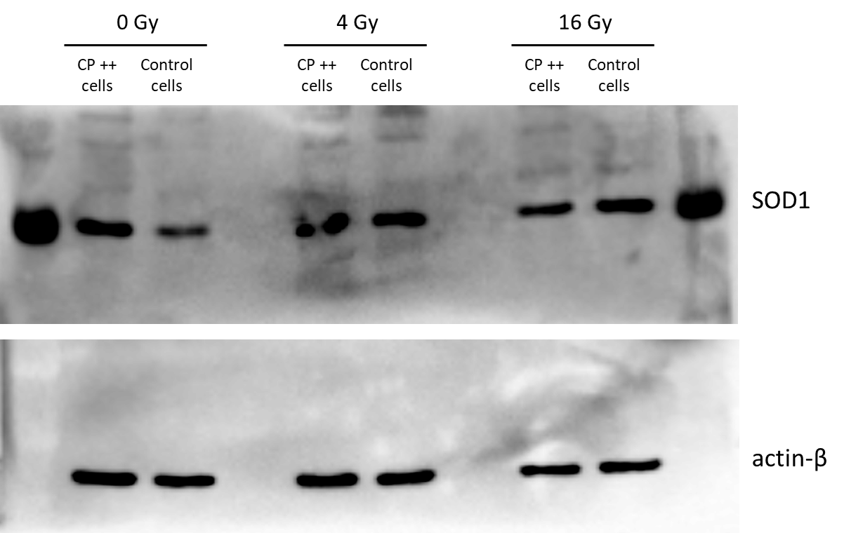

- Western blot gH2AX in U251-MG cell-lines ; Figure 5C in manuscript
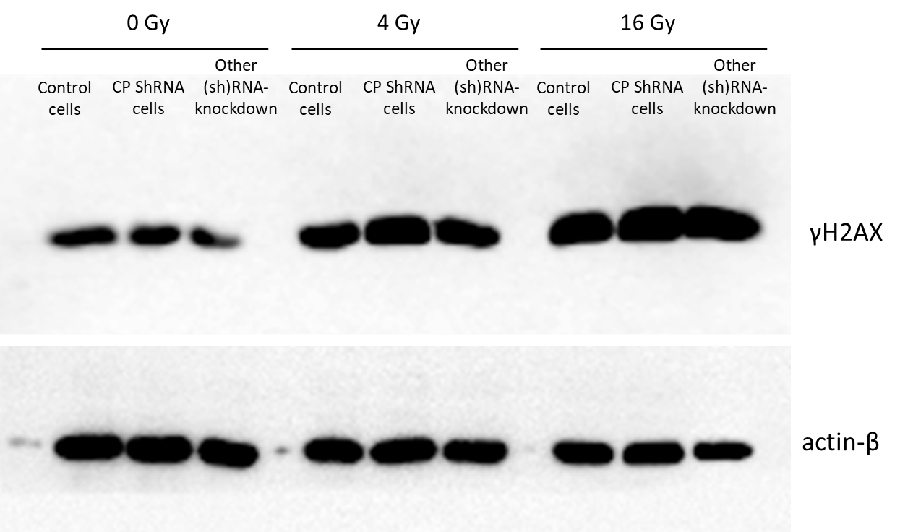

- Western blot gH2AX in U87-MG cell-lines ; Figure 5D in manuscript
