Supplementary Figures
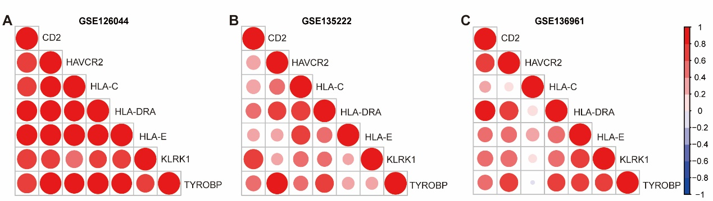
Figure S1. Correlations between seven potential biomarkers.
(A) Correlations in the GSE126044 dataset. (B) Correlations in the GSE13522 dataset. (C) Correlations in the GSE136961 dataset.

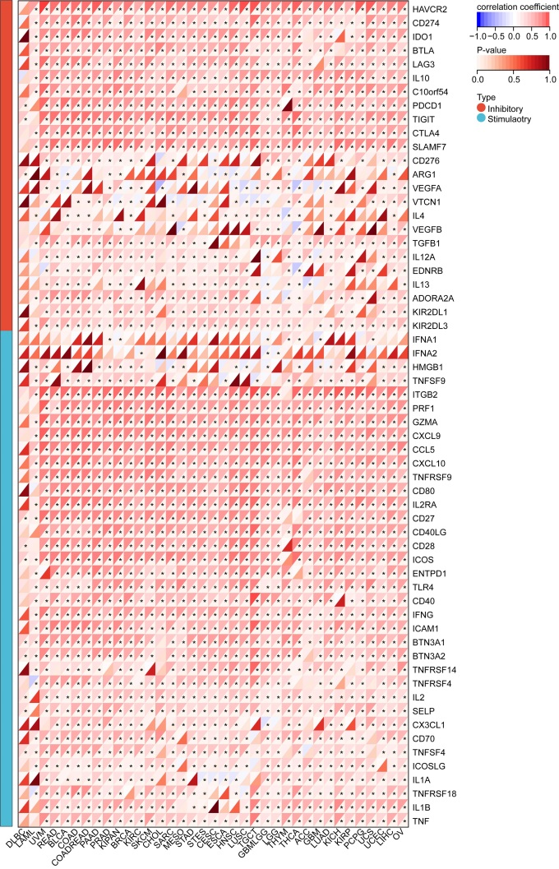
Figure S2. Correlations between HLA-DRA and immune checkpoints expression in pan-cancer. The color indicates the correlation coefficient. The asterisks indicate significant differences assessed by Pearson analysis.

Supplementary Tables
Table S1. Summary of abbreviations in the TCGA dataset.
Abbreviation | Full name
ACC | adrenocortical carcinoma
BLCA | bladder urothelial carcinoma
BRCA | breast invasive carcinoma
CESC | cervical & endocervical cancer
CHOL | cholangio carcinoma
COAD | colon adenocarcinoma
DLBC | lymphoid neoplasm diffuse large B-cell lymphoma
ESCA | esophageal carcinoma
GBM | glioblastoma multiforme
HNSC | head and neck squamous cell carcinoma
KICH | kidney chromophobe carcinoma
KIRC | kidney renal clear cell carcinoma
KIRP | kidney renal papillary cell carcinoma
LAML | acute myeloid leukemia
LGG | brain lower grade glioma
LIHC | liver hepatocellular carcinoma
LUAD | lung adenocarcinoma
LUSC | lung squamous cell carcinoma
MESO | mesothelioma
OV | ovarian serous cystadenocarcinoma
PAAD | pancreatic adenocarcinoma
PCPG | pheochromocytoma and paraganglioma
PRAD | prostate adenocarcinoma
READ | rectum adenocarcinoma
SARC | sarcoma
SKCM | skin cutaneous melanoma
STAD | stomach adenocarcinoma
TGCT | testicular germ cell tumors
THCA | thyroid carcinoma
THYM | thymoma
UCEC | uterine corpus endometrial carcinoma
UCS | uterine carcinosarcoma
UVM | uveal melanoma

Table S2. Detailed information on immunotherapy-related gene signatures.
Pathway | Reference | Genes
IFN-γ signature | PMID: 28650338 | TIGIT, CD27, CD8A, PDCD1LG2, LAG3, CD274, CXCR6, CMKLR1, NKG7, CCL5, PSMB10, IDO1, CXCL9, HLA-DQA1, CD276, STAT1, HLA-DRB1, HLA-E
APM signal | PMID: 31563503 | B2M, HLA-A, HLA-B, HLA-C, TAP1, TAP2
FGFR3-coexpressed genes | PMID: 31563503 | FGFR3, TP63, IRS1, SEMA4B, PTPN13, TMPRSS4
PPARG network | PMID: 27197067 | PPARG, IGFBP3, GDF15, MYH14, IHH, OCLN, AQP3, SCNN1G, PLIN5, KRT19, GPT, CYP4B1, UGT1A7, DGAT2, KRT20, SNCG, GSTA1, ACADL, BDH1, HMGCS2, LIPE
WNT/β-catenin network | PMID: 27197067 | CTNNB1, TFF1, HAPLN1, IHH, WNT7B, BMP7, SEMA5A, SCN5A, ERBB3, TSPAN8, EPCAM, TH, GPX2, GAD1, HSD17B2, KRT7, NOX1, CYB5A, CYP4F12, ID4, SIM2, MECOM, MSX2, KLF5, SMAD6, POU5F1, FOXQ1, GATA2, GATA3, EMX2
VEGFA pathway | PMID: 24793239 | VEGFA
Hypoxia | PMID: 31563503 | CAV1, COL5A1, ITGA5, P4HA2, SLC16A1, TGFBI, DPYSL2, SRPX, TRAM2, SYDE1, LRP1, PDLIM2, SAV1, AHNAK2, CAD, CYP1B1, DAAM1, DSC2, SLC2A3, FUT11, GLG1, GULP1, LDLR, THBS4

Table S3. Detailed information on BP enrichments of 7 candidates.
ID | Term | Count | P value | Genes
GO:0045087 | innate immune response | 5 | <0.001 | KLRK1, TYROBP, HLA-C, HAVCR2, HLA-E
GO:0050776 | regulation of immune response | 4 | <0.001 | KLRK1, TYROBP, HLA-C, HLA-E
GO:0019882 | antigen processing and presentation | 3 | <0.001 | HLA-DRA, HLA-C, HLA-E
GO:0060333 | interferon-gamma-mediated signaling pathway | 3 | <0.001 | HLA-DRA, HLA-C, HLA-E
GO:0050830 | defense response to Gram-positive bacterium | 3 | <0.001 | KLRK1, HAVCR2, HLA-E
GO:0002250 | adaptive immune response | 3 | 0.001 | KLRK1, HAVCR2, HLA-E
GO:0002281 | macrophage activation involved in immune response | 2 | 0.003 | TYROBP, HAVCR2
GO:0002480 | antigen processing and presentation of exogenous peptide antigen via MHC class I, TAP-independent | 2 | 0.003 | HLA-C, HLA-E
GO:0030101 | natural killer cell activation | 2 | 0.007 | CD2, KLRK1
GO:0032753 | positive regulation of interleukin-4 production | 2 | 0.007 | HAVCR2, HLA-E

