The uncropped gels/blots of Figure 1.
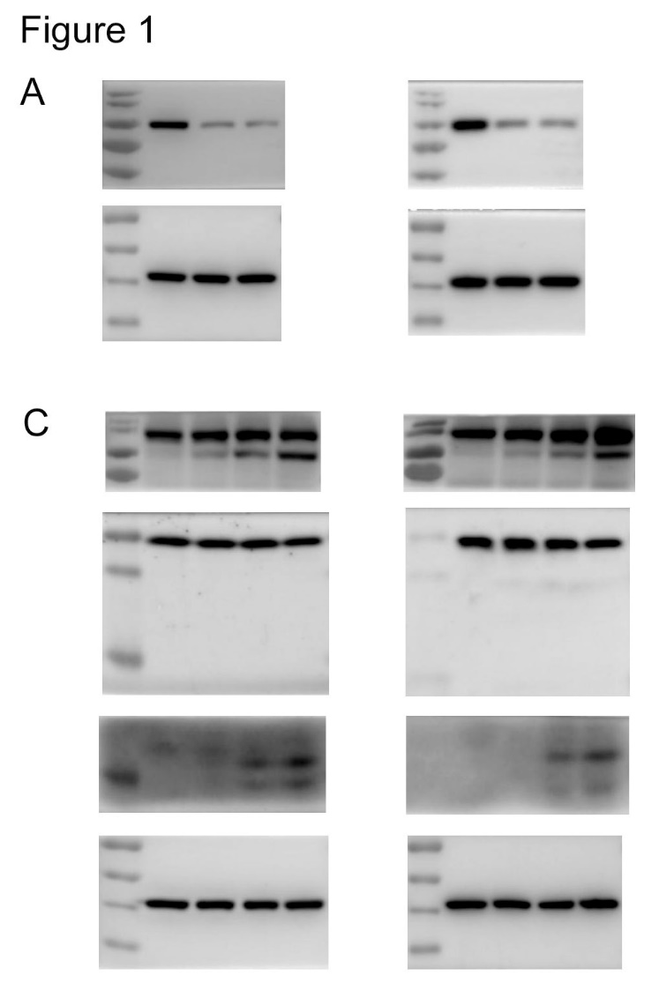

The uncropped gels/blots of Figure 2.
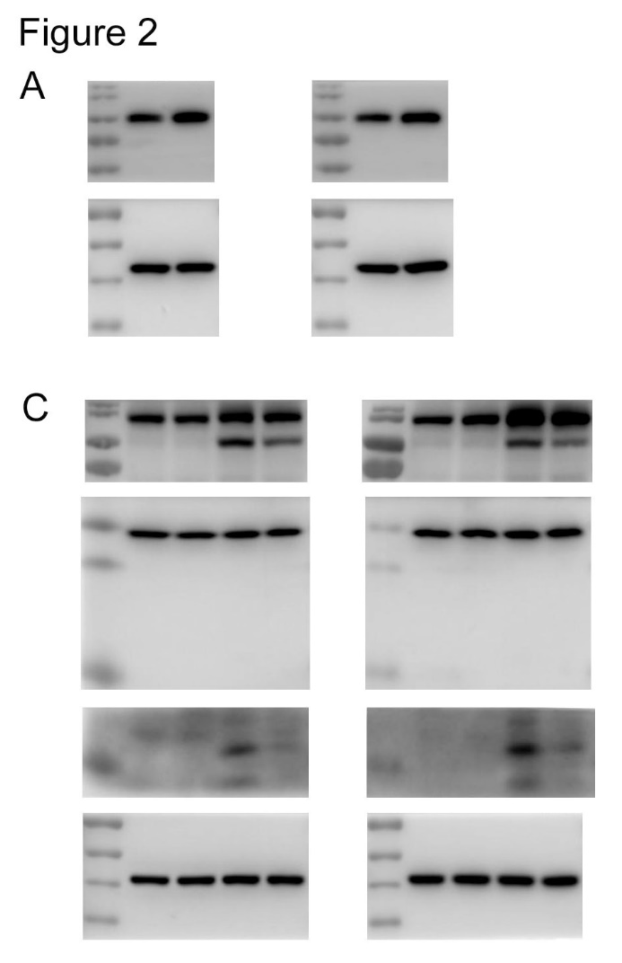

The uncropped gels/blots of Figure 3.
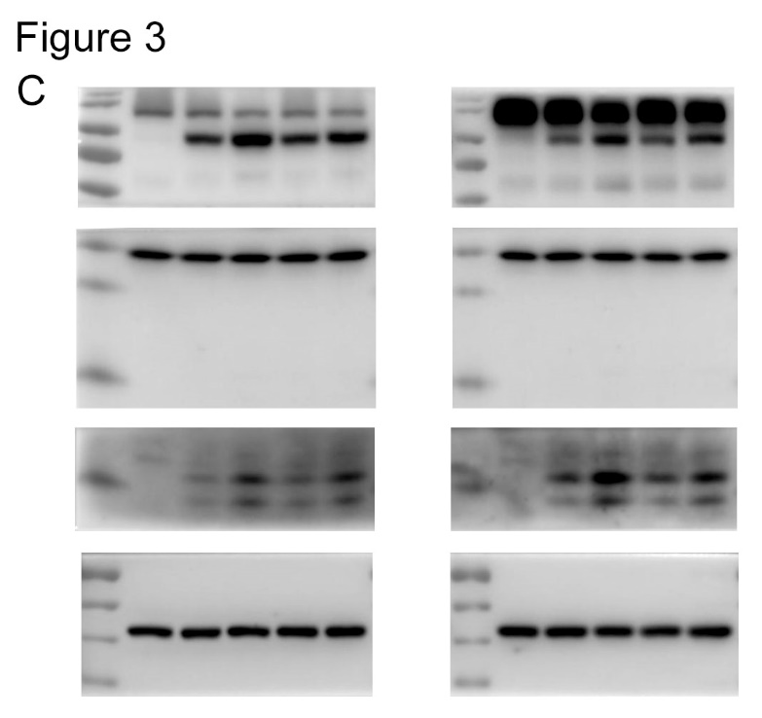

The uncropped gels/blots of Figure 5.
