Additional file 3. Kaplan-Meier Survival Analysis:
comparison of patient groups ARB and ACEI vs non-RASI

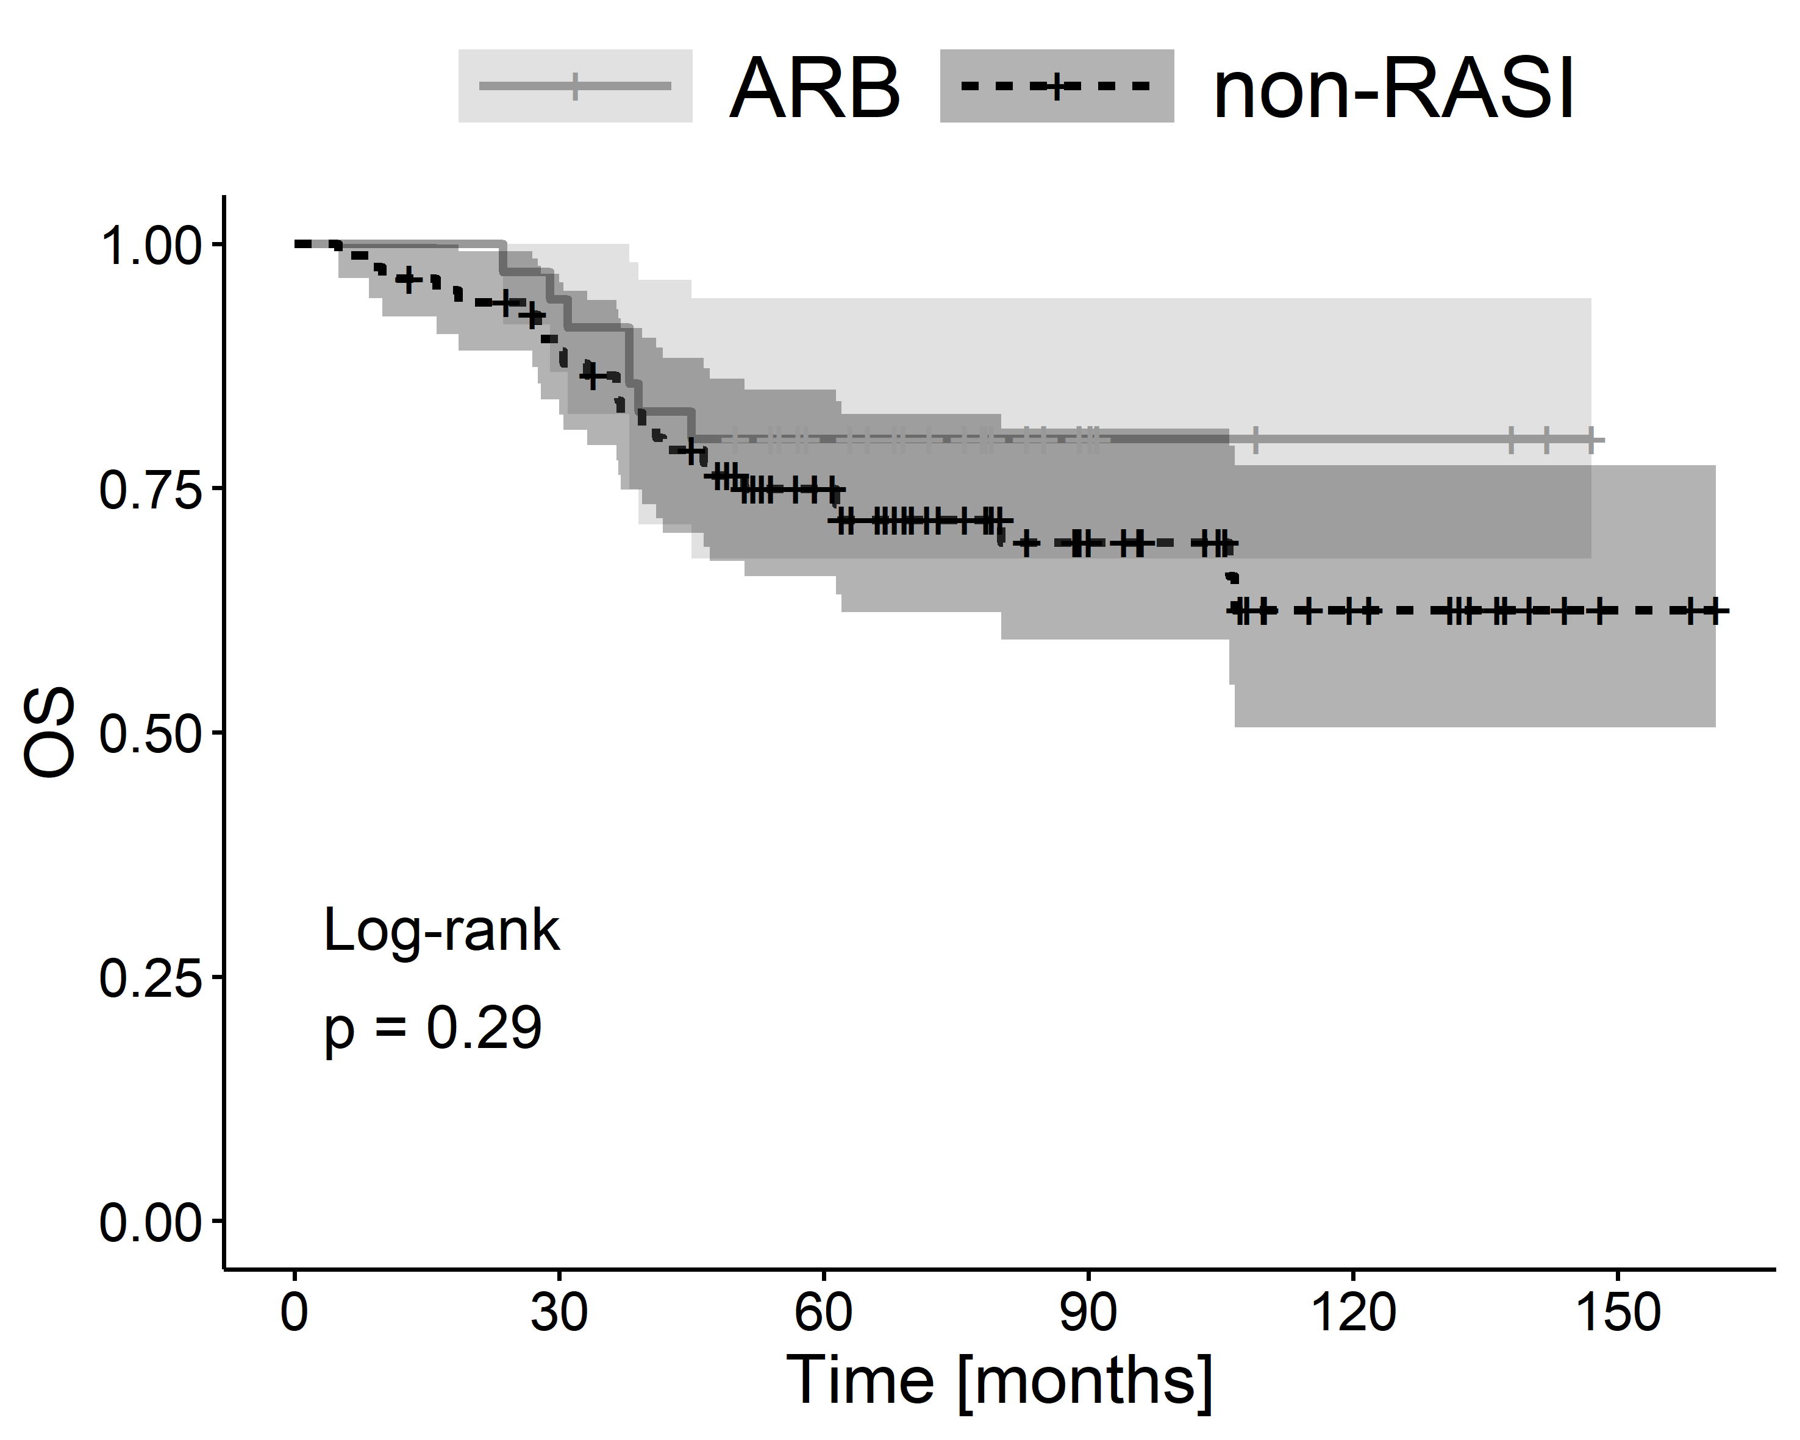
Additional file 3A. The Kaplan–Meier plots of overall survival (OS) for comparison of patient groups ARB vs non-RASI.

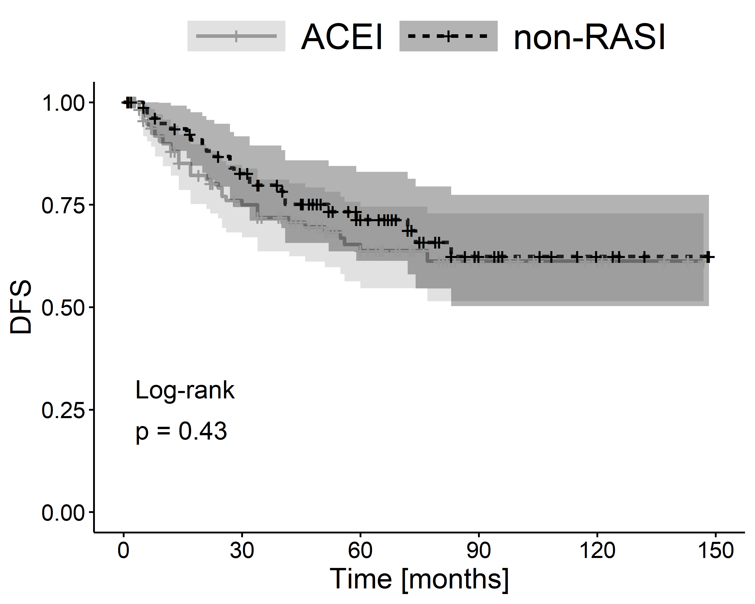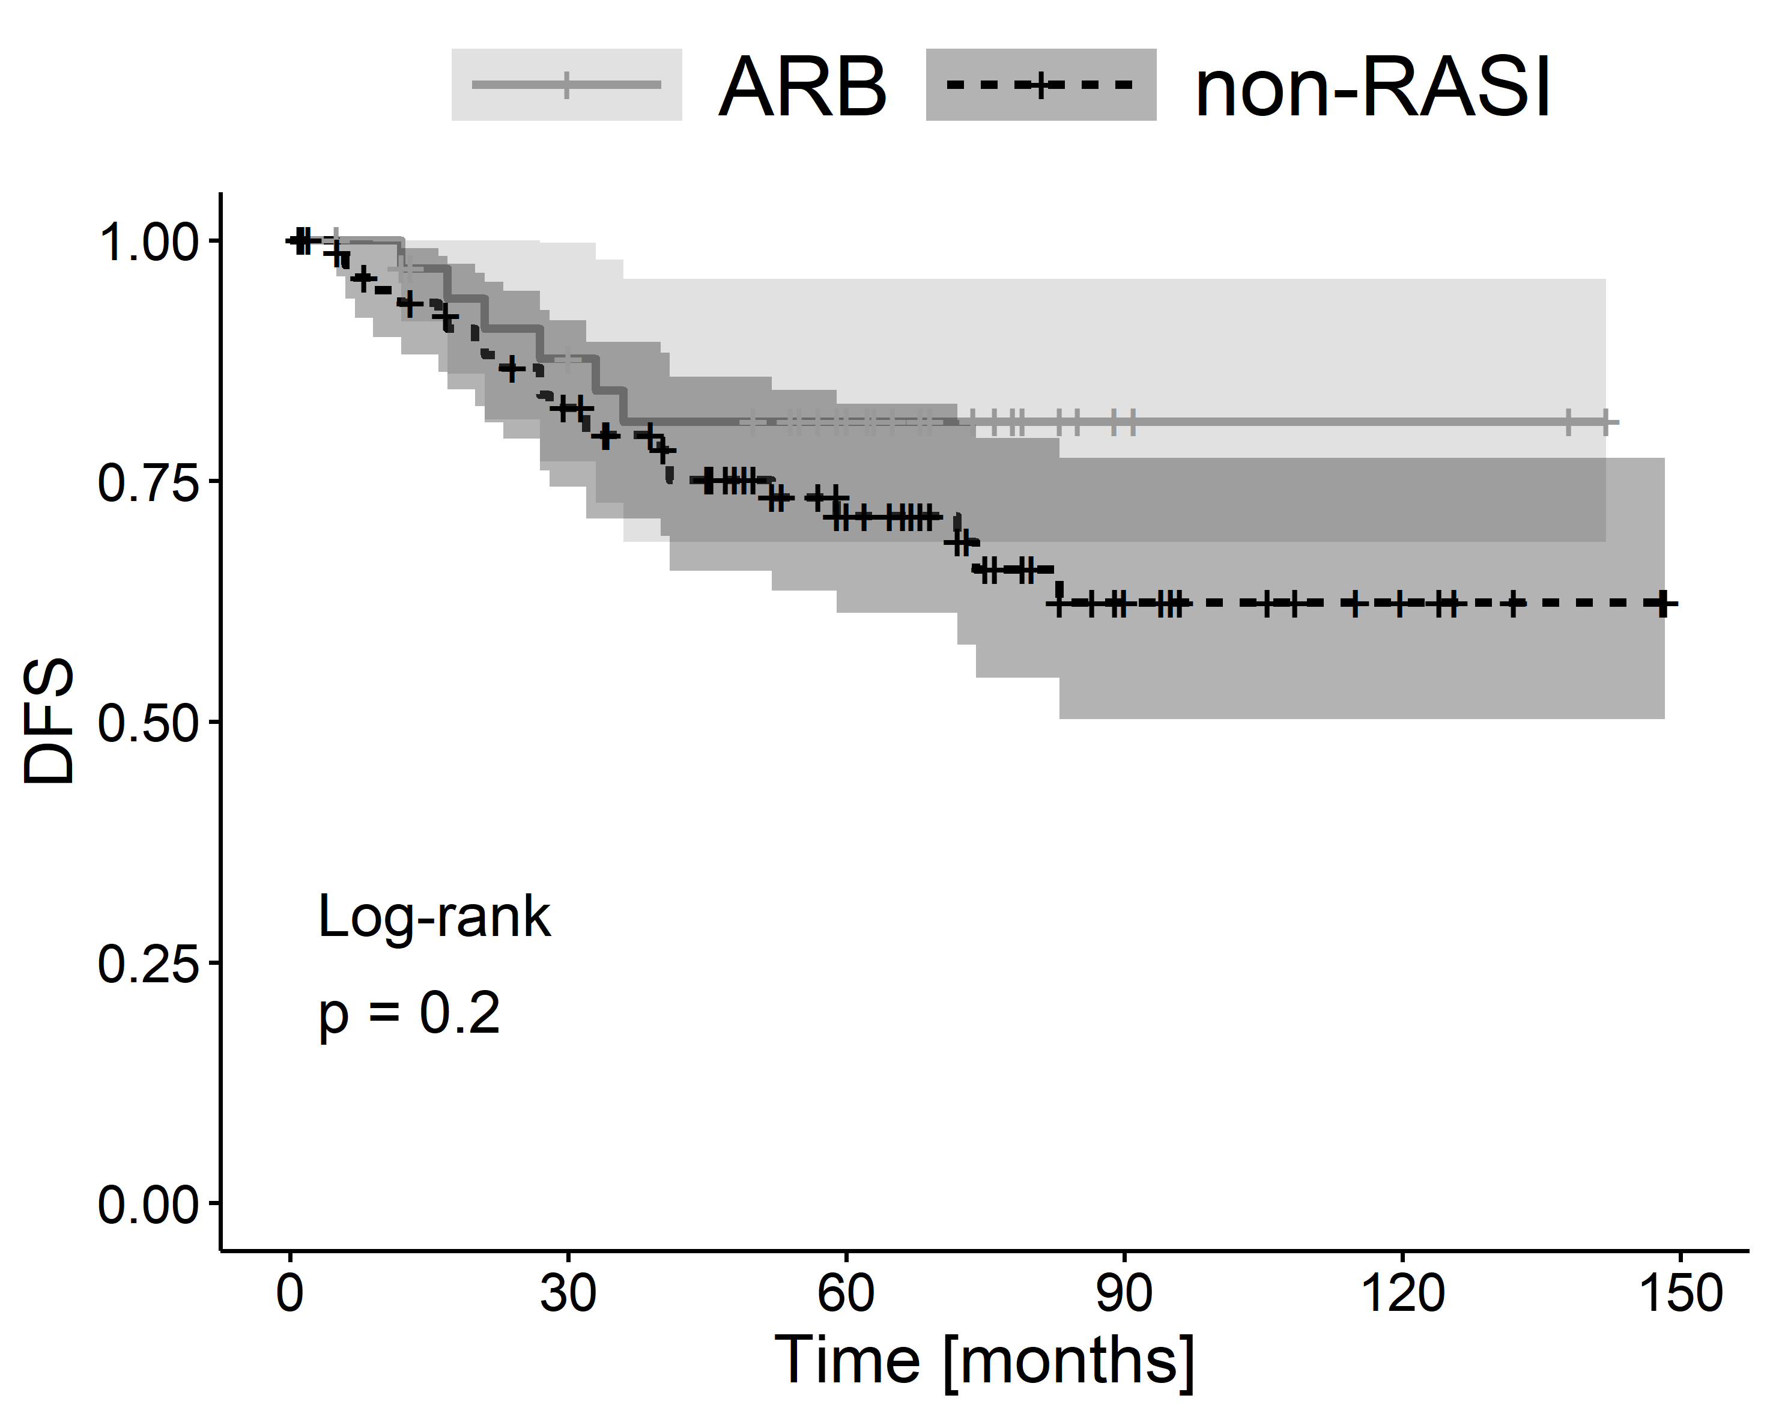

Additional file 3B. The Kaplan–Meier plots of disease free survival (DFS) for comparison of patient groups ACEI vs non-RASI and ARB vs non-RASI.

