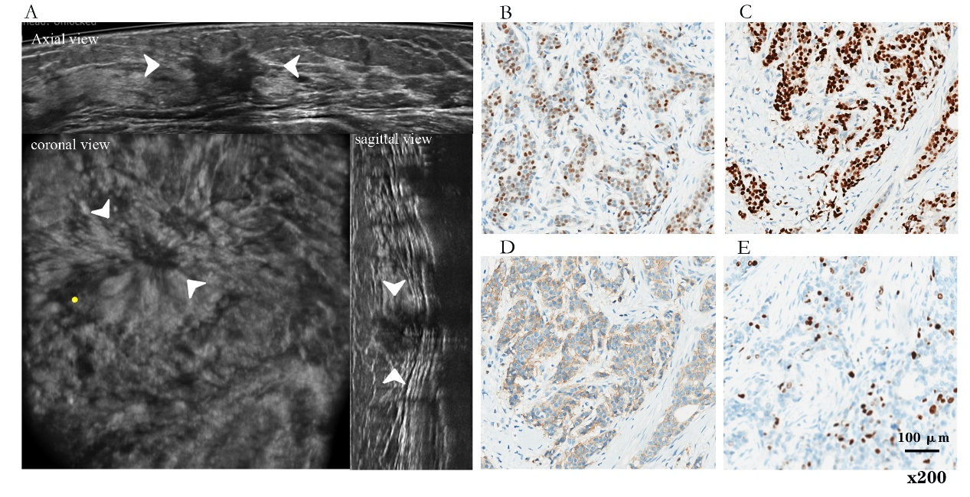
Figure S1. (A) ABUS image of 48-year-old woman in stage II (MD = 2.1 cm) breast cancer with ALNM. The coronal plane shows proper nipple position (yellow point). ABUS detected a big hypoechoic lesion (arrows) on outer quadrant in left breast with irregular shape, angular margin, microcalcification, posterior features shadowing, positive hyperechoic halo and retraction phenomenon. (B, C, D, E) ER (+), PR (+), HER2 (1+), Ki-67 = 15%; (scale bar = 100 μm, x200). The model predicted that the lesion possibly has ALNM (p = 0.83). MS is Lumina B. ABUS = Automated breast ultrasound, ALNM = axillary lymph node metastasis, MD = maximum diameter, MS = molecular subtype.

