The effect of Nrf₂ deletion on the proteomic signature in a human colorectal cancer cell line.

Omid Cheraghi¹. Bahareh Dabirmanesh^{1*}. Farideh Ghazi². Massoud Amanlou³.
Mona Atabakhshi-kashi⁴. Yaghoub Fathollahi⁵. Khosro Khajeh¹

¹ Department of Biochemistry, Faculty of Biological Science, Tarbiat Modares University,Tehran, Iran
² Department of Medical Genetics and Molecular Biology, School of Medicine, Iran University of Medical Sciences, Tehran, Iran
³ Department of Medical Chemistry, Faculty of Pharmacy and Pharmaceutical Science, Tehran, Iran
⁴ CAS Key Laboratory for Biomedical Effects of Nanomaterials & Nanosafety, CAS Center for Excellence in Nanoscience, National Center for Nanoscience and Technology, Beijing 100190, China
⁵ Department of medical physiology, Faculty of Medical Science, Tarbiat Modares University,Tehran, Iran

*Correspondence to: Bahareh Dabirmanesh (Tarbiat Modares University, Tehran, Iran. P.O. Box: 14115-175. Tel: +98 21 82883428. Fax: +98 21 82884717. E-mail: dabirmanesh@modares.ac.ir)

Original Western blot
The original Western blots are presented below. Methods for these blots have been written in the manuscript.

.

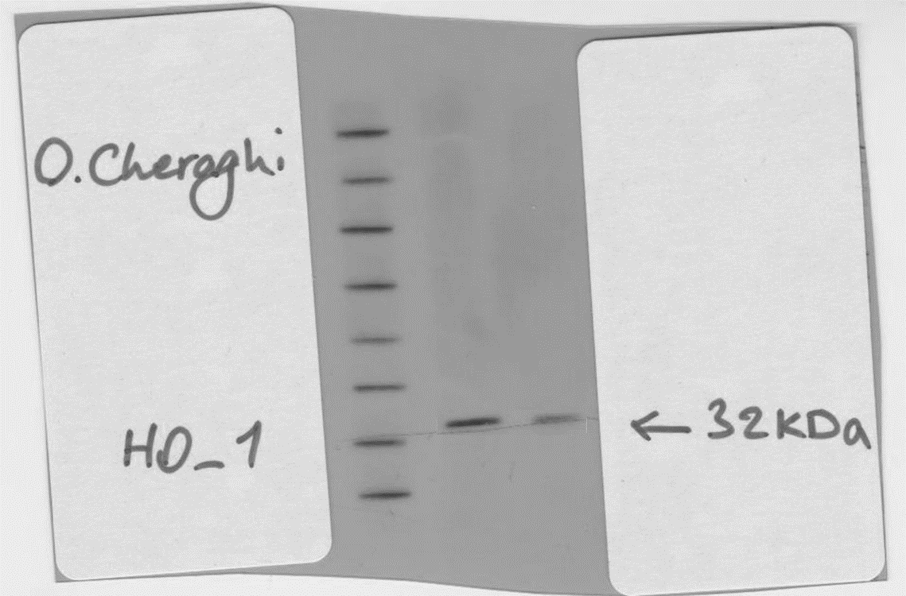
A
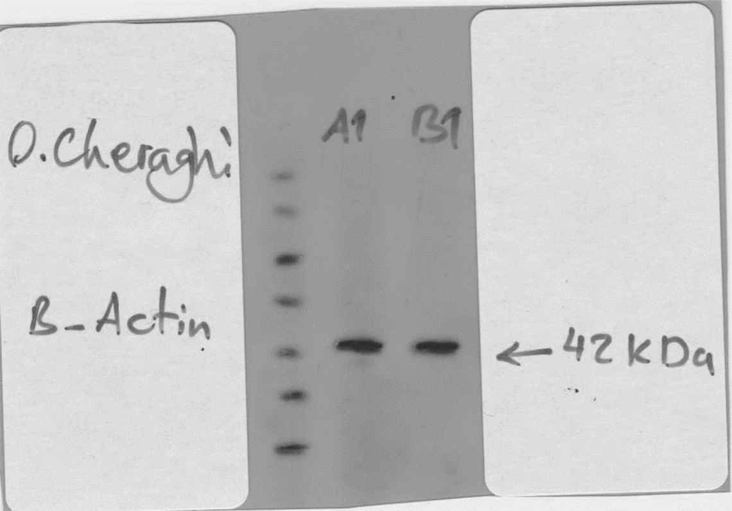
B

Fig. 1S) The original blot images of Fig. 1C in the manuscript. Western blot data of HO-1 (A) and β-actin (B) proteins. Left to right: marker, HT29 and HT29-Nrf₂⁻ cell lines.

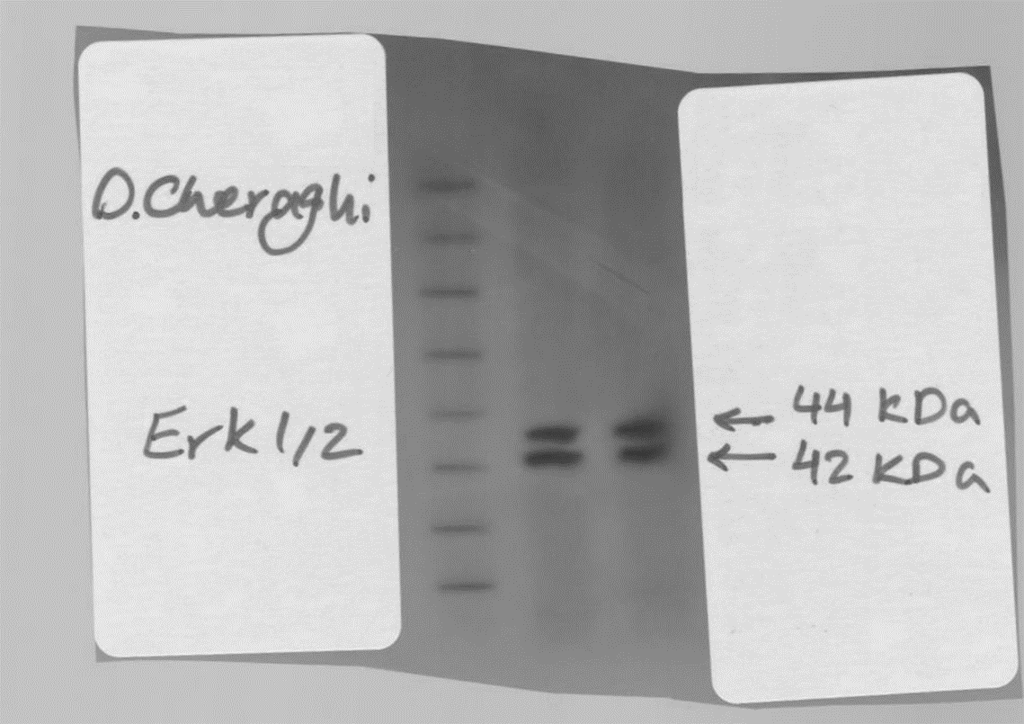
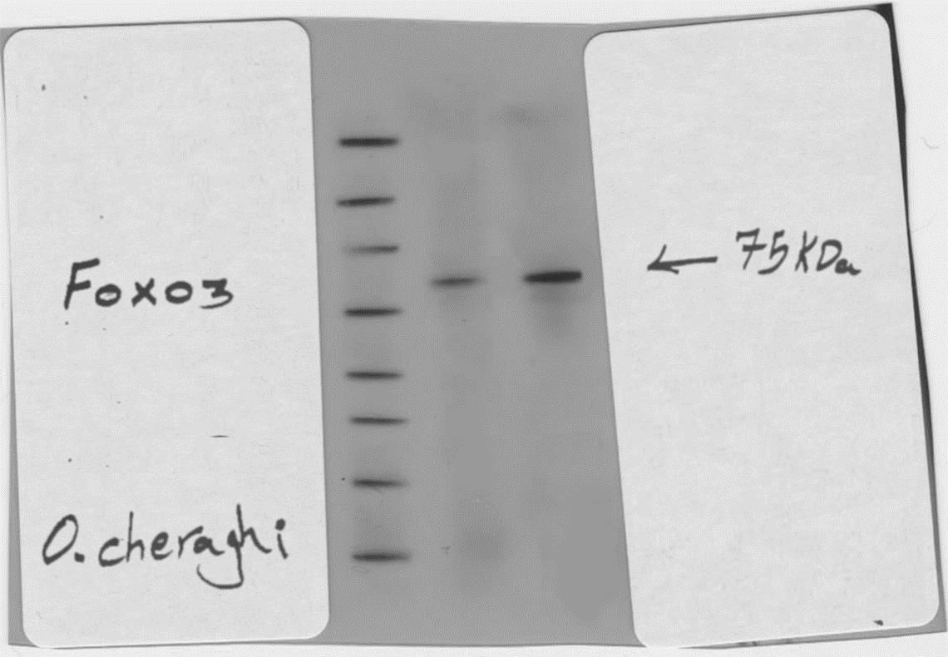
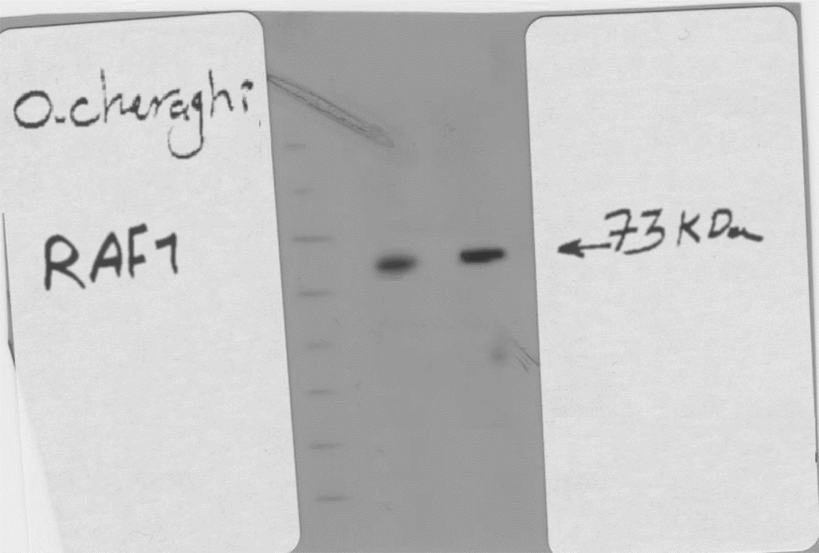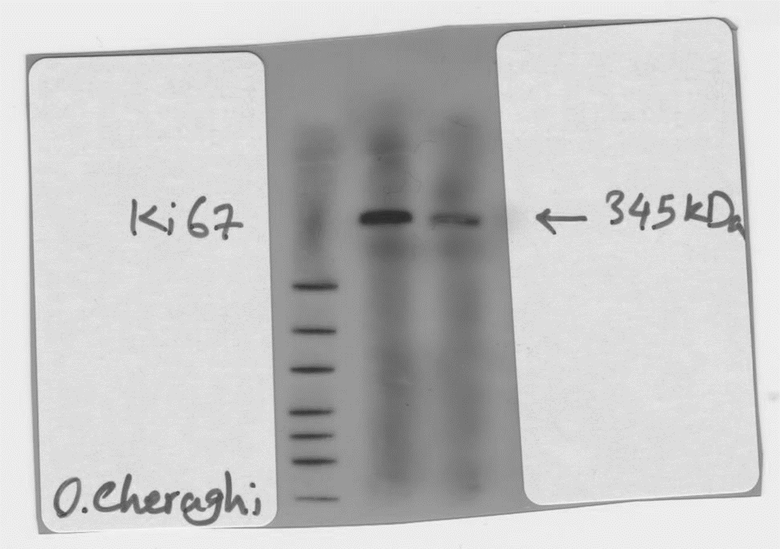
C
D
B
A
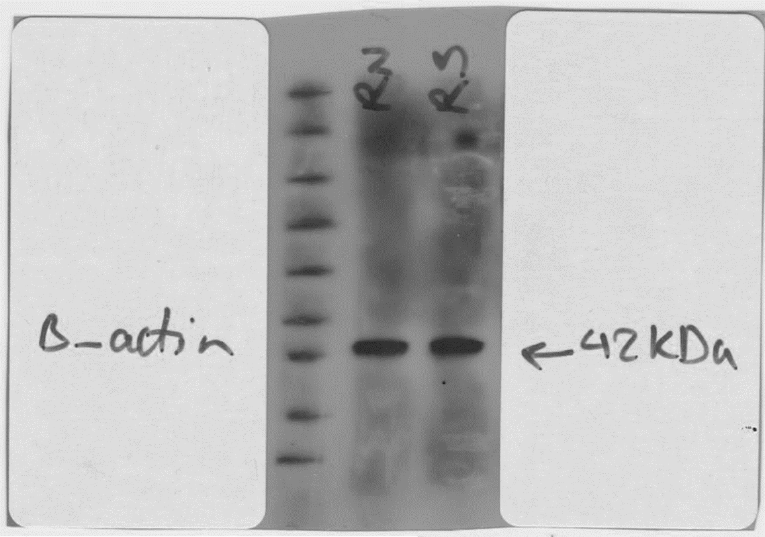
E
1-HT29
2-HT29-Nrf2-

Fig. 2S) The original blot images of Fig. 5C in the manuscript. Western blot data of Ki-67 (A), Erk1/2 (B), RAF1(C), FOXO3a (D) and β-actin (E) proteins. Left to right: marker, HT29 and HT29-Nrf₂⁻ cell lines.
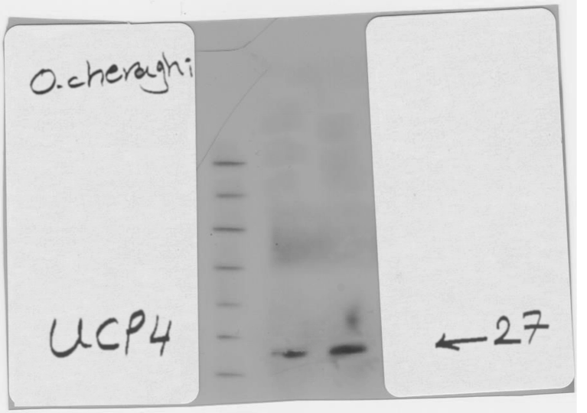
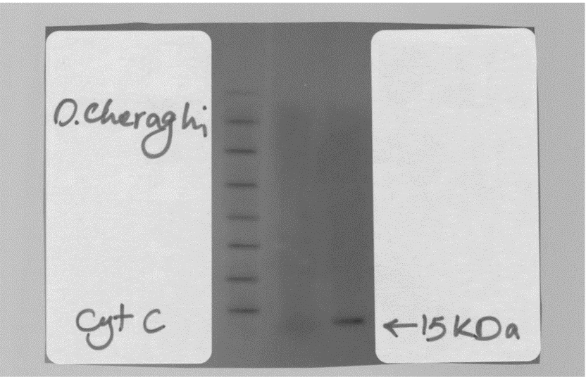
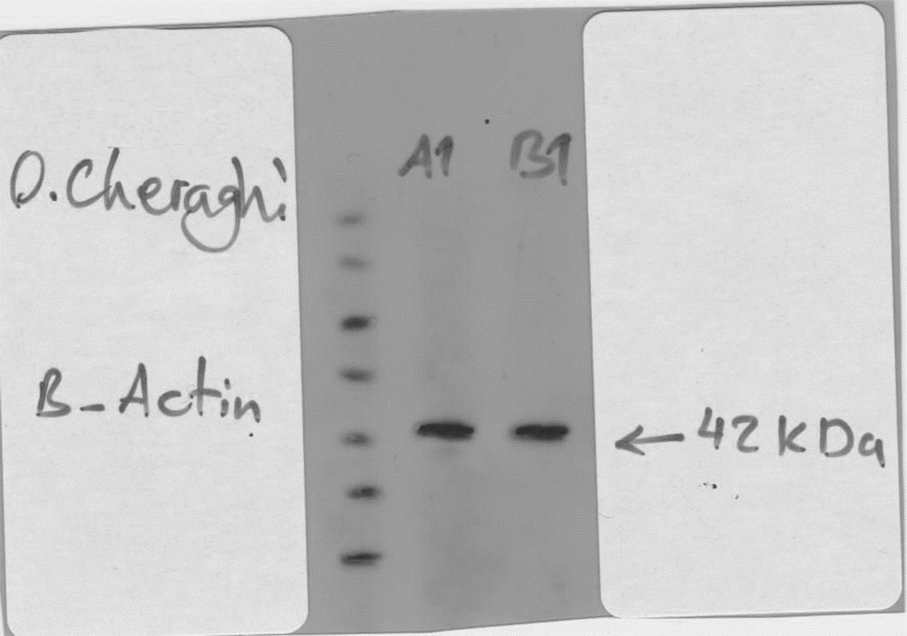
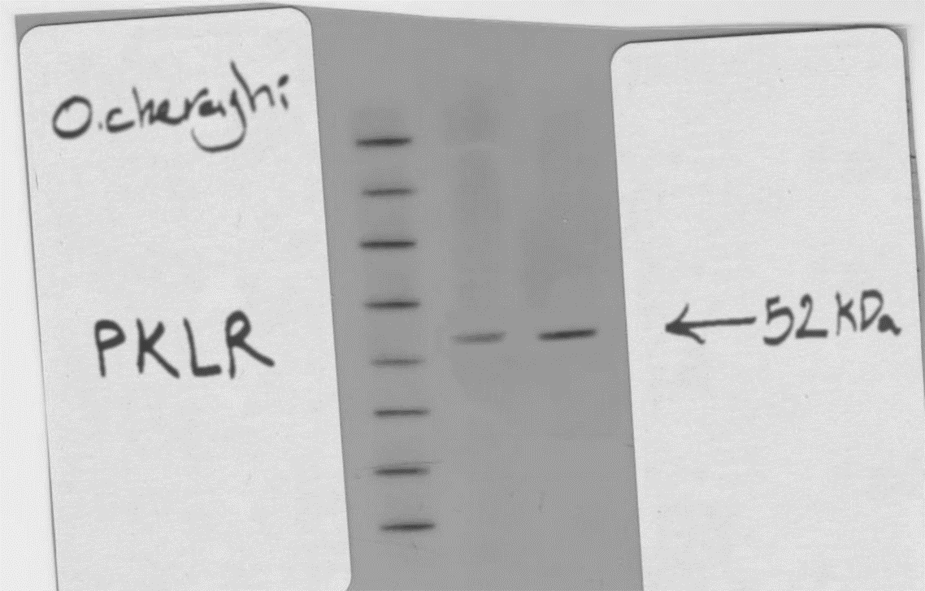
B
A
C
D
B
A

Fig. 3S) The original blot images of Fig. 6D in the manuscript. Western blot data of PKLR (A), UCP4 (B), Cyt c (C), β-actin (D) proteins. In A, B and D; left to right: marker, HT29 and HT29-Nrf₂⁻ cell lines. In C; left to right: marker, HT29-Nrf₂⁻ and HT29 cell lines.

