Supplementary figure 2：Original gels for all western blots in Figure 9

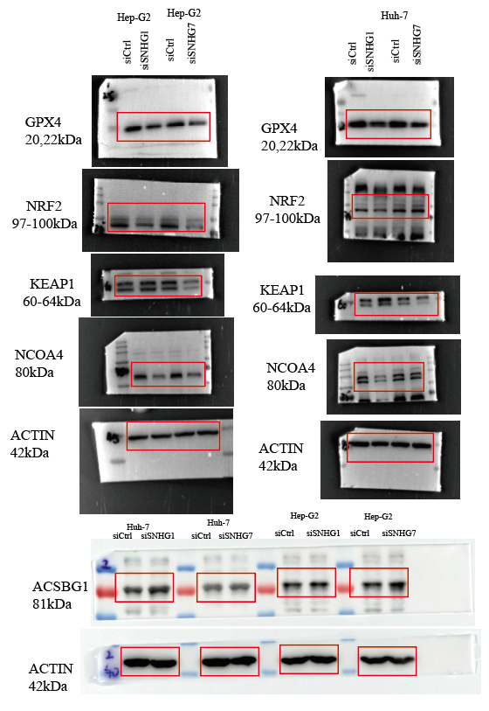
Figure legend: Original gel image measuring immunopositivity against ferroptosis markers in HCC cells. ACTIN was used as loading control. Bands used in the manuscript have been boxed in red.

