Original images for Figure 9
GPX4 HepG2 siCtrl siSNHG1 siCtrl siSNHG7 NRF2 HepG2 siCtrl siSNHG1 siCtrl siSNHG7
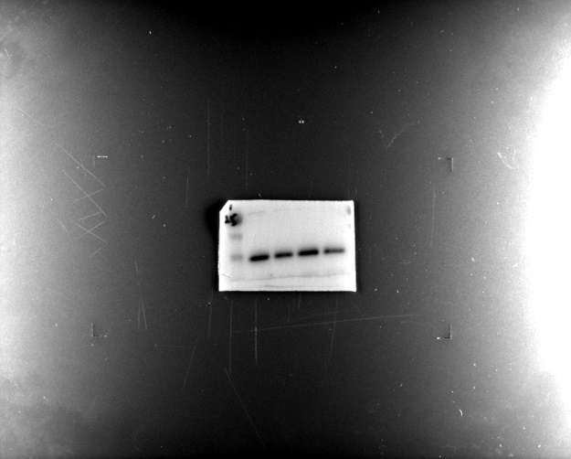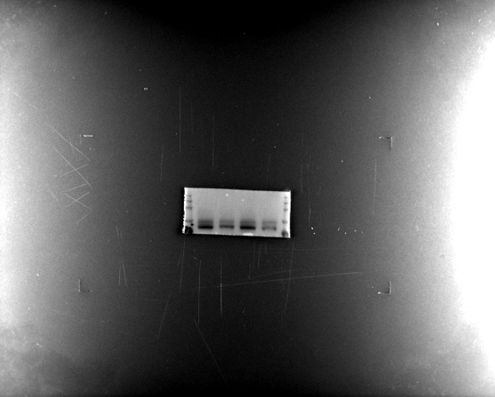

KEAP1 HepG2 siCtrl siSNHG1 siCtrl siSNHG7 NCOA4 HepG2 siCtrl siSNHG1 siCtrl siSNHG7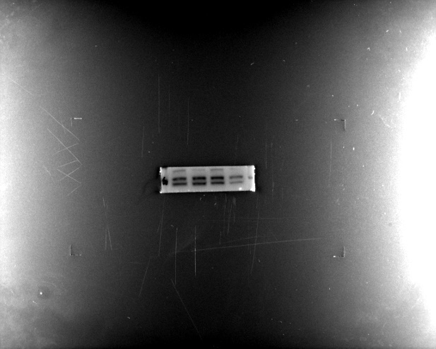 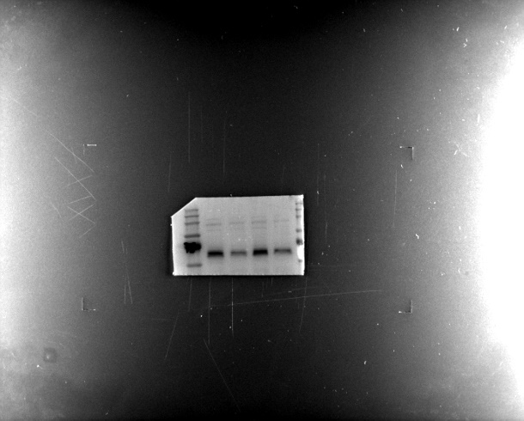
ACTIN HepG2 siCtrl siSNHG1 siCtrl siSNHG7
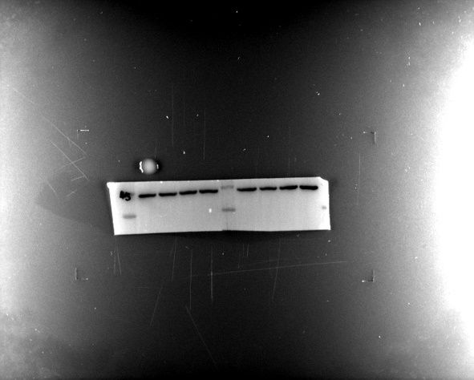\

GPX4 Huh7 siCtrl siSNHG1 siCtrl siSNHG7 NRF2 Huh7 siCtrl siSNHG1 siCtrl siSNHG7
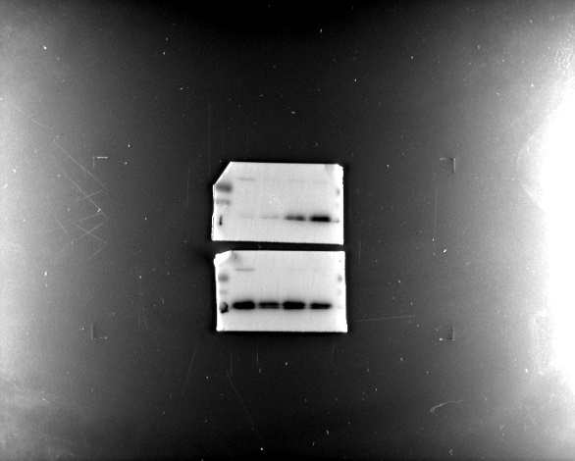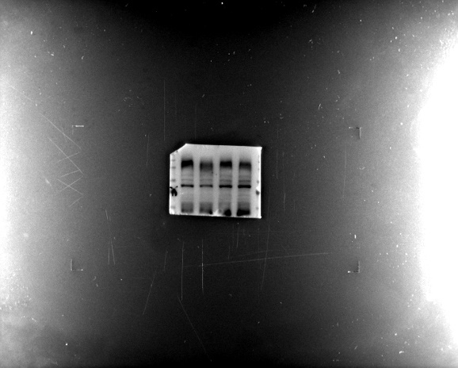
KEAP1 Huh7 siCtrl siSNHG1 siCtrl siSNHG7 NOCA4 Huh7 siCtrl siSNHG1 siCtrl siSNHG7
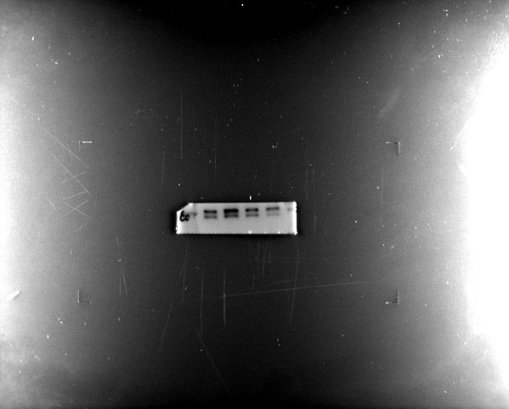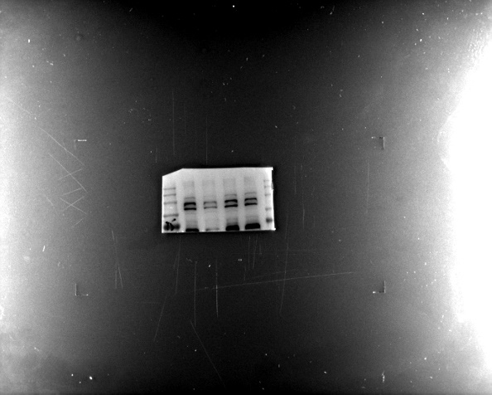
ACTIN Huh7 siCtrl siSNHG1 siCtrl siSNHG7
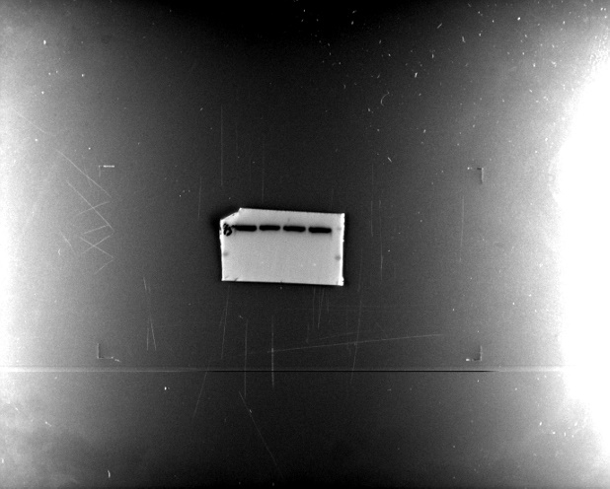

ACSBG1
Huh7(siCtrl siSNHG1 siCtrl siSNHG7) HepG2(siCtrl siSNHG1 siCtrl siSNHG7)
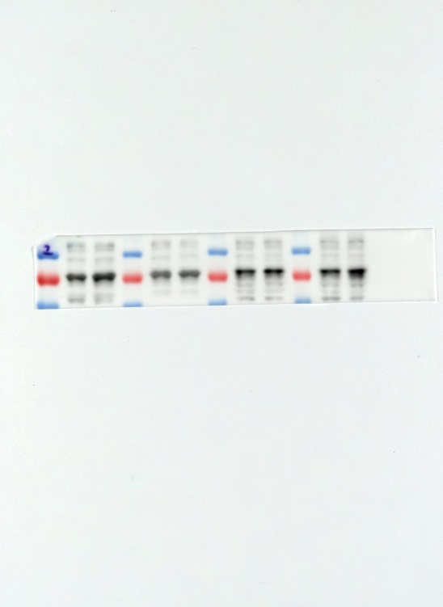

ACTIN
Huh7(siCtrl siSNHG1 siCtrl siSNHG7) HepG2(siCtrl siSNHG1 siCtrl siSNHG7)
