Prognostic significance of prognostic nutritional index and systemic immune‐inflammation index in patients after curative breast cancer resection: A retrospective cohort study

(Supplementary materials)

Table legends
Supplementary Table 1. Subgroup analyses in relation to tertiles of PNI with the DFS.
Supplementary Table 2. Subgroup analyses in relation to tertiles of SII with the DFS.
Supplementary Table 3. Subgroup analyses in relation to tertiles of NLR with the DFS.
Supplementary Table 4. Subgroup analyses in relation to tertiles of PLR with the DFS.

Figure legends
Supplementary Figure.1 The Kaplan‐Meier disease-free survival curves of all patients in the cohort according to tertiles of SII (log-rank analysis P = 0.817).
Supplementary Figure.2 The Kaplan‐Meier disease-free survival curves of all patients in the cohort according to tertiles of NLR (log-rank analysis P = 0.600).
Supplementary Figure.3 The Kaplan‐Meier disease-free survival curves of all patients in the cohort according to tertiles of PLR (log-rank analysis P = 0.090).

Supplementary Table 1. Subgroup analyses in relation to tertiles of PNI with the DFS.
 | No. | T1 |  | T2 |  |  |  |  | T3 |  |  |  | P interaction
 | No. | HR |  | HR | 95% CI |  | P value |  | HR | 95% CI |  | P value | P interaction
Family history of BC |  |  |  |  |  |  |  |  |  |  |  |  | 0.004
No | 367 | 1.00 (Ref) |  | 0.48 | 0.25 | 0.93 | 0.030 |  | 0.22 | 0.10 | 0.49 | <0.001
Yes | 141 | 1.00 (Ref) |  | 0.98 | 0.24 | 4.07 | 0.979 |  | 1.65 | 0.51 | 5.32 | 0.399
Body mass index (kg/m2) |  |  |  |  |  |  |  |  |  |  |  |  | 0.677
18.5-22.9 | 168 | 1.00 (Ref) |  | 0.68 | 0.21 | 2.24 | 0.527 |  | 0.11 | 0.02 | 0.58 | 0.009
23-27.4 | 236 | 1.00 (Ref) |  | 0.46 | 0.17 | 1.26 | 0.132 |  | 0.49 | 0.20 | 1.24 | 0.134
≥27.5 | 75 | 1.00 (Ref) |  | 0.21 | 0.03 | 1.50 | 0.120 |  | 0.31 | 0.06 | 1.69 | 0.175
Histological diagnosis |  |  |  |  |  |  |  |  |  |  |  |  | 0.220
Invasive carcinoma | 452 | 1.00 (Ref) |  | 0.52 | 0.27 | 0.99 | 0.047 |  | 0.44 | 0.23 | 0.83 | 0.011
Carcinoma in situ | 56 | 1.00 (Ref) |  | 0.01 | 0.00 | 0.07 | <0.001 |  | 0.00 | 0.00 | Inf | 0.994
Clinical stage |  |  |  |  |  |  |  |  |  |  |  |  | 0.347
0 | 53 | 1.00 (Ref) |  | Inf | 0 | Inf | 0.968 |  | Inf | 0 | Inf | 0.975
I | 106 | 1.00 (Ref) |  | 0.12 | 0.01 | 1.33 | 0.085 |  | 0.26 | 0.06 | 1.24 | 0.091
II | 243 | 1.00 (Ref) |  | 0.44 | 0.18 | 1.10 | 0.078 |  | 0.28 | 0.11 | 0.72 | 0.008
III | 92 | 1.00 (Ref) |  | 0.71 | 0.22 | 2.34 | 0.575 |  | 0.37 | 0.10 | 1.34 | 0.129
IV | 14 | 1.00 (Ref) |  | Inf | 0 | Inf | 1.000 |  | Inf | 0 | Inf | 1.000
Tumour size, cm |  |  |  |  |  |  |  |  |  |  |  |  | 0.545
≥ 4 | 391 | 1.00 (Ref) |  | 0.45 | 0.22 | 0.92 | 0.028 |  | 0.37 | 0.19 | 0.73 | 0.004
< 4 | 79 | 1.00 (Ref) |  | 0.59 | 0.10 | 3.55 | 0.564 |  | 0.09 | 0.01 | 1.27 | 0.075
Status of ER |  |  |  |  |  |  |  |  |  |  |  |  | 0.890
Negative | 149 | 1.00 (Ref) |  | 0.53 | 0.18 | 1.54 | 0.243 |  | 0.50 | 0.16 | 1.59 | 0.241
Positive | 357 | 1.00 (Ref) |  | 0.56 | 0.28 | 1.10 | 0.091 |  | 0.41 | 0.20 | 0.84 | 0.015
Status of PR |  |  |  |  |  |  |  |  |  |  |  |  | 0.625
Negative | 203 | 1.00 (Ref) |  | 0.96 | 0.28 | 3.32 | 0.946 |  | 0.55 | 0.15 | 2.03 | 0.369
Positive | 303 | 1.00 (Ref) |  | 0.54 | 0.26 | 1.09 | 0.083 |  | 0.42 | 0.20 | 0.88 | 0.021
Status of HER-2 |  |  |  |  |  |  |  |  |  |  |  |  | 0.984
Negative | 114 | 1.00 (Ref) |  | 0.38 | 0.09 | 1.53 | 0.172 |  | 0.35 | 0.09 | 1.34 | 0.125
Positive | 347 | 1.00 (Ref) |  |  |  |  |  |  |  |  |  |  | 0.529
Ki67-index
≥ 27.5% | 272 | 1.00 (Ref) |  | 0.70 | 0.29 | 1.69 | 0.424 |  | 0.42 | 0.17 | 1.05 | 0.063
< 27.5% | 236 | 1.00 (Ref) |  | 0.41 | 0.16 | 1.10 | 0.078 |  | 0.31 | 0.11 | 0.83 | 0.020
Surgical forms |  |  |  |  |  |  |  |  |  |  |  |  | 0.474
Breast conserving surgery | 62 | 1.00 (Ref) |  | 0.10 | 0.02 | 0.53 | 0.007 |  | 0.04 | 0.00 | 0.32 | 0.003
Modified radical mastectomy | 247 | 1.00 (Ref) |  | 0.70 | 0.31 | 1.57 | 0.385 |  | 0.48 | 0.20 | 1.15 | 0.100
Total mastectomy | 188 | 1.00 (Ref) |  | 0.39 | 0.16 | 1.00 | 0.051 |  | 0.35 | 0.14 | 0.84 | 0.019
Unclear | 11 | 1.00 (Ref) |  | NA | NA | NA | NA |  | NA | NA | NA | NA
Chemotherapy |  |  |  |  |  |  |  |  |  |  |  |  | 0.370
No | 140 | 1.00 (Ref) |  | 0.20 | 0.05 | 0.79 | 0.021 |  | 0.11 | 0.02 | 0.60 | 0.011
Yes | 368 | 1.00 (Ref) |  | 0.55 | 0.28 | 1.10 | 0.091 |  | 0.44 | 0.22 | 0.88 | 0.020
Radiotherapy |  |  |  |  |  |  |  |  |  |  |  |  | 0.025
No | 355 | 1.00 (Ref) |  | 0.55 | 0.26 | 1.15 | 0.113 |  | 0.63 | 0.31 | 1.27 | 0.197
Yes | 368 | 1.00 (Ref) |  | 0.55 | 0.28 | 1.10 | 0.092 |  | 0.45 | 0.23 | 0.88 | 0.020
Endocrine therapy |  |  |  |  |  |  |  |  |  |  |  |  | 0.742
No | 160 | 1.00 (Ref) |  | 1.58 | 0.40 | 6.26 | 0.516 |  | 0.93 | 0.20 | 4.30 | 0.922
Yes | 348 | 1.00 (Ref) |  | 0.48 | 0.24 | 0.95 | 0.035 |  | 0.38 | 0.19 | 0.77 | 0.007
Targeted therapy |  |  |  |  |  |  |  |  |  |  |  |  | 0.996
No | 462 | 1.00 (Ref) |  | 0.57 | 0.31 | 1.02 | 0.059 |  | 0.41 | 0.22 | 0.76 | 0.004
Yes | 46 | 1.00 (Ref) |  | 0.00 | 0.00 | Inf | 1.000 |  | 0.00 | 0.00 | Inf | 1.000
LNM, clinical |  |  |  |  |  |  |  |  |  |  |  |  | 0.613
No | 283 | 1.00 (Ref) |  | 0.34 | 0.15 | 0.79 | 0.012 |  | 0.32 | 0.14 | 0.72 | 0.006
Yes | 223 | 1.00 (Ref) |  | 0.82 | 0.35 | 1.90 | 0.638 |  | 0.37 | 0.14 | 0.99 | 0.048
Notes: All the data were adjusted for the covariates in multivariate model; P for trend, P value for trend across tertiles; P for interaction, P value for interaction across variable; T1-T3, PNI were divided into 3 quartiles: ≤ 53.0, 53.0~57.5, >57.5;
Abbreviations: BC, breast cancer; PNI, prognostic nutritional index; DFS, disease free-survival; ER, estrogen receptor; PR, progesterone receptor; HER-2, human epidermal growth factor receptor type 2; Ki67 index, percentage of Ki67-positive cancer nuclei; LNM, lymph node metastasis; Inf: infinite; NA: not available.

Supplementary Table 2. Subgroup analyses in relation to tertiles of SII with the DFS.
 | No. | T1 |  | T2 |  |  |  |  | T3 |  |  |  | P interaction
 | No. | HR |  | HR | 95% CI |  | P value |  | HR | 95% CI |  | P value | P interaction
Family history of BC |  |  |  |  |  |  |  |  |  |  |  |  | 0.178
No | 367 | 1.00 (Ref) |  | 1.26 | 0.64 | 2.51 | 0.506 |  | 0.72 | 0.33 | 1.55 | 0.400
Yes | 141 | 1.00 (Ref) |  | 7.15 | 1.40 | 36.52 | 0.018 |  | 2.12 | 0.33 | 13.40 | 0.426
Body mass index (kg/m2) |  |  |  |  |  |  |  |  |  |  |  |  | 0.480
18.5-22.9 | 168 | 1.00 (Ref) |  | 3.93 | 1.15 | 13.43 | 0.029 |  | 0.83 | 0.17 | 3.94 | 0.810
23-27.4 | 236 | 1.00 (Ref) |  | 1.09 | 0.45 | 2.67 | 0.846 |  | 0.62 | 0.22 | 1.75 | 0.364
≥27.5 | 75 | 1.00 (Ref) |  | 2.30 | 0.36 | 14.76 | 0.379 |  | 1.47 | 0.16 | 13.19 | 0.729
Histological diagnosis |  |  |  |  |  |  |  |  |  |  |  |  | 0.849
Invasive carcinoma | 452 | 1.00 (Ref) |  | 1.75 | 0.92 | 3.33 | 0.087 |  | 0.93 | 0.45 | 1.96 | 0.858
Carcinoma in situ | 56 | 1.00 (Ref) |  | 0.77 | 0.14 | 4.37 | 0.771 |  | 0.23 | 0.04 | 1.40 | 0.111
Clinical stage |  |  |  |  |  |  |  |  |  |  |  |  | 0.401
0 | 53 | 1.00 (Ref) |  | Inf | Inf | Inf | <0.001 |  | 0.27 | 0.02 | 3.15 | 0.295
I | 106 | 1.00 (Ref) |  | 2.63 | 0.55 | 12.57 | 0.226 |  | 0.83 | 0.14 | 4.90 | 0.841
II | 243 | 1.00 (Ref) |  | 2.47 | 0.95 | 6.46 | 0.065 |  | 1.52 | 0.52 | 4.38 | 0.442
III | 92 | 1.00 (Ref) |  | 0.96 | 0.29 | 3.19 | 0.950 |  | 0.56 | 0.10 | 3.12 | 0.505
IV | 14 | 1.00 (Ref) |  | Inf | 0 | Inf | 1.000 |  | Inf | 0 | Inf | 1.000
Tumour size, cm |  |  |  |  |  |  |  |  |  |  |  |  | 0.241
≥ 4 | 391 | 1.00 (Ref) |  | 1.80 | 0.90 | 3.57 | 0.094 |  | 0.79 | 0.35 | 1.74 | 0.554
< 4 | 79 | 1.00 (Ref) |  | 0.09 | 0.01 | 1.15 | 0.064 |  | 1.45 | 0.15 | 14.59 | 0.750
Status of ER |  |  |  |  |  |  |  |  |  |  |  |  | 0.579
Negative | 149 | 1.00 (Ref) |  | 3.47 | 1.26 | 9.56 | 0.016 |  | 2.55 | 0.81 | 8.03 | 0.111
Positive | 357 | 1.00 (Ref) |  | 1.45 | 0.73 | 2.87 | 0.292 |  | 0.81 | 0.37 | 1.77 | 0.590
Status of PR |  |  |  |  |  |  |  |  |  |  |  |  | 0.917
Negative | 203 | 1.00 (Ref) |  | 2.07 | 0.64 | 6.76 | 0.227 |  | 1.04 | 0.22 | 5.00 | 0.960
Positive | 303 | 1.00 (Ref) |  | 1.57 | 0.75 | 3.28 | 0.226 |  | 0.93 | 0.42 | 2.08 | 0.868
Status of HER-2 |  |  |  |  |  |  |  |  |  |  |  |  | 0.396
Negative | 114 | 1.00 (Ref) |  | 0.64 | 0.20 | 2.03 | 0.451 |  | 0.30 | 0.07 | 1.36 | 0.118
Positive | 347 | 1.00 (Ref) |  | 2.38 | 1.05 | ,5.38 | 0.038 |  | 0.92 | 0.35 | 2.40 | 0.861
Ki67-index |  |  |  |  |  |  |  |  |  |  |  |  | 0.391
≥ 27.5% | 272 | 1.00 (Ref) |  | 1.31 | 0.58 | 2.92 | 0.516 |  | 0.71 | 0.25 | 1.97 | 0.508
< 27.5% | 236 | 1.00 (Ref) |  | 3.29 | 1.05 | 10.31 | 0.041 |  | 1.48 | 0.41 | 5.34 | 0.545
Surgical forms |  |  |  |  |  |  |  |  |  |  |  |  | 0.560
Breast conserving surgery | 62 | 1.00 (Ref) |  | 2.67 | 0.50 | 14.15 | 0.248 |  | 1.18 | 0.22 | 6.33 | 0.846
Modified radical mastectomy | 247 | 1.00 (Ref) |  | 1.80 | 0.75 | 4.30 | 0.185 |  | 1.54 | 0.57 | 4.19 | 0.185
Total mastectomy | 188 | 1.00 (Ref) |  | 1.67 | 0.75 | 3.73 | 0.213 |  | 0.82 | 0.33 | 2.08 | 0.683
Unclear | 11 | 1.00 (Ref) |  | NA | NA | NA | NA |  | NA | NA | NA | NA
Chemotherapy |  |  |  |  |  |  |  |  |  |  |  |  | 0.453
No | 140 | 1.00 (Ref) |  | 3.57 | 0.81 | 15.62 | 0.091 |  | 1.02 | 0.19 | 5.48 | 0.986
Yes | 368 | 1.00 (Ref) |  | 1.50 | 0.77 | 2.93 | 0.238 |  | 0.83 | 0.38 | 1.81 | 0.634
Radiotherapy |  |  |  |  |  |  |  |  |  |  |  |  | 0.411
No | 355 | 1.00 (Ref) |  | 1.57 | 0.76 | 3.25 | 0.224 |  | 1.09 | 0.49 | 2.41 | 0.836
Yes | 368 | 1.00 (Ref) |  | 1.49 | 0.76 | 2.92 | 0.241 |  | 0.83 | 0.38 | 1.80 | 0.632
Endocrine therapy |  |  |  |  |  |  |  |  |  |  |  |  | 0.333
No | 160 | 1.00 (Ref) |  | 3.84 | 0.73 | 20.18 | 0.112 |  | 2.45 | 0.42 | 14.42 | 0.321
Yes | 348 | 1.00 (Ref) |  | 1.53 | 0.77 | 3.03 | 0.227 |  | 0.80 | 0.36 | 1.80 | 0.591
Targeted therapy |  |  |  |  |  |  |  |  |  |  |  |  | 1.000
No | 462 | 1.00 (Ref) |  | 1.59 | 0.88 | 2.88 | 0.128 |  | 0.88 | 0.44 | 1.74 | 0.711
Yes | 46 | 1.00 (Ref) |  | Inf | 0.00 | Inf | 1.000 |  | Inf | 0.00 | Inf | 1.000
LNM, clinical |  |  |  |  |  |  |  |  |  |  |  |  | 0.542
No | 283 | 1.00 (Ref) |  | 1.60 | 0.72 | 3.57 | 0.250 |  | 0.72 | 0.29 | 1.77 | 0.473
Yes | 223 | 1.00 (Ref) |  | 1.76 | 0.68 | 4.59 | 0.245 |  | 1.30 | 0.44 | 3.83 | 0.635
Notes: All the data were adjusted for the covariates in multivariate model; P for trend, P value for trend across tertiles; P for interaction, P value for interaction across variable; T1-T3, SII were divided into 3 tertiles: ≤ 429.43, 429.43~665.24, >665.24;
Abbreviations: BC, breast cancer; SII, systemic immune‐inflammation index; DFS, disease free-survival; ER, estrogen receptor; PR, progesterone receptor; HER-2, human epidermal growth factor receptor type 2; Ki67 index, percentage of Ki67-positive cancer nuclei; LNM, lymph node metastasis; Inf: infinite; NA: not available.

Supplementary Table 3. Subgroup analyses in relation to tertiles of NLR with the DFS.
 | No. | T1 |  | T2 |  |  |  |  | T3 |  |  |  | P interaction
 | No. | HR |  | HR | 95% CI |  | P value |  | HR | 95% CI |  | P value | P interaction
Family history of BC |  |  |  |  |  |  |  |  |  |  |  |  | 0.205
No | 367 | 1.00 (Ref) |  | 1.16 | 0.57 | 2.39 | 0.681 |  | 1.05 | 0.50 | 2.20 | 0.897
Yes | 141 | 1.00 (Ref) |  | 1.21 | 0.26 | 5.60 | 0.812 |  | 2.63 | 0.71 | 9.69 | 0.147
Body mass index (kg/m2) |  |  |  |  |  |  |  |  |  |  |  |  | 0.093
18.5-22.9 | 168 | 1.00 (Ref) |  | 1.91 | 0.55 | 6.58 | 0.308 |  | 1.24 | 0.35 | 4.44 | 0.737
23-27.4 | 236 | 1.00 (Ref) |  | 1.12 | 0.43 | 2.96 | 0.813 |  | 1.05 | 0.40 | 2.74 | 0.927
≥27.5 | 75 | 1.00 (Ref) |  | 5.35 | 0.67 | 42.92 | 0.114 |  | 6.99 | 0.91 | 53.66 | 0.062
Histological diagnosis |  |  |  |  |  |  |  |  |  |  |  |  | 0.483
Invasive carcinoma | 452 | 1.00 (Ref) |  | 1.21 | 0.62 | 2.34 | 0.578 |  | 1.33 | 0.69 | 2.58 | 0.395
Carcinoma in situ | 56 | 1.00 (Ref) |  | 0.76 | 0.09 | 6.64 | 0.803 |  | 0.85 | 0.15 | 4.70 | 0.849
Clinical stage |  |  |  |  |  |  |  |  |  |  |  |  | 0.196
0 | 53 | 1.00 (Ref) |  | Inf | 0 | Inf | 0.987 |  | 0.58 | 0.04 | 9.39 | 0.070
I | 106 | 1.00 (Ref) |  | 1.01 | 0.19 | 5.40 | 0.988 |  | 1.43 | 0.29 | 6.97 | 0.658
II | 243 | 1.00 (Ref) |  | 3.01 | 0.98 | 9.28 | 0.054 |  | 3.06 | 1.04 | 9.02 | 0.042
III | 92 | 1.00 (Ref) |  | 0.52 | 0.16 | 1.66 | 0.267 |  | 0.71 | 0.19 | 2.63 | 0.612
IV | 14 | 1.00 (Ref) |  | 0.96 | 0 | Inf | 1.000 |  | 0.96 | 0 | Inf | 1.000
Tumour size, cm |  |  |  |  |  |  |  |  |  |  |  |  | 0.821
≥ 27.5% | 391 | 1.00 (Ref) |  | 1.29 | 0.63 | 2.65 | 0.480 |  | 1.21 | 0.59 | 2.47 | 0.597
< 27.5% | 79 | 1.00 (Ref) |  | 3.49 | 0.24 | 51.53 | 0.364 |  | 4.29 | 0.29 | 63.85 | 0.290
Status of ER |  |  |  |  |  |  |  |  |  |  |  |  | 0.568
Negative | 149 | 1.00 (Ref) |  | 1.67 | 0.53 | 5.25 | 0.383 |  | 2.78 | 1.03 | 7.55 | 0.044
Positive | 357 | 1.00 (Ref) |  | 1.20 | 0.58 | 2.46 | 0.628 |  | 1.22 | 0.58 | 2.56 | 0.602
Status of PR |  |  |  |  |  |  |  |  |  |  |  |  | 0.892
Negative | 203 | 1.00 (Ref) |  | 1.36 | 0.37 | 5.08 | 0.644 |  | 1.44 | 0.38 | 5.45 | 0.590
Positive | 303 | 1.00 (Ref) |  | 1.26 | 0.58 | 2.74 | 0.564 |  | 1.41 | 0.66 | 3.01 | 0.374
Status of HER-2 |  |  |  |  |  |  |  |  |  |  |  |  | 0.693
Negative | 114 | 1.00 (Ref) |  | 0.72 | 0.18 | 2.83 | 0.639 |  | 0.41 | 0.10 | 1.69 | 0.217
Positive | 347 | 1.00 (Ref) |  | 1.82 | 0.74 | 4.47 | 0.195 |  | 2.11 | 0.88 | 5.0 | 0.095
Ki67-index |  |  |  |  |  |  |  |  |  |  |  |  | 0.113
≥ 4 | 272 | 1.00 (Ref) |  | 1.08 | 0.46 | 2.56 | 0.859 |  | 1.01 | 0.39 | 2.58 | 0.991
< 4 | 236 | 1.00 (Ref) |  | 2.81 | 0.81 | 9.80 | 0.105 |  | 3.31 | 1.02 | 10.74 | 0.046
Surgical forms |  |  |  |  |  |  |  |  |  |  |  |  | 0.810
Breast conserving surgery | 62 | 1.00 (Ref) |  | 1.68 | 0.33 | 9.85 | 0.845 |  | 2.11 | 0.47 | 9.53 | 0.333
Modified radical mastectomy | 247 | 1.00 (Ref) |  | 0.95 | 0.38 | 2.35 | 0.904 |  | 1.95 | 0.86 | 4.45 | 0.112
Total mastectomy | 188 | 1.00 (Ref) |  | 2.89 | 1.28 | 6.49 | 0.010 |  | 1.42 | 0.58 | 3.46 | 0.440
Unclear | 11 | 1.00 (Ref) |  | NA | NA | NA | NA |  | NA | NA | NA | NA
Chemotherapy |  |  |  |  |  |  |  |  |  |  |  |  | 0.809
No | 140 | 1.00 (Ref) |  | 2.68 | 0.59 | 12.10 | 0.199 |  | 1.28 | 0.25 | 6.58 | 0.766
Yes | 368 | 1.00 (Ref) |  | 1.06 | 0.51 | 2.23 | 0.872 |  | 1.41 | 0.70 | 2.84 | 0.334
Radiotherapy |  |  |  |  |  |  |  |  |  |  |  |  | 0.678
No | 355 | 1.00 (Ref) |  | 1.74 | 0.83 | 3.67 | 0.145 |  | 1.19 | 0.55 | 2.60 | 0.660
Yes | 368 | 1.00 (Ref) |  | 1.06 | 0.51 | 2.22 | 0.873 |  | 1.41 | 0.70 | 2.83 | 0.333
Endocrine therapy |  |  |  |  |  |  |  |  |  |  |  |  | 0.754
No | 160 | 1.00 (Ref) |  | 1.39 | 0.27 | 7.16 | 0.693 |  | 1.61 | 0.39 | 6.58 | 0.509
Yes | 348 | 1.00 (Ref) |  | 1.32 | 0.63 | 2.77 | 0.462 |  | 1.41 | 0.67 | 2.97 | 0.365
Targeted therapy |  |  |  |  |  |  |  |  |  |  |  |  | 1.000
No | 462 | 1.00 (Ref) |  | 1.26 | 0.66 | 2.38 | 0.484 |  | 1.34 | 0.72 | 2.50 | 0.354
Yes | 46 | 1.00 (Ref) |  | Inf | 0.00 | Inf | 1.000 |  | Inf | 0.00 | Inf | 1.000
LNM, clinical |  |  |  |  |  |  |  |  |  |  |  |  | 0.932
No | 283 | 1.00 (Ref) |  | 2.07 | 0.83 | 5.15 | 0.116 |  | 1.42 | 0.57 | 3.55 | 0.447
Yes | 223 | 1.00 (Ref) |  | 0.70 | 0.26 | 1.88 | 0.484 |  | 1.49 | 0.61 | 3.63 | 0.384
Notes: All the data were adjusted for the covariates in multivariate model; P for trend, P value for trend across tertiles; P for interaction, P value for interaction across variable; T1-T3, NLR were divided into 3 tertiles: ≤ 1.71, 1.71~2.43, >2.43;
Abbreviations: BC, breast cancer; NLR, neutrophil-lymphocyte ratio; DFS, disease free-survival; ER, estrogen receptor; PR, progesterone receptor; HER-2, human epidermal growth factor receptor type 2; Ki67 index, percentage of Ki67-positive cancer nuclei; LNM, lymph node metastasis; Inf: infinite; NA: not available.

Supplementary Table 4. Subgroup analyses in relation to tertiles of PLR with the DFS.
 | No. | T1 |  | T2 |  |  |  |  | T3 |  |  |  | P interaction
 | No. | HR |  | HR | 95% CI |  | P value |  | HR | 95% CI |  | P value | P interaction
Family history of BC |  |  |  |  |  |  |  |  |  |  |  |  | 0.713
No | 367 | 1.00 (Ref) |  | 1.61 | 0.75 | 3.45 | 0.218 |  | 1.63 | 0.75 | 3.55 | 0.220
Yes | 141 | 1.00 (Ref) |  | 3.94 | 0.95 | 16.33 | 0.059 |  | 1.58 | 0.33 | 7.64 | 0.567
Body mass index (kg/m2) |  |  |  |  |  |  |  |  |  |  |  |  | 0.126
18.5-22.9 | 168 | 1.00 (Ref) |  | 11.08 | 1.84 | 63.31 | 0.008 |  | 4.71 | 0.73 | 30.53 | 0.104
23-27.4 | 236 | 1.00 (Ref) |  | 1.79 | 0.71 | 4.50 | 0.219 |  | 1.18 | 0.44 | 3.16 | 0.736
≥27.5 | 75 | 1.00 (Ref) |  | 0.94 | 0.07 | 13.0 | 0.963 |  | 9.36 | 1.45 | 60.16 | 0.019
Surgical forms |  |  |  |  |  |  |  |  |  |  |  |  | 0.369
Breast conserving surgery | 62 | 1.00 (Ref) |  | 10.18 | 2.01 | 51.55 | 0.005 |  | 1.79 | 0.21 | 15.62 | 0.598
Modified radical mastectomy | 247 | 1.00 (Ref) |  | 1.78 | 0.67 | 4.75 | 0.247 |  | 2.91 | 1.14 | 7.42 | 0.025
Total mastectomy | 188 | 1.00 (Ref) |  | 1.85 | 0.83 | 4.12 | 0.135 |  | 1.81 | 0.75 | 4.40 | 0.190
Unclear | 11 | 1.00 (Ref) |  | NA | NA | NA | NA |  | NA | NA | NA | NA
Histological diagnosis |  |  |  |  |  |  |  |  |  |  |  |  | 0.165
Invasive carcinoma | 452 | 1.00 (Ref) |  | 2.56 | 1.25 | 5.28 | 0.011 |  | 2.13 | 1.01 | 4.49 | 0.048
Carcinoma in situ | 56 | 1.00 (Ref) |  | 6.93 | 1.33 | 35.94 | 0.021 |  | 4.96 | 0.55 | 45.06 | 0.155
Clinical stage |  |  |  |  |  |  |  |  |  |  |  |  | 0.555
0 | 53 | 1.00 (Ref) |  | Inf | 0 | Inf | 0.911 |  | Inf | 0 | Inf | 0.973
I | 106 | 1.00 (Ref) |  | 2.06 | 0.38 | 11.08 | 0.401 |  | 1.20 | 0.25 | 5.77 | 0.824
II | 243 | 1.00 (Ref) |  | 4.61 | 1.49 | 14.26 | 0.008 |  | 3.82 | 1.13 | 12.83 | 0.030
III | 92 | 1.00 (Ref) |  | 0.97 | 0.26 | 3.57 | 0.963 |  | 1.80 | 0.49 | 6.66 | 0.376
IV | 14 | 1.00 (Ref) |  | NA | NA | NA | NA |  | NA | NA | NA | NA
Tumour size, cm |  |  |  |  |  |  |  |  |  |  |  |  | 0.445
≥ 4 | 391 | 1.00 (Ref) |  | 3.05 | 1.34 | 6.95 | 0.008 |  | 2.42 | 1.03 | 5.70 | 0.043
< 4 | 79 | 1.00 (Ref) |  | 0.37 | 0.04 | 3.67 | 0.395 |  | 1.20 | 0.20 | 7.25 | 0.840
Status of ER |  |  |  |  |  |  |  |  |  |  |  |  | 0.861
Negative | 149 | 1.00 (Ref) |  | 1.42 | 0.53 | 3.85 | 0.487 |  | 1.60 | 0.55 | 4.64 | 0.390
Positive | 357 | 1.00 (Ref) |  | 2.12 | 0.98 | 4.62 | 0.057 |  | 1.85 | 0.83 | 4.14 | 0.134
Status of PR |  |  |  |  |  |  |  |  |  |  |  |  | 0.579
Negative | 203 | 1.00 (Ref) |  | 2.21 | 0.65 | 7.51 | 0.206 |  | 1.64 | 0.37 | 7.25 | 0.516
Positive | 303 | 1.00 (Ref) |  | 1.95 | 0.87 | 4.36 | 0.104 |  | 1.96 | 0.87 | 4.43 | 0.107
Chemotherapy |  |  |  |  |  |  |  |  |  |  |  |  | 0.937
No | 140 | 1.00 (Ref) |  | 0.91 | 0.18 | 4.61 | 0.913 |  | 1.73 | 0.45 | 6.58 | 0.422
Yes | 368 | 1.00 (Ref) |  | 3.16 | 1.45 | 6.90 | 0.004 |  | 2.00 | 0.87 | 4.59 | 0.103
Radiotherapy |  |  |  |  |  |  |  |  |  |  |  |  | 0.501
No | 355 | 1.00 (Ref) |  | 1.76 | 0.80 | 3.90 | 0.162 |  | 1.91 | 0.86 | 4.26 | 0.114
Yes | 368 | 1.00 (Ref) |  | 3.16 | 1.45 | 6.89 | 0.004 |  | 1.99 | 0.87 | 4.58 | 0.104
Status of HER-2 |  |  |  |  |  |  |  |  |  |  |  |  | 0.377
Negative | 114 | 1.00 (Ref) |  | 2.35 | 0.63 | 8.74 | 0.201 |  | 1.84 | 0.43 | 7.88 | 0.411
Positive | 347 | 1.00 (Ref) |  | 2.26 | 0.94 | 5.46 | 0.070 |  | 1.77 | 0.70 | 4.45 | 0.227
Ki67-index |  |  |  |  |  |  |  |  |  |  |  |  | 0.737
≥ 27.5% | 272 | 1.00 (Ref) |  | 3.00 | 1.18 | 7.65 | 0.021 |  | 1.92 | 0.72 | 5.11 | 0.194
< 27.5% | 236 | 1.00 (Ref) |  | 2.33 | 0.75 | 7.23 | 0.145 |  | 2.64 | 0.82 | 8.52 | 0.104
Endocrine therapy |  |  |  |  |  |  |  |  |  |  |  |  | 0.965
No | 160 | 1.00 (Ref) |  | 1.88 | 0.42 | 8.39 | 0.410 |  | 2.00 | 0.46 | 8.79 | 0.357
Yes | 348 | 1.00 (Ref) |  | 2.25 | 1.04 | 4.86 | 0.039 |  | 1.85 | 0.82 | 4.16 | 0.137
Targeted therapy |  |  |  |  |  |  |  |  |  |  |  |  | 0.911
No | 462 | 1.00 (Ref) |  | 1.95 | 1.01 | 3.77 | 0.047 |  | 1.72 | 0.87 | 3.42 | 0.121
Yes | 46 | 1.00 (Ref) |  | Inf | 0.00 | Inf | 1.000 |  | Inf | 0.00 | Inf | 1.000
LNM, clinical |  |  |  |  |  |  |  |  |  |  |  |  | 0.355
No | 283 | 1.00 (Ref) |  | 1.82 | 0.78 | 4.25 | 0.163 |  | 1.19 | 0.47 | 3.02 | 0.718
Yes | 223 | 1.00 (Ref) |  | 2.49 | 0.81 | 7.43 | 0.101 |  | 3.32 | 1.11 | 9.97 | 0.032
Notes: All the data were adjusted for the covariates in multivariate model; P for trend, P value for trend across tertiles; P for interaction, P value for interaction across variable; T1-T3, PLR were divided into 3 tertiles: ≤ 115.66, 115.66~150.65, >150.65;
Abbreviations: BC, breast cancer; PLR, platelet-lymphocyte ratio; DFS, disease free-survival; ER, estrogen receptor; PR, progesterone receptor; HER-2, human epidermal growth factor receptor type 2; Ki67 index, percentage of Ki67-positive cancer nuclei; LNM, lymph node metastasis; Inf: infinite; NA: not available.

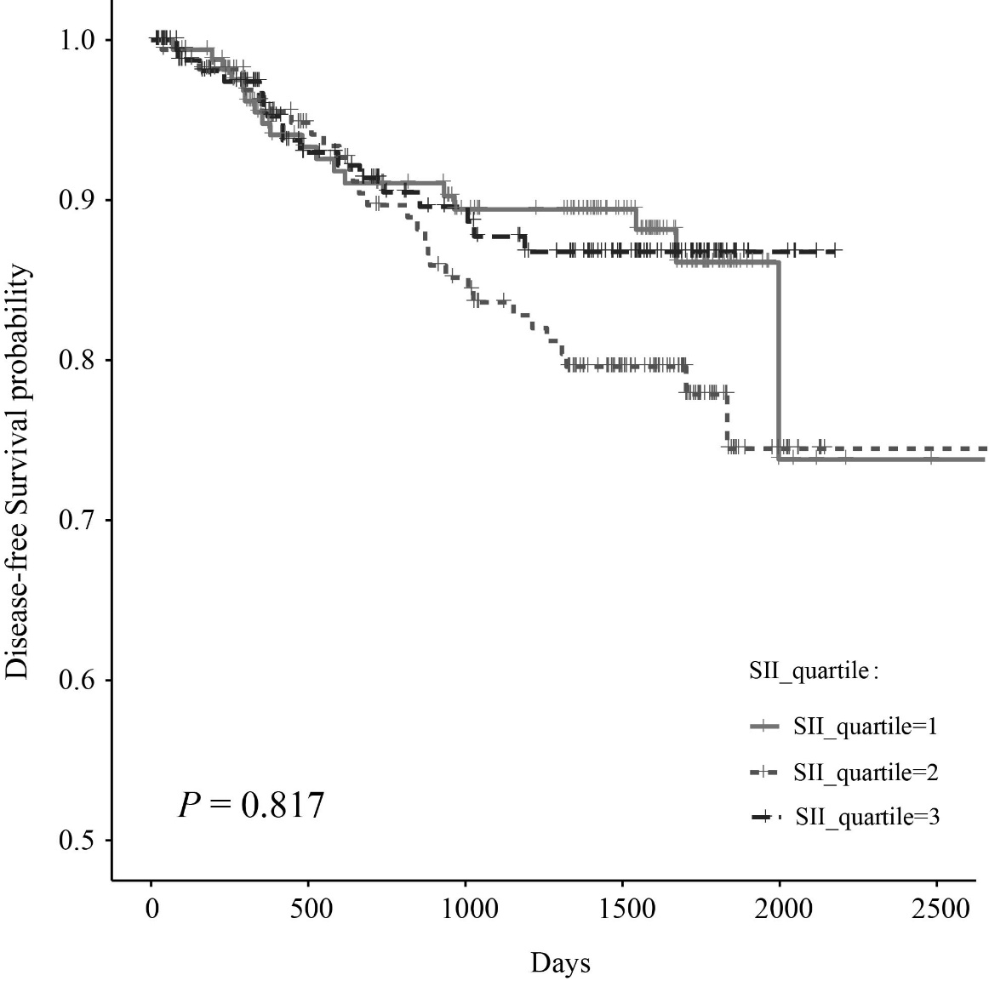
Supplementary Figure.1 Kaplan‐Meier disease-free survival curves of all patients in the cohort according to tertiles of SII (log-rank analysis P = 0.817).
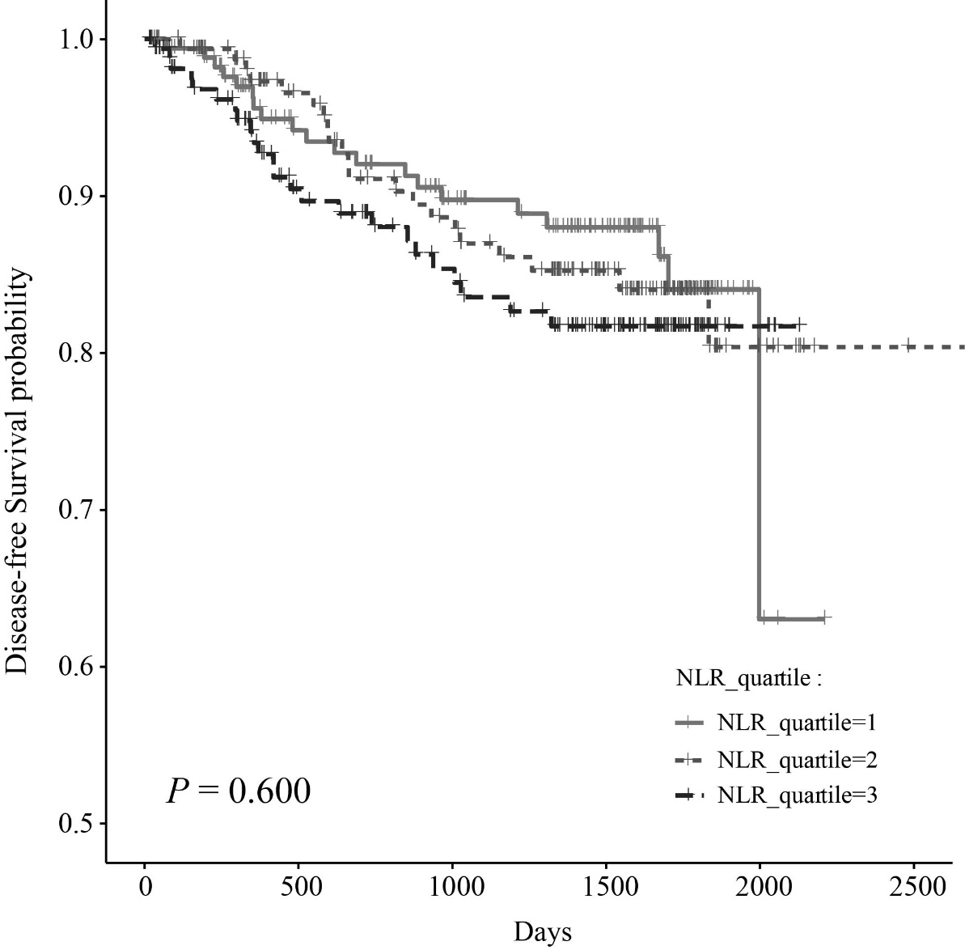
Supplementary Figure.2 Kaplan‐Meier disease-free survival curves of all patients in the cohort according to tertiles of NLR (log-rank analysis P = 0.600).
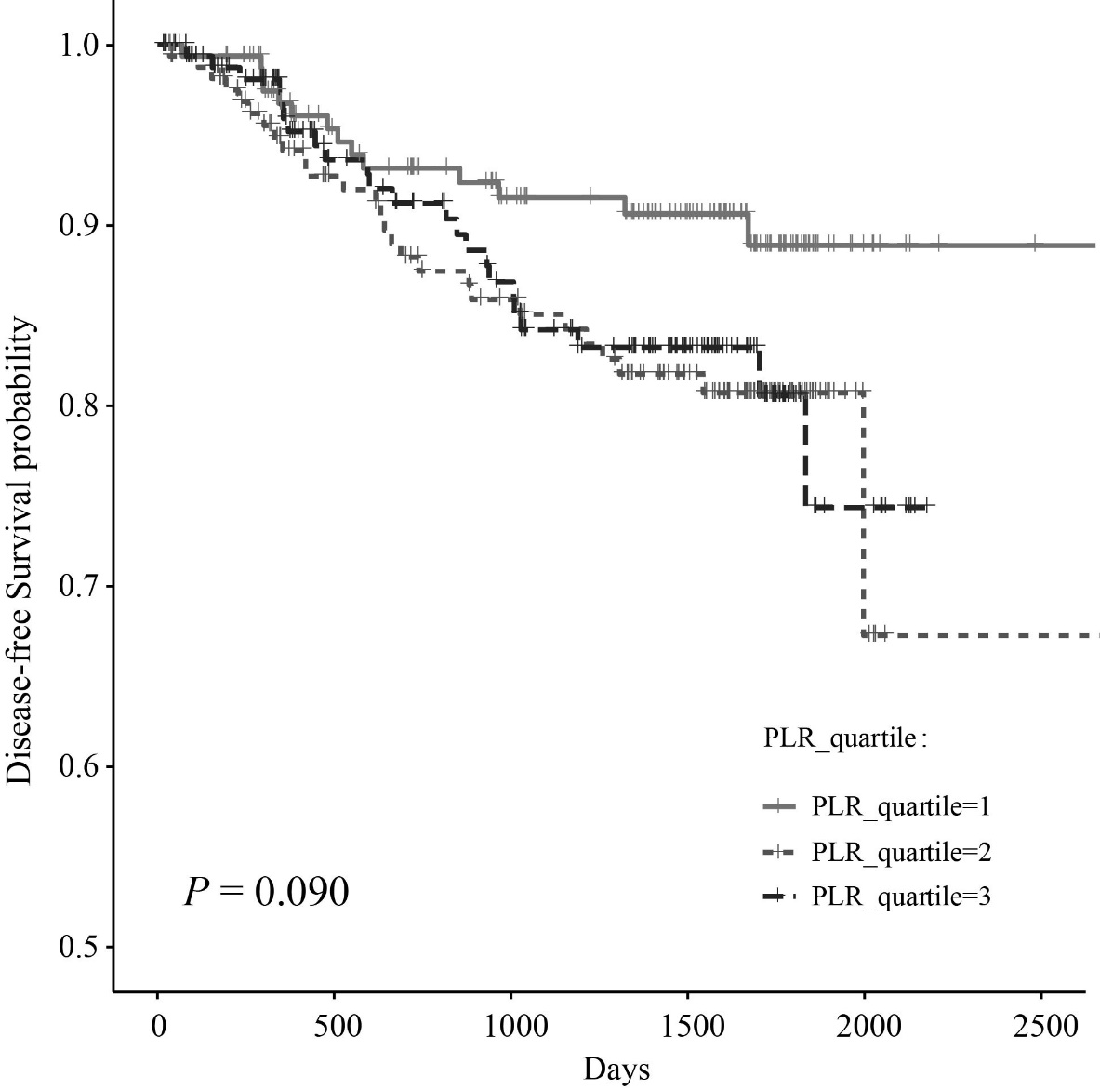
Supplementary Figure.3 Kaplan‐Meier disease-free survival curves of all patients in the cohort according to tertiles of PLR (log-rank analysis P = 0.090).

