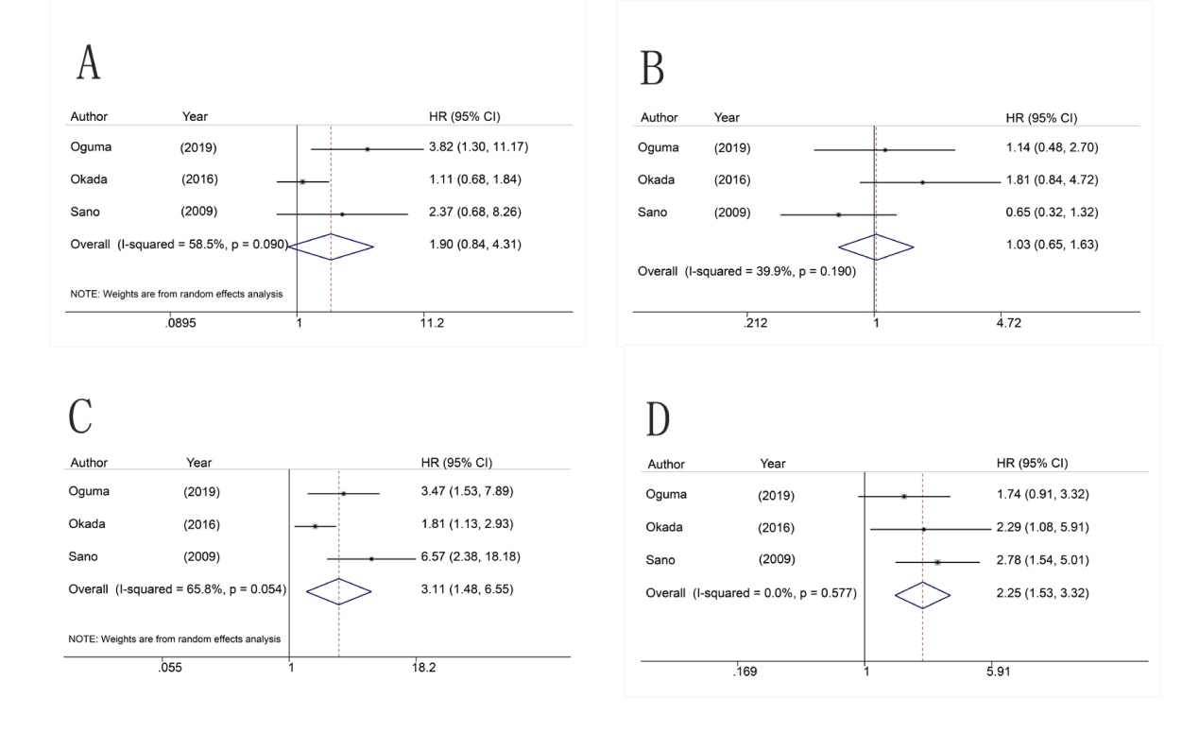
Supplementary Figure 2: Forrest plot showing the pooled HR for RFS, (A) LI from multivariate analysis, (B) VI from multivariate analysis, (C) LI from univariate analysis, (D) VI from univariate analysis

