
Request form – N21FMT

Study ID sticker

Technician:
Date in freezer |  |  |  |  |  |  | Time
 | - |  | -

Type of material
■ Stool/Feces

Additional questions
Date |  |  |  |  |  |  | Time
 | - |  | -

□ On which day did you collect the stool, and at what time?

□ At what time did you put the stool in the fridge?

Time

□ What did the stool look like?
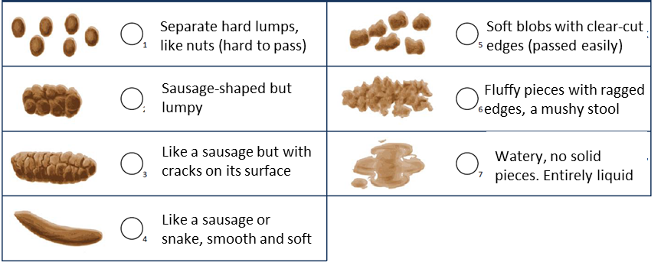

□ Have you used any nutritional supplements (e.g. vitamins, probiotics*) in the past three months? If yes, which one? *A probiotic is a food supplement that affects the intestinal flora, such as Yakult, Activia, Vifit, Actimel.
………………………………………………………………………………………………………………………………………………………………………
………………………………………………………………………………………………………………………………………………………………………
□ Do you follow a special diet (e.g. gluten-free, vegetarian, vegan etc). If yes, what kind of diet?
……………………………………………………………………………………………………………………………………………………………………….
……………………………………………………………………………………………………………………………………………………………………….

□ How many times a week do you have stools? ……………………………………………………………………………………………………………………………………………………………………….
……………………………………………………………………………………………………………………………………………………………………….

