Original blots

Depletion of SOD2 Enhances Nasopharyngeal Carcinoma Cell Radiosensitivity via Ferroptosis Induction Modulated by DHODH Inhibition
Alvan Amos^{1,2}, Ning Jiang³, Dan Zong³, Jiajia Gu³, Jiawei Zhou¹, Li Yin³, Xia He³, Yong Xu⁴, Lirong Wu³

Blots were cut prior to hybridization with antibodies

Figure 1A
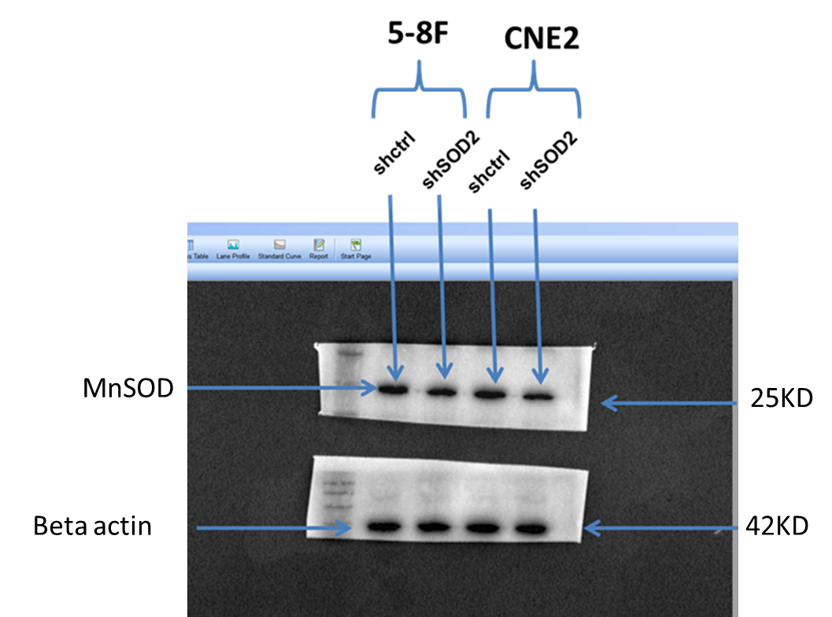

Replicate
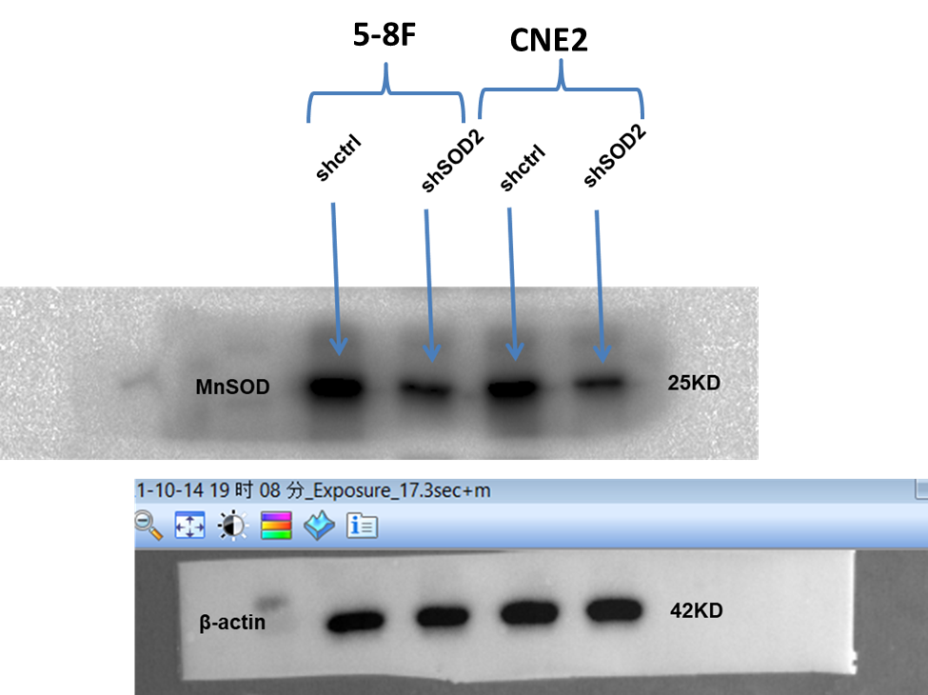

Figure 2A
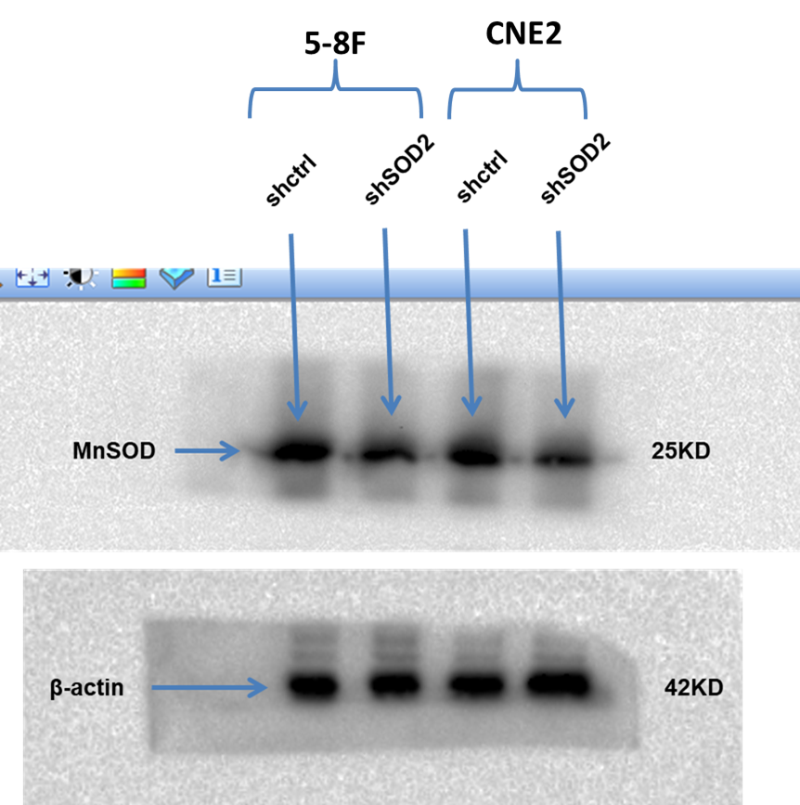

Replicate
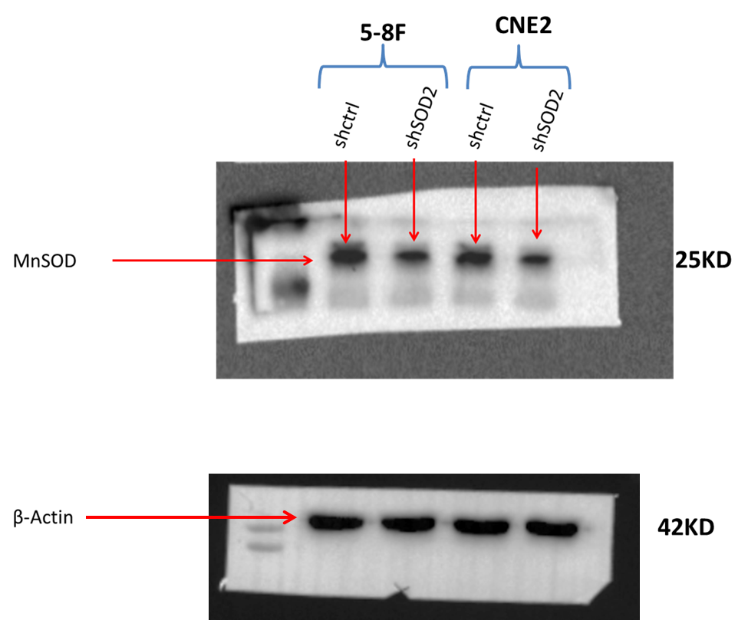
Figure 3F
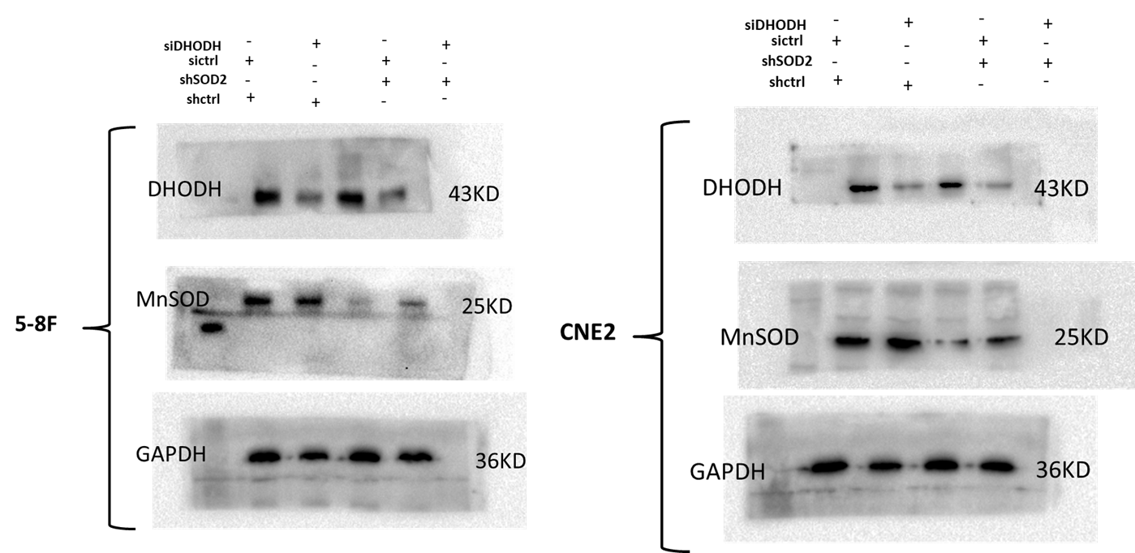

Replicate

