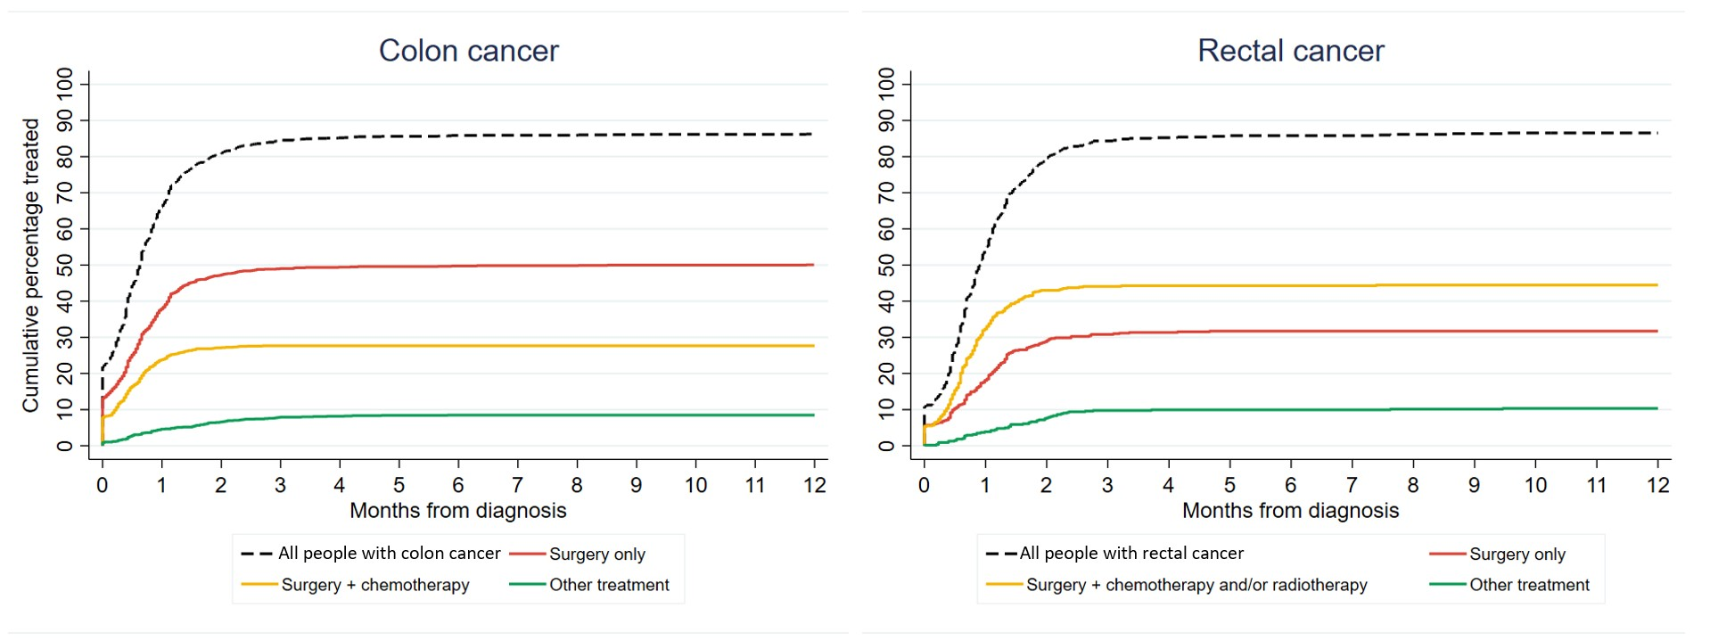
Additional file 10: Time from diagnosis to first cancer treatment received in the 0-2 years after diagnosis, by treatment category. The cumulative percentage was obtained using the cumulative incidence function (CIF).

