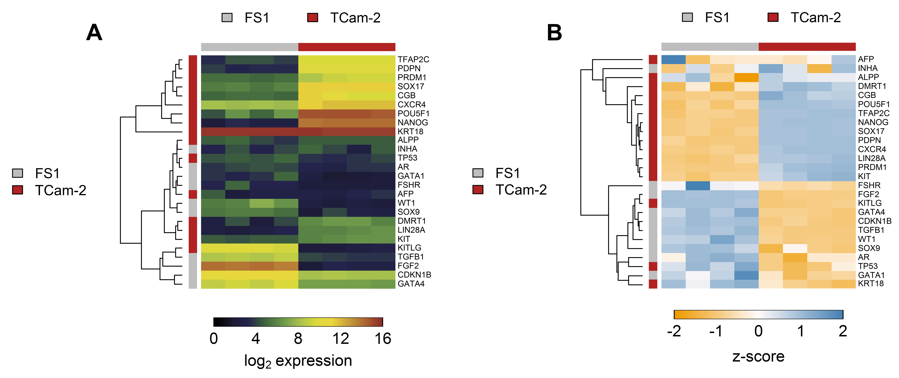
Supplementary Fig. 9 Expression of certain known marker genes in FS1 and TCam-2 cells. The heatmaps show results for the microarray analysis of monocultured FS1 and TCam-2 cells. Columns represent biological replicates of either FS1 or TCam-2 cells, and rows represent a selection of expressed marker genes typical for adult Sertoli/FS1 cells and seminoma/TCam-2 cells, respectively. Heatmap (A) shows expression values and heatmap (B) shows z-scores.

