Supplementary Fig. 10 Full-length Western blot for Fig. 3: Qualitative analysis of N-cadherin in FS1 and TCam-2 cells. Results for different FS1 and TCam-2 samples are presented. Every picture shows the same membrane. In images (A.1) and (A.2), the respective marker is visible after white light exposure. Images (B.1), (C.1), (D.1) and (E.1) show the results for N-cadherin, after exposure for 27 s (B.1, C.1) and 1 min and 30 s (D.1, E.1), respectively, whereby images (C.1) and (E.1) represent inverted versions for better contrast. Images (B.2), (C.2), (D.2) and (E.2) show the corresponding results for the loading control beta-actin, after the membrane was treated with stripping buffer, at an exposure of 29 s (B.2, C.2) and 1 min and 30 s (D.2, E.2), respectively. Again, images (C.2) and (E.2) are inverted versions. The immunoreactive band representing N-cadherin can be observed at 140 kDa for FS1 and TCam-2 samples (B.1, C.1, D.1, E.1). The typical band for beta-actin is located at 43 kDa and is also present for FS1 and TCam-2 samples (B.2, C.2, D.2, E.2). The bands that are depicted in Fig. 3 of the main article are marked with arrows.

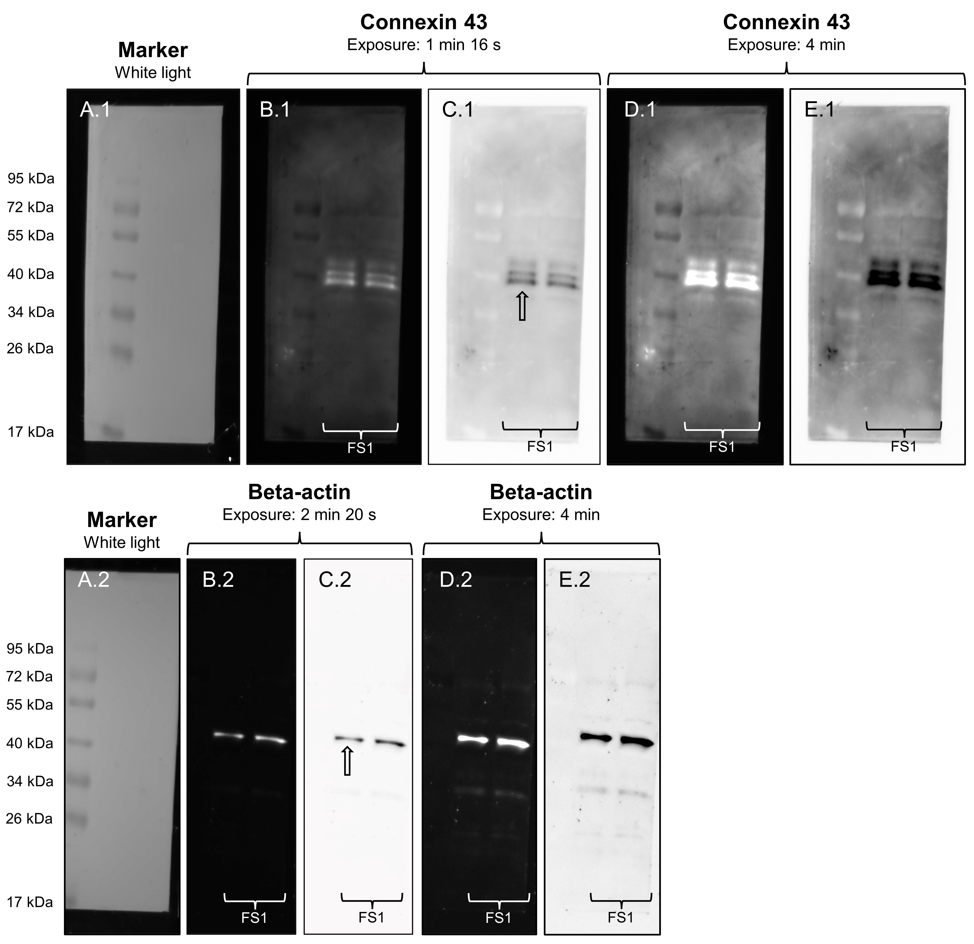
Supplementary Fig. 11 Full-length Western blot for Fig. 3: Qualitative analysis of connexin 43 in FS1 cells. Results for two different FS1 samples are presented. Every picture shows the same membrane. In images (A.1) and (A.2), the respective marker is visible after white light exposure. Images (B.1), (C.1), (D.1) and (E.1) show the results for connexin 43, after exposure for 1 min and 16 s (B.1, C.1) and 4 min (D.1, E.1), respectively, whereby images (C.1) and (E.1) represent inverted versions for better contrast. Images (B.2), (C.2), (D.2) and (E.2) show the corresponding results for the loading control beta-actin, after the membrane was treated with stripping buffer, at an exposure of 2 min 20 s (B.2, C.2) and 4 min (D.2, E.2), respectively. Again, images (C.2) and (E.2) are inverted versions. The immunoreactive bands representing connexin 43 can be observed at 39 kDa, 41 kDa and 43/44 kDa for FS1 samples, probably representing different phosphorylated isoforms (B.1, C.1, D.1, E.1). The typical band for beta-actin is located at 43 kDa and is also present for FS1 samples (B.2, C.2, D.2, E.2). The bands that are depicted in Fig. 3 of the main article are marked with arrows.

Supplementary Fig. 12 Full-length Western blot for Fig. 3: Qualitative analysis of connexin 43 in TCam-2 cells. Results for two different TCam-2 samples are presented. Every picture shows the same membrane. In images (A.1) and (A.2), the respective marker is visible after white light exposure. Images (B.1), (C.1), (D.1) and (E.1) show the results for connexin 43, after exposure for 2 min and 9 s (B.1, C.1) and 4 min (D.1, E.1), respectively, whereby images (C.1) and (E.1) represent inverted versions for better contrast. Images (B.2), (C.2), (D.2) and (E.2) show the corresponding results for the loading control beta-actin, after the membrane was treated with stripping buffer, at an exposure of 2 min and 20 s (B.2, C.2) and 4 min (D.2, E.2), respectively. Again, images (C.2) and (E.2) are inverted versions. The immunoreactive bands representing connexin 43 can be observed at 39 kDa and 41 kDa for TCam-2 samples (B.1, C.1, D.1, E.1). The typical band for beta-actin is located at 43 kDa and is also present for TCam-2 samples (B.2, C.2, D.2, E.2). The bands that are depicted in Fig. 3 of the main article are marked with arrows.

Supplementary Fig. 13 Full-length Western blot for Fig. 3: Qualitative analysis of connexin 45 in FS1 and TCam-2 cells. Results for different FS1 and TCam-2 samples are presented. Every picture shows the same membrane. In images (A.1) and (A.2), the respective marker is visible after white light exposure. Images (B.1), (C.1), (D.1) and (E.1) show the results for connexin 45, after exposure for 1 min (B.1, C.1) and 1 min and 30 s (D.1, E.1), respectively, whereby images (C.1) and (E.1) represent inverted versions for better contrast. Images (B.2), (C.2), (D.2) and (E.2) show the corresponding results for the loading control beta-actin, after the membrane was treated with stripping buffer, at an exposure of 1 min and 19 s (B.2, C.2) and 1 min and 30 s (D.2, E.2), respectively. Again, images (C.2) and (E.2) are inverted versions. The immunoreactive bands representing connexin 45 can be observed at 45 kDa for FS1 and TCam-2 samples (B.1, C.1, D.1, E.1). The typical band for beta-actin is located at 43 kDa and is also present for FS1 and TCam-2 samples (B.2, C.2, D.2, E.2). Additional bands can be considered nonspecific. The bands that are depicted in Fig. 3 of the main article are marked with arrows.
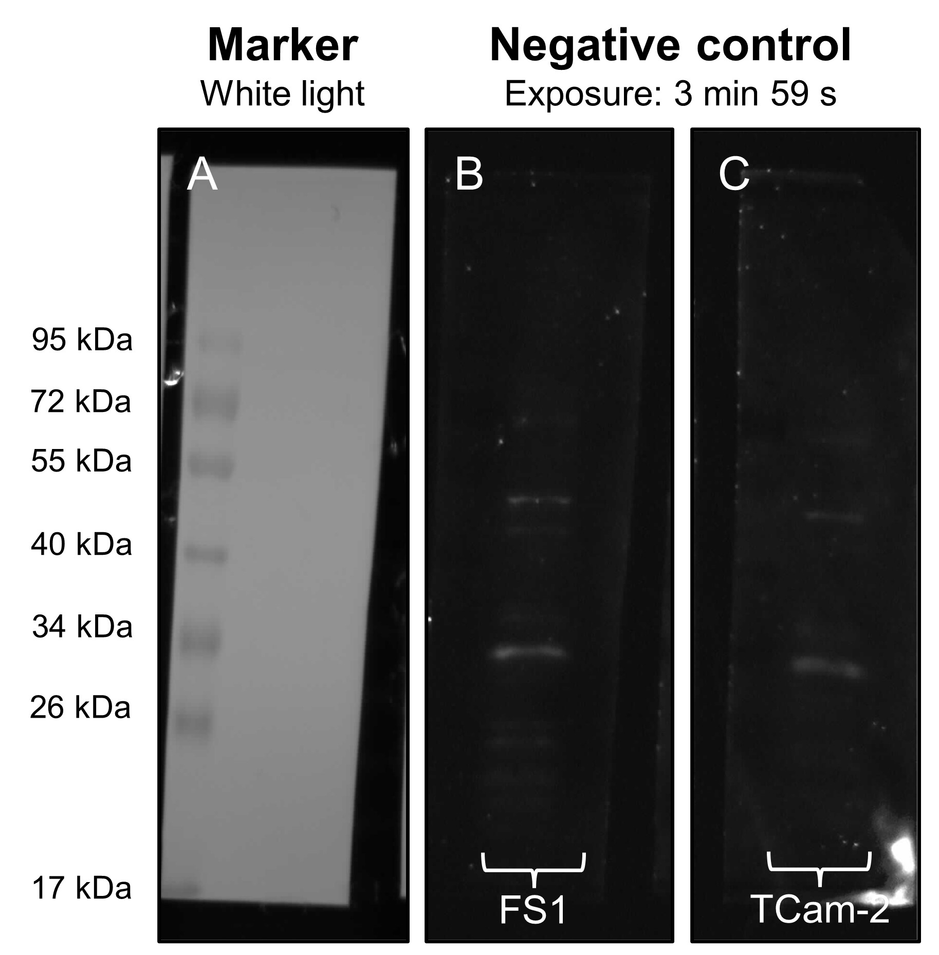
Supplementary Fig. 14 Western blot representing negative controls (anti-mouse) for FS1 and TCam-2 cells. Only anti-mouse secondary antibody has been used but no primary antibody. Image (A) shows the marker after white light exposure and images (B) and (C) show the negative controls for FS1 and TCam-2 cells, respectively, after exposure for 3 min and 59 s. (B, C) Only faint bands can be observed, which can be considered nonspecific.

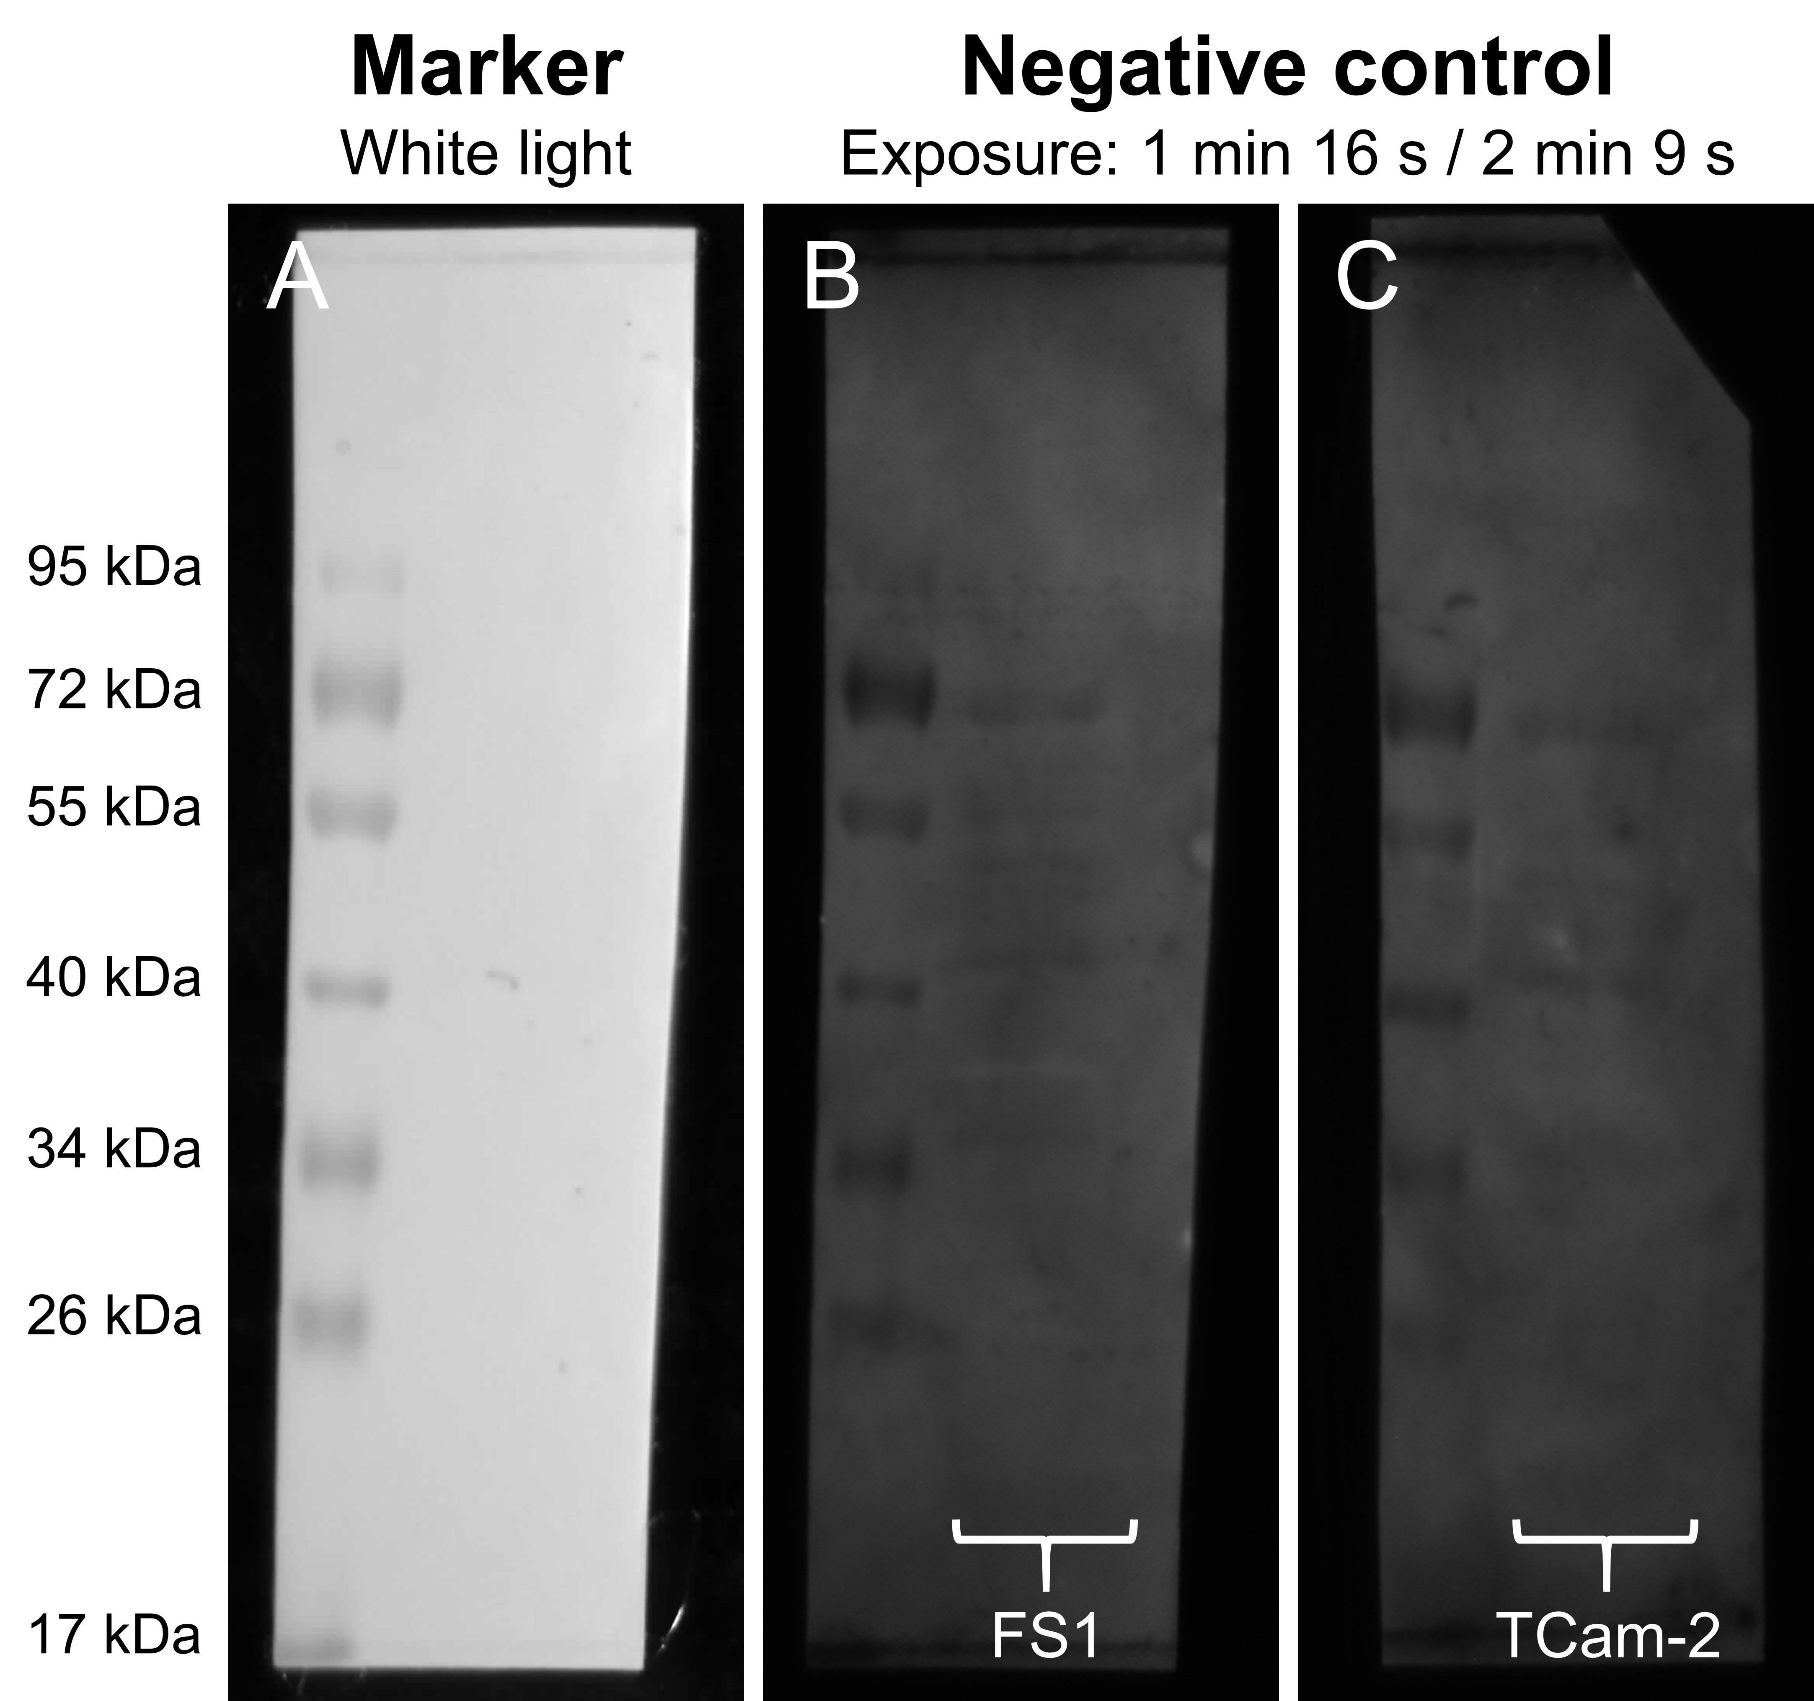
Supplementary Fig. 15 Western blot representing negative controls (anti-rabbit) for FS1 and TCam-2 cells. Only anti-rabbit secondary antibody has been used but no primary antibody. Image (A) shows the marker after white light exposure and images (B) and (C) show the negative controls for FS1 (exposure: 1 min 16 s) and TCam-2 cells (exposure: 2 min 9 s), respectively. (B, C) No immunoreactive bands can be observed.

