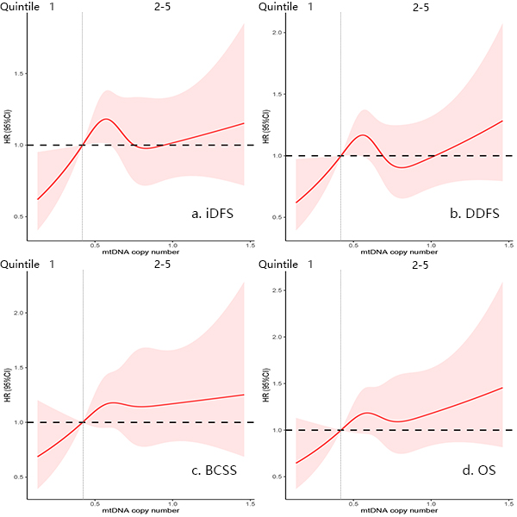
Figure S1. Adjusted nonlinear splines (and 95% confidence bands) for the association between increasing mitochondrial (mt) DNA copy number and hazard ratio (HR) of iDFS (a), DDFS (b), BCSS (c), OS(d) (adjusted for age at diagnosis, tumor size, Lymph node involvement, grade, hormone receptor status, and HER2 status). Vertical dotted lines indicate the threshold for the first quintile of mtDNA copy number; the first quintile value of mtDNA is set as a reference (HR = 1; horizontal dashed line).

