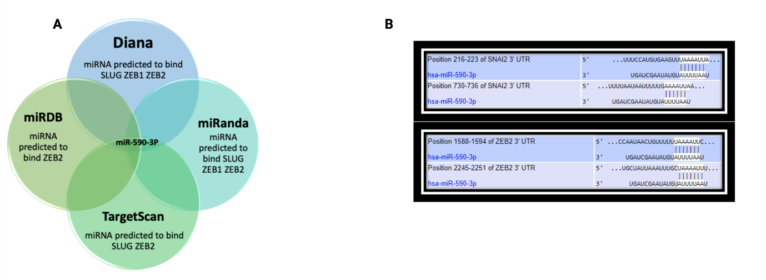Aditional file 1

Figure S1: miR-590-3p directly targets EMT-TF SLUG, ZEB1, and ZEB2 in HCC, as determined by bioinformatics analysis (A) CSmiRTar database analysis showing SLUG, ZEB1 and ZEB2 as miR-590-3p potential target genes. (B) TargetScan analysis showing the sequence alignment between the seed region of miR-50-3p and its downstream target genes. Although SNAIL was not predicted as a direct target of miR-590-3p by CSmiRTar database or TargetScan, we observed a marked reduction in the transcript levels of SNAIL using RT-qPCR analysis, suggesting that miR-590-3p may target SNAIL through other players primarily regulated by miR-590-3p, such as MDM2. * SNAI2= SLUG

