Additional file 3
Western blot uncropped full-length blots
A

GAPDH
MDM2
Si-NTC
si-MDM2
Laddar

siMDM2-rep2
siNTC
B
Laddar
siMDM2- rep1

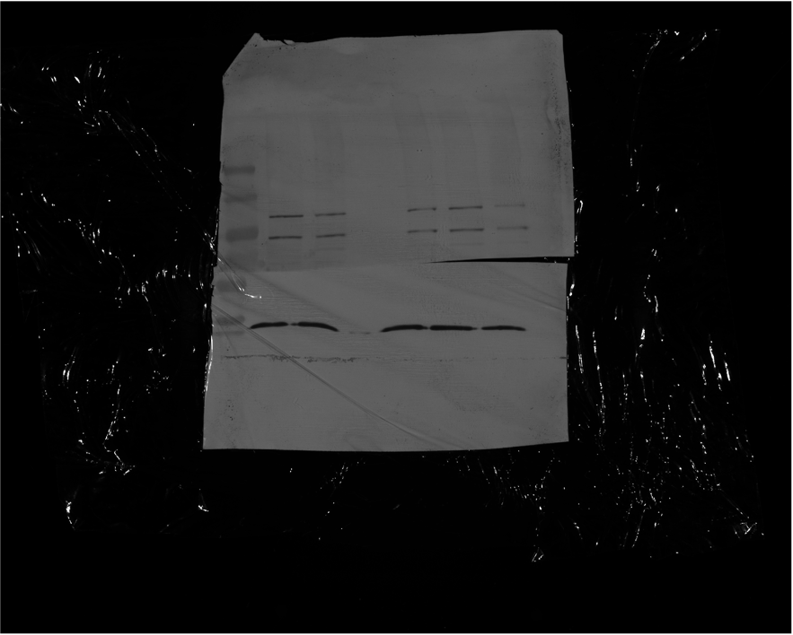
GAPDH
MDM2

Figure (S3) MDM2 siRNA effectively silences MDM2 expression at the protein levels.
Western blot uncropped full-length blot for A) first biological replicate and B) second biological replicate.

